Supplemental Materials

Risk characterization and probabilistic concentration-response modeling of complex environmental mixtures using novel approach methodologies (NAMs) data from the organotypic *in-vitro* human stem cell assays

Nan-Hung Hsieh $​^{1,2,**}$, Zunwei Chen $​^{1,2,**}$, Ivan Rusyn $​^{1,2,*}$, Weihsueh A. Chiu $​^{1,2,*}$

$​^{1}$ Interdisciplinary Faculty of Toxicology $​^{2}$ Department of Veterinary Integrative Biosciences, College of Veterinary Medicine and Biomedical Sciences, Texas A&M University, College Station, TX 77843

Table of Contents

Supplementary Data 4

Supplementary Tables 5

Supplementary Figures 17

Curve-fitting of single chemical concentration-respsonse 17

iCell Neurons 17

HUVECs 27

iCell Hepatocytes 35

iCell Endothelial cells 40

iCell Cardiomyocytes 48

Curve-fitting of mixture concentration-respsonse 64

iCell Neurons 64

HUVECs 69

iCell Hepatocytes 73

iCell Endothelial cells 76

iCell Cardiomyocytes 80

Curve-fitting and prediction of AC50-H concentration-response 88

iCell Neurons 88

HUVECs 89

iCell Hepatocytes 90

iCell Endothelial cells 91

iCell Cardiomyocytes 92

Estimation of the margin of exposure under AC50-H exposure 93

iCell Neurons 93

HUVECs 94

iCell Hepatocytes 95

iCell Endothelial cells 96

iCell Cardiomyocytes 97

Session Information 98

$​^{*}$ To whom correspondence should be addressed:

Ivan Rusyn, MD, Ph.D., Department of Veterinary Integrative Biosciences, Texas A&M University, College Station, TX 77843; [irusyn@cvm.tamu.edu](mailto:irusyn@cvm.tamu.edu)

Weihsueh A. Chiu, Ph.D., Department of Veterinary Integrative Biosciences, Texas A&M University, College Station, TX 77843; [wchiu@cvm.tamu.edu](mailto:wchiu@cvm.tamu.edu)

$​^{**}$ These authors contributed equally to this manuscript.

# Supplementary Data

The Github repository <https://github.com/nanhung/EHP7600> contains the R code (**codes**) and datasets (**datasets**) that can reproduce the modeling and analyze result (in **outputs** folder) and visualize plots (in **plots** folder) and final report (in **reports** folder). The details and data pipelines are included in:

* **codes:** The source code to reproduce the modeling and analyze result that include:
  + *hill_two.stan:* Stan code of Hill model for the concentration-response modeling.
  + *0_mcmc_ind_chems.R*: R code for conducting the Hamiltonian Monte chain Monte Carlo simulation for individual chemicals.
  + *1_mcmc_mixtures.R*: R code for conducting the Hamiltonian Monte chain Monte Carlo simulation for mixtures.
  + *2_ec_10_pred.R*: R code to to estimate curve-fitting and predicted EC $​_{10}$ in mixture for each phenotype.
  + *3_conc_resp_pred.R*: R code to reconstruct the concentration-response profiles.
  + *4_plot.R*: R codes to generate the figures in manuscript.
  + *5_plot_suppl.R*: R codes to generate the same figures in Supplemental Materials.
* **datasets:** The provided tidy data files include the individual chemical information (*chem_info.csv*) and cell assay results (*chem_data.csv*). The mixture information and cell assay results can be found in *mix_info.csv* and *mix_data.csv*. The data files contained the following columns:
  + *chemical*: Name of chemical.
  + *mixture*: Name of mixture.
  + *Replication*: Replication number. Two replications were conducted in individual chemicals. The mixtures had six replication.
  + *Concentration*: Experimental concentration (unit = micromole).
  + *Dilution*: Diluted factor according to the designed concentration in mixture.
  + *Response*: Response proportion that had been normalized (0 - 1) based on the control group.
  + *celltype*: Name of human induced pluripotent stem cells-derived cells.
  + *phenotype*: Cytotoxicity and functional phenotypes for each cell.
* **outputs**: The files in the output folder are generated by the above R code and datasets. The Bayesain estimated model parameters for individual chemicals were named like *HUVECs_42_chem_params.rda*. Also, the mixtures were named like *HUVECs_mixtures_params.rda*. The outputs of curve-fitting and predicted EC $​_{10}$ in the mixture for each phenotype were stored in *ec_10_pred.rda*. Also, the calculated outputs to reconstruct the mixture concentration-response profile are in *mix_CR.rda*.
* **plots:** All plots showed in the manuscript were saved in this folder. The **suppl** folder includes the supplementary figures that showed below.

# Supplementary Tables

Table S1. The list of chemical that were be used in this study.

|  |  |  |  |  |  |
| --- | --- | --- | --- | --- | --- |
| No. | Chemical | CAS_trimmed | Class | Molecular.weight | class |
| 1 | Benz(a)anthracene | 56-55-3 | PAH | 228.2900 | PAH |
| 2 | Naphthalene | 91-20-3 | PAH | 128.1700 | PAH |
| 3 | Fluoranthene | 206-44-0 | PAH | 202.2600 | PAH |
| 4 | p,p’-DDT | 50-29-3 | Pesticide | 354.4800 | Pesticides |
| 5 | Dieldrin | 60-57-1 | Pesticide | 380.9100 | Pesticides |
| 6 | Aldrin | 309-00-2 | Pesticide | 364.9000 | Pesticides |
| 7 | Heptachlor | 76-44-8 | Pesticide | 373.3200 | Pesticides |
| 8 | Lindane | 58-89-9 | Pesticide | 290.8300 | Pesticides |
| 9 | Disulfoton | 298-04-4 | Pesticide | 274.4040 | Pesticides |
| 10 | Endrin | 72-20-8 | Pesticide | 380.9070 | Pesticides |
| 11 | Diazinon | 333-41-5 | Pesticide | 304.3400 | Pesticides |
| 12 | Heptachlor epoxide | 1024-57-3 | Pesticide | 389.3200 | Pesticides |
| 13 | Pentachlorophenol | 87-86-5 | HPV | 266.3400 | HPV |
| 14 | Dibutyl phthalate | 84-74-2 | Plasticizer | 278.3500 | Phthalates |
| 15 | Chlorpyrifos | 2921-88-2 | Pesticide | 350.5700 | Pesticides |
| 16 | Di(2-ethylhexyl) phthalate | 117-81-7 | Plasticizer | 390.5600 | Phthalates |
| 17 | 2,4,6-Trichlorophenol | 88-06-2 | HPV | 197.4500 | HPV |
| 18 | Ethion | 563-12-2 | Pesticide | 384.4800 | Pesticides |
| 19 | Azinphos-methyl | 86-50-0 | Pesticide | 317.3200 | Pesticides |
| 20 | 2,4,5-Trichlorophenol | 95-95-4 | HPV | 197.4460 | HPV |
| 21 | Parathion | 56-38-2 | Pesticide | 291.2600 | Pesticides |
| 22 | Benzo(b)fluoranthene | 205-99-2 | PAH | 252.3200 | PAH |
| 23 | Trifluralin | 1582-09-8 | Pesticide | 335.2800 | Pesticides |
| 24 | Acenaphthene | 83-32-9 | PAH | 154.2100 | PAH |
| 25 | p,p’-DDD | 72-54-8 | Pesticide | 320.0400 | Pesticides |
| 26 | Benzidine | 92-87-5 | HPV | 184.2400 | HPV |
| 27 | Endosulfan | 115-29-7 | Pesticide | 406.9000 | Pesticides |
| 28 | Methoxychlor | 72-43-5 | Pesticide | 345.6500 | Pesticides |
| 29 | 2,4-Dinitrophenol | 51-28-5 | Pesticide | 184.1100 | Pesticides |
| 30 | 2,4-Dinitrotoluene | 121-14-2 | HPV | 182.1340 | HPV |
| 31 | Dicofol | 115-32-2 | Pesticide | 370.4800 | Pesticides |
| 32 | p-Cresol | 106-44-5 | HPV | 108.1300 | HPV |
| 33 | o,p’-DDT | 789-02-6 | Pesticide | 354.4900 | Pesticides |
| 34 | 2-Methyl-4,6-dinitrophenol | 534-52-1 | HPV | 198.1300 | HPV |
| 35 | 1,2,3-Trichlorobenzene | 87-61-6 | HPV | 181.4470 | HPV |
| 36 | Lead nitrate | 7439-92-1 | Metal | 331.2000 | Heavy Metals |
| 37 | Cadmium chloride | 7440-43-9 | Metal | 183.3100 | Heavy Metals |
| 38 | Zinc chloride | 7440-66-6 | Metal | 136.3150 | Heavy Metals |
| 39 | Mercuric chloride | 7487-94-7 | Metal | 271.5200 | Heavy Metals |
| 40 | Potassium chromate (VI) | 18540-29-9 | Metal | 194.1900 | Heavy Metals |
| 41 | Cobalt chloride | 7440-48-4 | Metal | 129.8390 | Heavy Metals |
| 42 | Nickel chloride | 7440-02-0 | Metal | 129.5994 | Heavy Metals |

Table S2. The summary of the AC50-based designed mixture.

|  |  |  |  |  |
| --- | --- | --- | --- | --- |
| Chemical | AC50-L (micromole) | AC50-H (micromole) | AC50-L (%) | AC50-H (%) |
| Benz(a)anthracene | 0.018100 | 112.0 | 0.04 | 1.80 |
| Naphthalene | 0.002330 | 144.0 | 0.00 | 2.31 |
| Fluoranthene | 0.077900 | 164.0 | 0.16 | 2.63 |
| p,p’-DDT | 0.000479 | 253.0 | 0.00 | 4.06 |
| Dieldrin | 0.040600 | 169.0 | 0.08 | 2.71 |
| Aldrin | 0.912000 | 253.0 | 1.89 | 4.06 |
| Heptachlor | 5.050000 | 164.0 | 10.46 | 2.63 |
| Lindane | 5.680000 | 116.0 | 11.76 | 1.86 |
| Disulfoton | 5.870000 | 81.8 | 12.16 | 1.31 |
| Endrin | 0.219000 | 64.9 | 0.45 | 1.04 |
| Diazinon | 0.061600 | 118.0 | 0.13 | 1.89 |
| Heptachlor epoxide | 1.670000 | 107.0 | 3.46 | 1.72 |
| Pentachlorophenol | 0.993000 | 164.0 | 2.06 | 2.63 |
| Dibutyl phthalate | 0.010200 | 72.4 | 0.02 | 1.16 |
| Chlorpyrifos | 2.350000 | 164.0 | 4.87 | 2.63 |
| Di(2-ethylhexyl) phthalate | 0.370000 | 67.2 | 0.77 | 1.08 |
| 2,4,6-Trichlorophenol | 0.808000 | 316.0 | 1.67 | 5.07 |
| Ethion | 0.163000 | 285.0 | 0.34 | 4.57 |
| Azinphos-methyl | 0.094200 | 253.0 | 0.20 | 4.06 |
| 2,4,5-Trichlorophenol | 0.552000 | 133.0 | 1.14 | 2.13 |
| Parathion | 0.100000 | 81.8 | 0.21 | 1.31 |
| Benzo(b)fluoranthene | 0.004000 | 253.0 | 0.01 | 4.06 |
| Trifluralin | 0.094600 | 113.0 | 0.20 | 1.81 |
| Acenaphthene | 2.450000 | 78.1 | 5.07 | 1.25 |
| p,p’-DDD | 0.981000 | 133.0 | 2.03 | 2.13 |
| Benzidine | 3.110000 | 632.0 | 6.44 | 10.13 |
| Endosulfan | 0.164000 | 253.0 | 0.34 | 4.06 |
| Methoxychlor | 0.476000 | 181.0 | 0.99 | 2.90 |
| 2,4-Dinitrophenol | 0.094400 | 122.0 | 0.20 | 1.96 |
| 2,4-Dinitrotoluene | 4.850000 | 28.3 | 10.04 | 0.45 |
| Dicofol | 0.634000 | 117.0 | 1.31 | 1.88 |
| p-Cresol | 0.156000 | 25.3 | 0.32 | 0.41 |
| o,p’-DDT | 0.105000 | 112.0 | 0.22 | 1.80 |
| 2-Methyl-4,6-dinitrophenol | 0.002230 | 164.0 | 0.00 | 2.63 |
| 1,2,3-Trichlorobenzene | 0.002150 | 15.5 | 0.00 | 0.25 |
| Lead nitrate | 1.000000 | 100.0 | 2.07 | 1.60 |
| Cadmium chloride | 5.000000 | 100.0 | 10.35 | 1.60 |
| Zinc chloride | 1.000000 | 100.0 | 2.07 | 1.60 |
| Mercuric chloride | 0.126000 | 126.0 | 0.26 | 2.02 |
| Potassium chromate (VI) | 1.000000 | 100.0 | 2.07 | 1.60 |
| Cobalt chloride | 1.000000 | 100.0 | 2.07 | 1.60 |
| Nickel chloride | 1.000000 | 100.0 | 2.07 | 1.60 |

Table S3. The summary of the exposure-based designed mixture.

|  |  |  |  |  |
| --- | --- | --- | --- | --- |
| Chemical | Expo-L (micromole) | Expo-H (micromole) | Expo-L (%) | Expo-H (%) |
| Benz(a)anthracene | 0.0000004 | 0.0001142 | 0.00 | 0.00 |
| Naphthalene | 0.0005857 | 0.1578079 | 0.00 | 0.20 |
| Fluoranthene | 0.0000012 | 0.0003547 | 0.00 | 0.00 |
| p,p’-DDT | 0.0000000 | 0.0000047 | 0.00 | 0.00 |
| Dieldrin | 0.0000140 | 0.0047156 | 0.00 | 0.01 |
| Aldrin | 0.0000101 | 0.0036380 | 0.00 | 0.00 |
| Heptachlor | 0.0000000 | 0.0000021 | 0.00 | 0.00 |
| Lindane | 0.0000063 | 0.0051959 | 0.00 | 0.01 |
| Disulfoton | 0.0000001 | 0.0000846 | 0.00 | 0.00 |
| Endrin | 0.0000205 | 0.0110974 | 0.00 | 0.01 |
| Diazinon | 0.0000002 | 0.0001608 | 0.00 | 0.00 |
| Heptachlor epoxide | 0.0000000 | 0.0000021 | 0.00 | 0.00 |
| Pentachlorophenol | 0.0000017 | 0.0000052 | 0.00 | 0.00 |
| Dibutyl phthalate | 0.0000256 | 0.0044487 | 0.00 | 0.01 |
| Chlorpyrifos | 0.0000002 | 0.0000950 | 0.00 | 0.00 |
| Di(2-ethylhexyl) phthalate | 0.0000256 | 0.0044487 | 0.00 | 0.01 |
| 2,4,6-Trichlorophenol | 0.0000000 | 0.0000173 | 0.00 | 0.00 |
| Ethion | 0.0000002 | 0.0001369 | 0.00 | 0.00 |
| Azinphos-methyl | 0.0000000 | 0.0000007 | 0.00 | 0.00 |
| 2,4,5-Trichlorophenol | 0.0000001 | 0.0000954 | 0.00 | 0.00 |
| Parathion | 0.0000011 | 0.0006720 | 0.00 | 0.00 |
| Benzo(b)fluoranthene | 0.0000008 | 0.0004048 | 0.00 | 0.00 |
| Trifluralin | 0.0003642 | 0.1946423 | 0.00 | 0.24 |
| Acenaphthene | 0.0000002 | 0.0000342 | 0.00 | 0.00 |
| p,p’-DDD | 0.0000043 | 0.0005338 | 0.00 | 0.00 |
| Benzidine | 0.0000014 | 0.0003953 | 0.00 | 0.00 |
| Endosulfan | 0.0000260 | 0.0167759 | 0.00 | 0.02 |
| Methoxychlor | 0.0000000 | 0.0000102 | 0.00 | 0.00 |
| 2,4-Dinitrophenol | 0.0000048 | 0.0007032 | 0.00 | 0.00 |
| 2,4-Dinitrotoluene | 0.0000008 | 0.0001844 | 0.00 | 0.00 |
| Dicofol | 0.0000004 | 0.0002233 | 0.00 | 0.00 |
| p-Cresol | 0.0000018 | 0.0002292 | 0.00 | 0.00 |
| o,p’-DDT | 0.0000000 | 0.0000050 | 0.00 | 0.00 |
| 2-Methyl-4,6-dinitrophenol | 0.0000535 | 0.0446951 | 0.00 | 0.06 |
| 1,2,3-Trichlorobenzene | 0.0000012 | 0.0004521 | 0.00 | 0.00 |
| Lead nitrate | 0.0723938 | 0.0723938 | 0.09 | 0.09 |
| Cadmium chloride | 0.0444800 | 0.0444800 | 0.06 | 0.06 |
| Zinc chloride | 76.9230769 | 76.9230769 | 96.84 | 96.29 |
| Mercuric chloride | 0.0099701 | 0.0099701 | 0.01 | 0.01 |
| Potassium chromate (VI) | 1.9232249 | 1.9232249 | 2.42 | 2.41 |
| Cobalt chloride | 0.0339386 | 0.0339386 | 0.04 | 0.04 |
| Nickel chloride | 0.4259452 | 0.4259452 | 0.54 | 0.53 |

Table S4. The summary of the POD-based designed mixture.

|  |  |  |  |  |
| --- | --- | --- | --- | --- |
| Chemical | POD-L (micromole) | POD-H (micromole) | POD-L (%) | POD-H (%) |
| Benz(a)anthracene | 1.0000000 | 100.0000000 | 0.04 | 0.47 |
| Naphthalene | 564.2592537 | 2739.4526320 | 20.39 | 12.83 |
| Fluoranthene | 157.4135185 | 1015.6731090 | 5.69 | 4.76 |
| p,p’-DDT | 0.0072505 | 0.0321568 | 0.00 | 0.00 |
| Dieldrin | 0.5444496 | 5.2629070 | 0.02 | 0.02 |
| Aldrin | 9.6012594 | 299.5681404 | 0.35 | 1.40 |
| Heptachlor | 0.0218881 | 0.0492708 | 0.00 | 0.00 |
| Lindane | 1.0000000 | 100.0000000 | 0.04 | 0.47 |
| Disulfoton | 0.0590265 | 0.5495373 | 0.00 | 0.00 |
| Endrin | 9.6012594 | 299.5681404 | 0.35 | 1.40 |
| Diazinon | 0.0338929 | 0.5057353 | 0.00 | 0.00 |
| Heptachlor epoxide | 0.0218881 | 0.0492708 | 0.00 | 0.00 |
| Pentachlorophenol | 0.3042524 | 7.0331182 | 0.01 | 0.03 |
| Dibutyl phthalate | 34.8952467 | 351.8825255 | 1.26 | 1.65 |
| Chlorpyrifos | 0.2062983 | 2.0496652 | 0.01 | 0.01 |
| Di(2-ethylhexyl) phthalate | 34.8952467 | 351.8825255 | 1.26 | 1.65 |
| 2,4,6-Trichlorophenol | 11.5355283 | 64.6773746 | 0.42 | 0.30 |
| Ethion | 0.0781195 | 0.8800805 | 0.00 | 0.00 |
| Azinphos-methyl | 0.0282547 | 0.0638165 | 0.00 | 0.00 |
| 2,4,5-Trichlorophenol | 665.1268293 | 7335.1382110 | 24.04 | 34.36 |
| Parathion | 0.1244289 | 1.2897856 | 0.00 | 0.01 |
| Benzo(b)fluoranthene | 157.4135185 | 1015.6731090 | 5.69 | 4.76 |
| Trifluralin | 173.9842357 | 1486.5754780 | 6.29 | 6.96 |
| Acenaphthene | 534.1177738 | 2973.7880630 | 19.30 | 13.93 |
| p,p’-DDD | 0.0072505 | 0.0321568 | 0.00 | 0.00 |
| Benzidine | 2.6654363 | 8.1475274 | 0.10 | 0.04 |
| Endosulfan | 83.3342176 | 1791.4633860 | 3.01 | 8.39 |
| Methoxychlor | 0.9835145 | 6.4378968 | 0.04 | 0.03 |
| 2,4-Dinitrophenol | 155.1683360 | 439.4894992 | 5.61 | 2.06 |
| 2,4-Dinitrotoluene | 13.9218878 | 96.1295837 | 0.50 | 0.45 |
| Dicofol | 0.4281083 | 5.1148034 | 0.02 | 0.02 |
| p-Cresol | 49.3945062 | 609.6607949 | 1.79 | 2.86 |
| o,p’-DDT | 0.0072505 | 0.0321568 | 0.00 | 0.00 |
| 2-Methyl-4,6-dinitrophenol | 13.9218878 | 96.1295837 | 0.50 | 0.45 |
| 1,2,3-Trichlorobenzene | 11.5355283 | 64.6773746 | 0.42 | 0.30 |
| Lead nitrate | 0.0723938 | 0.0723938 | 0.00 | 0.00 |
| Cadmium chloride | 0.0444800 | 0.0444800 | 0.00 | 0.00 |
| Zinc chloride | 76.9230769 | 76.9230769 | 2.78 | 0.36 |
| Mercuric chloride | 0.0099701 | 0.0099701 | 0.00 | 0.00 |
| Potassium chromate (VI) | 1.9232249 | 1.9232249 | 0.07 | 0.01 |
| Cobalt chloride | 0.0339386 | 0.0339386 | 0.00 | 0.00 |
| Nickel chloride | 0.4259452 | 0.4259452 | 0.02 | 0.00 |

Table S5. The summary of the RFD-based designed mixture.

|  |  |  |  |  |
| --- | --- | --- | --- | --- |
| Chemical | RFD-L (micromole) | RFD-H (micromole) | RFD-L (%) | RFD-H (%) |
| Benz(a)anthracene | 0.0000029 | 0.0032744 | 0.00 | 0.00 |
| Naphthalene | 0.1589463 | 0.7716768 | 0.19 | 0.67 |
| Fluoranthene | 0.0508532 | 0.2475908 | 0.06 | 0.21 |
| p,p’-DDT | 0.0000725 | 0.0003216 | 0.00 | 0.00 |
| Dieldrin | 0.0054445 | 0.0526291 | 0.01 | 0.05 |
| Aldrin | 0.0023863 | 0.0169737 | 0.00 | 0.01 |
| Heptachlor | 0.0000730 | 0.0001642 | 0.00 | 0.00 |
| Lindane | 0.0000052 | 0.0089029 | 0.00 | 0.01 |
| Disulfoton | 0.0000590 | 0.0005495 | 0.00 | 0.00 |
| Endrin | 0.0054445 | 0.0526291 | 0.01 | 0.05 |
| Diazinon | 0.0003389 | 0.0050574 | 0.00 | 0.00 |
| Heptachlor epoxide | 0.0000730 | 0.0001642 | 0.00 | 0.00 |
| Pentachlorophenol | 0.0077979 | 0.0234437 | 0.01 | 0.02 |
| Dibutyl phthalate | 0.0319486 | 0.0833089 | 0.04 | 0.07 |
| Chlorpyrifos | 0.0020630 | 0.0204967 | 0.00 | 0.02 |
| Di(2-ethylhexyl) phthalate | 0.0319486 | 0.0833089 | 0.04 | 0.07 |
| 2,4,6-Trichlorophenol | 0.0038452 | 0.0215591 | 0.00 | 0.02 |
| Ethion | 0.0007812 | 0.0088008 | 0.00 | 0.01 |
| Azinphos-methyl | 0.0002844 | 0.0006424 | 0.00 | 0.00 |
| 2,4,5-Trichlorophenol | 0.6651268 | 7.3351382 | 0.79 | 6.34 |
| Parathion | 0.0004106 | 0.0042563 | 0.00 | 0.00 |
| Benzo(b)fluoranthene | 0.0000089 | 0.0129301 | 0.00 | 0.01 |
| Trifluralin | 1.7398424 | 14.8657548 | 2.08 | 12.84 |
| Acenaphthene | 0.2071549 | 0.6465155 | 0.25 | 0.56 |
| p,p’-DDD | 0.0001958 | 0.0504065 | 0.00 | 0.04 |
| Benzidine | 0.0029616 | 0.0090528 | 0.00 | 0.01 |
| Endosulfan | 1.1467985 | 10.6739559 | 1.37 | 9.22 |
| Methoxychlor | 0.0009816 | 0.0064250 | 0.00 | 0.01 |
| 2,4-Dinitrophenol | 0.1551683 | 0.4394895 | 0.19 | 0.38 |
| 2,4-Dinitrotoluene | 0.0444733 | 0.1201537 | 0.05 | 0.10 |
| Dicofol | 0.0042811 | 0.0511480 | 0.01 | 0.04 |
| p-Cresol | 0.0000102 | 0.0067740 | 0.00 | 0.01 |
| o,p’-DDT | 0.0000725 | 0.0003216 | 0.00 | 0.00 |
| 2-Methyl-4,6-dinitrophenol | 0.0595455 | 0.6597063 | 0.07 | 0.57 |
| 1,2,3-Trichlorobenzene | 0.0042347 | 0.0242737 | 0.01 | 0.02 |
| Lead nitrate | 0.0723938 | 0.0723938 | 0.09 | 0.06 |
| Cadmium chloride | 0.0444800 | 0.0444800 | 0.05 | 0.04 |
| Zinc chloride | 76.9230769 | 76.9230769 | 91.83 | 66.46 |
| Mercuric chloride | 0.0099701 | 0.0099701 | 0.01 | 0.01 |
| Potassium chromate (VI) | 1.9232249 | 1.9232249 | 2.30 | 1.66 |
| Cobalt chloride | 0.0339386 | 0.0339386 | 0.04 | 0.03 |
| Nickel chloride | 0.4259452 | 0.4259452 | 0.51 | 0.37 |

Table S6. High-content screening phenotypes (n=47) evaluated in this study. Phenotypes are listed for each cell type (n=5) tested. Please refer to the Methods for references to the published manuscripts that describe each assay type for each cell type.

|  |  |
| --- | --- |
| Cell Type | Phenotype |
| iCell Neurons | ATP |
|  | Cell number |
|  | Cells with significant outgrowth |
|  | Cytoplasmic integrity |
|  | Mean outgrowth |
|  | Mitochondrial integrity |
|  | Total branches |
|  | Total cell body area |
|  | Total outgrowth |
|  | Total process |
| iCell Hepatocytes | All cell mean area |
|  | Cell number |
|  | Mitochondrial intensity |
|  | Mitochondrial integrity |
|  | Nuclei mean area |
| HUVEC | Cell number |
|  | Cytoplasmic integrity |
|  | Mean tube length |
|  | Mitochondrial intensity |
|  | Mitochondrial integrity |
|  | Nuclei mean area |
|  | Total tube area |
|  | Total tube length |
| iCell Endothelial cells | Cell number |
|  | Cytoplasmic integrity |
|  | Mean tube length |
|  | Mitochondrial intensity |
|  | Mitochondrial integrity |
|  | Nuclei mean area |
|  | Total tube area |
|  | Total tube length |
| iCell Cardiomyocytes | Beats per minute – 15 min |
|  | Beats per minute – 90 min |
|  | Cell number |
|  | Peak decay time – 15 min |
|  | Peak decay time – 90 min |
|  | Decay to rise ratio – 15 min |
|  | Decay to rise ratio – 90 min |
|  | Mitochondrial integrity |
|  | Peak amplitude – 15 min |
|  | Peak amplitude – 90 min |
|  | Peak spacing – 15 min |
|  | Peak spacing – 90 min |
|  | Peak width – 15 min |
|  | Peak width – 90 min |
|  | Peak rise time – 15 min |
|  | Peak rise time – 90 min |

# Supplementary Figures

## Curve-fitting of single chemical concentration-respsonse

### iCell Neurons

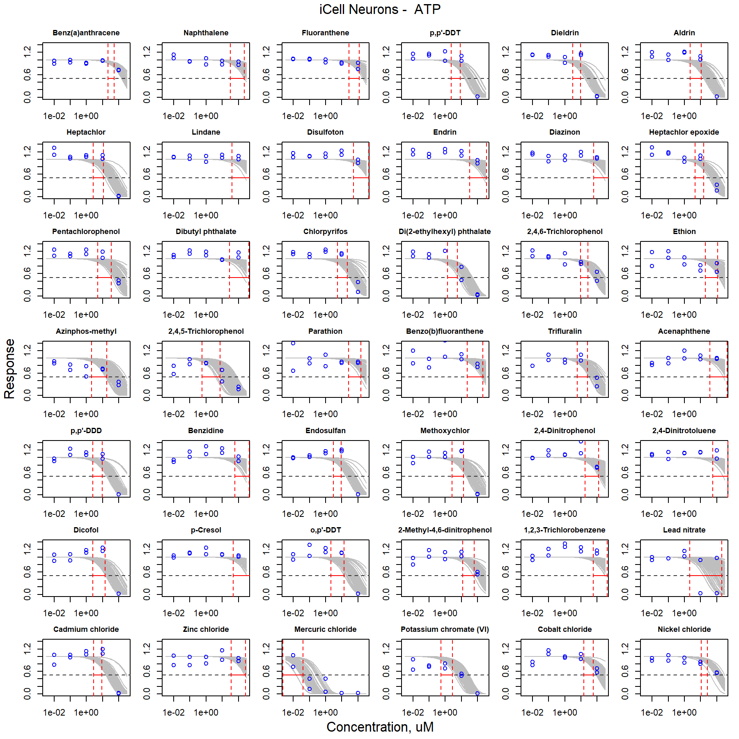

Figure S1. Curve-fitting of single chemical concentration and observed response (ATP) in iCell Neurons.

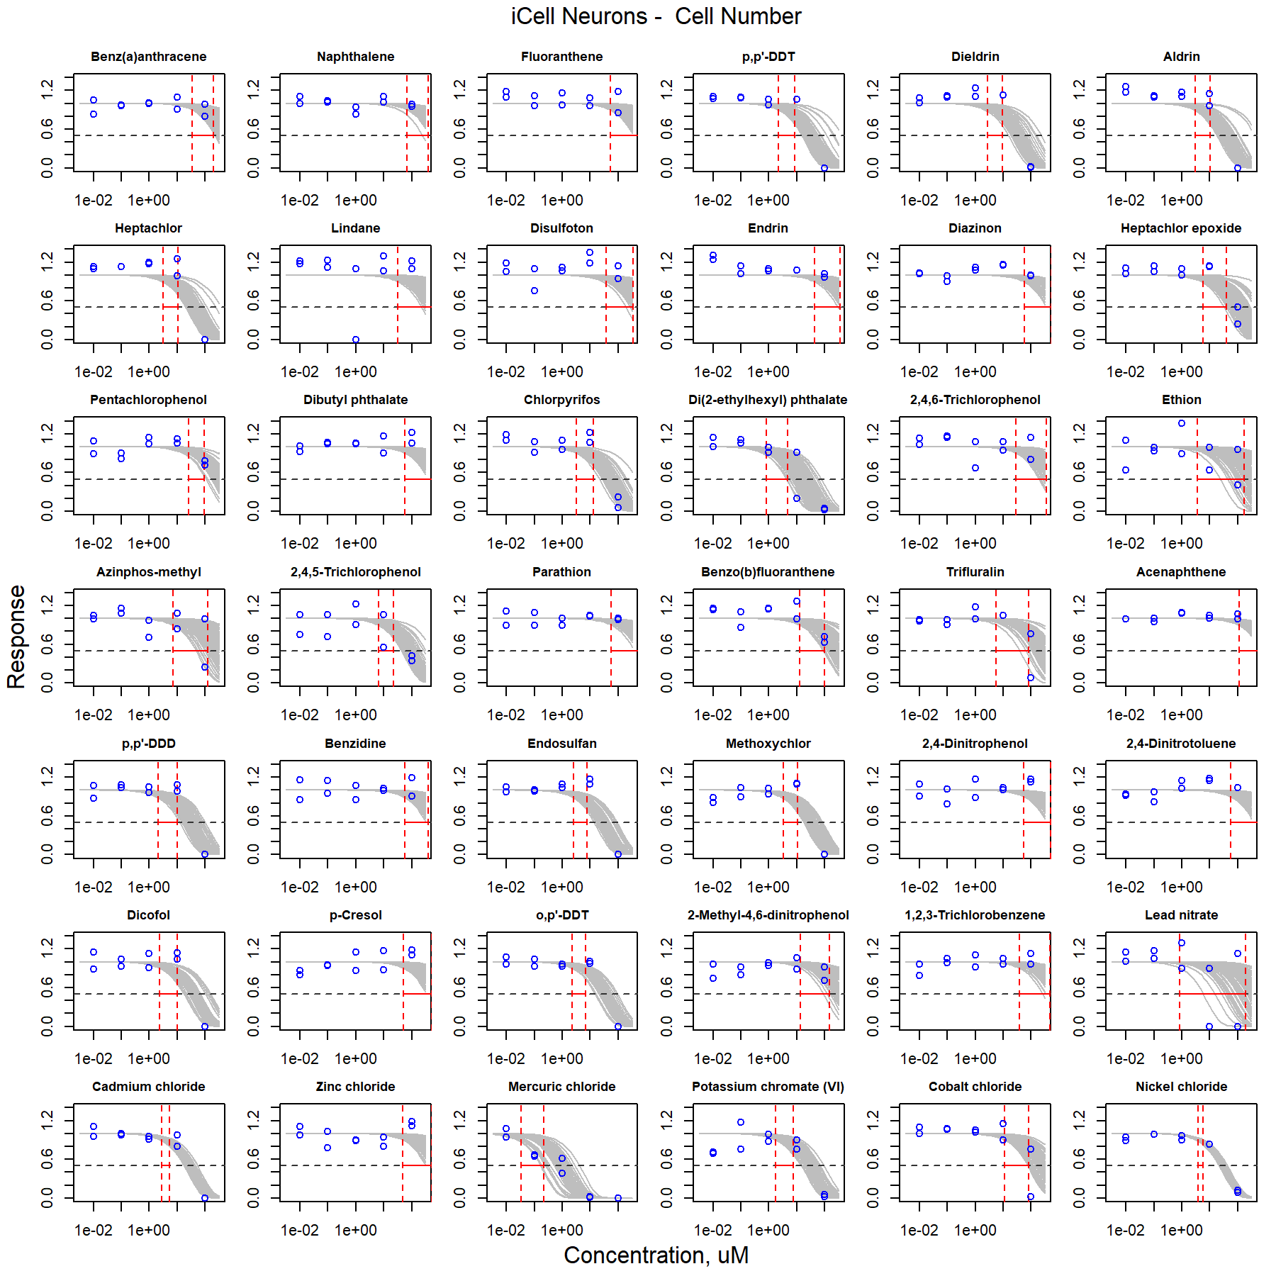

Figure S2. Curve-fitting of single chemical concentration and observed response (Cell Number) in iCell Neurons.

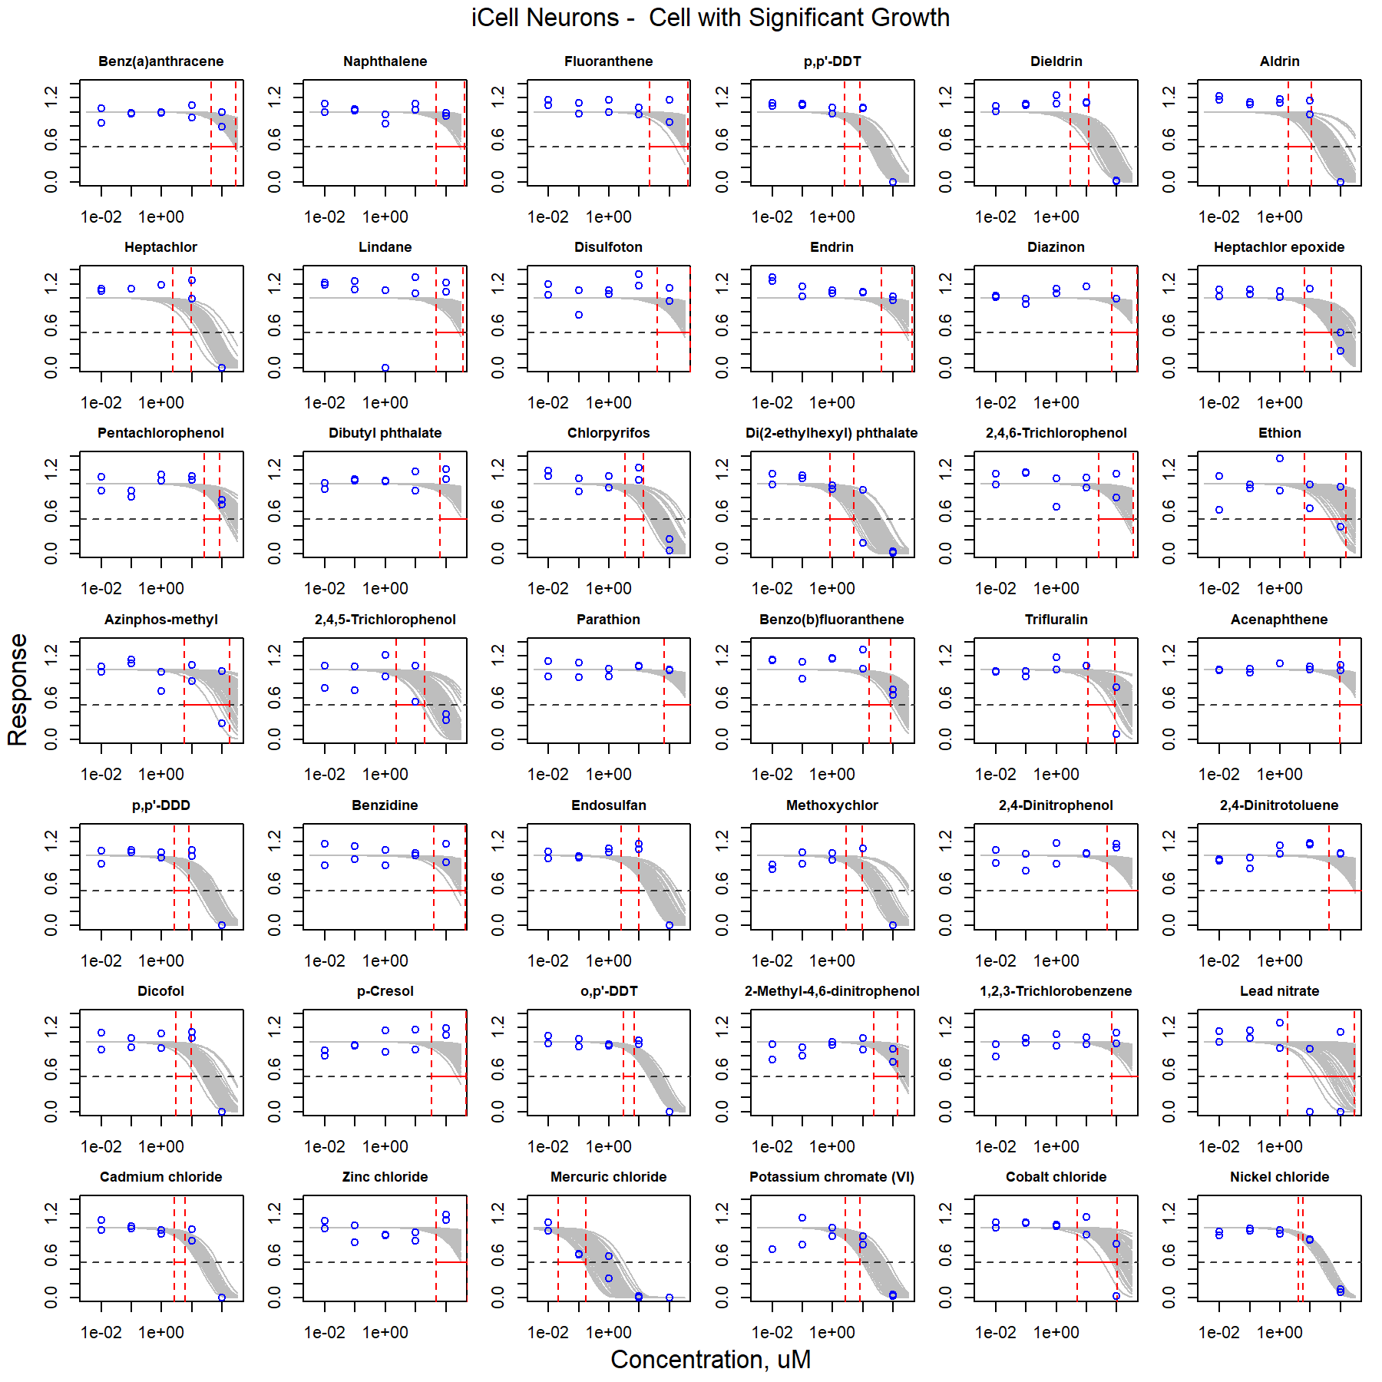

Figure S3. Curve-fitting of single chemical concentration and observed response (Cell with Significant Growth) in iCell Neurons.

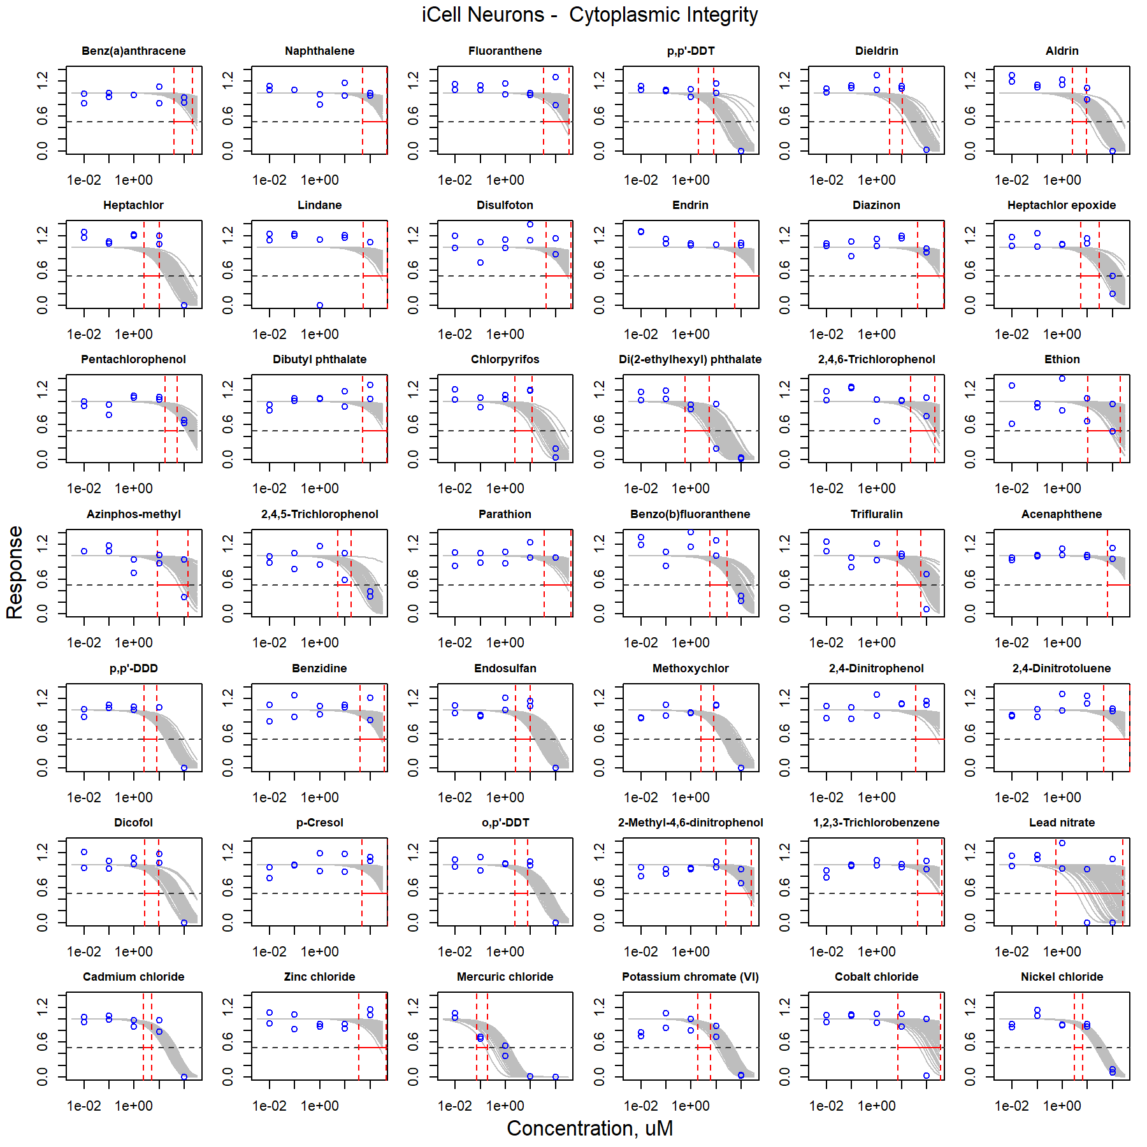

Figure S4. Curve-fitting of single chemical concentration and observed response (Cytoplasmic Integrity) in iCell Neurons.

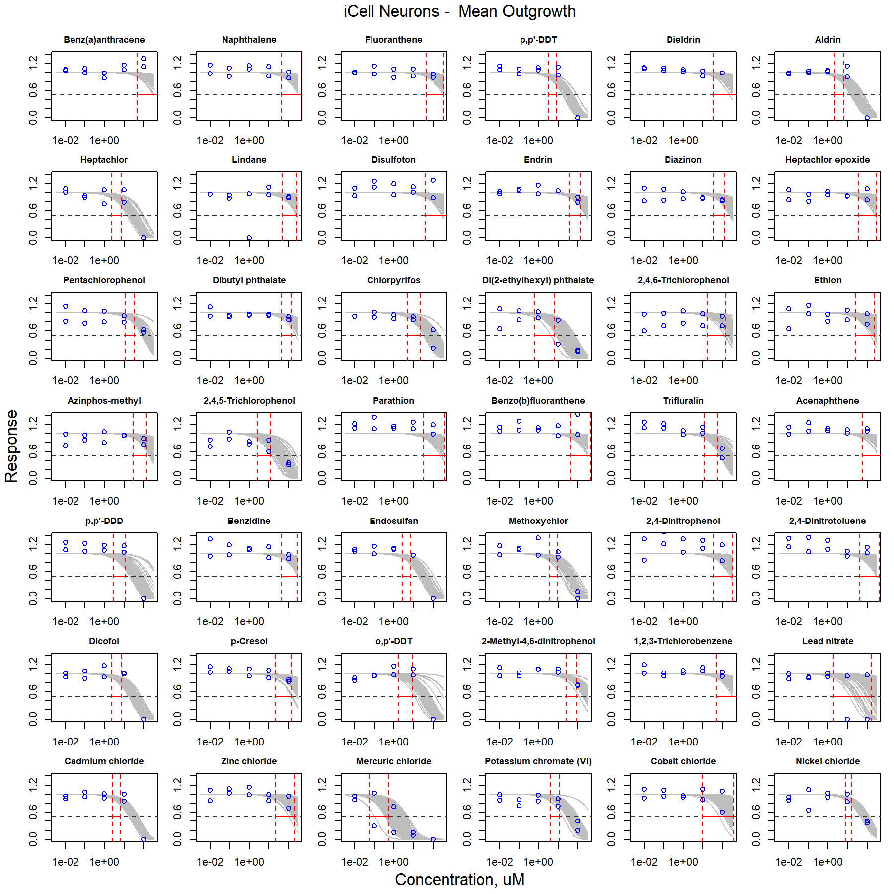

Figure S5. Curve-fitting of single chemical concentration and observed response (Mean Outgrowth) in iCell Neurons.

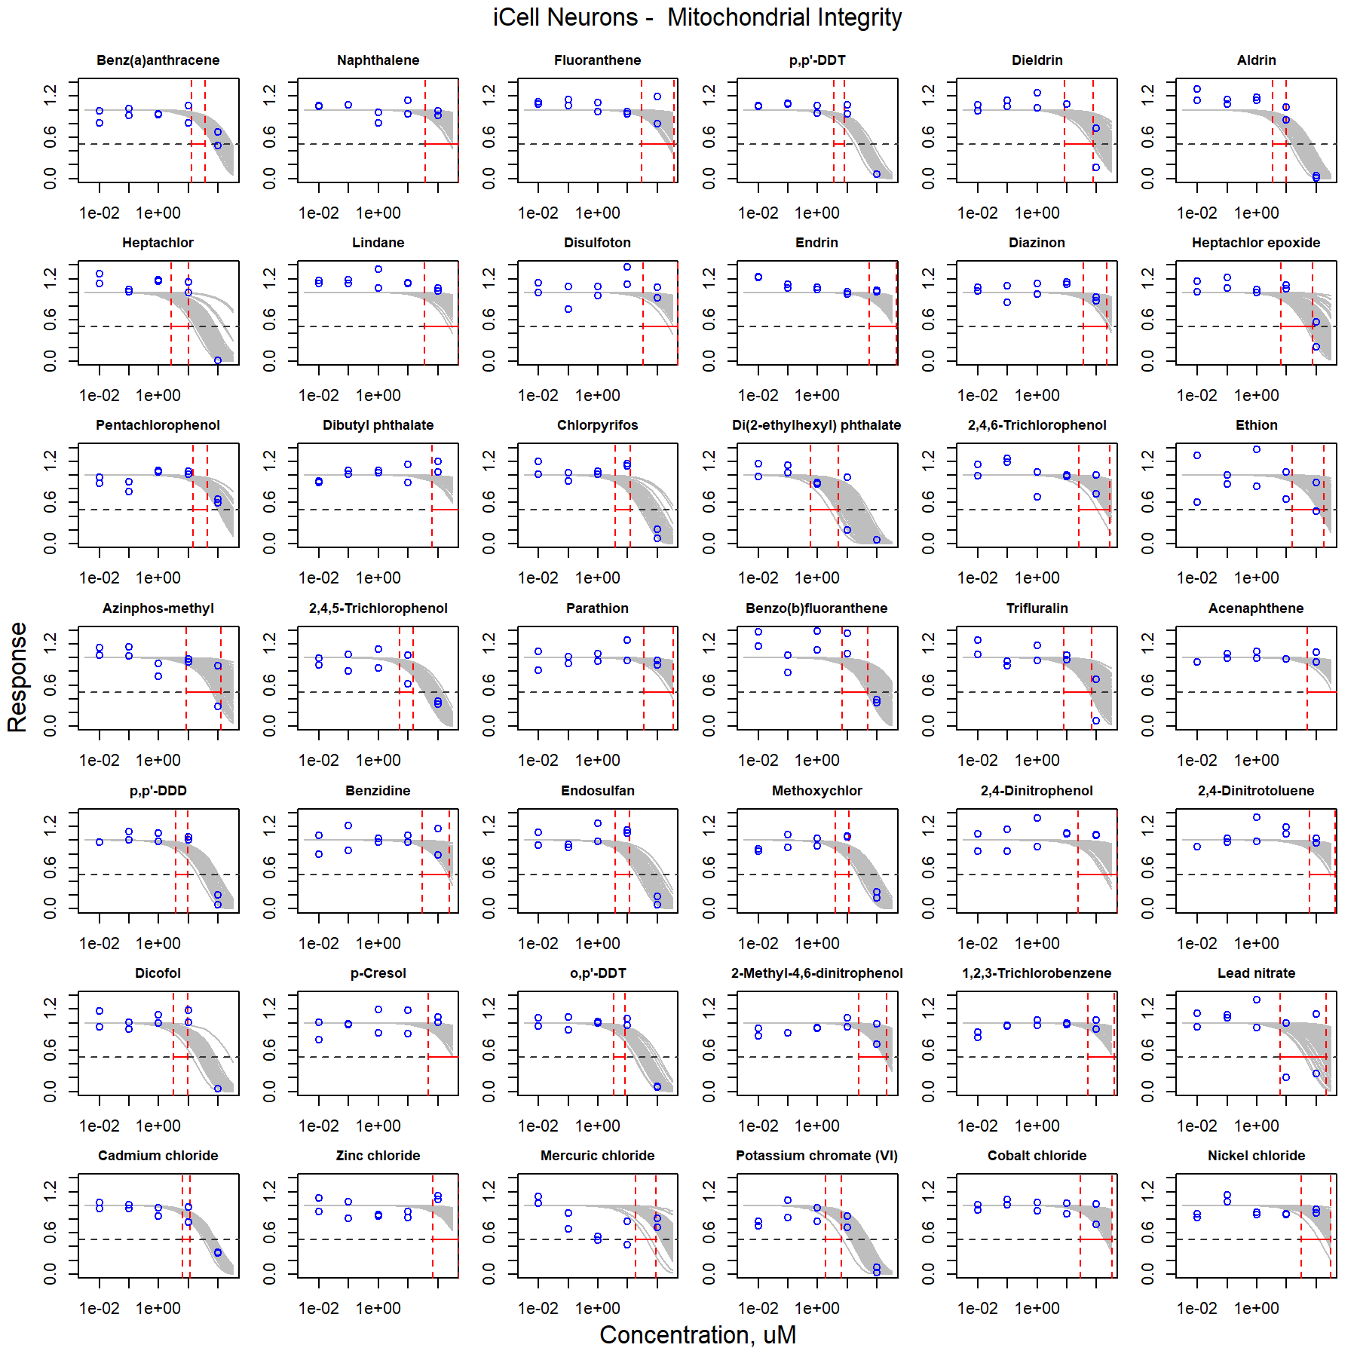

Figure S6. Curve-fitting of single chemical concentration and observed response (Mitochondrial Integrity) in iCell Neurons.

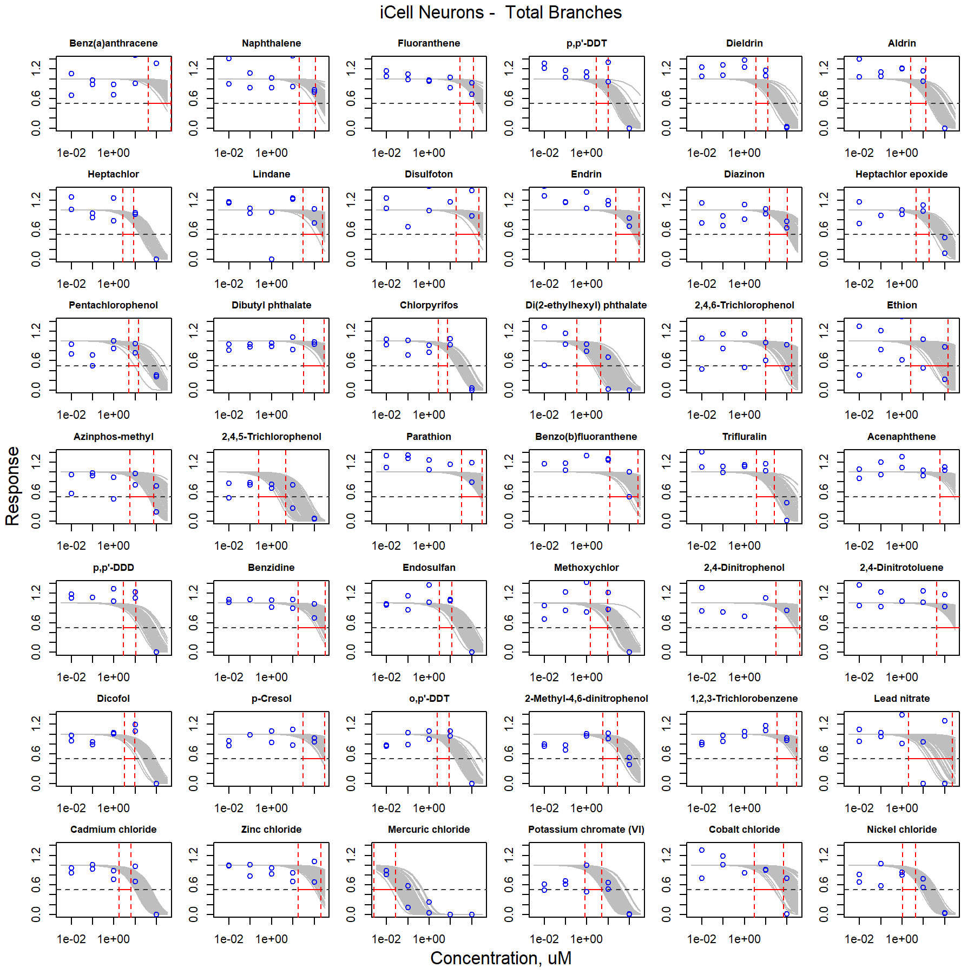

Figure S7. Curve-fitting of single chemical concentration and observed response (Total Branches) in iCell Neurons.

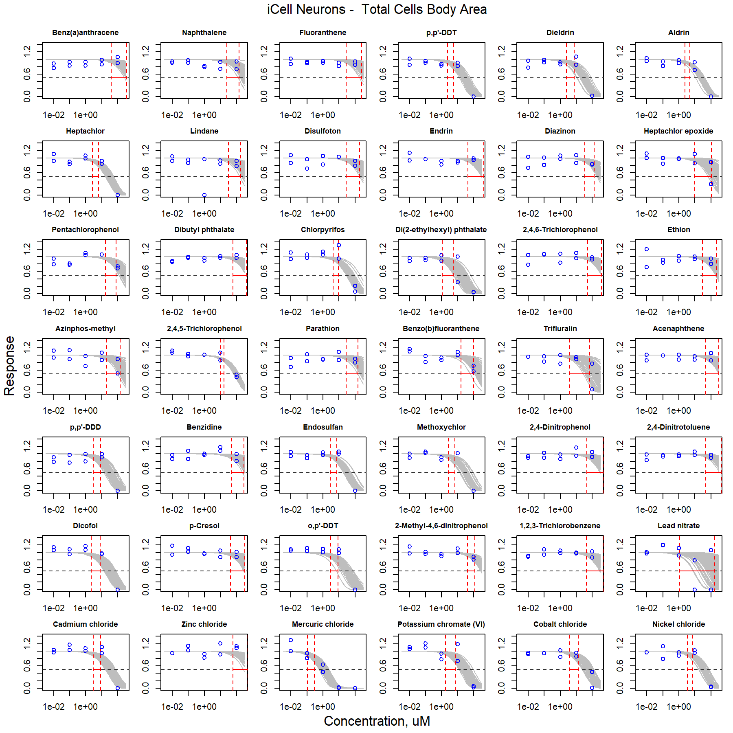

Figure S8. Curve-fitting of single chemical concentration and observed response (Total Cells Body Area) in iCell Neurons.

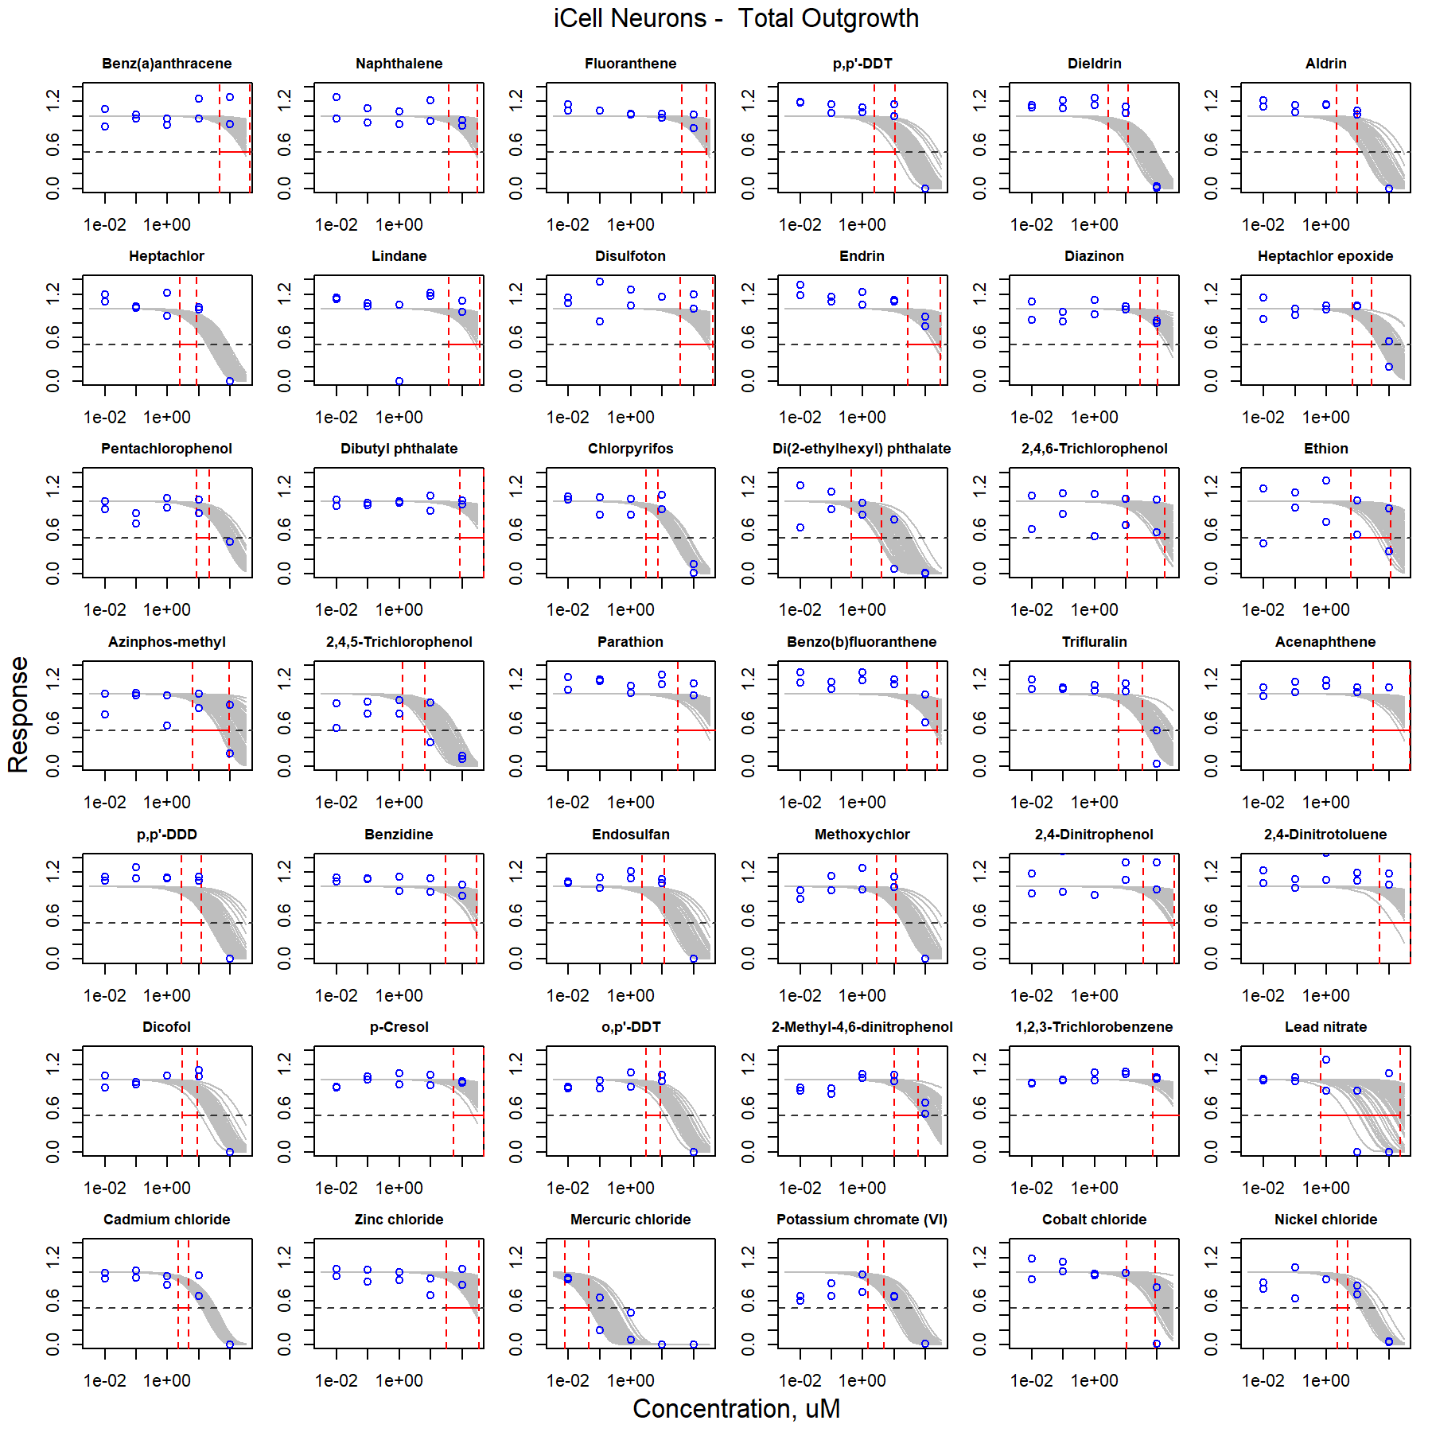

Figure S9. Curve-fitting of single chemical concentration and observed response (Total Outgrowth) in iCell Neurons.

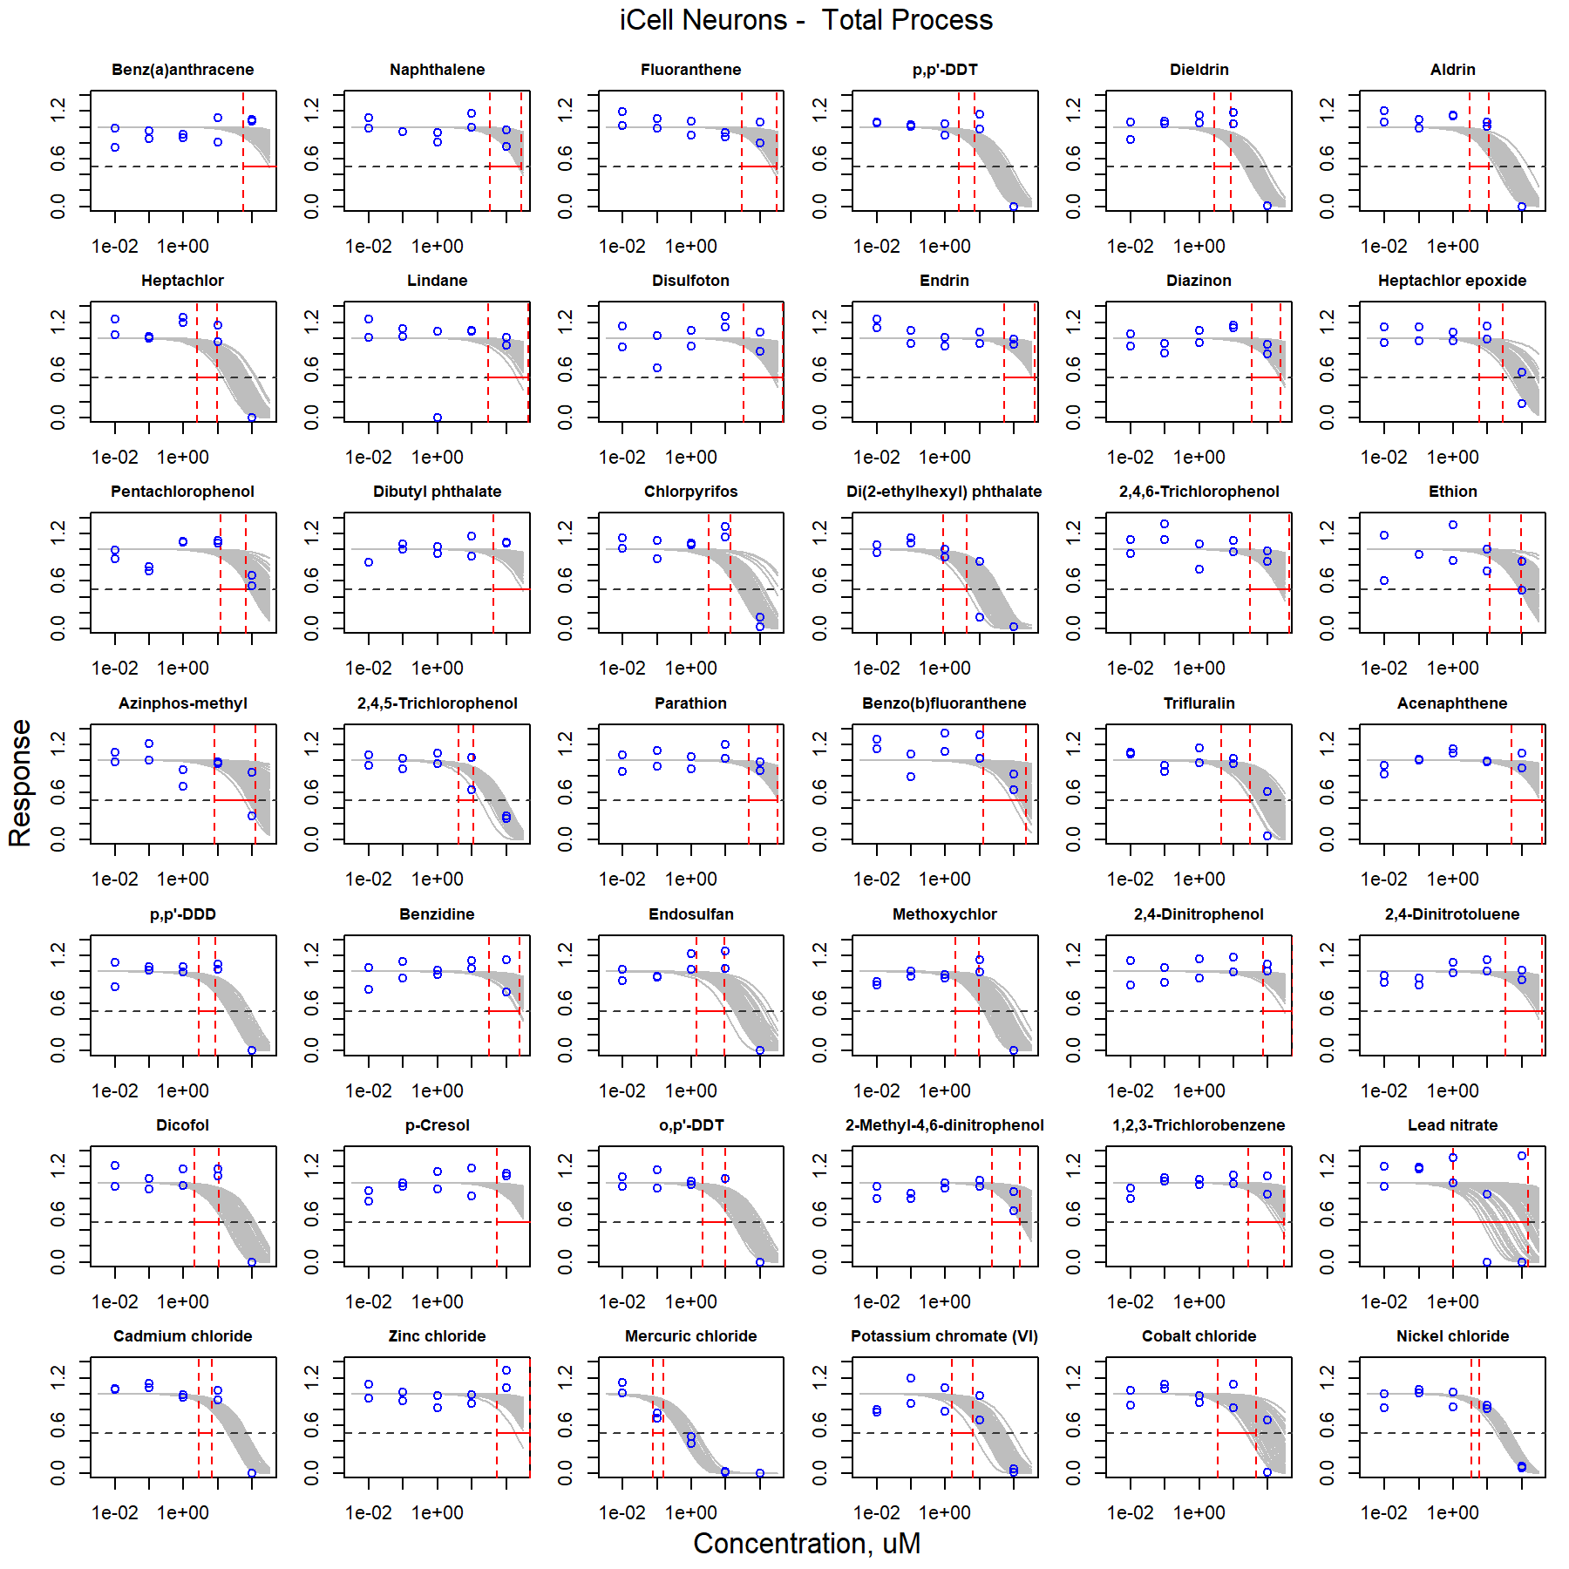

Figure S10. Curve-fitting of single chemical concentration and observed response (Total Process) in iCell Neurons.

### HUVECs

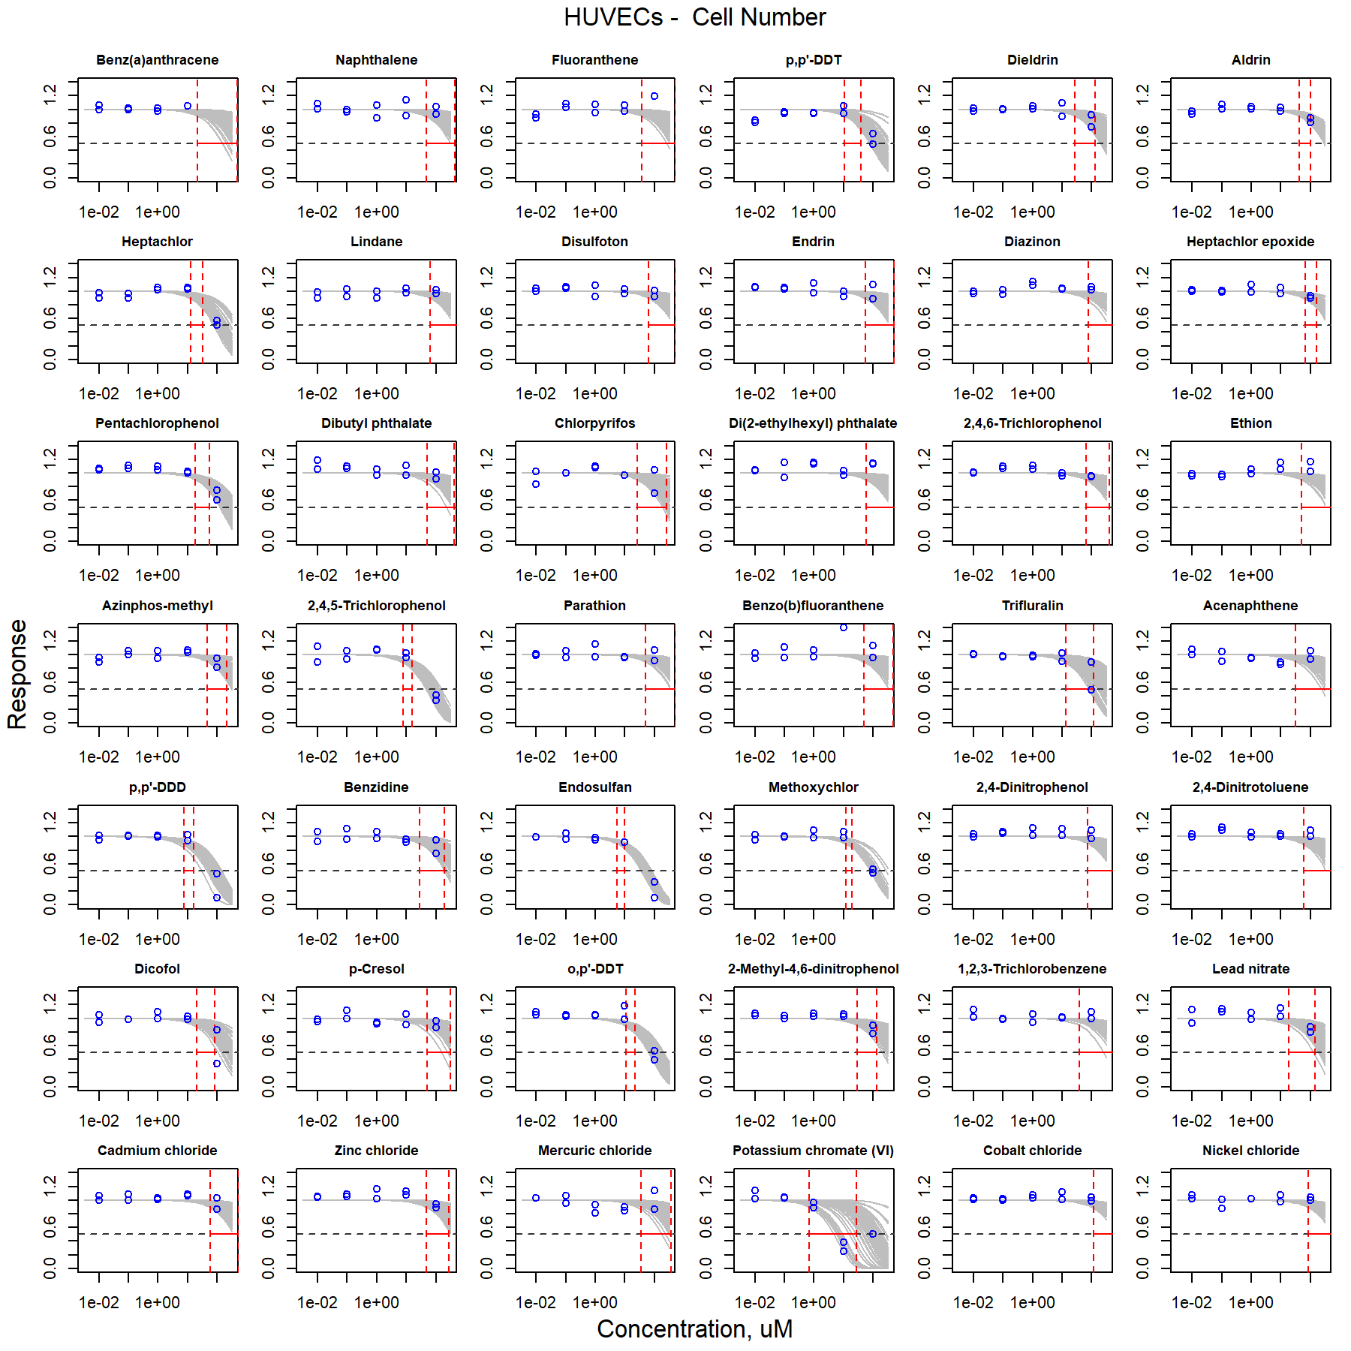

Figure S11. Curve-fitting of single chemical concentration and observed response (Cell Number) in HUVECs.

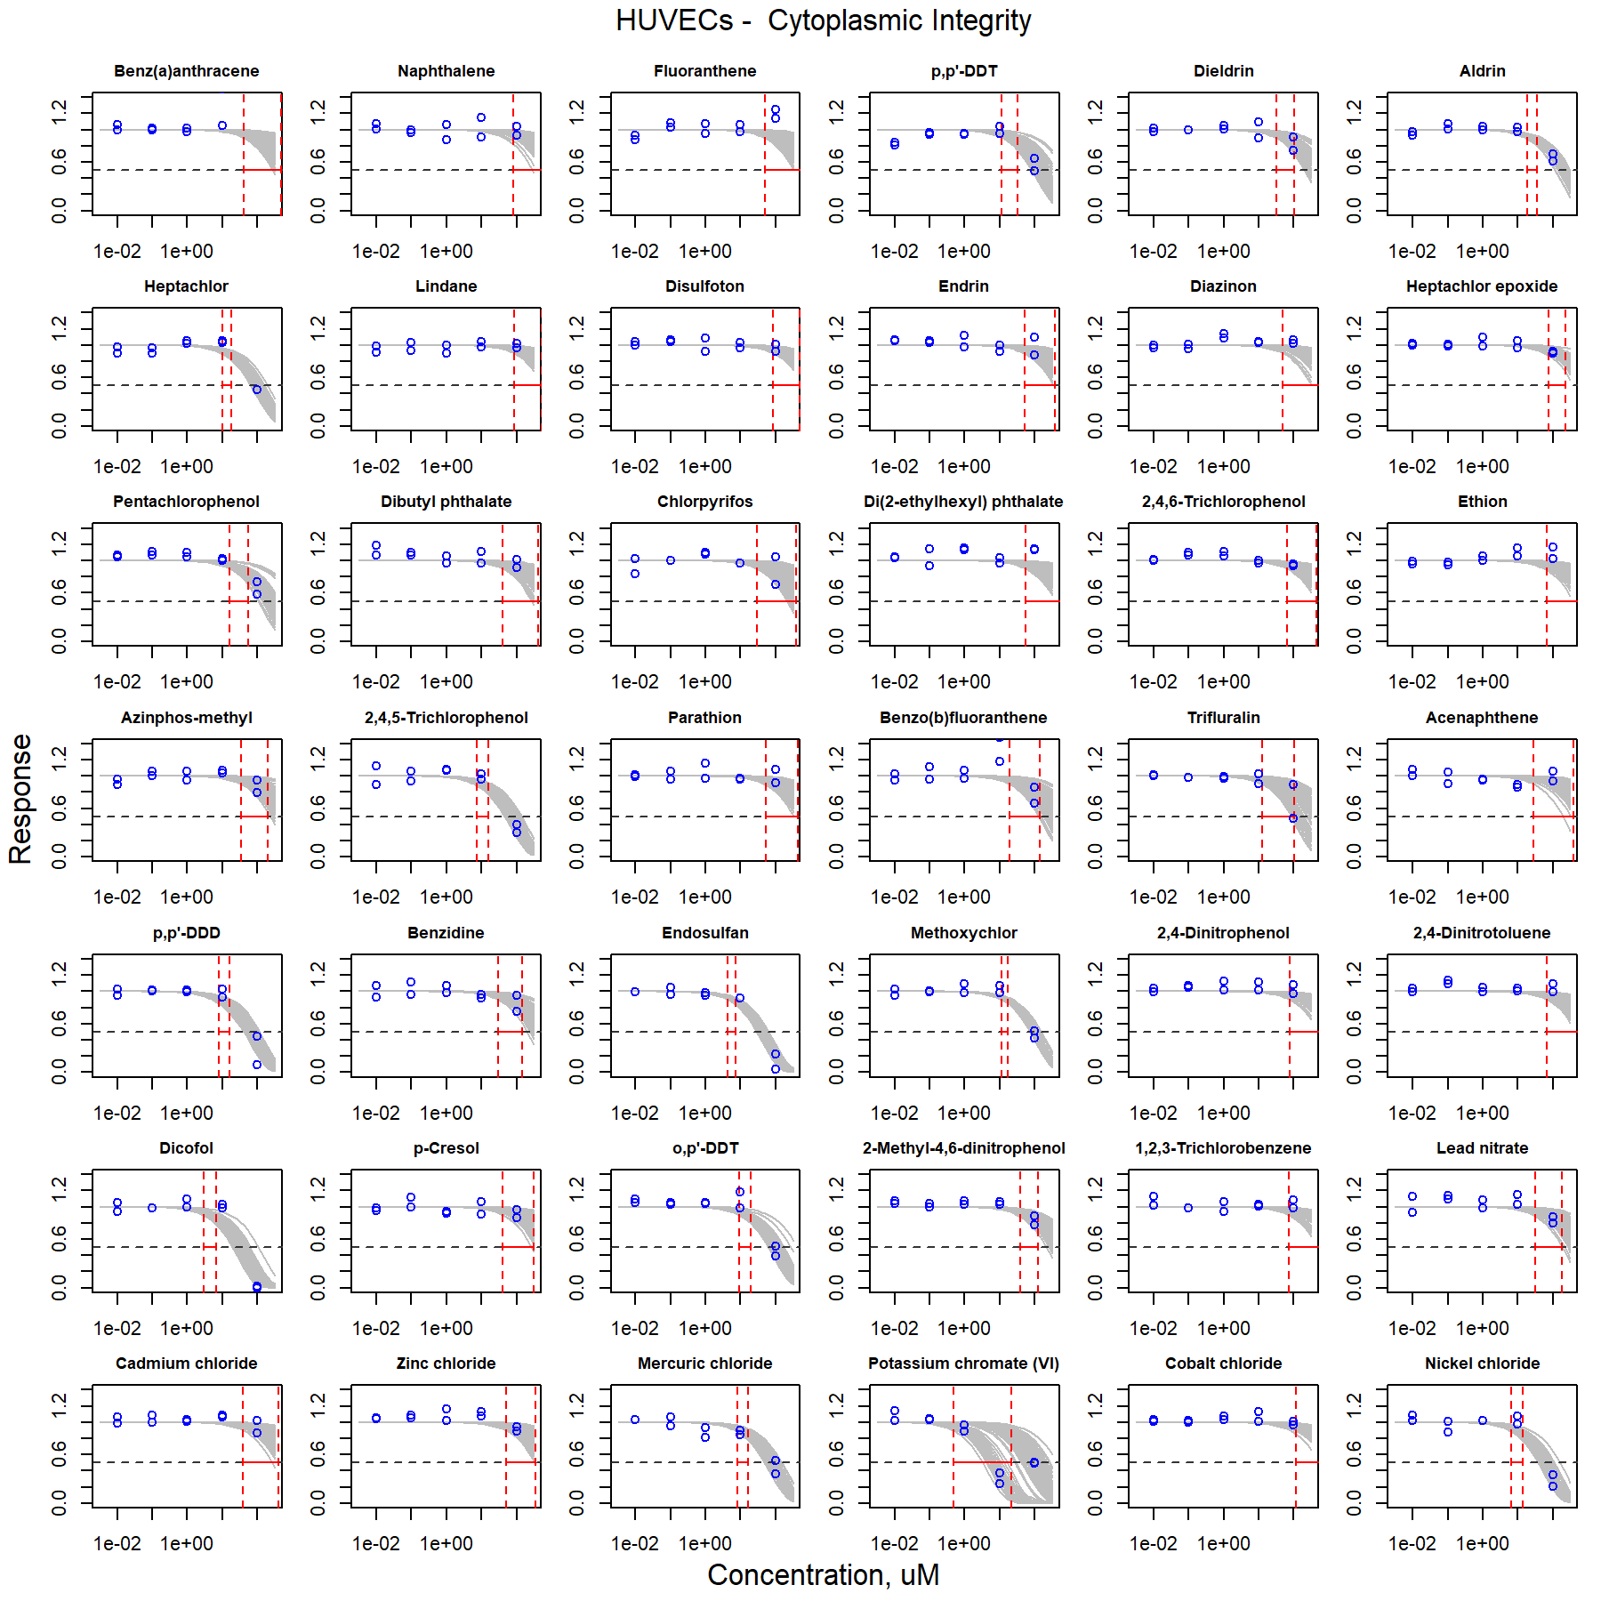

Figure S12. Curve-fitting of single chemical concentration and observed response (Cytoplasmic Integrity) in HUVECs.

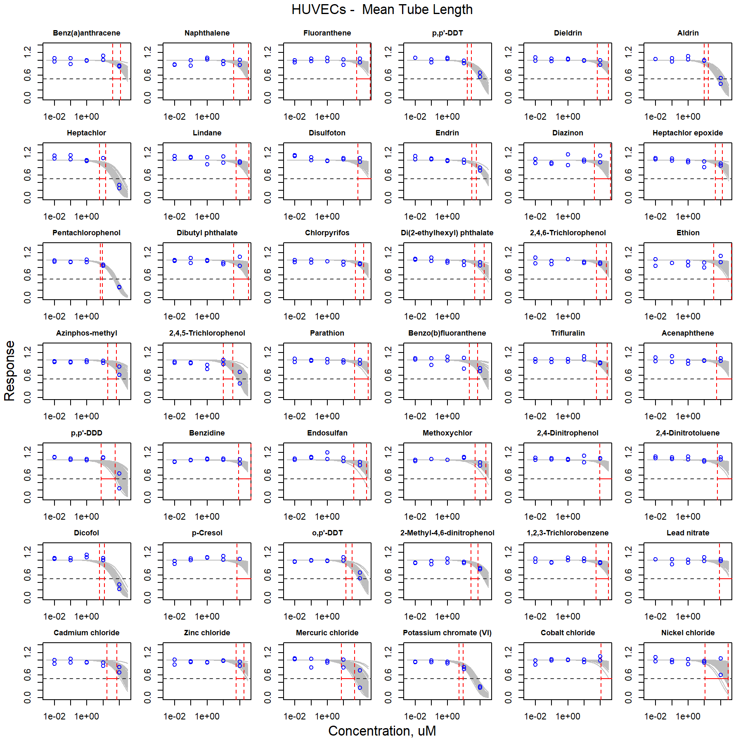

Figure S13. Curve-fitting of single chemical concentration and observed response (Mean Tube Length) in HUVECs.

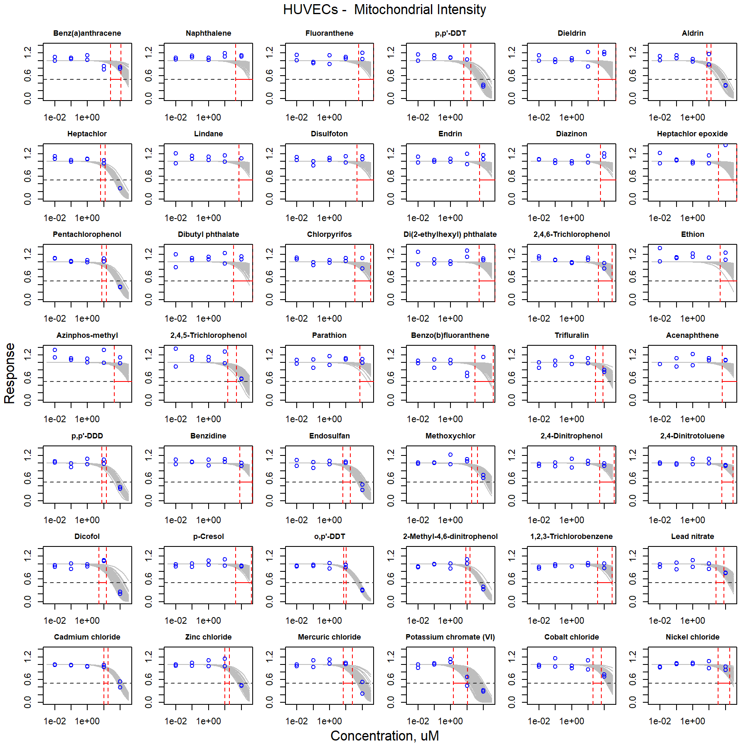

Figure S14. Curve-fitting of single chemical concentration and observed response (Mitochondrial Intensity) in HUVECs.

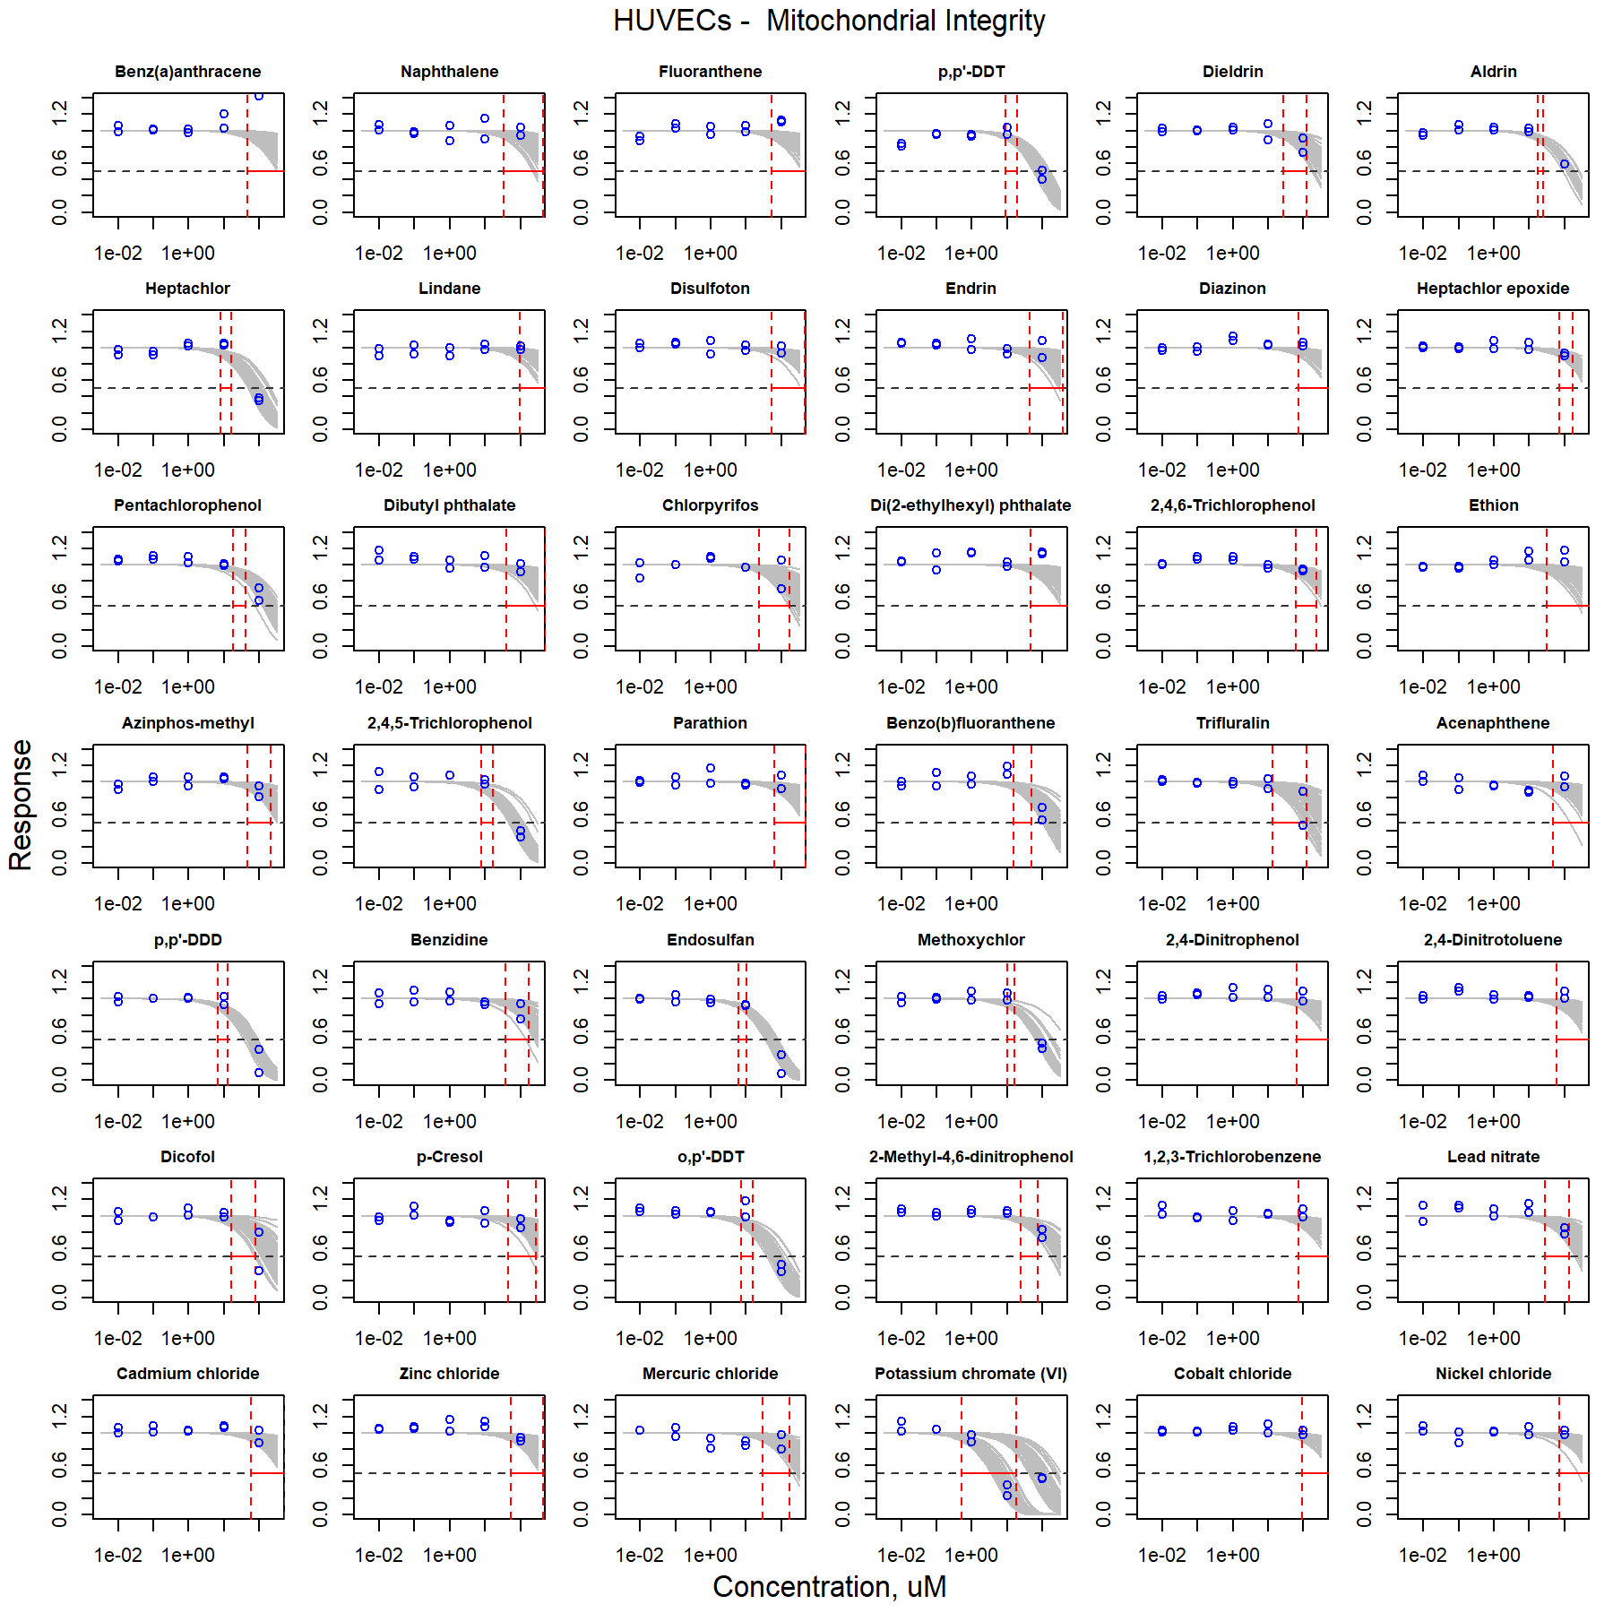

Figure S15. Curve-fitting of single chemical concentration and observed response (Mitochondrial Integrity) in HUVECs.

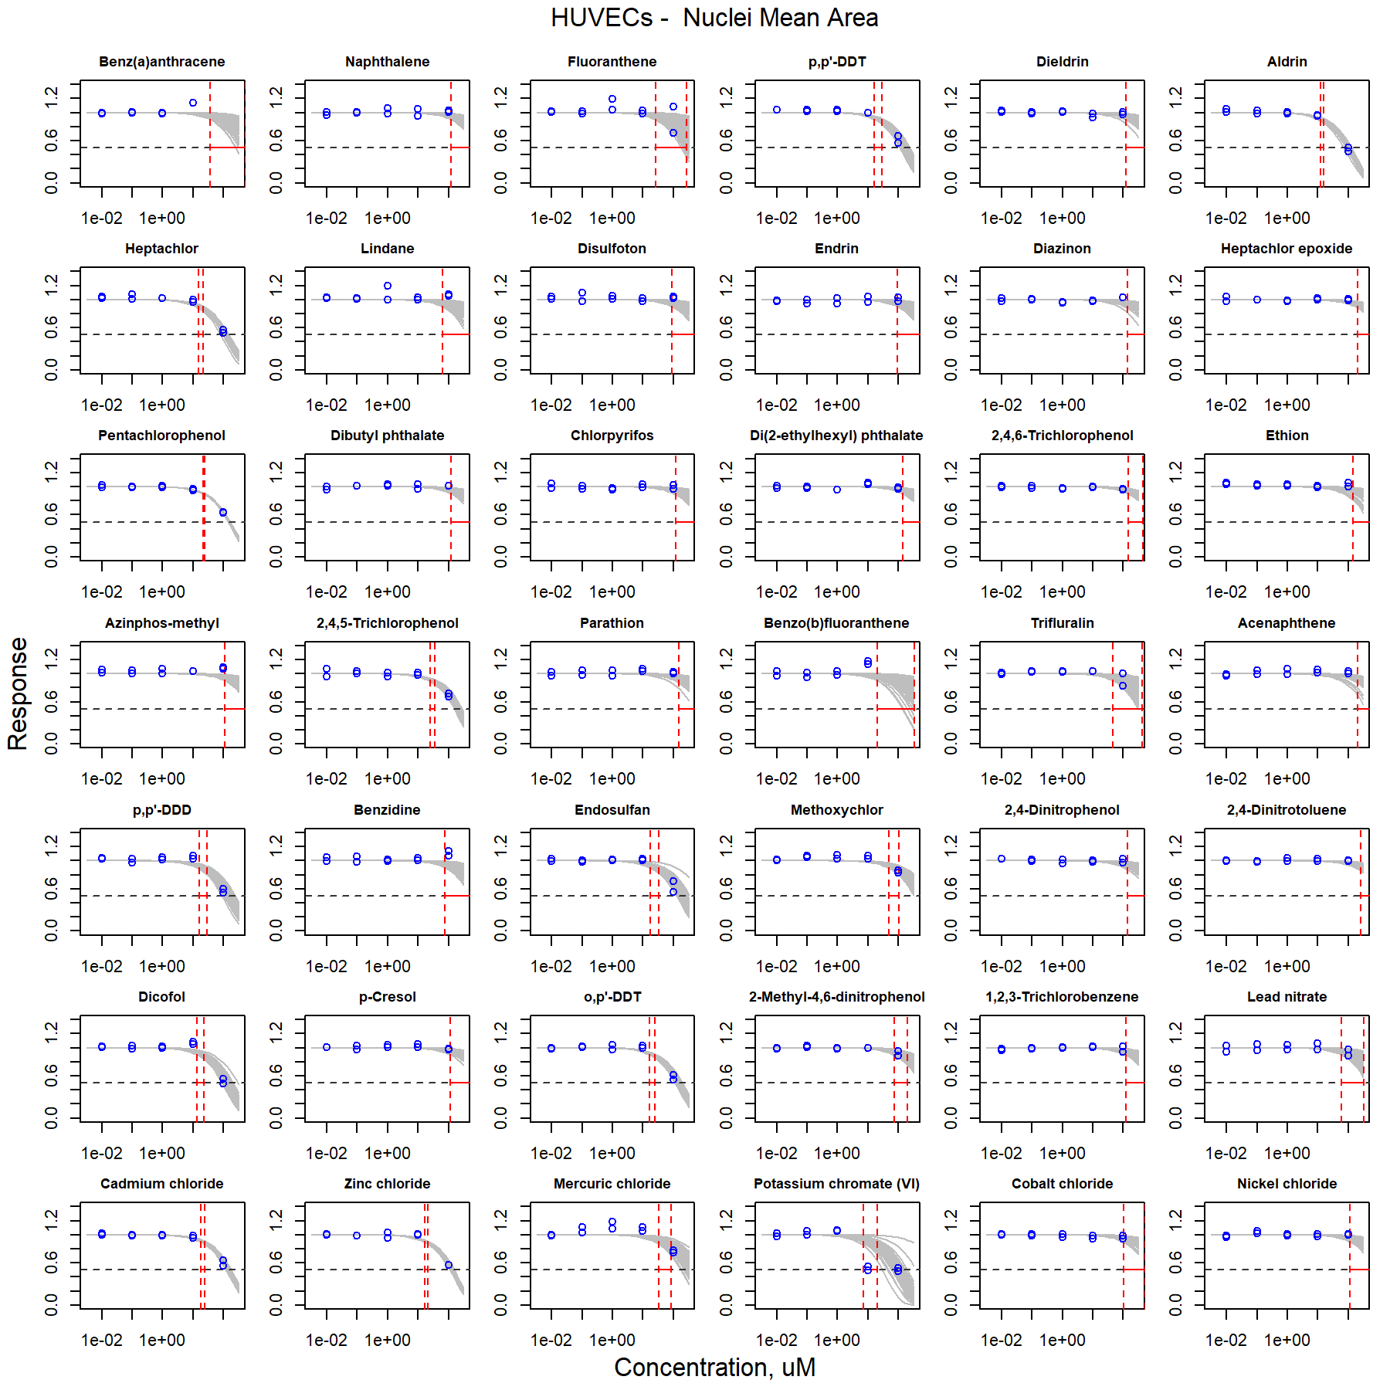

Figure S16. Curve-fitting of single chemical concentration and observed response (Nuclei Mean Area) in HUVECs.

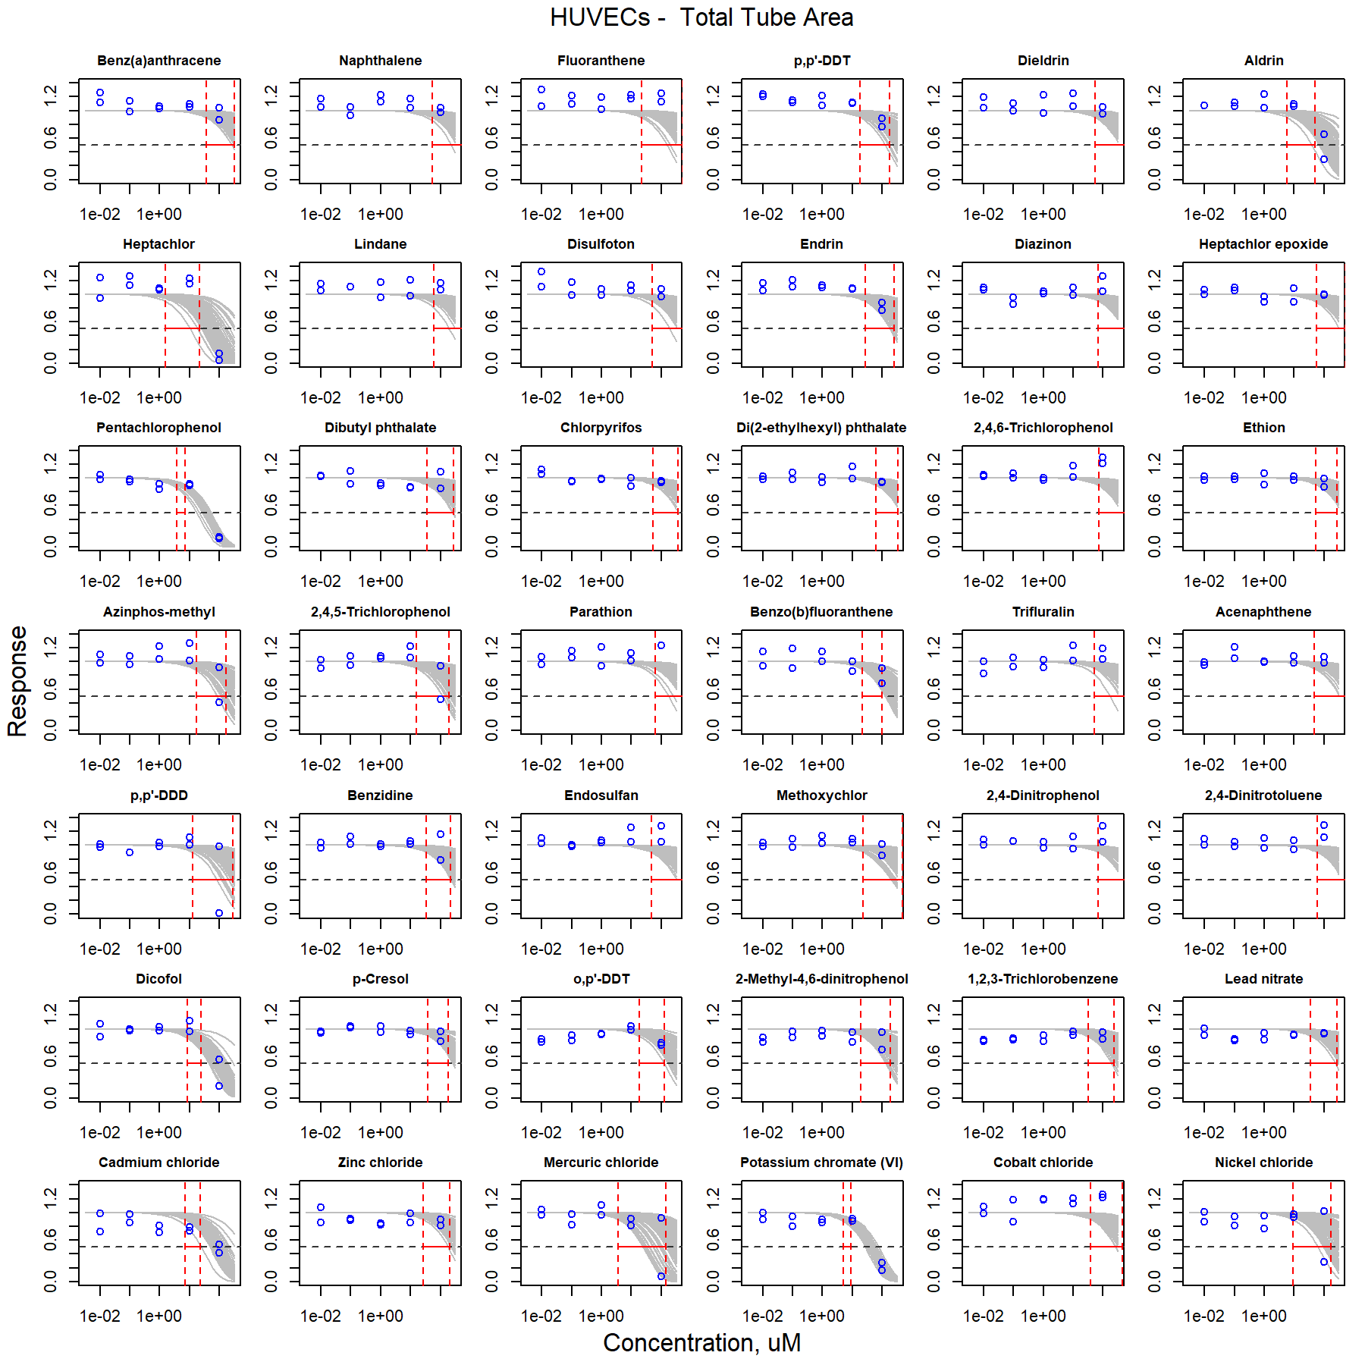

Figure S17. Curve-fitting of single chemical concentration and observed response (Total Tube Area) in HUVECs.

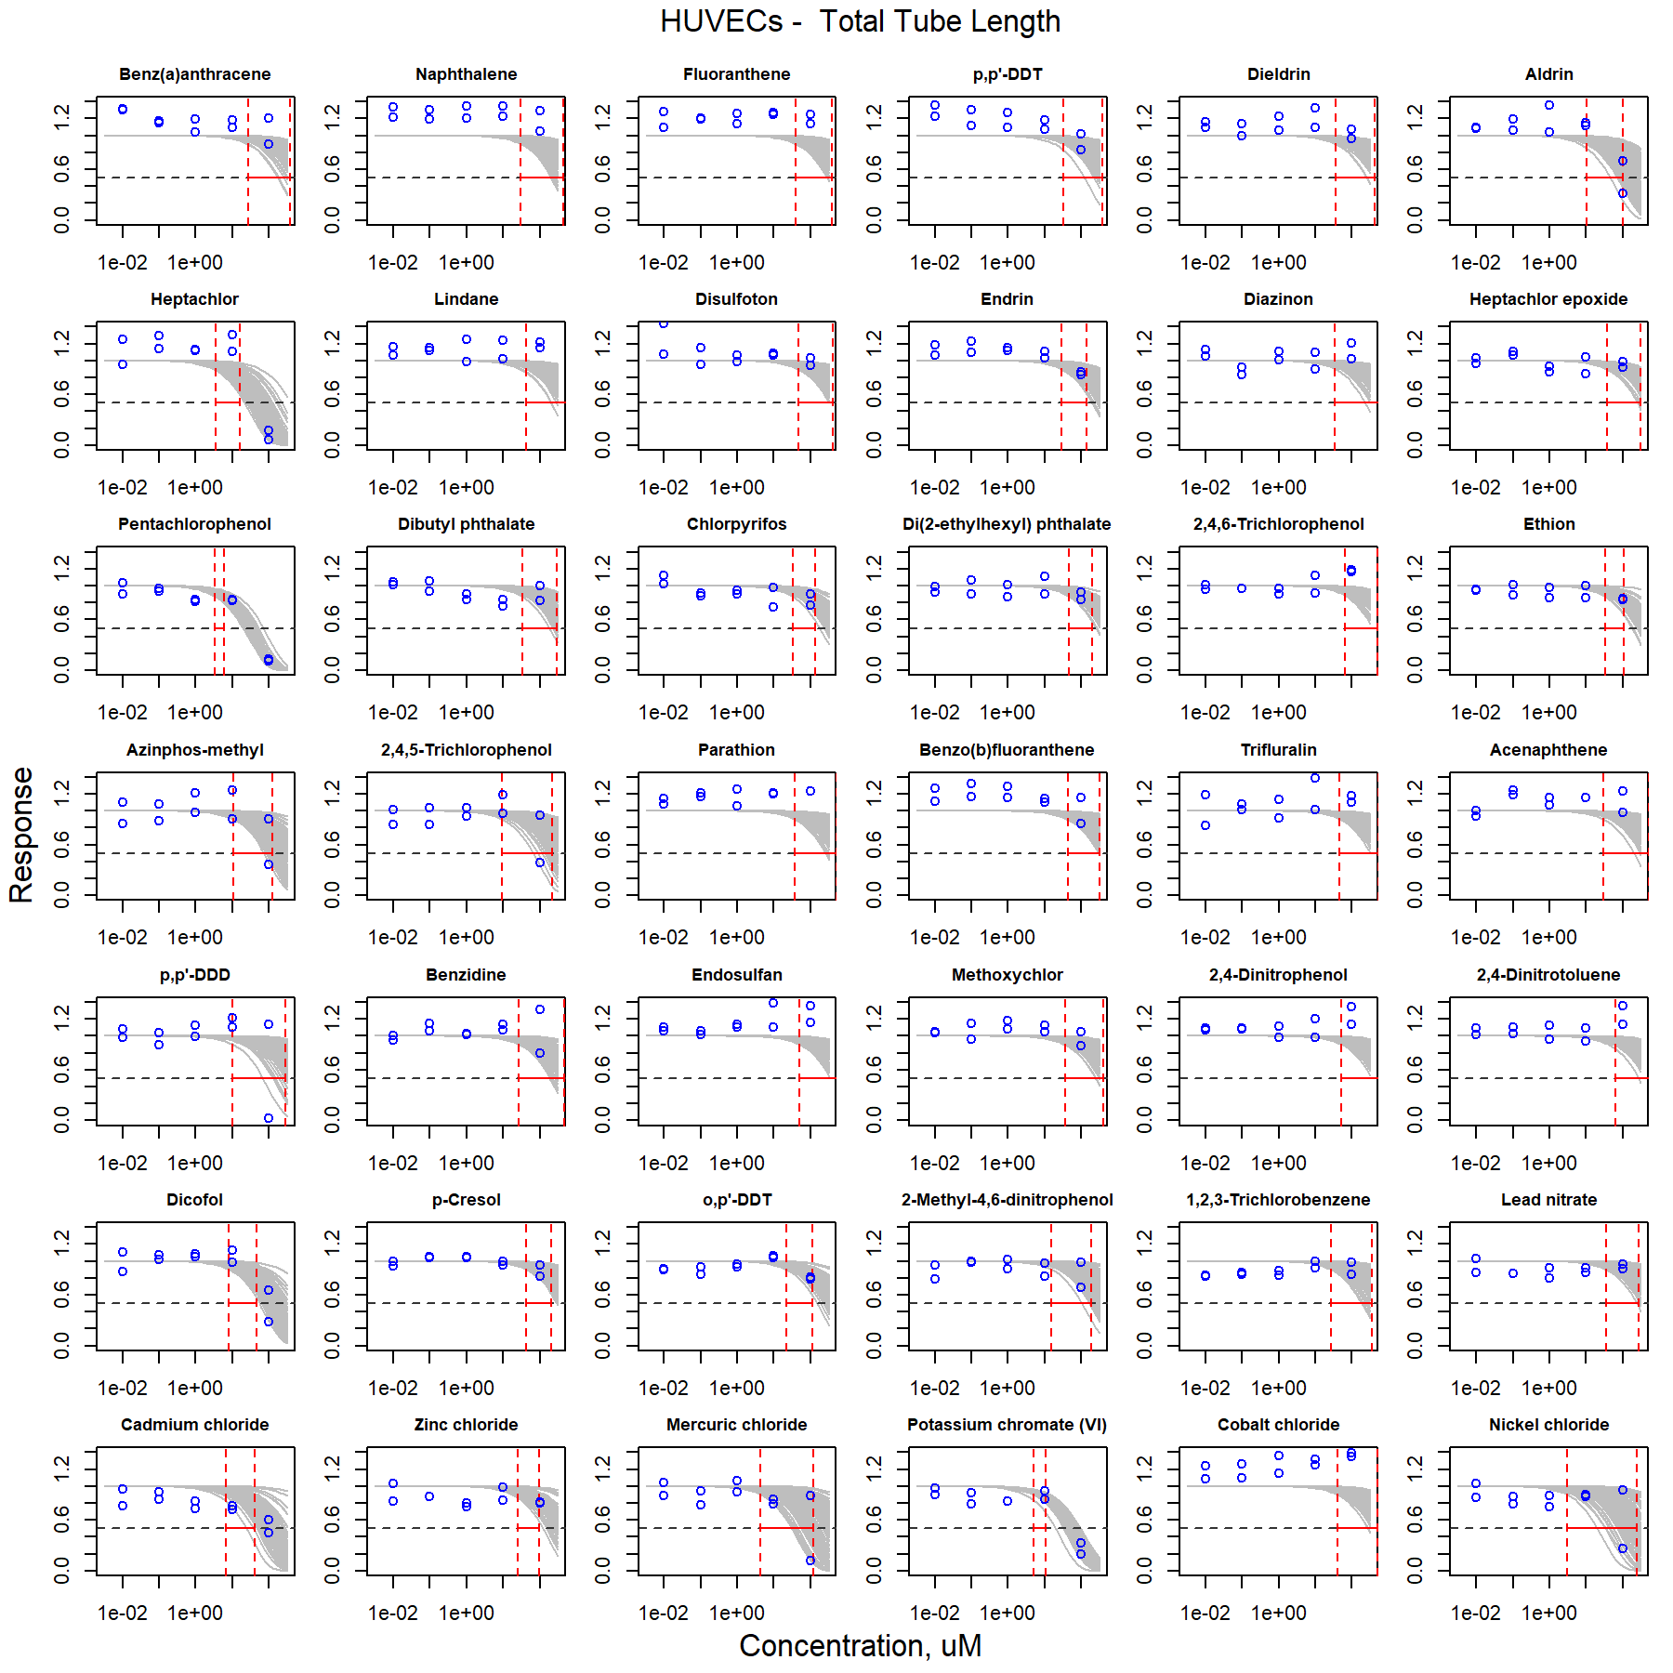

Figure S18. Curve-fitting of single chemical concentration and observed response (Total Tube Length) in HUVECs.

### iCell Hepatocytes

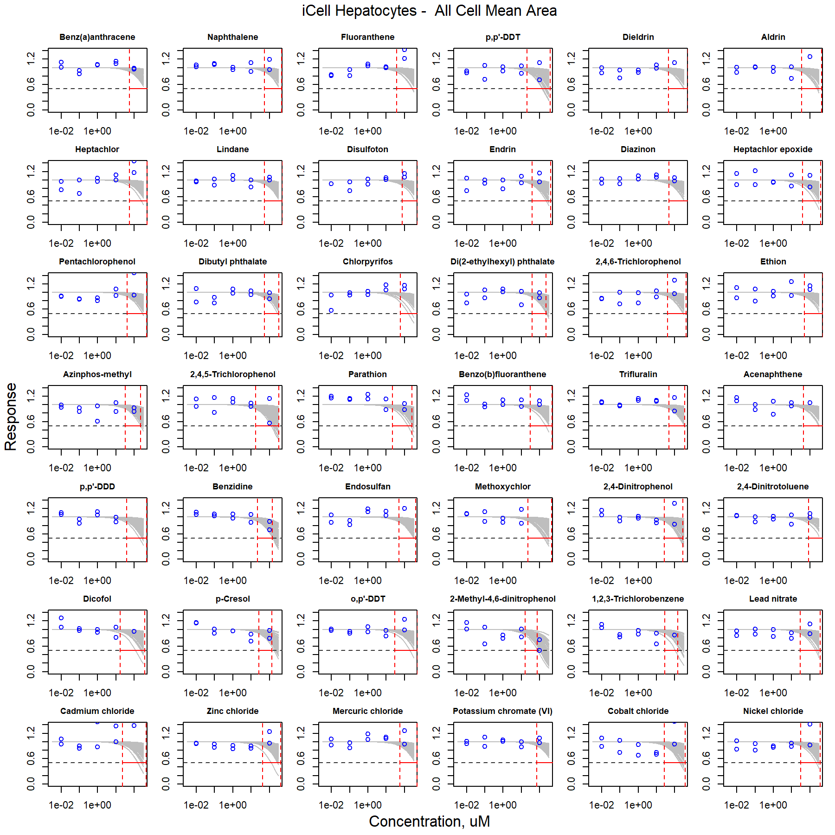

Figure S19. Curve-fitting of single chemical concentration and observed response (All Cell Mean Area) in iCell Hepatocytes.

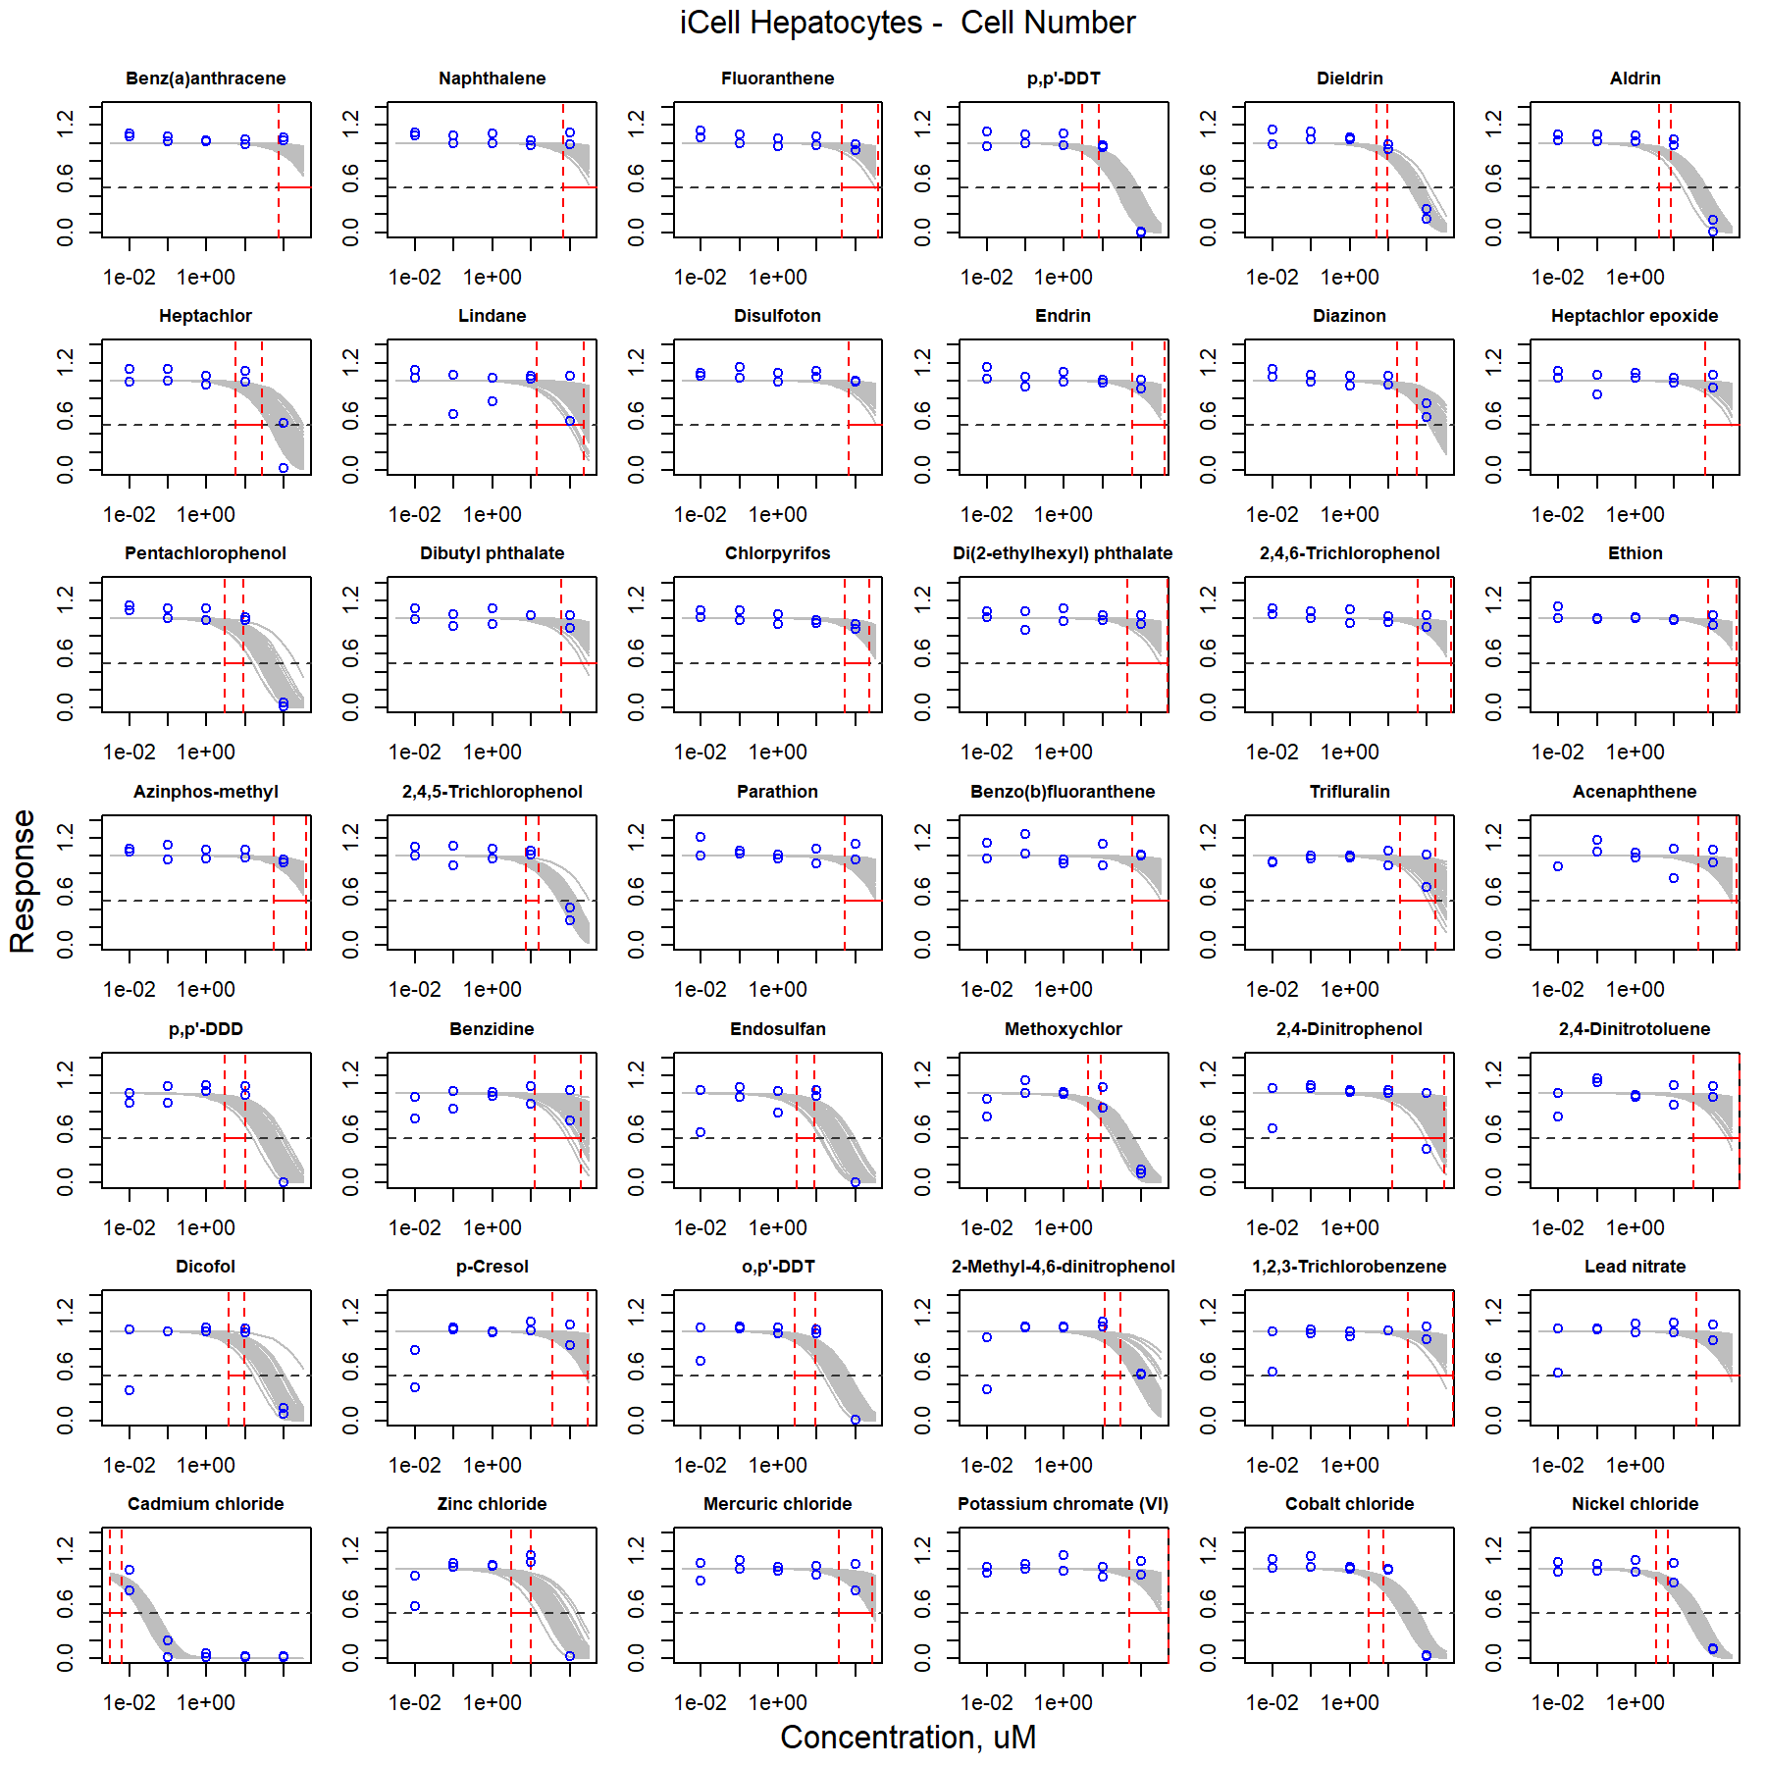

Figure S20. Curve-fitting of single chemical concentration and observed response (Cell Number) in iCell Hepatocytes.

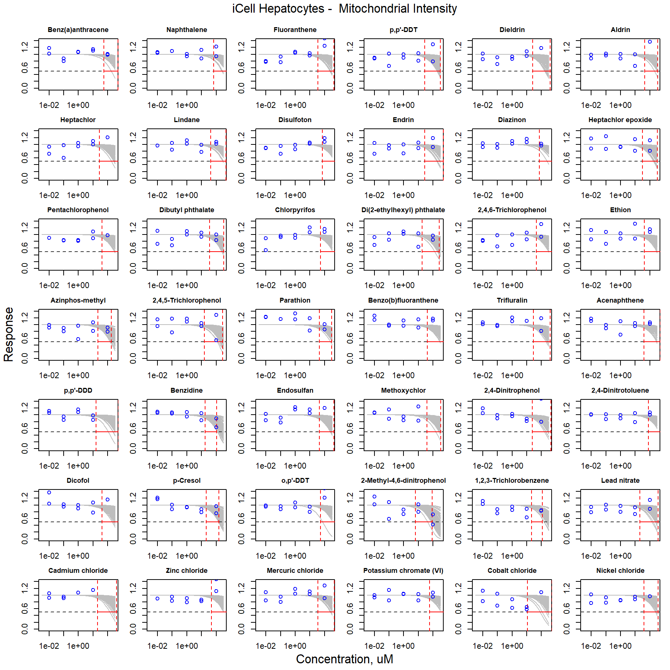

Figure S21. Curve-fitting of single chemical concentration and observed response (Mitochondrial Intensity) in iCell Hepatocytes.

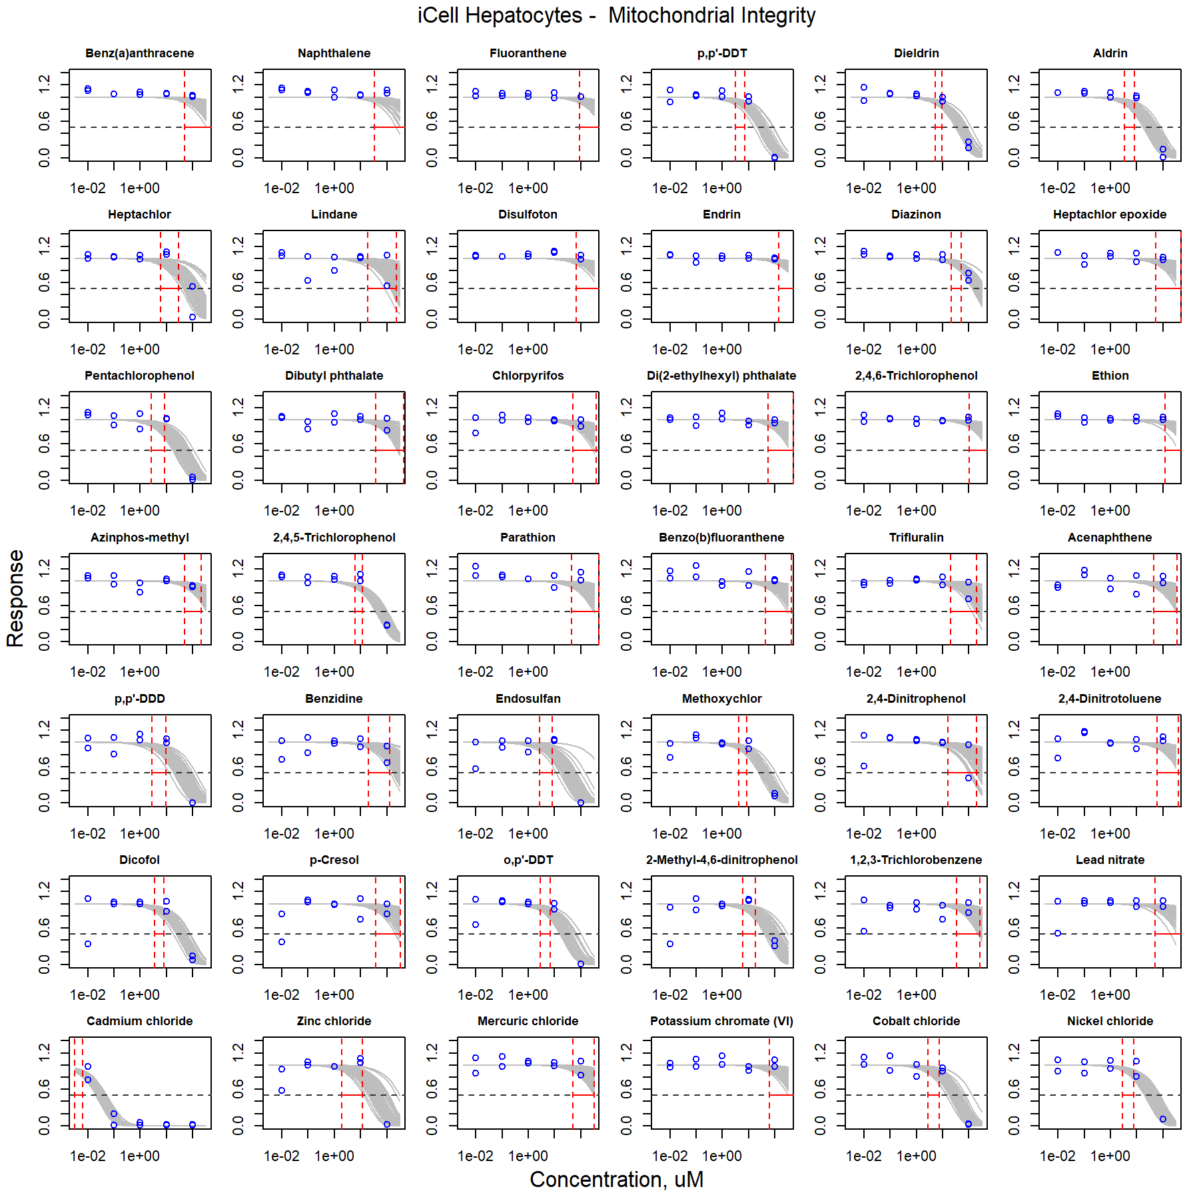

Figure S22. Curve-fitting of single chemical concentration and observed response (Mitochondrial Integrity) in iCell Hepatocytes.

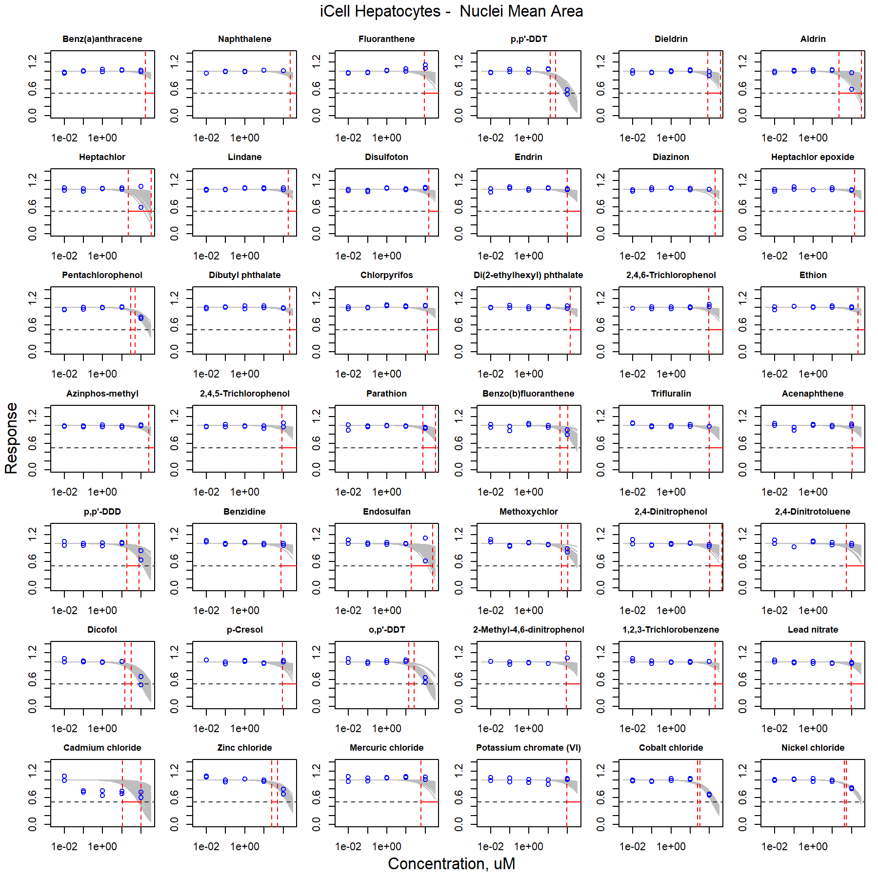

Figure S23. Curve-fitting of single chemical concentration and observed response (Nuclei Mean Area) in iCell Hepatocytes.

### iCell Endothelial cells

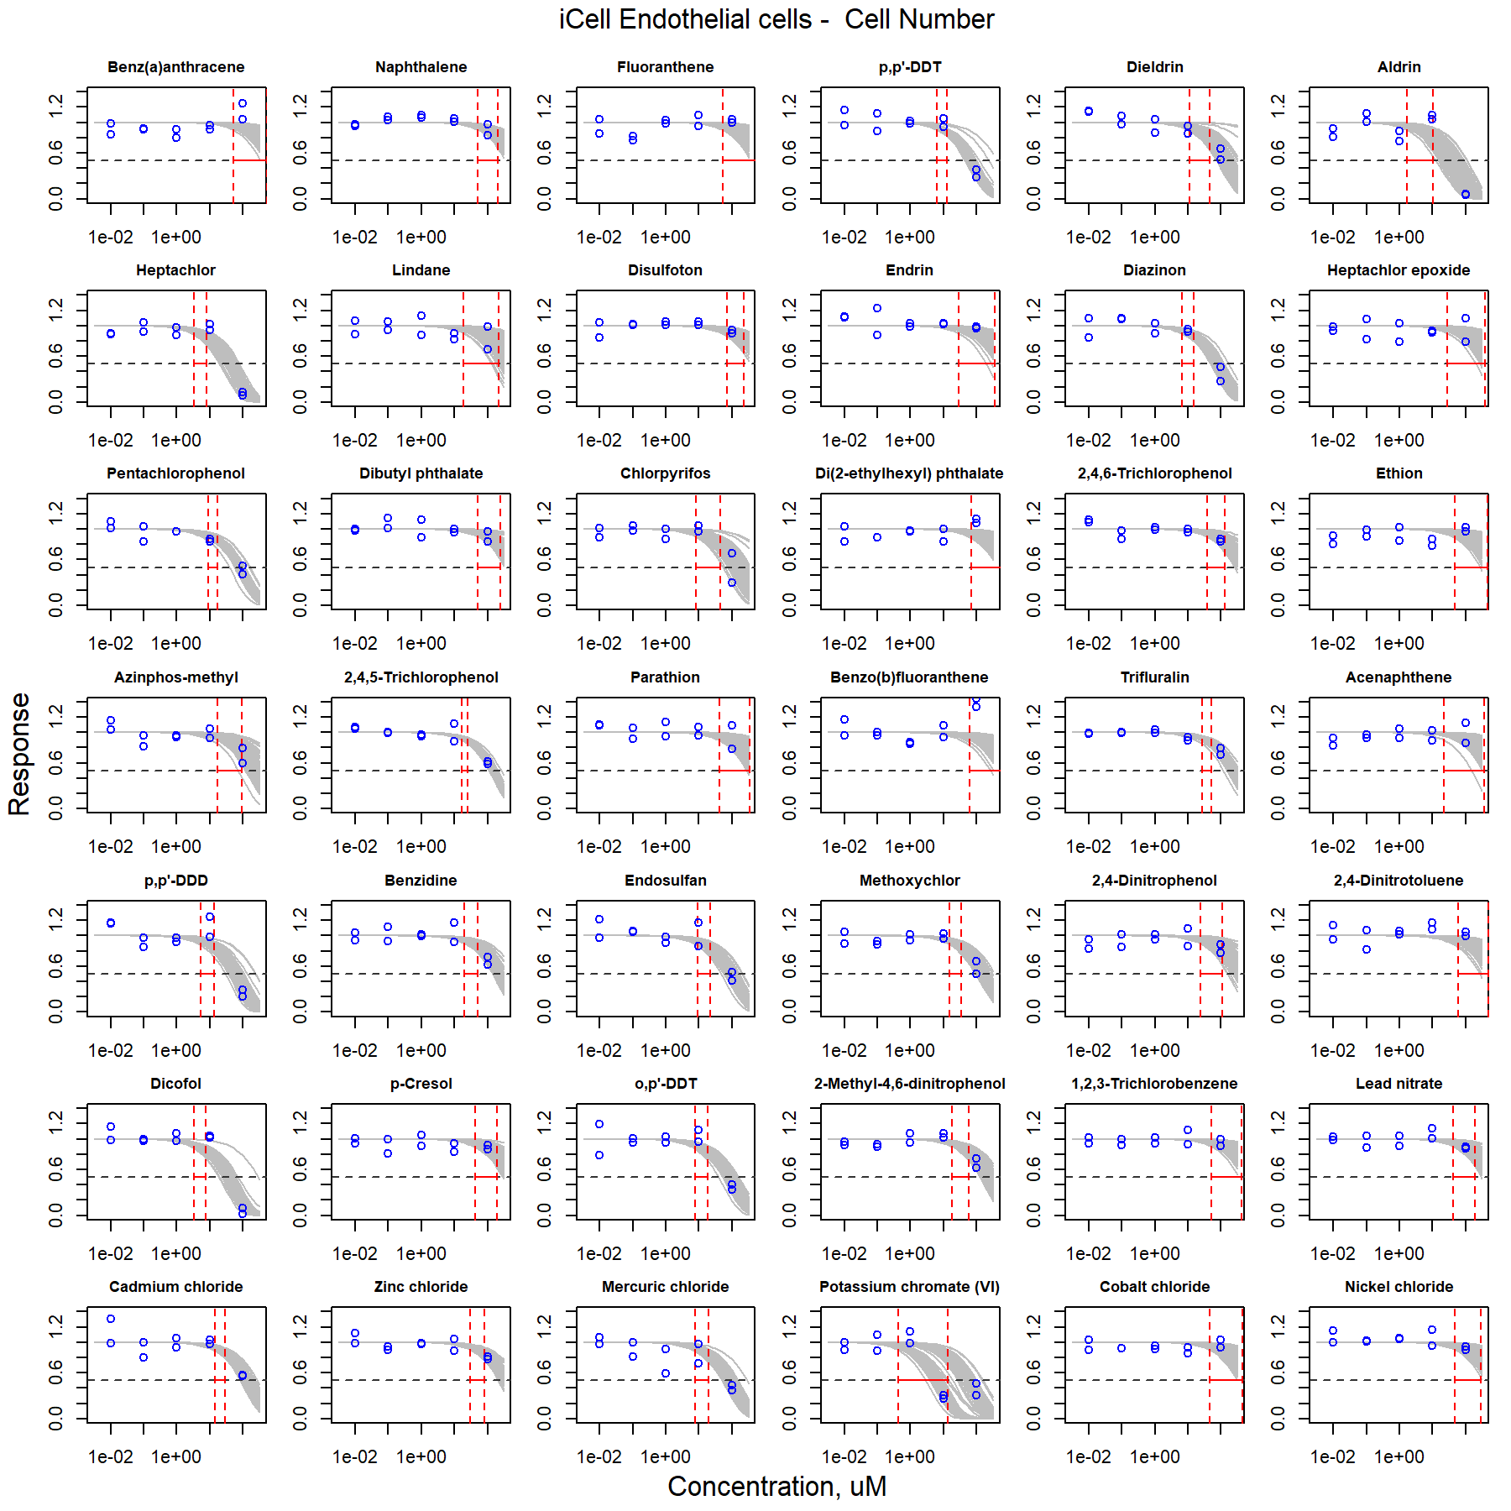

Figure S24. Curve-fitting of single chemical concentration and observed response (Cell Number) in iCell Endothelial cells.

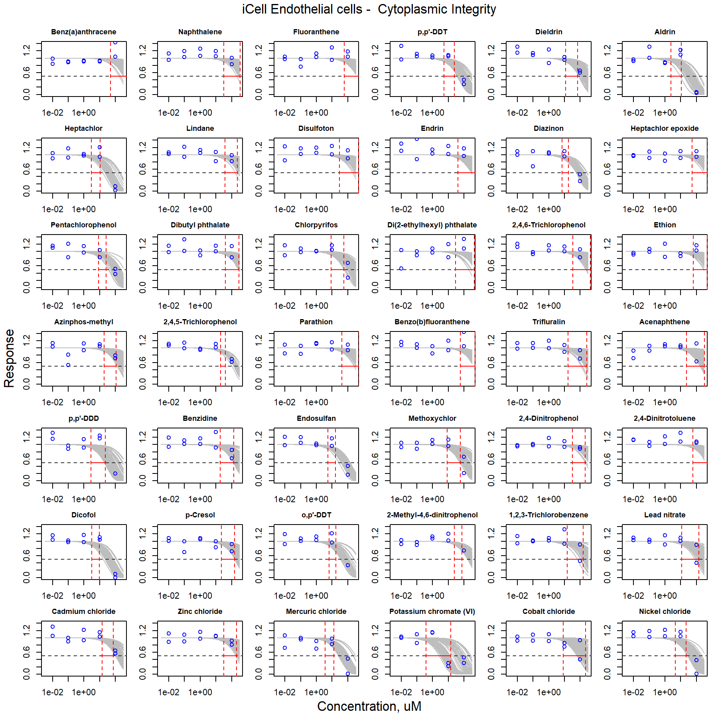

Figure S25. Curve-fitting of single chemical concentration and observed response (Cytoplasmic Integrity) in iCell Endothelial cells.

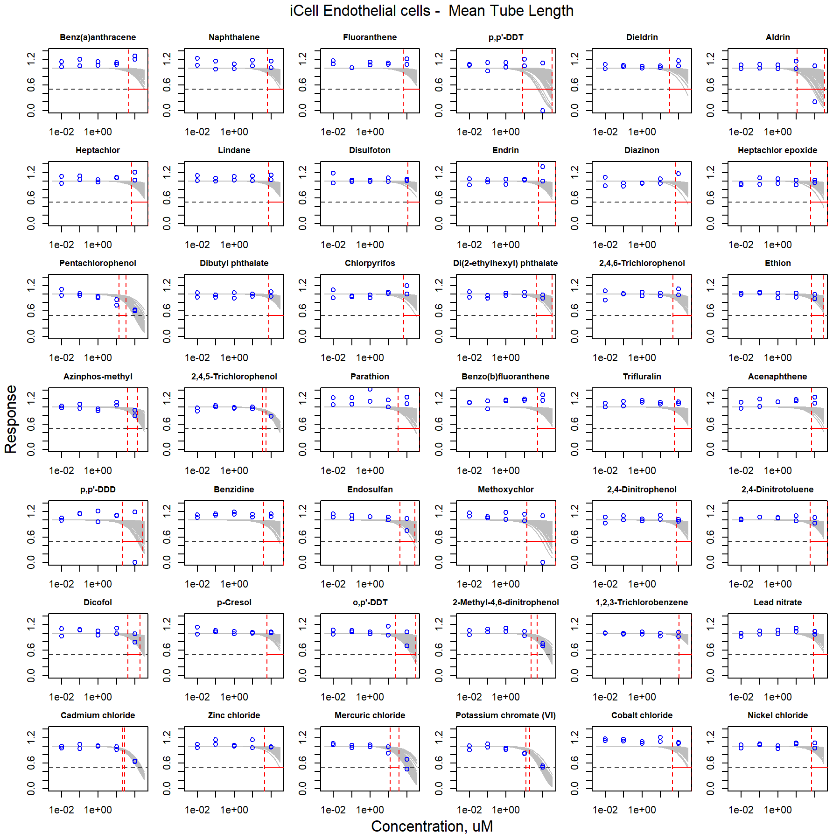

Figure S26. Curve-fitting of single chemical concentration and observed response (Mean Tube Length) in iCell Endothelial cells.

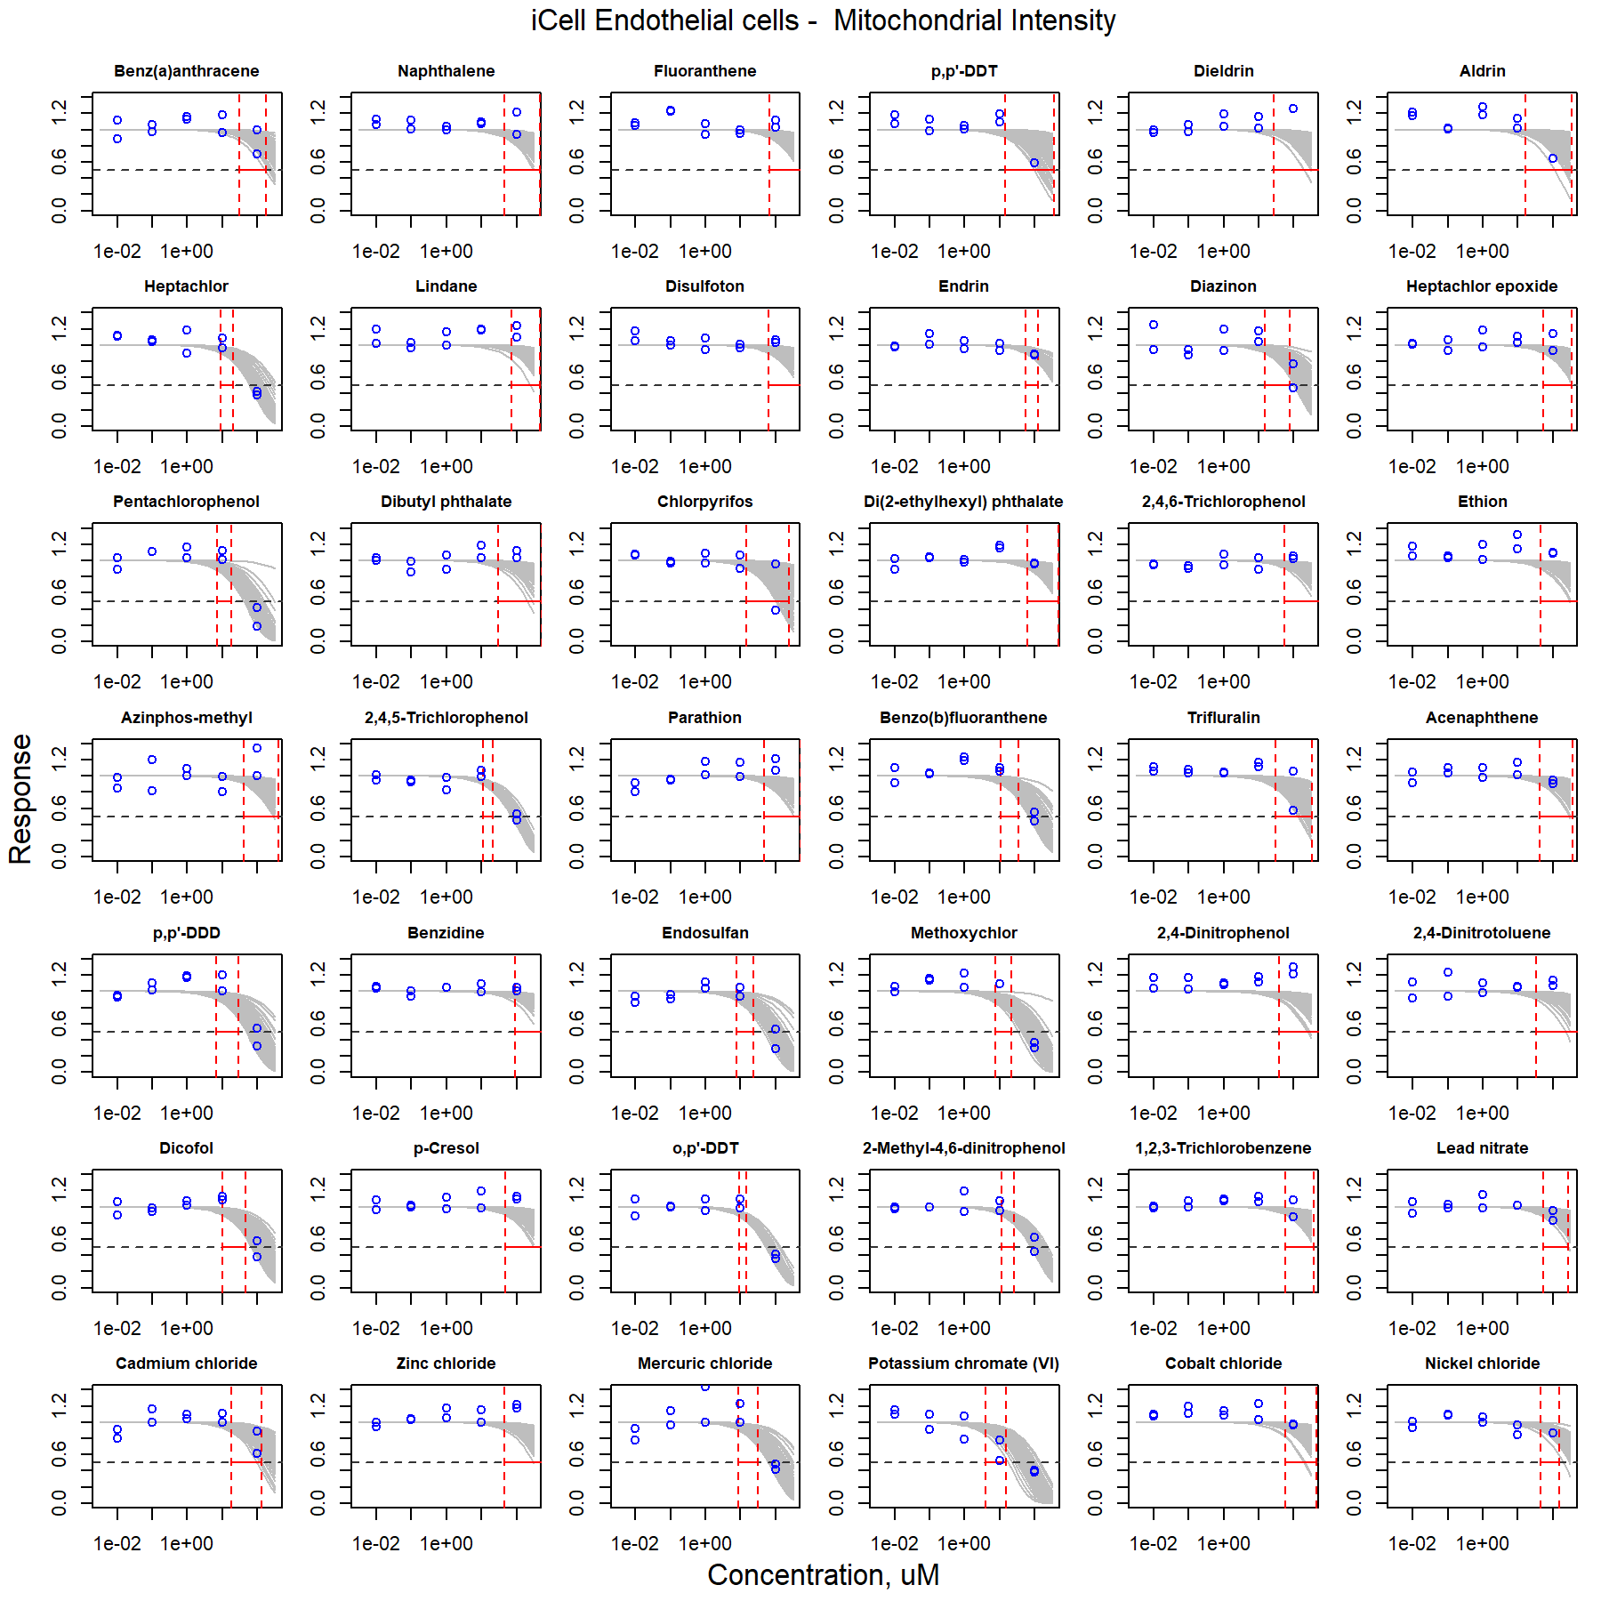

Figure S27. Curve-fitting of single chemical concentration and observed response (Mitochondrial Intensity) in iCell Endothelial cells.

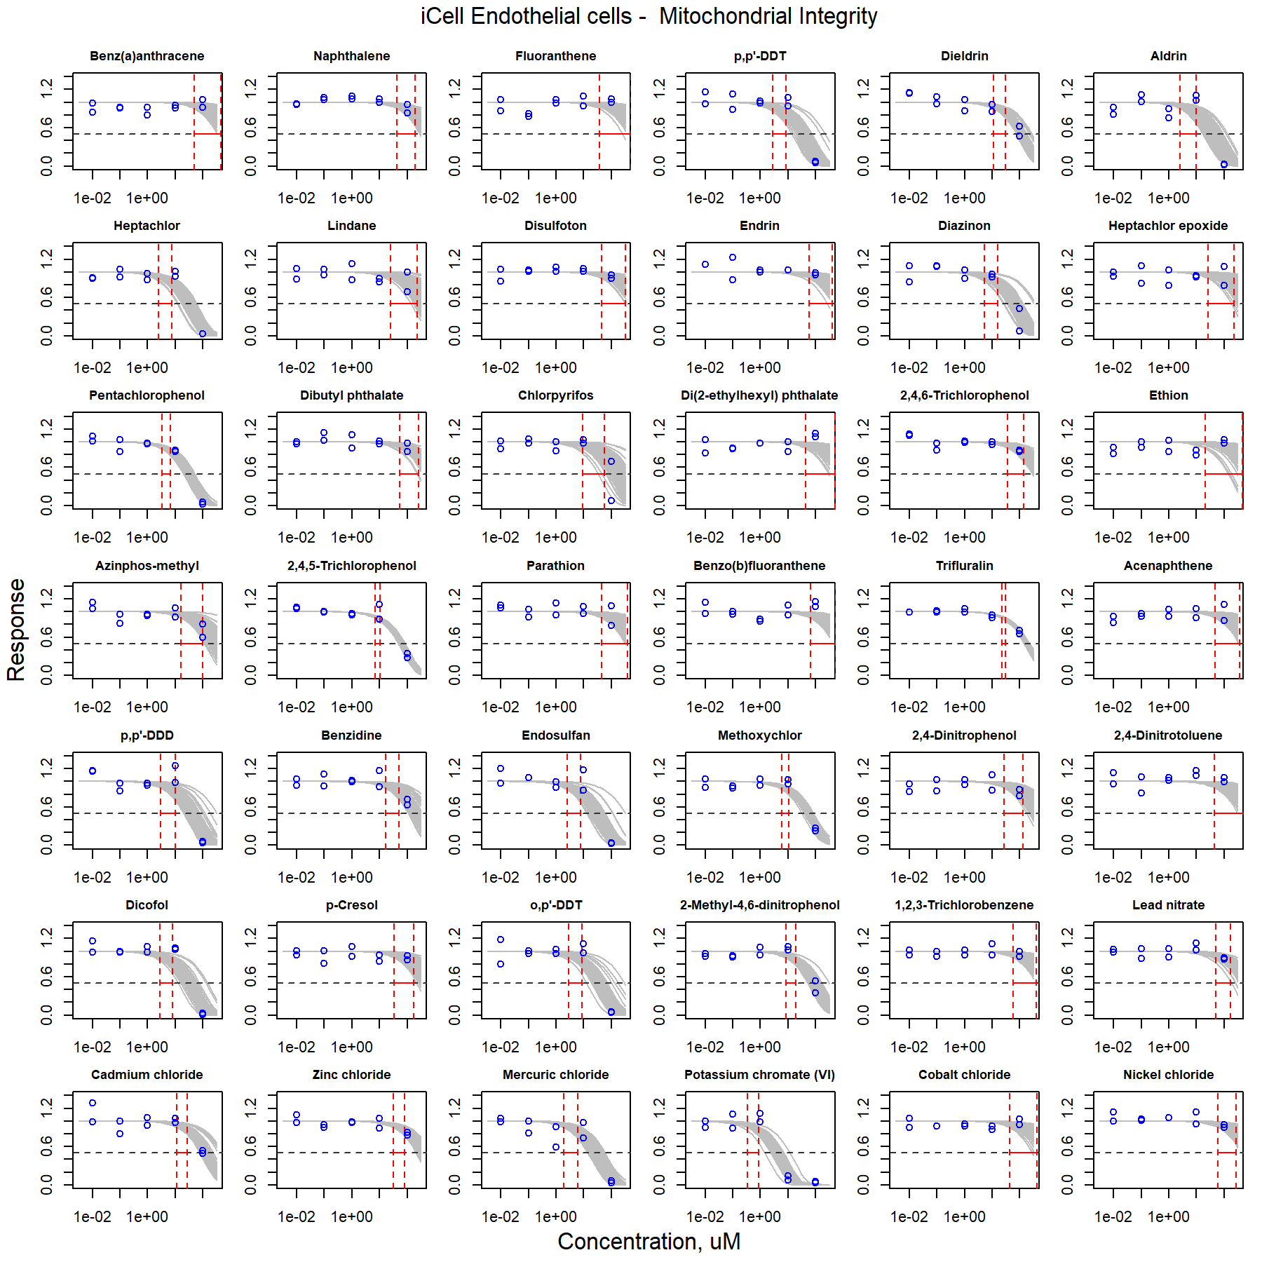

Figure S28. Curve-fitting of single chemical concentration and observed response (Mitochondrial Integrity) in iCell Endothelial cells.

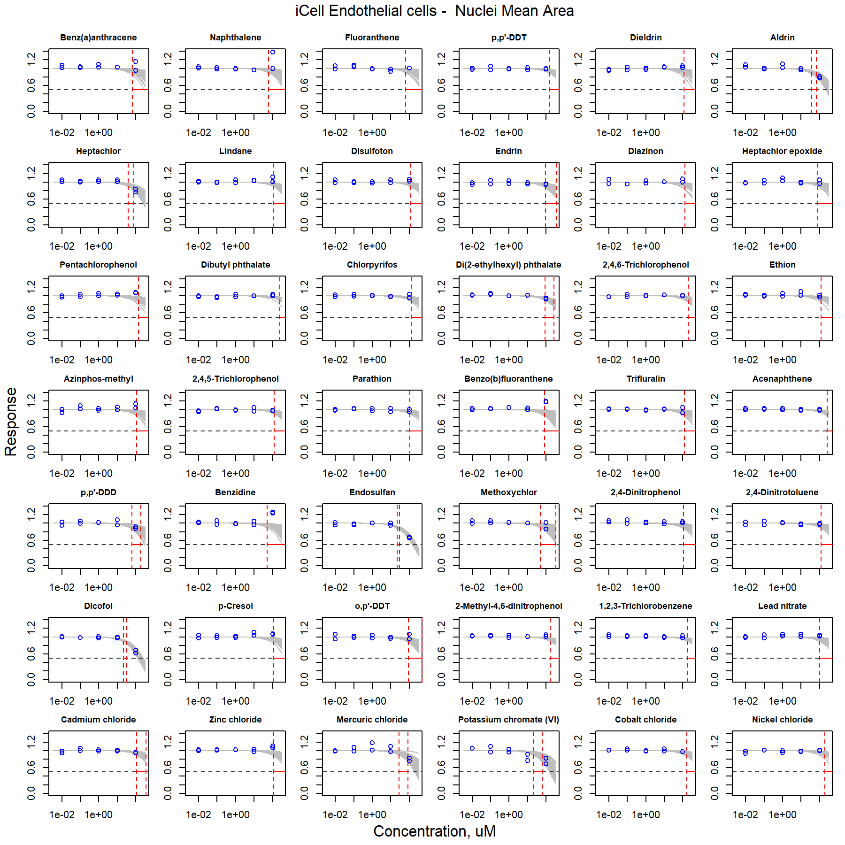

Figure S29. Curve-fitting of single chemical concentration and observed response (Nuclei Mean Area) in iCell Endothelial cells.

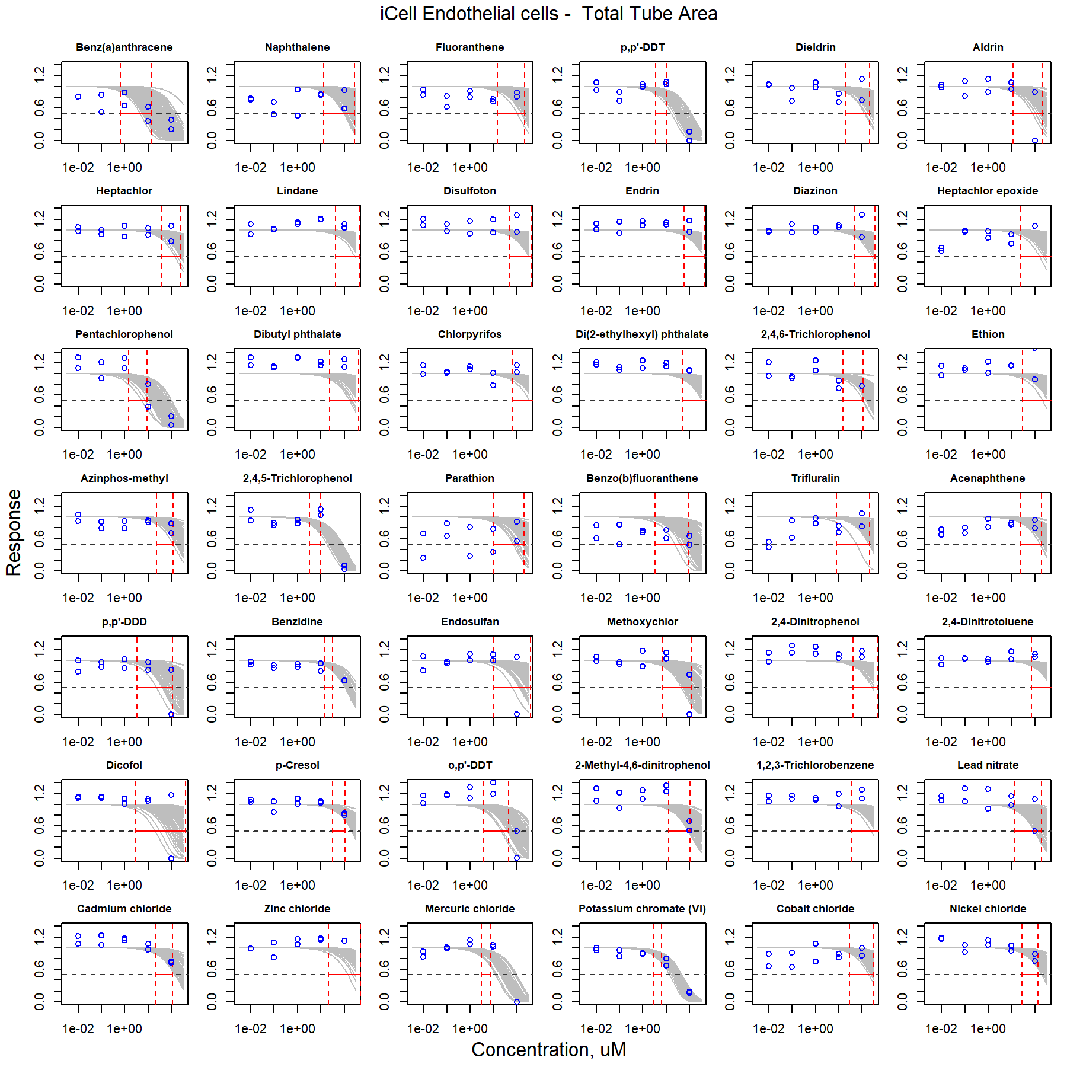

Figure S30. Curve-fitting of single chemical concentration and observed response (Total Tube Area) in iCell Endothelial cells.

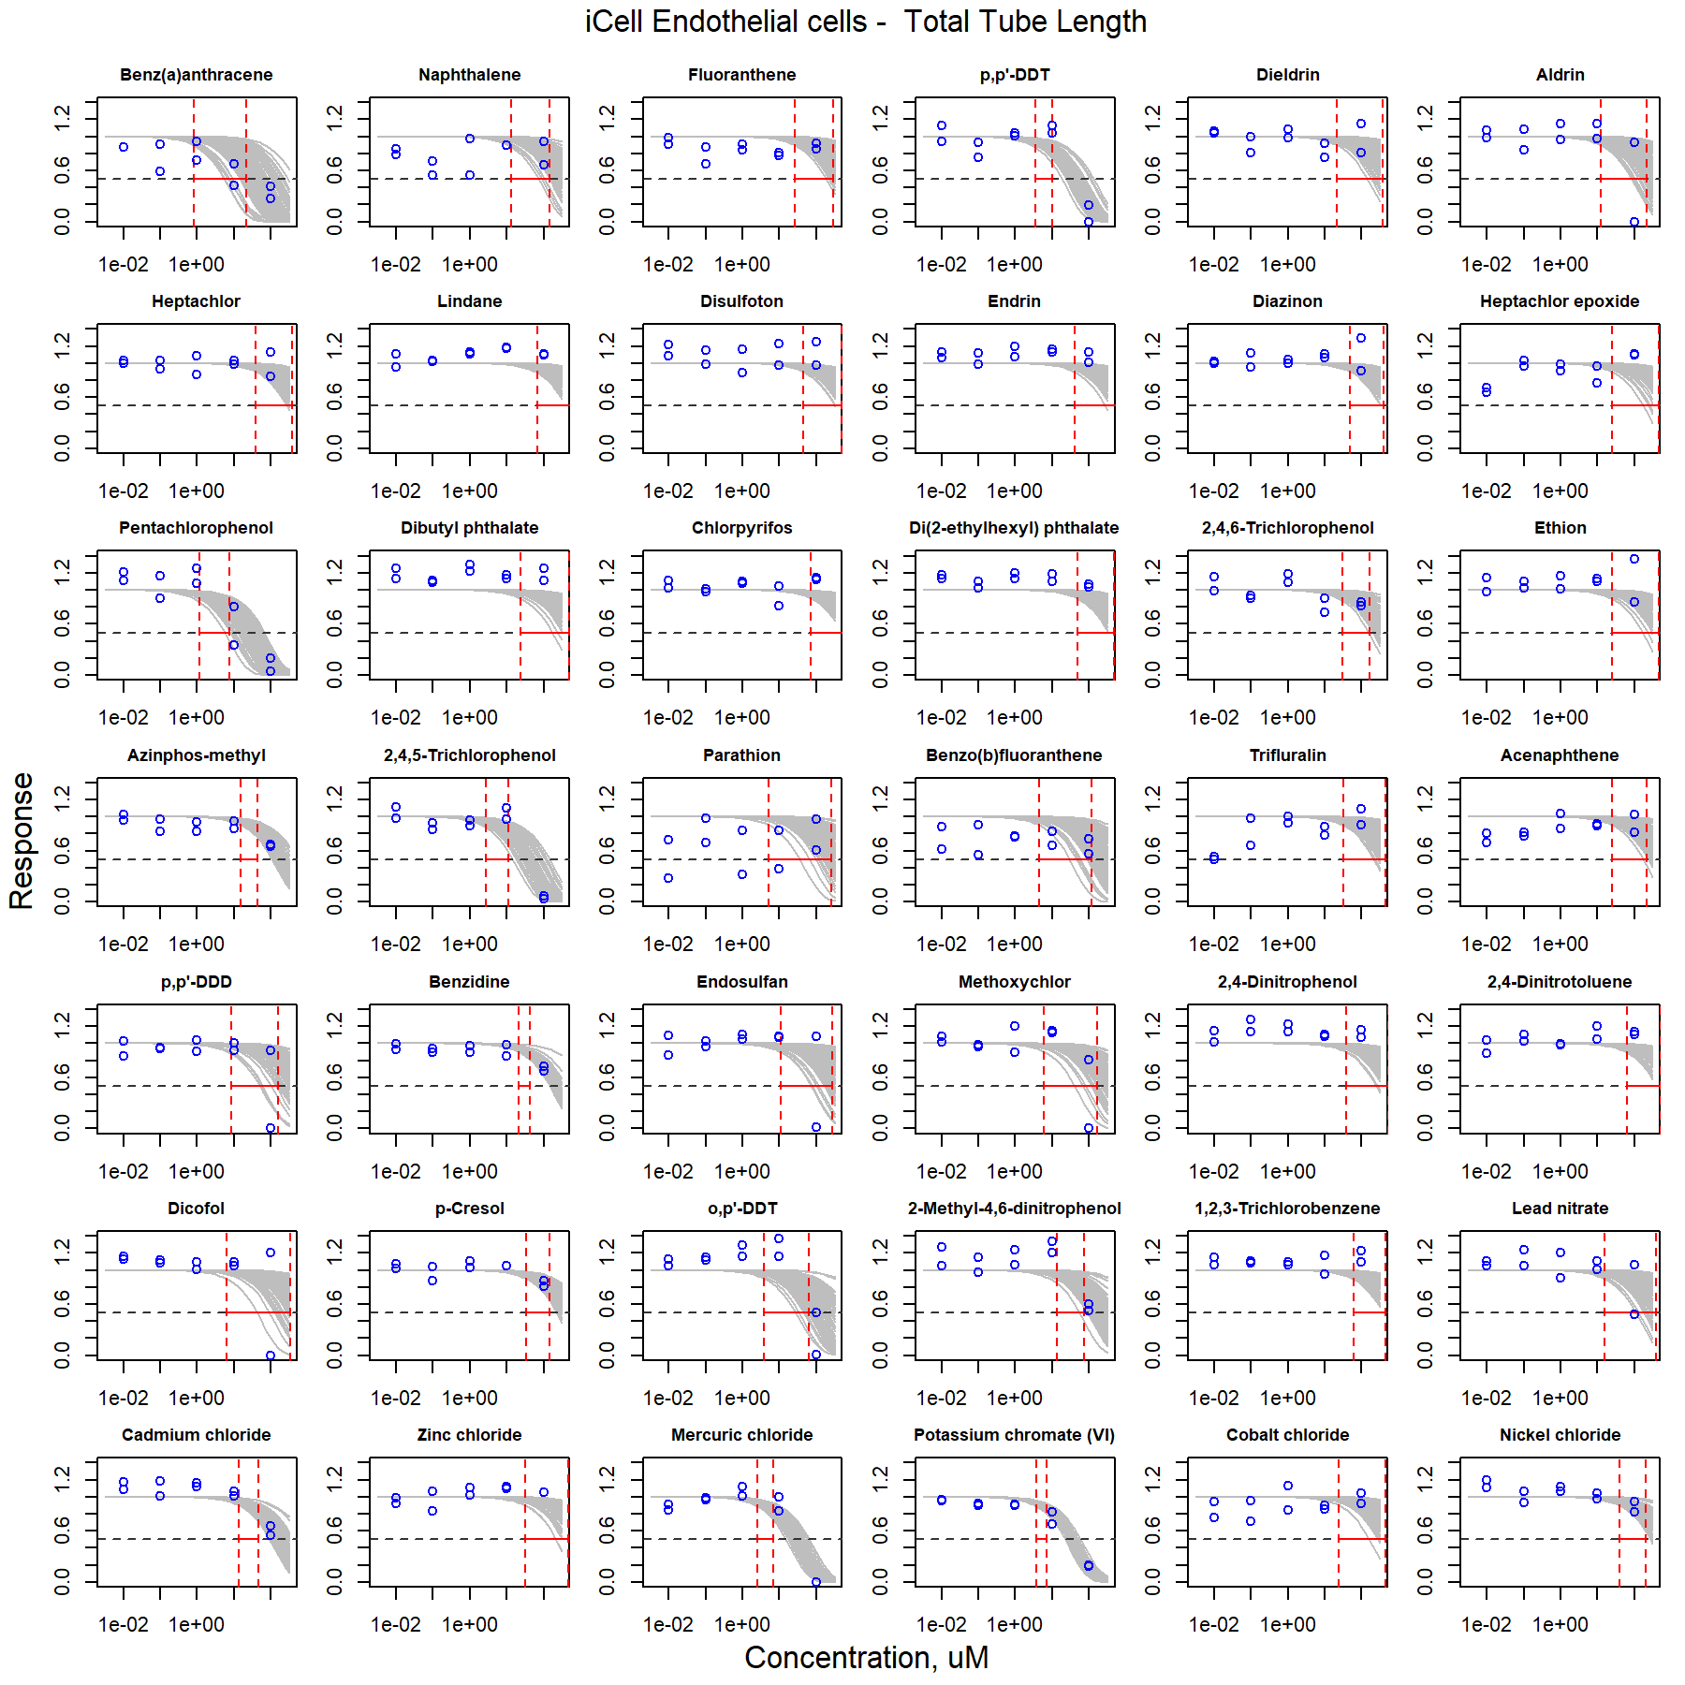

Figure S31. Curve-fitting of single chemical concentration and observed response (Total Tube Length) in iCell Endothelial cells.

### iCell Cardiomyocytes

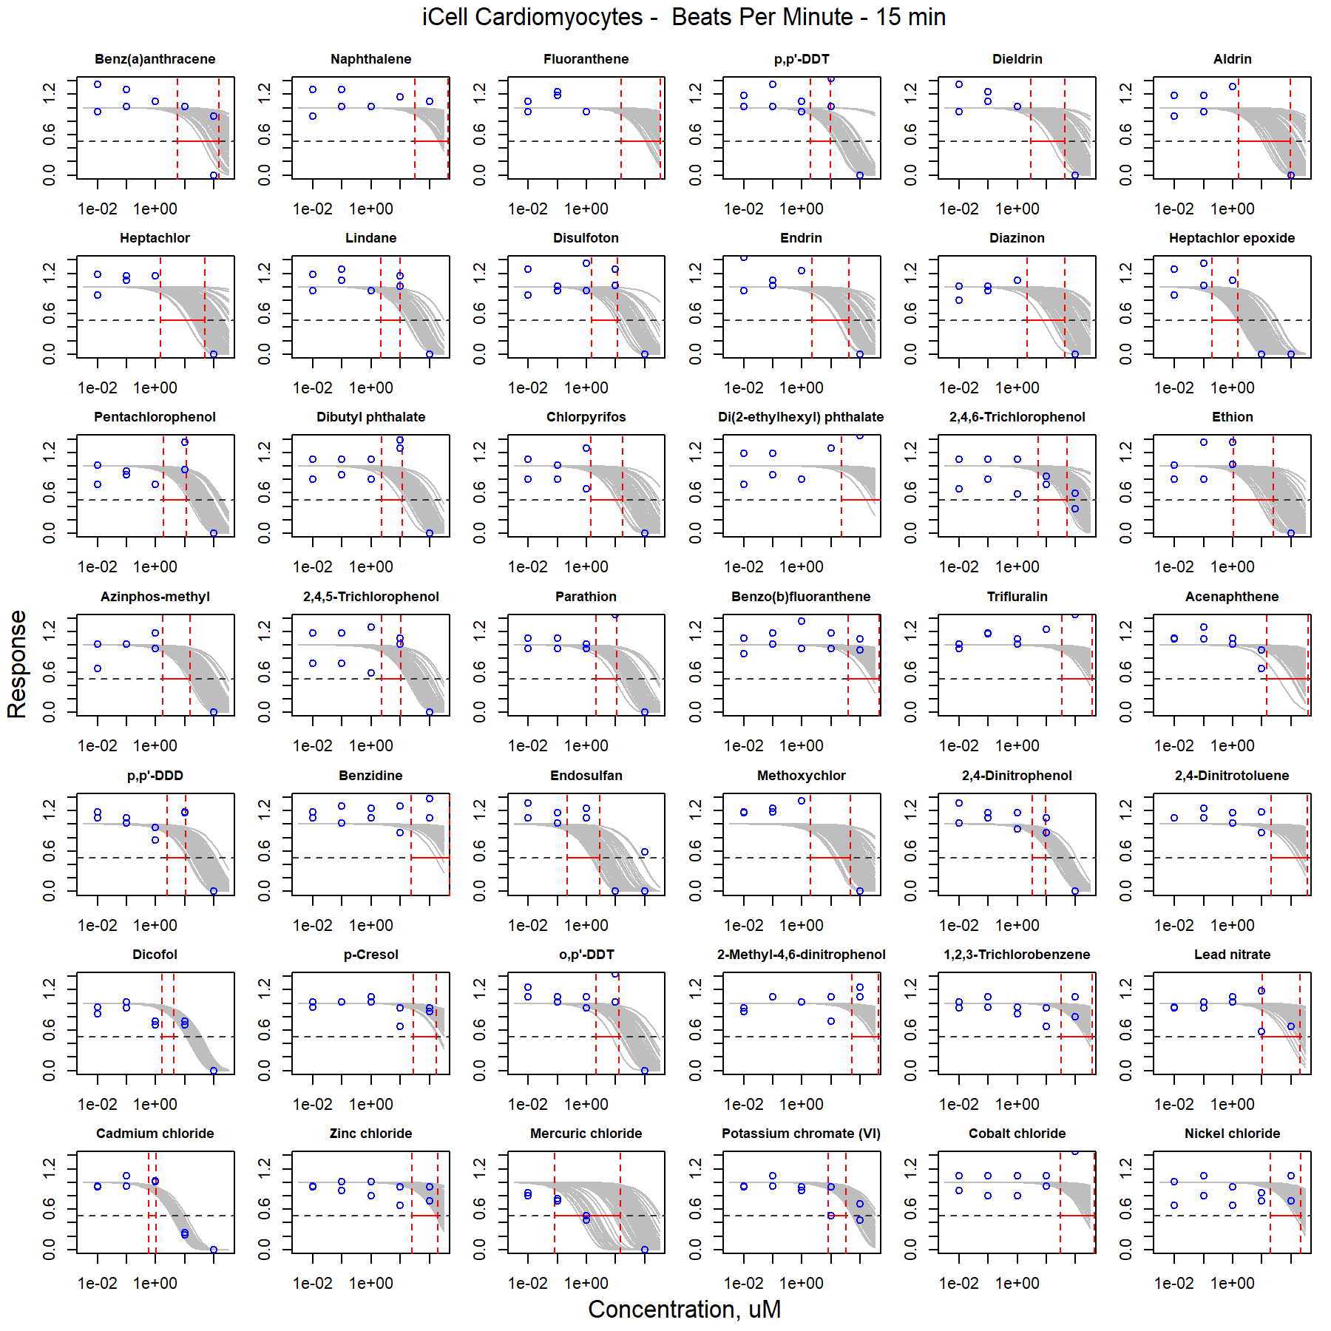

Figure S32. Curve-fitting of single chemical concentration and observed response (Beats Per Minute - 15 min) in iCell Cardiomyocytes.

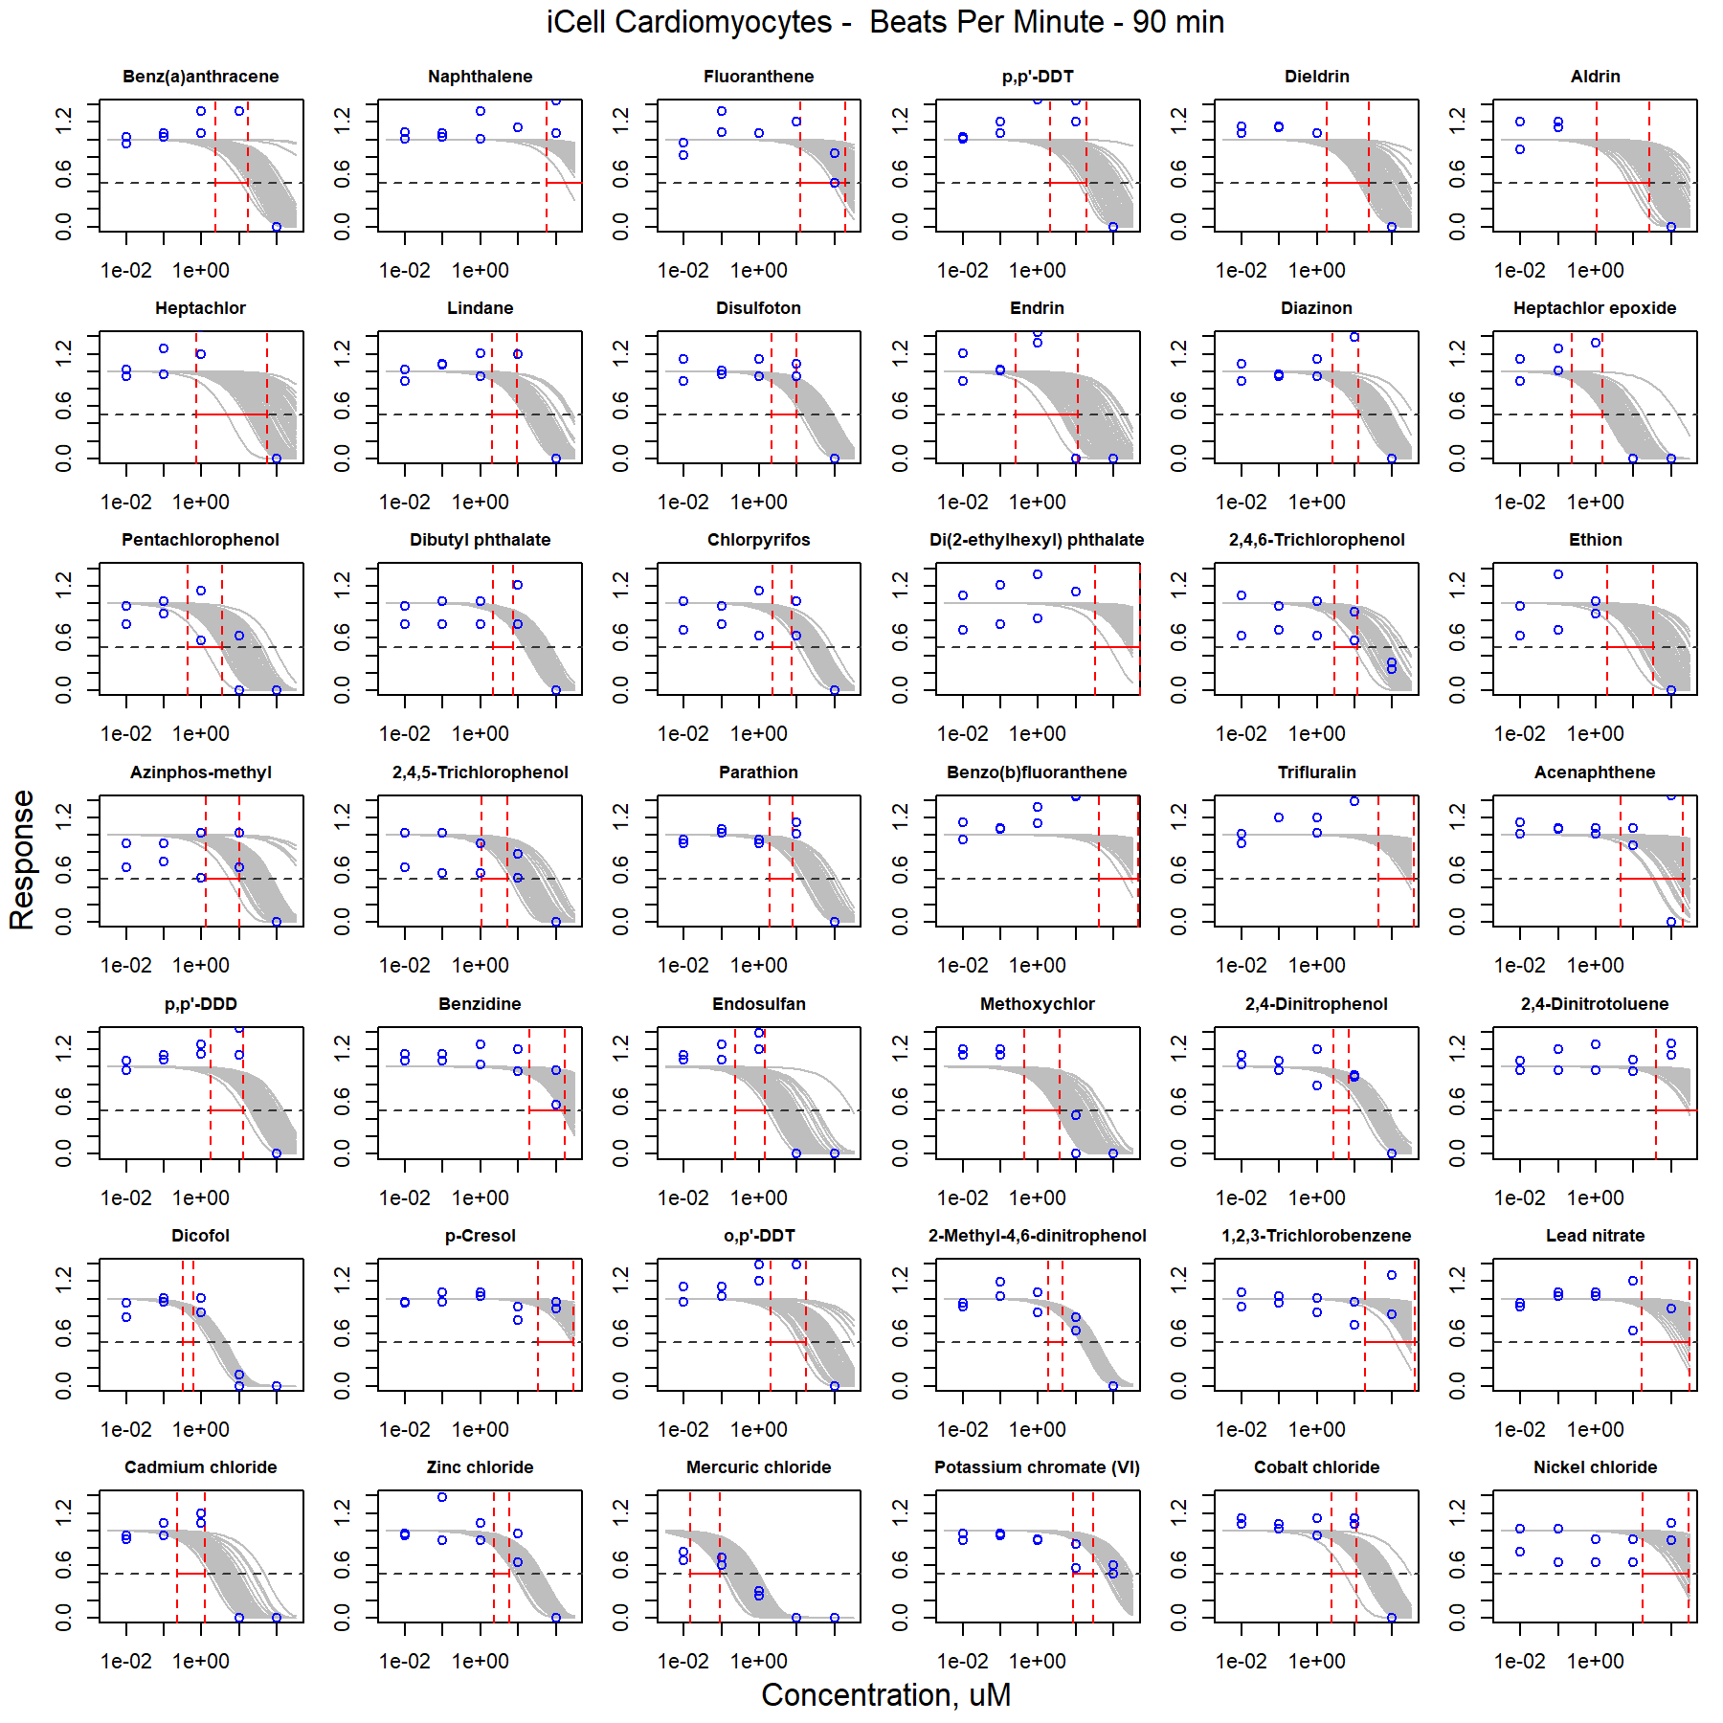

Figure S33. Curve-fitting of single chemical concentration and observed response (Beats Per Minute - 90 min) in iCell Cardiomyocytes.

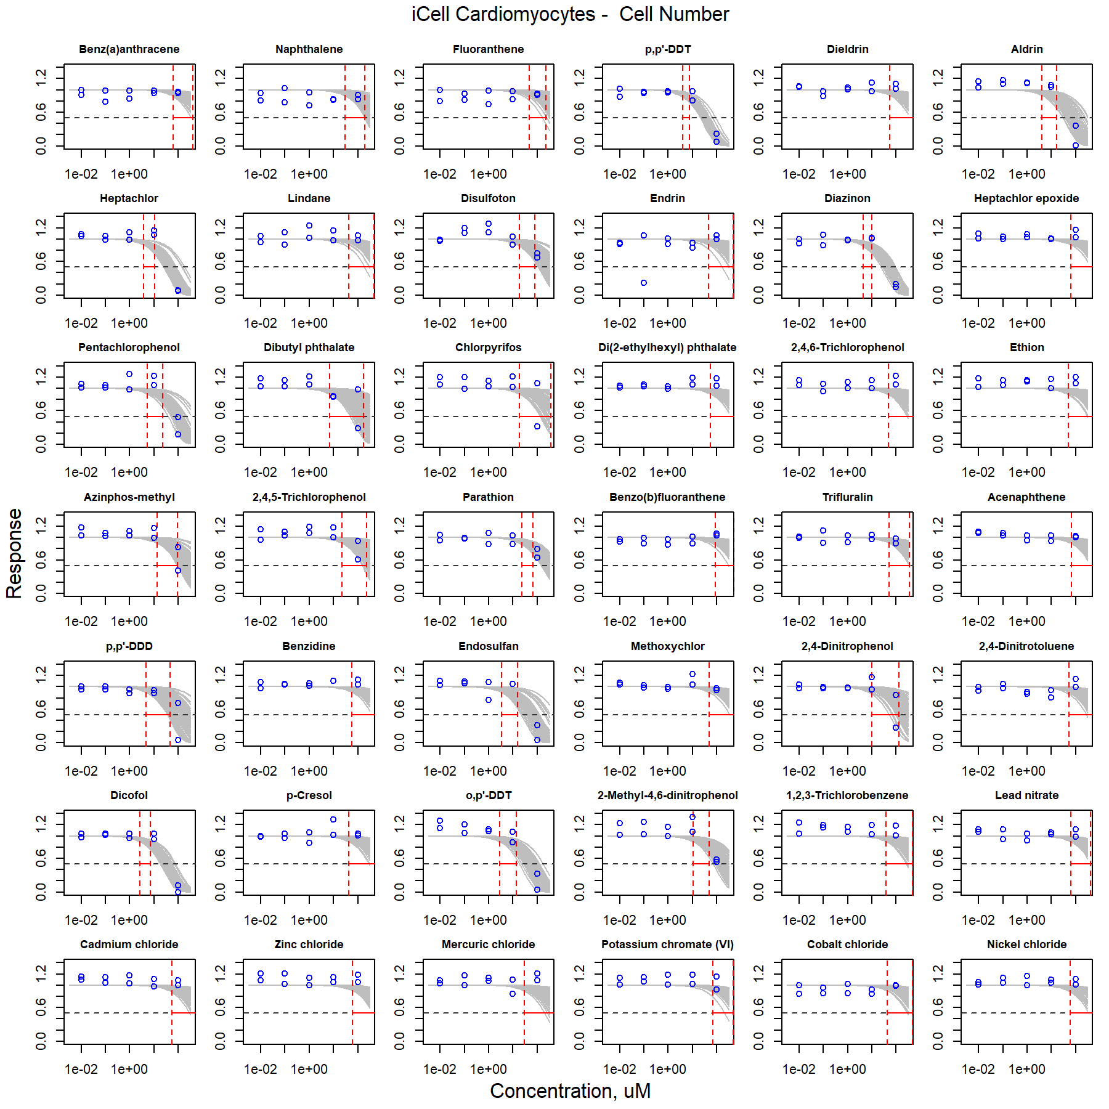

Figure S34. Curve-fitting of single chemical concentration and observed response (Cell Number) in iCell Cardiomyocytes.

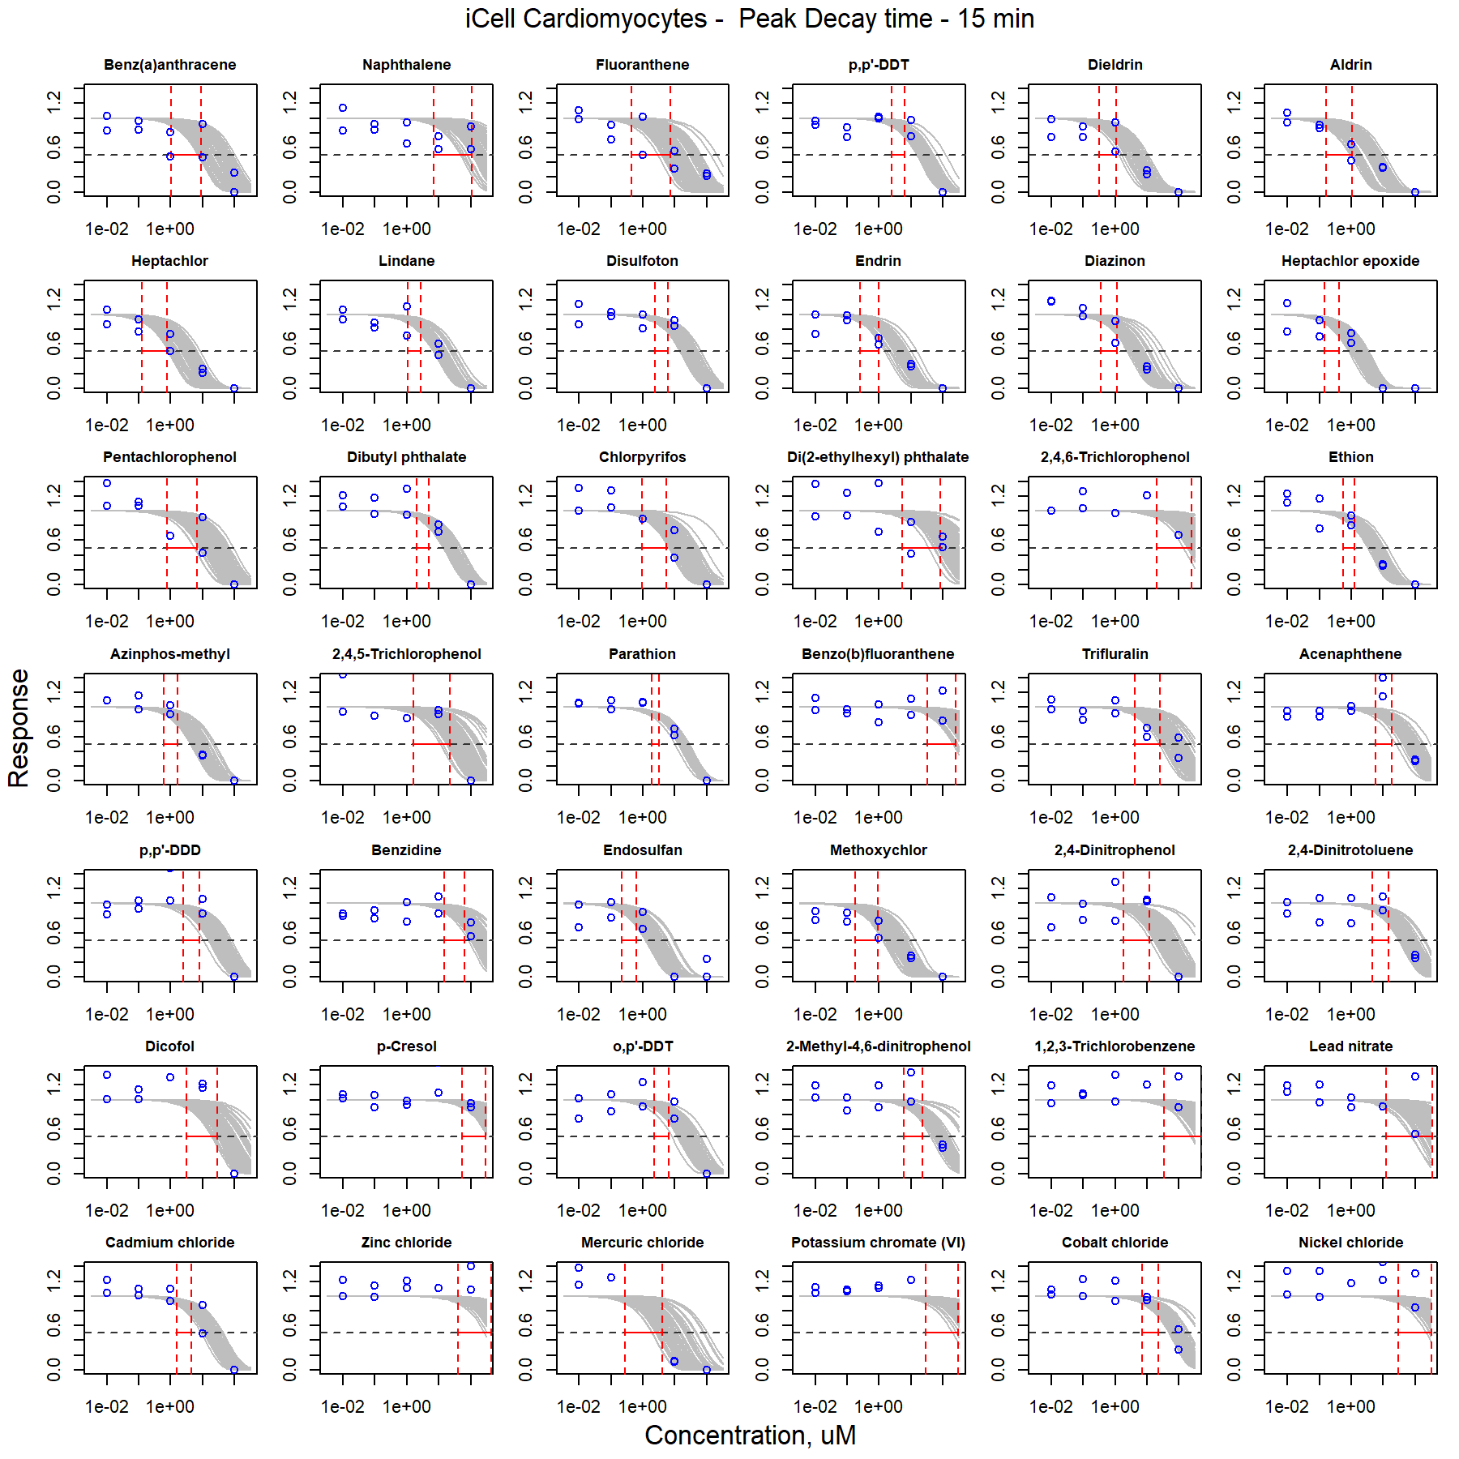

Figure S35. Curve-fitting of single chemical concentration and observed response (Peak Decay time - 15 min) in iCell Cardiomyocytes.

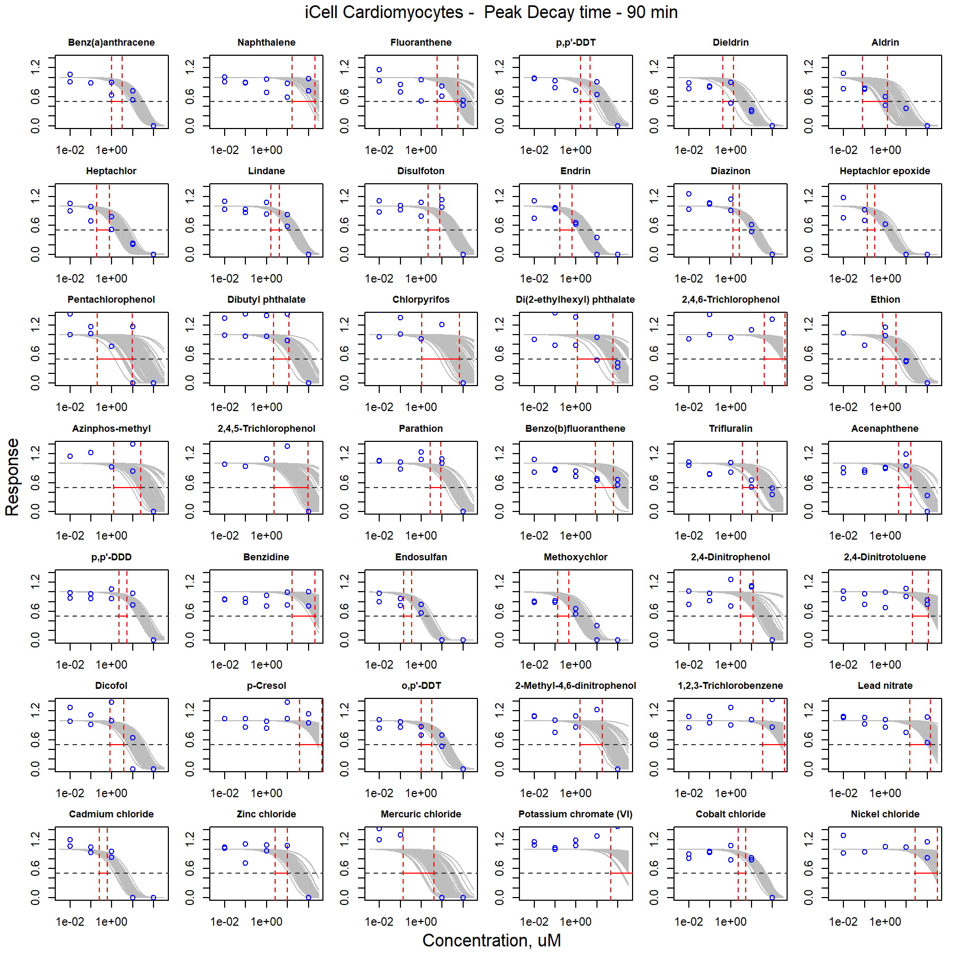

Figure S36. Curve-fitting of single chemical concentration and observed response (Peak Decay time - 90 min) in iCell Cardiomyocytes.

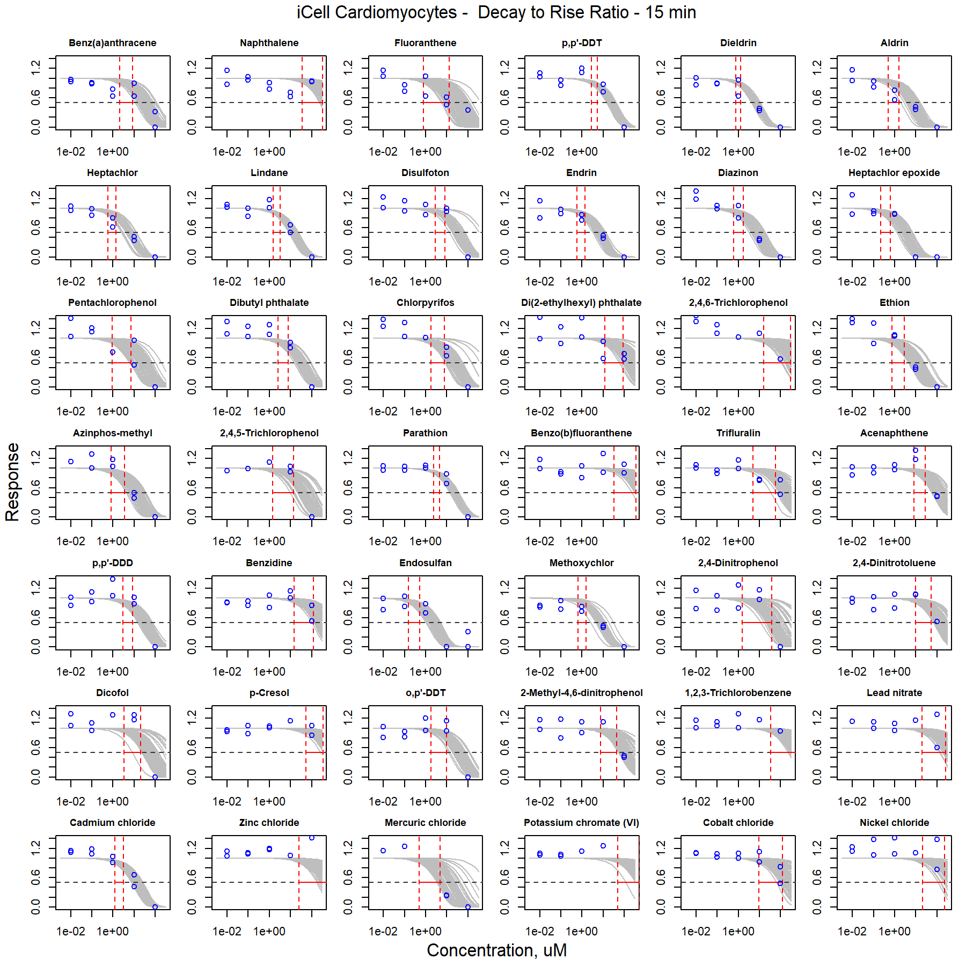

Figure S37. Curve-fitting of single chemical concentration and observed response (Decay to Rise Ratio - 15 min) in iCell Cardiomyocytes.

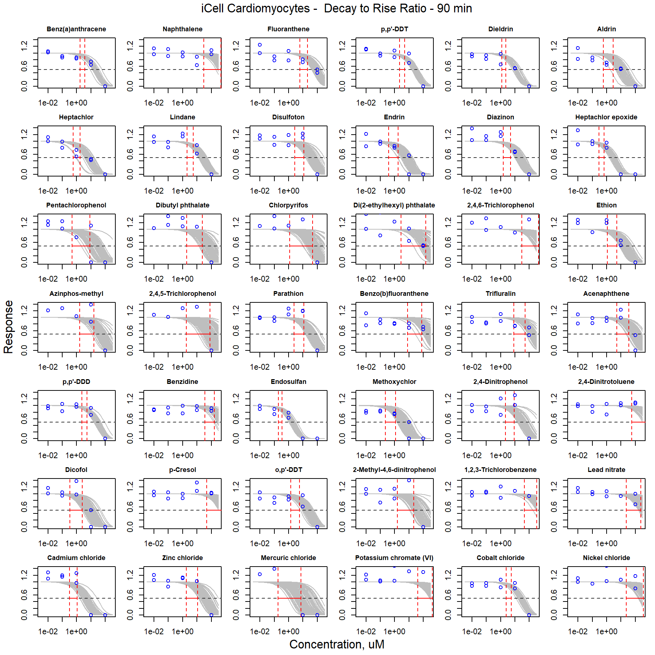

Figure S38. Curve-fitting of single chemical concentration and observed response (Decay to Rise Ratio - 90 min) in iCell Cardiomyocytes.

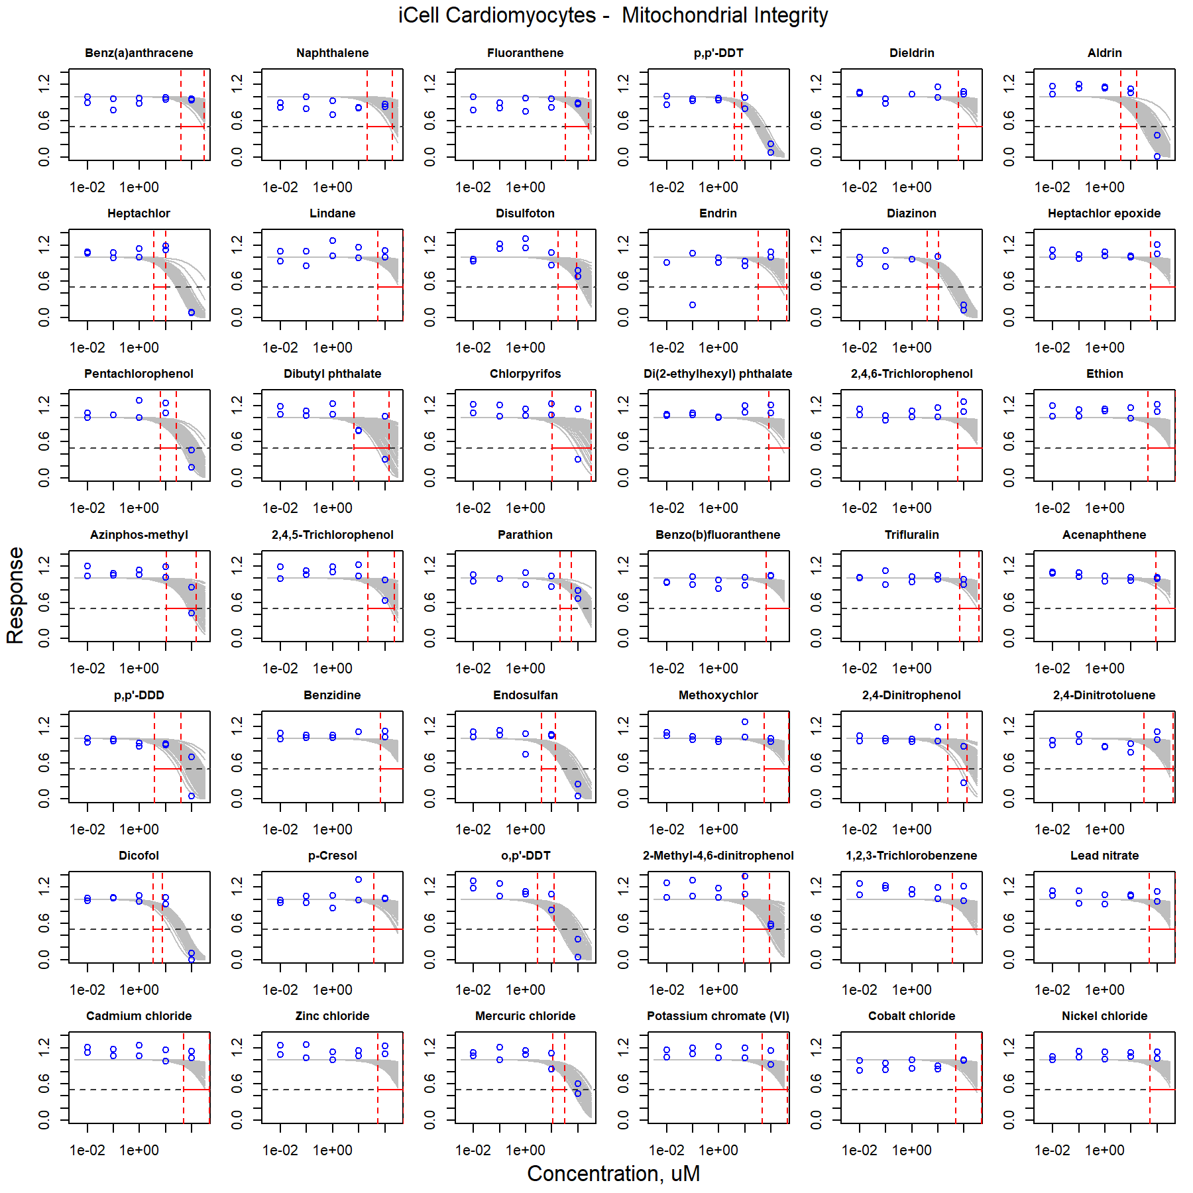

Figure S39. Curve-fitting of single chemical concentration and observed response (Mitochondrial Integrity) in iCell Cardiomyocytes.

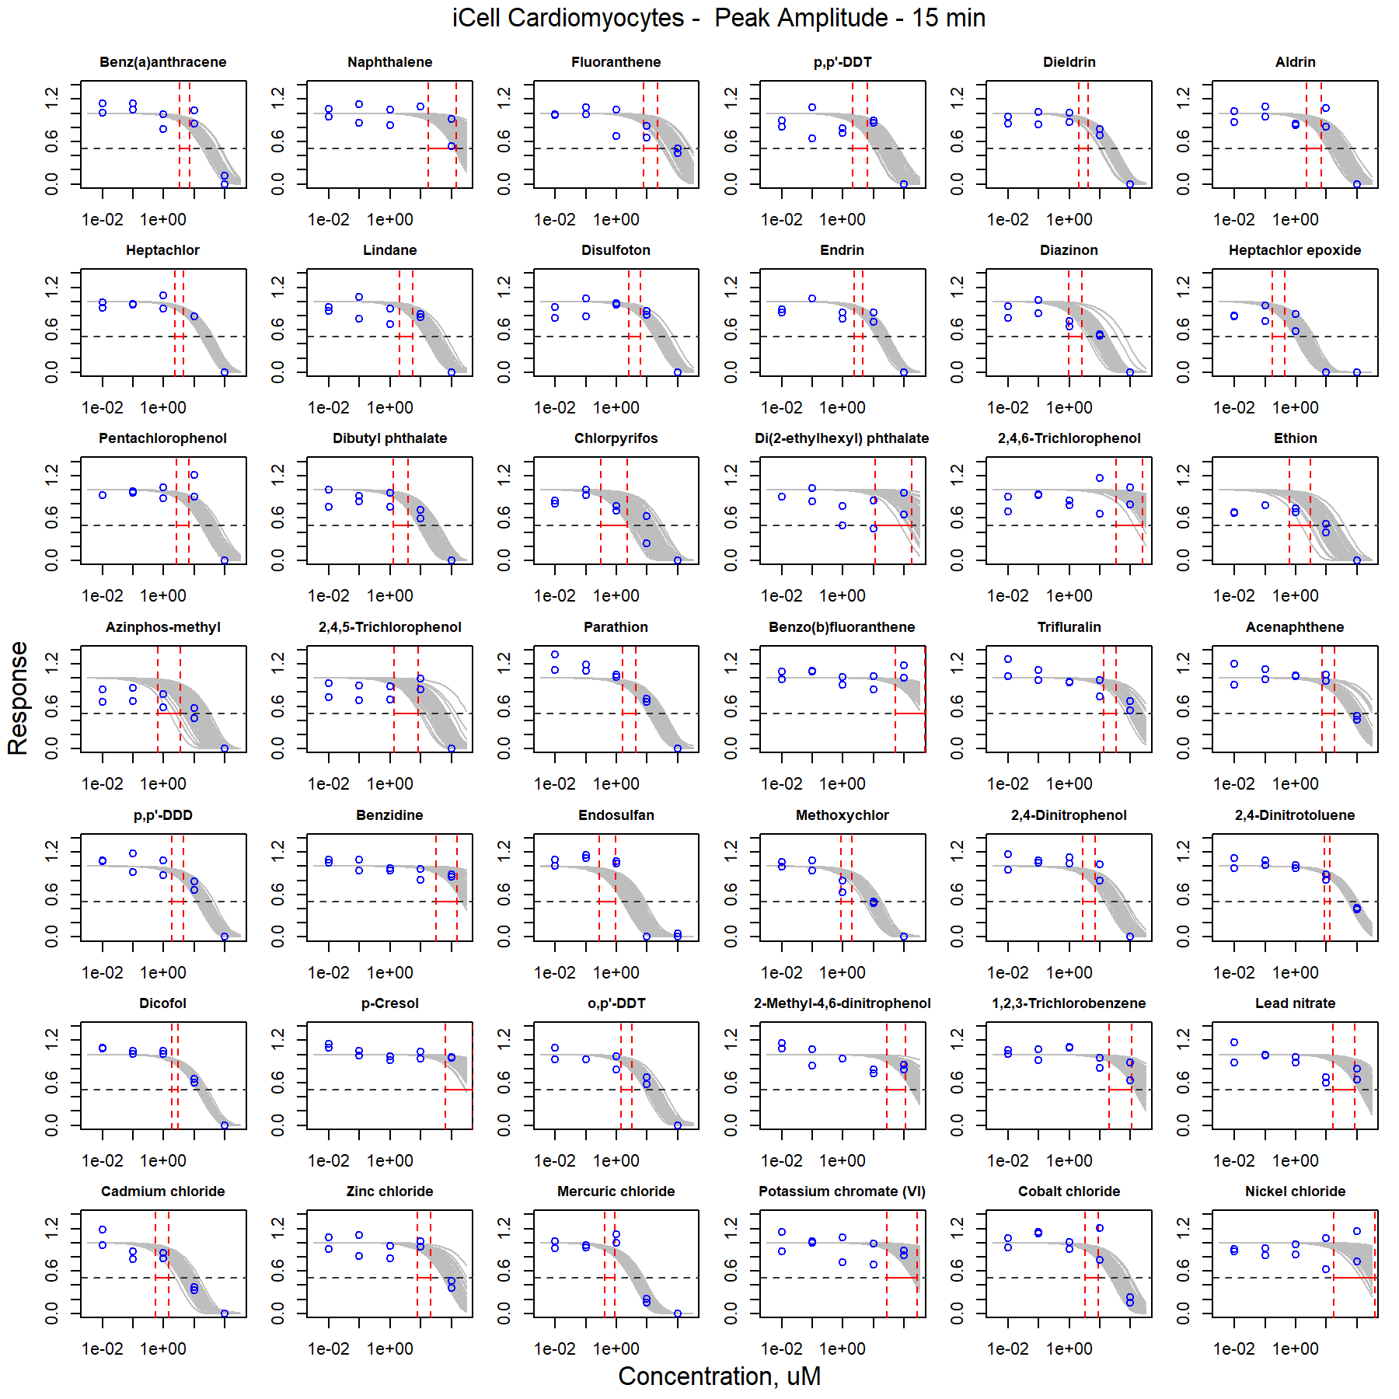

Figure S40. Curve-fitting of single chemical concentration and observed response (Peak Amplitude - 15 min) in iCell Cardiomyocytes.

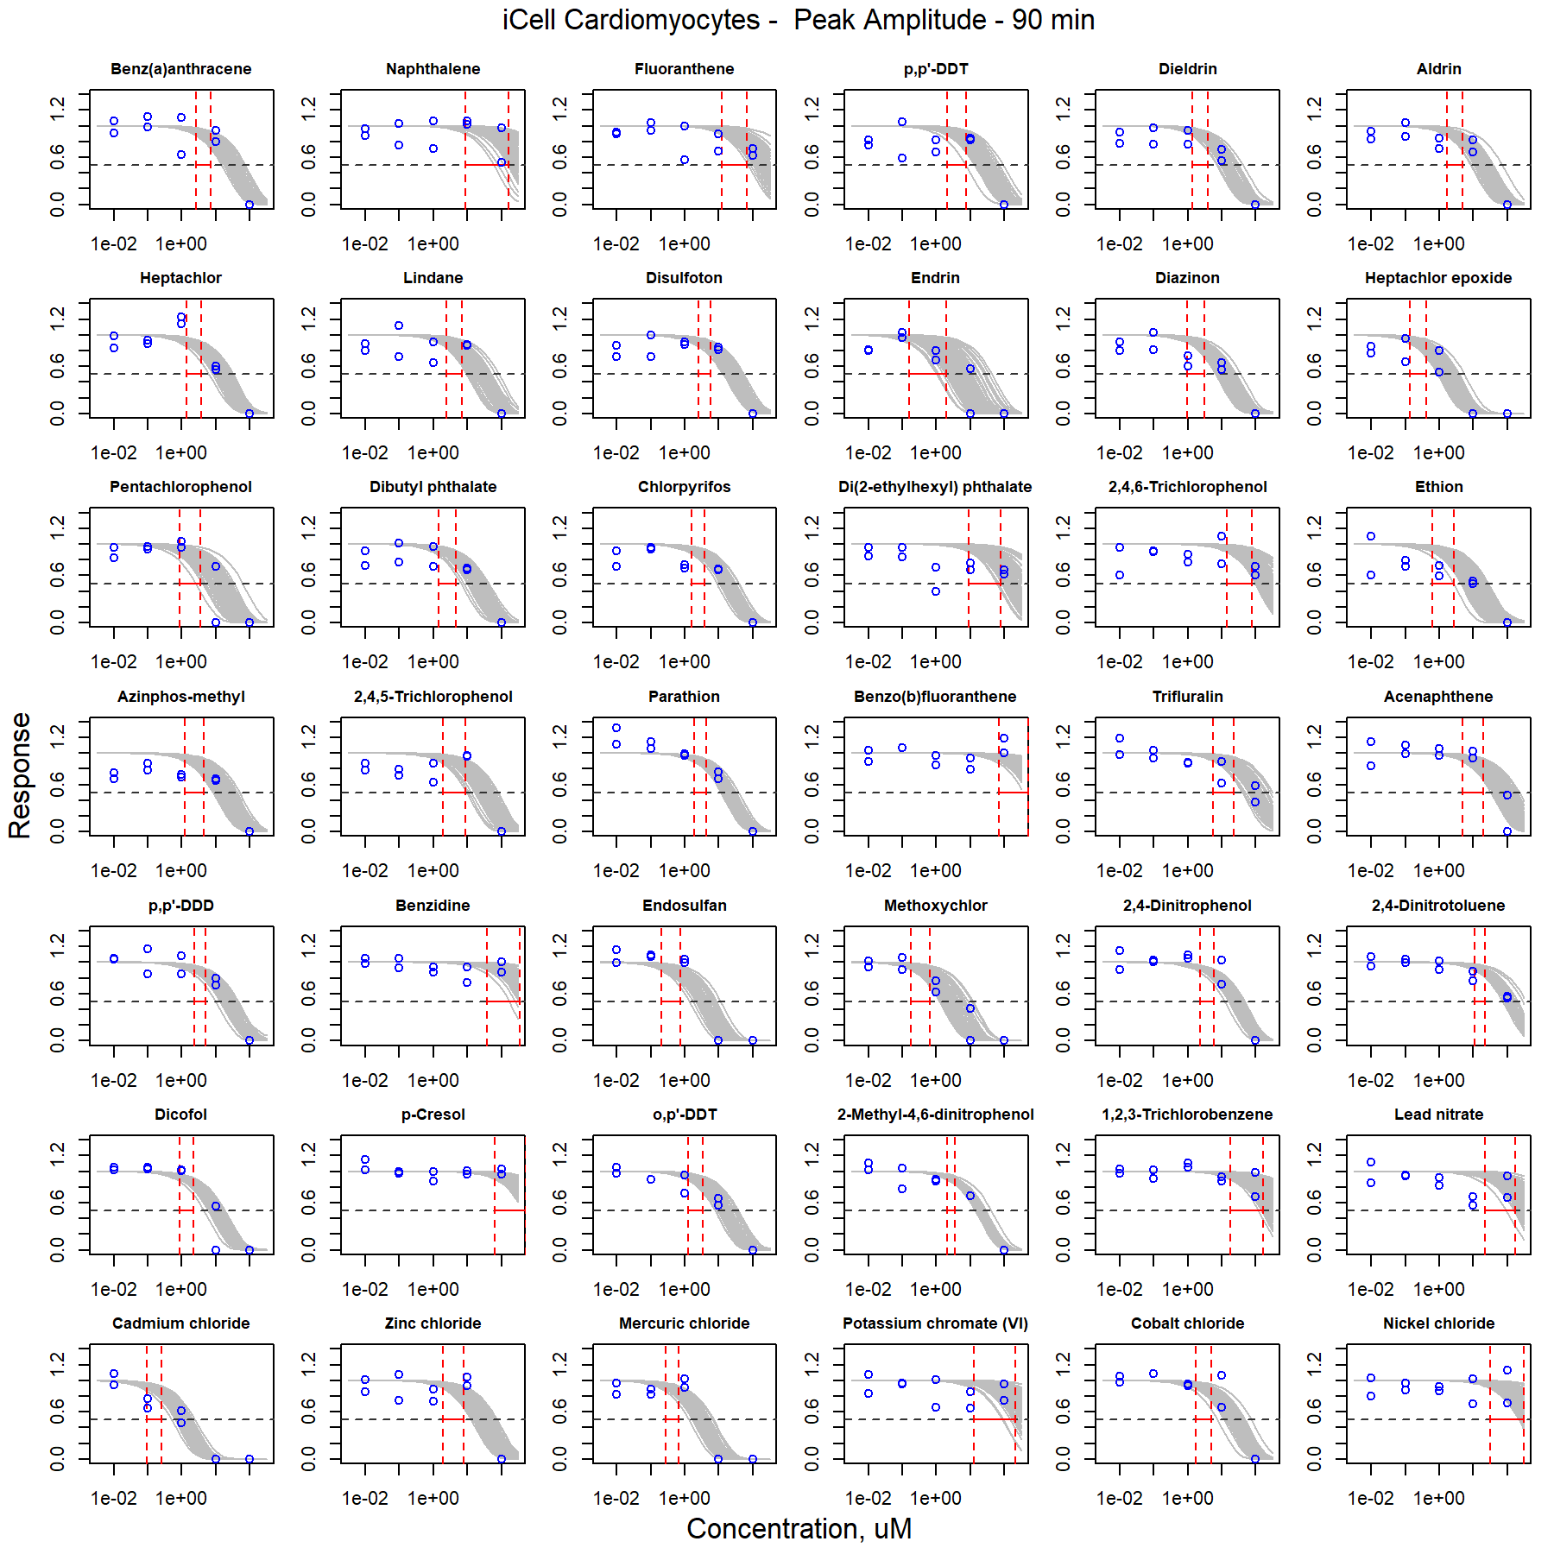

Figure S41. Curve-fitting of single chemical concentration and observed response (Peak Amplitude - 90 min) in iCell Cardiomyocytes.

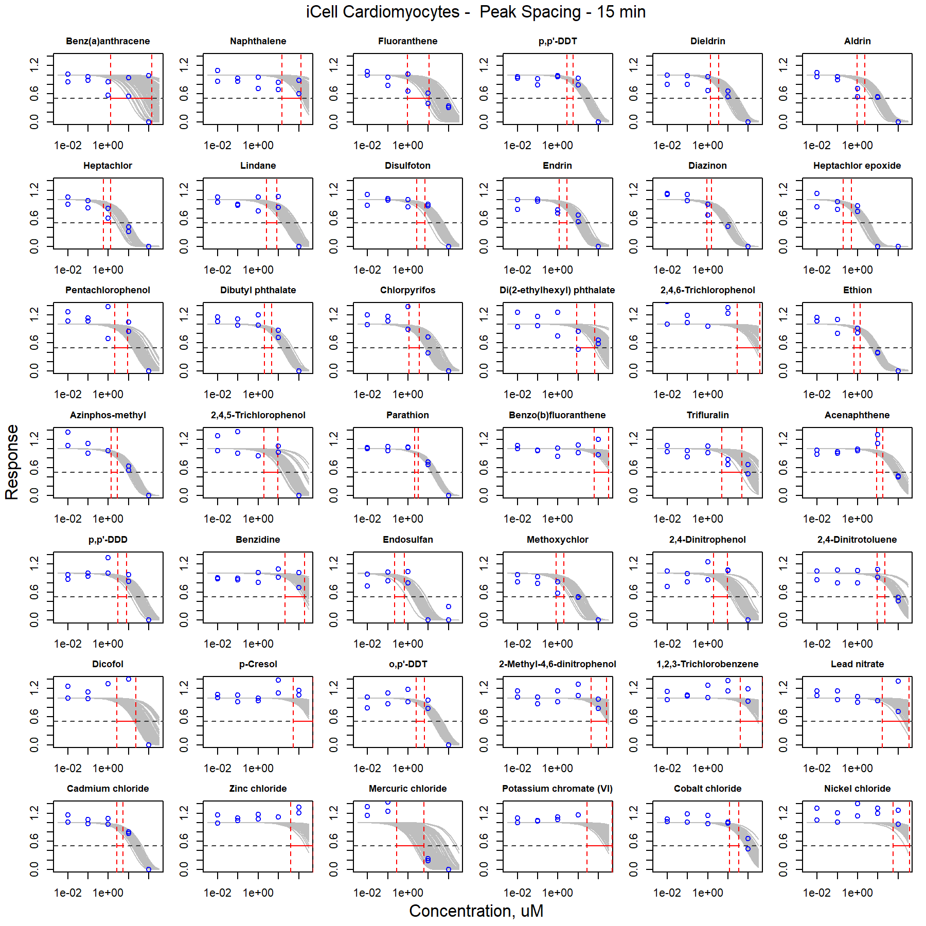

Figure S42. Curve-fitting of single chemical concentration and observed response (Peak Spacing - 15 min) in iCell Cardiomyocytes.

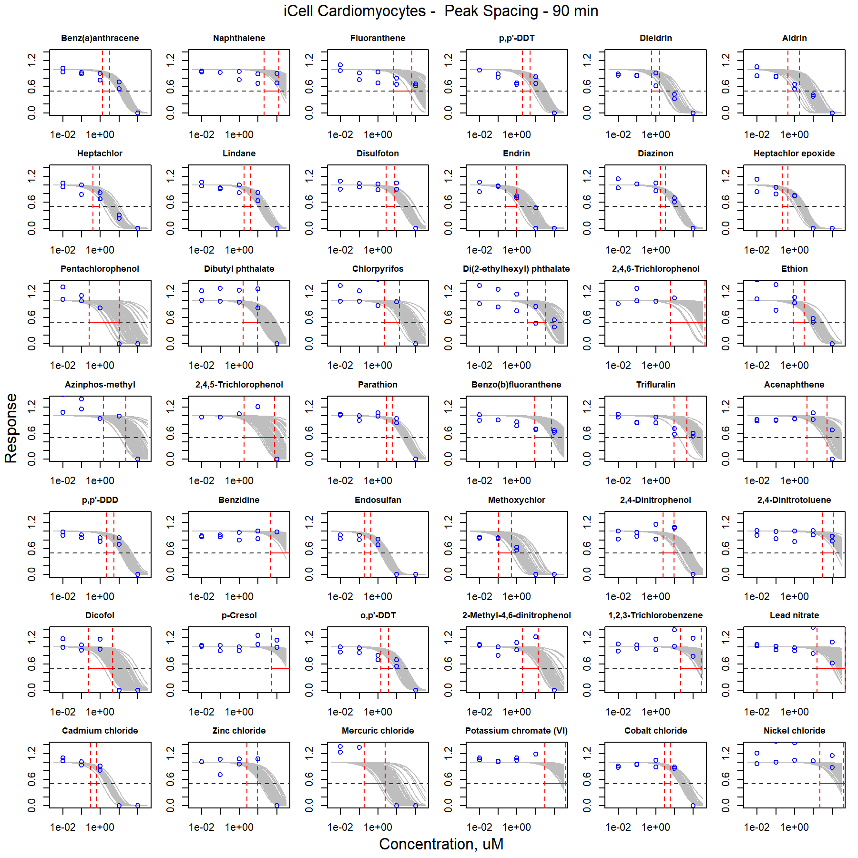

Figure S43. Curve-fitting of single chemical concentration and observed response (Peak Spacing - 90 min) in iCell Cardiomyocytes.

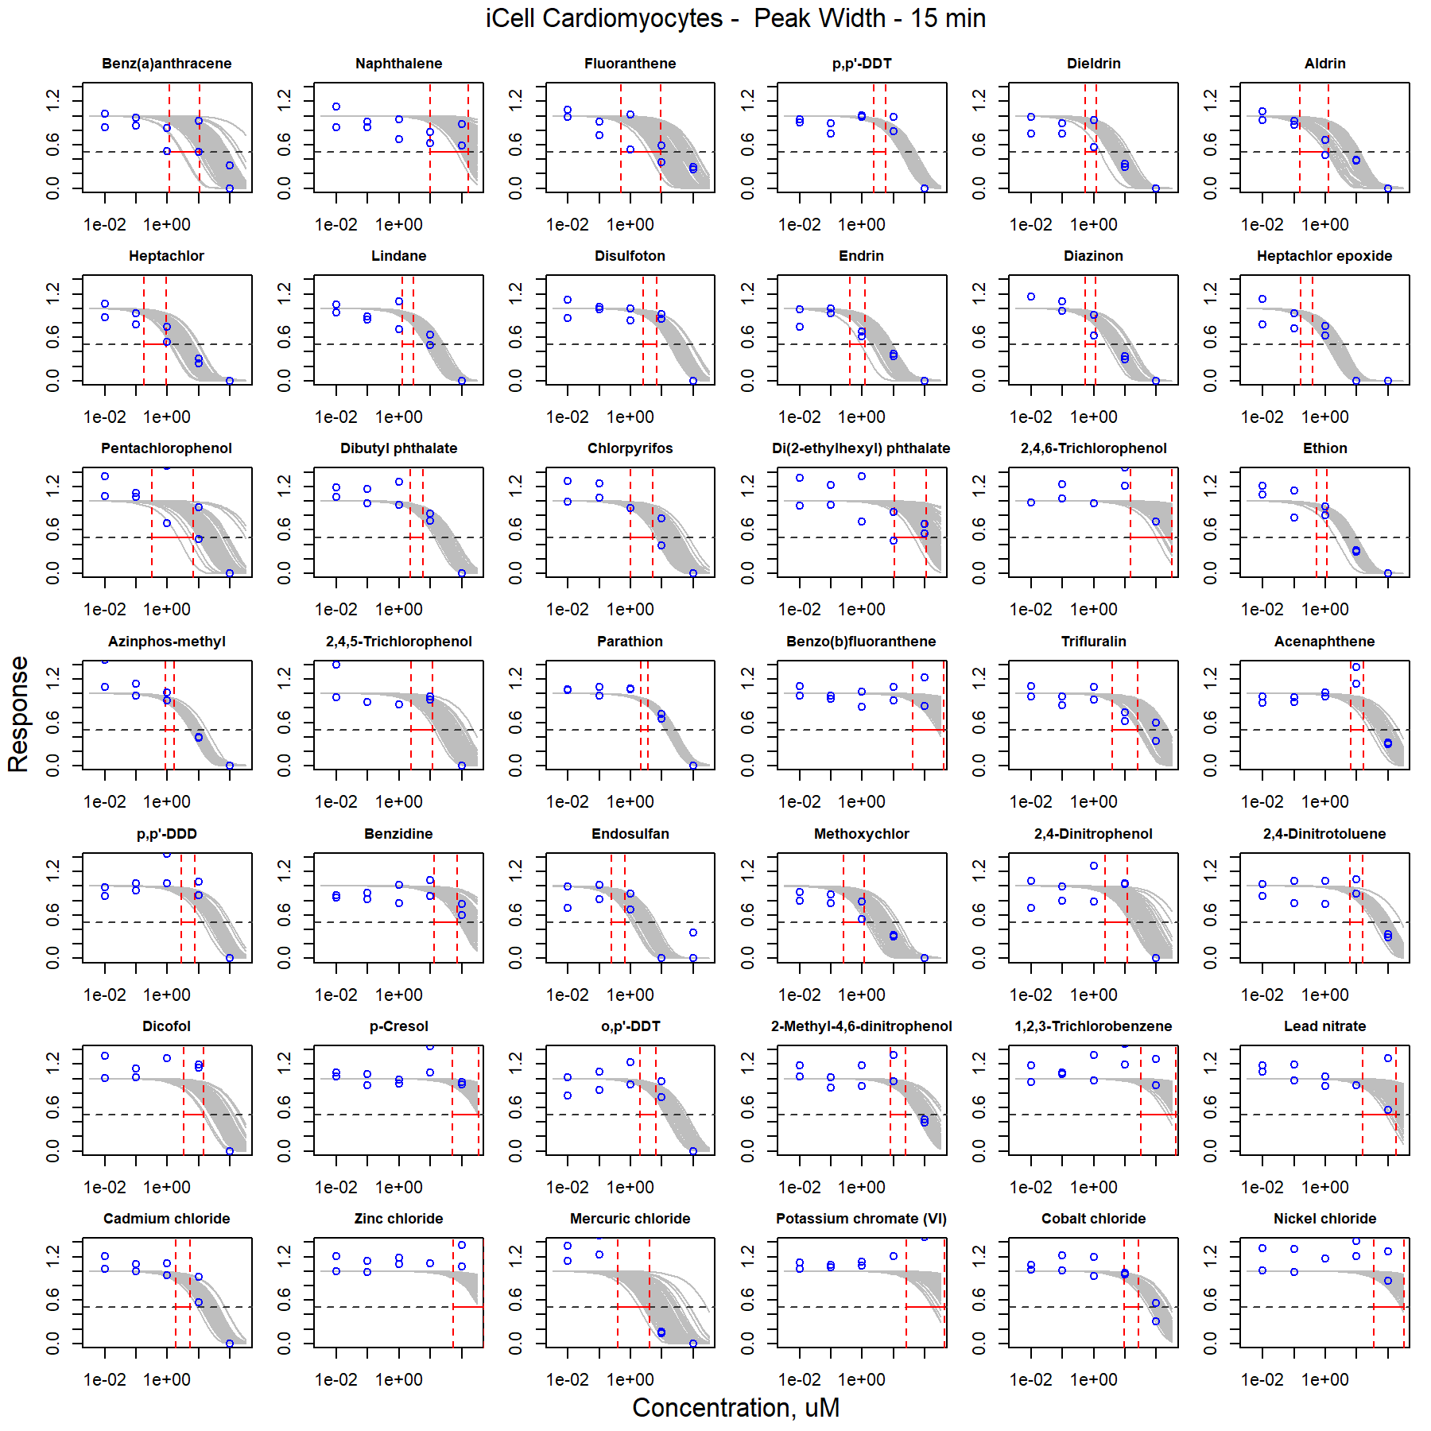

Figure S44. Curve-fitting of single chemical concentration and observed response (Peak Width - 15 min) in iCell Cardiomyocytes.

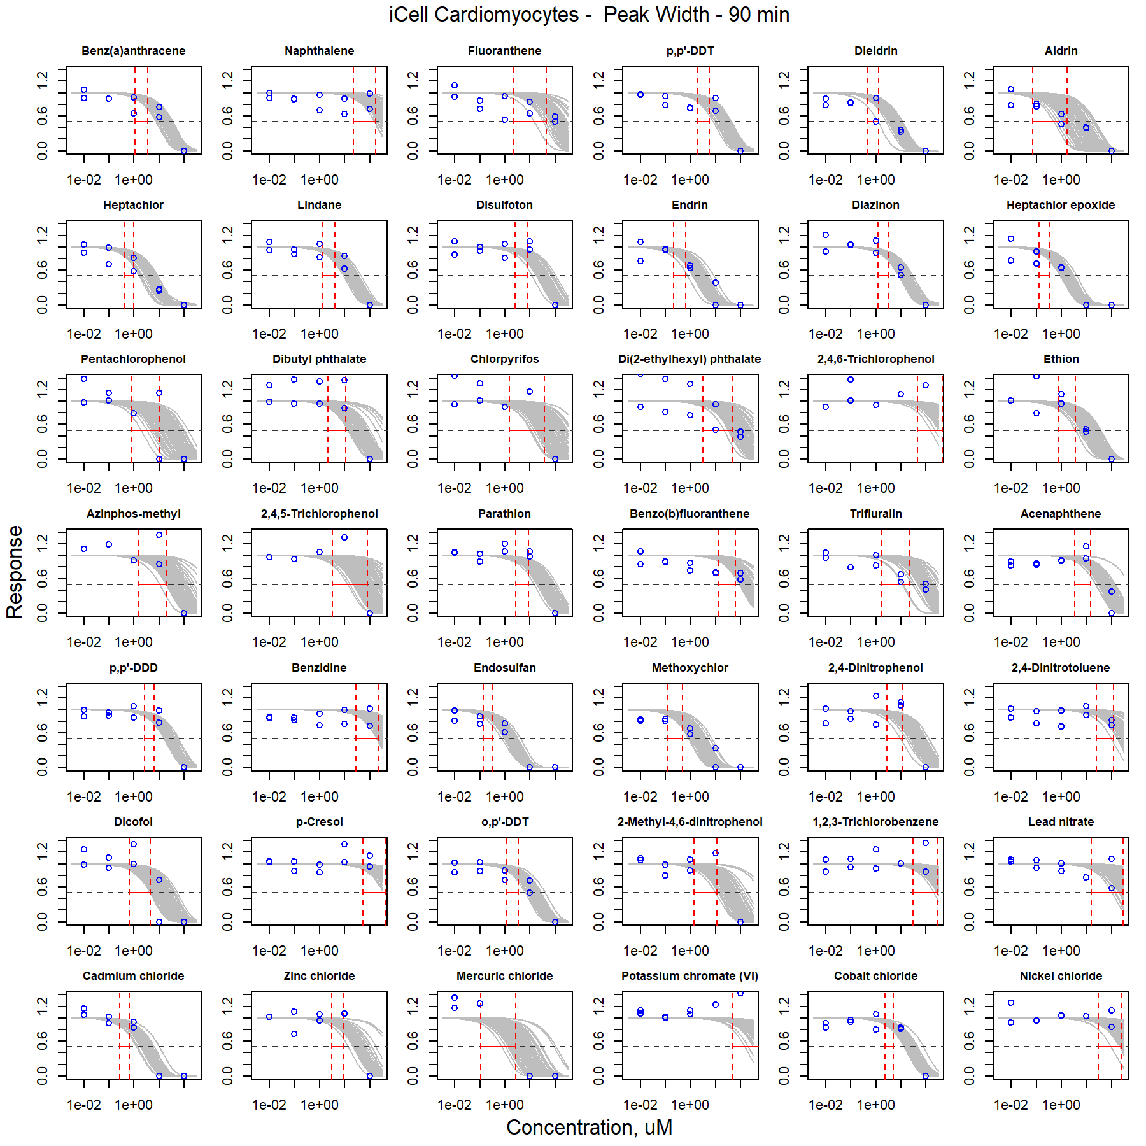

Figure S45. Curve-fitting of single chemical concentration and observed response (Peak Width - 90 min) in iCell Cardiomyocytes.

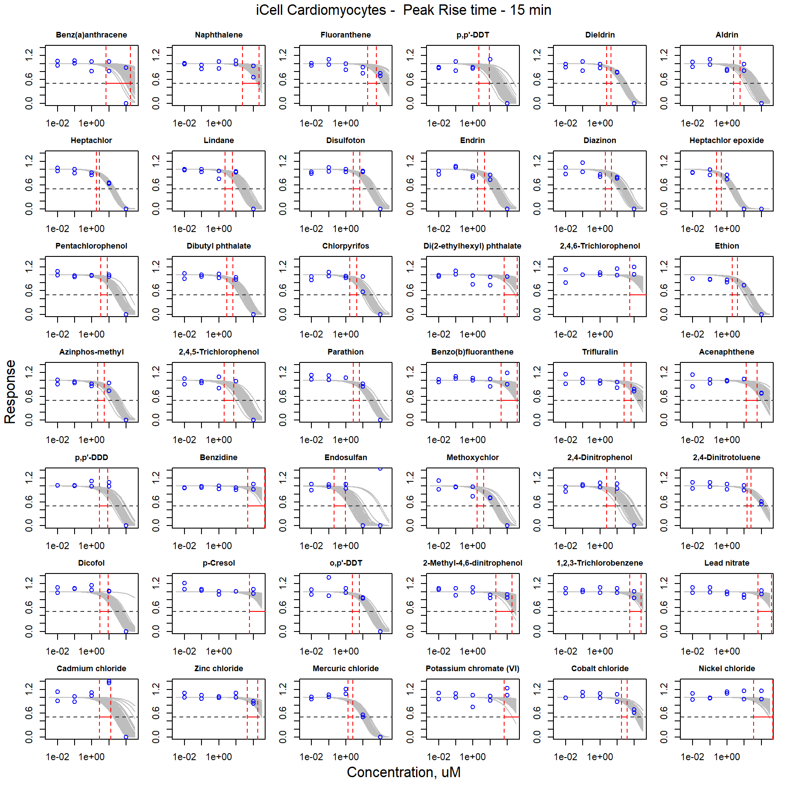

Figure S46. Curve-fitting of single chemical concentration and observed response (Peak Rise time - 15 min) in iCell Cardiomyocytes.

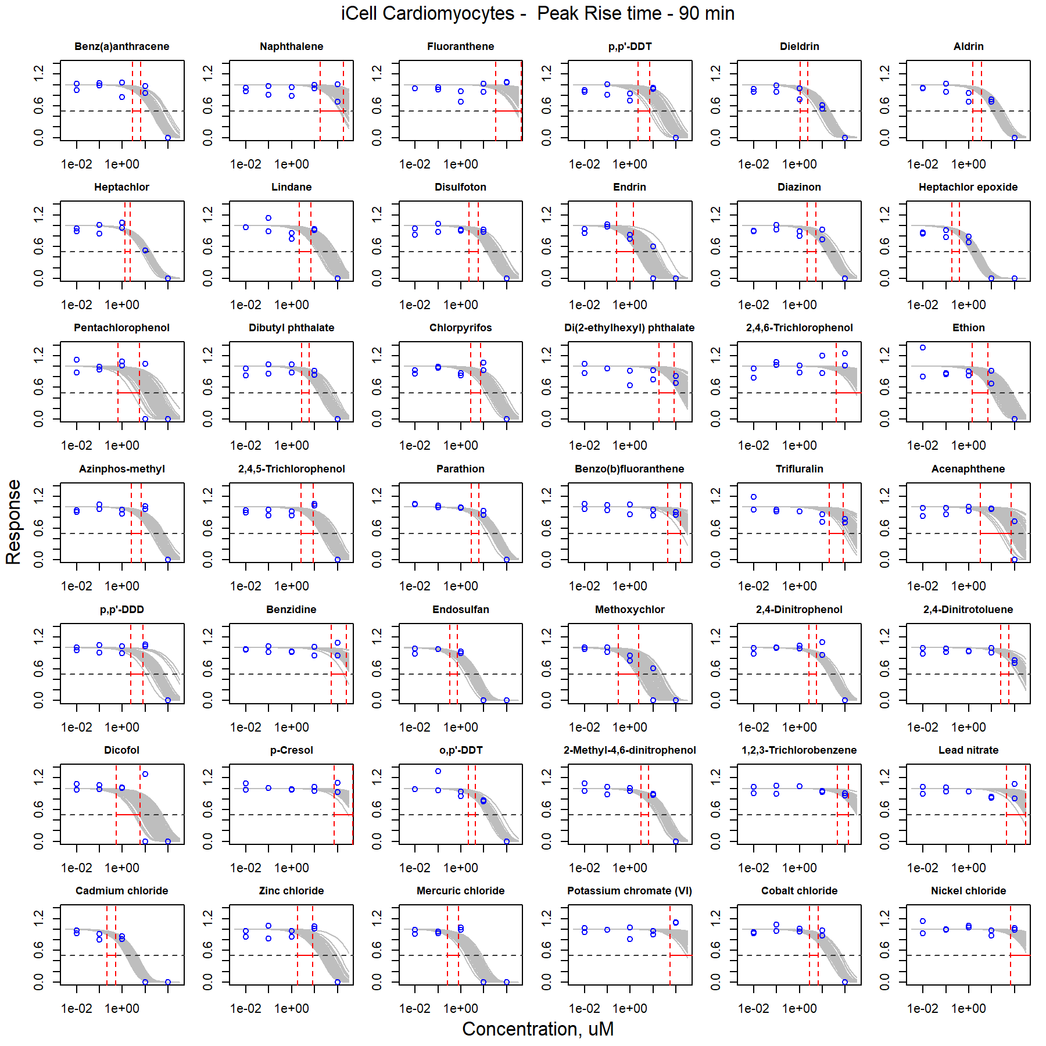

Figure S47. Curve-fitting of single chemical concentration and observed response (Peak Rise time - 90 min) in iCell Cardiomyocytes.

## Curve-fitting of mixture concentration-respsonse

### iCell Neurons

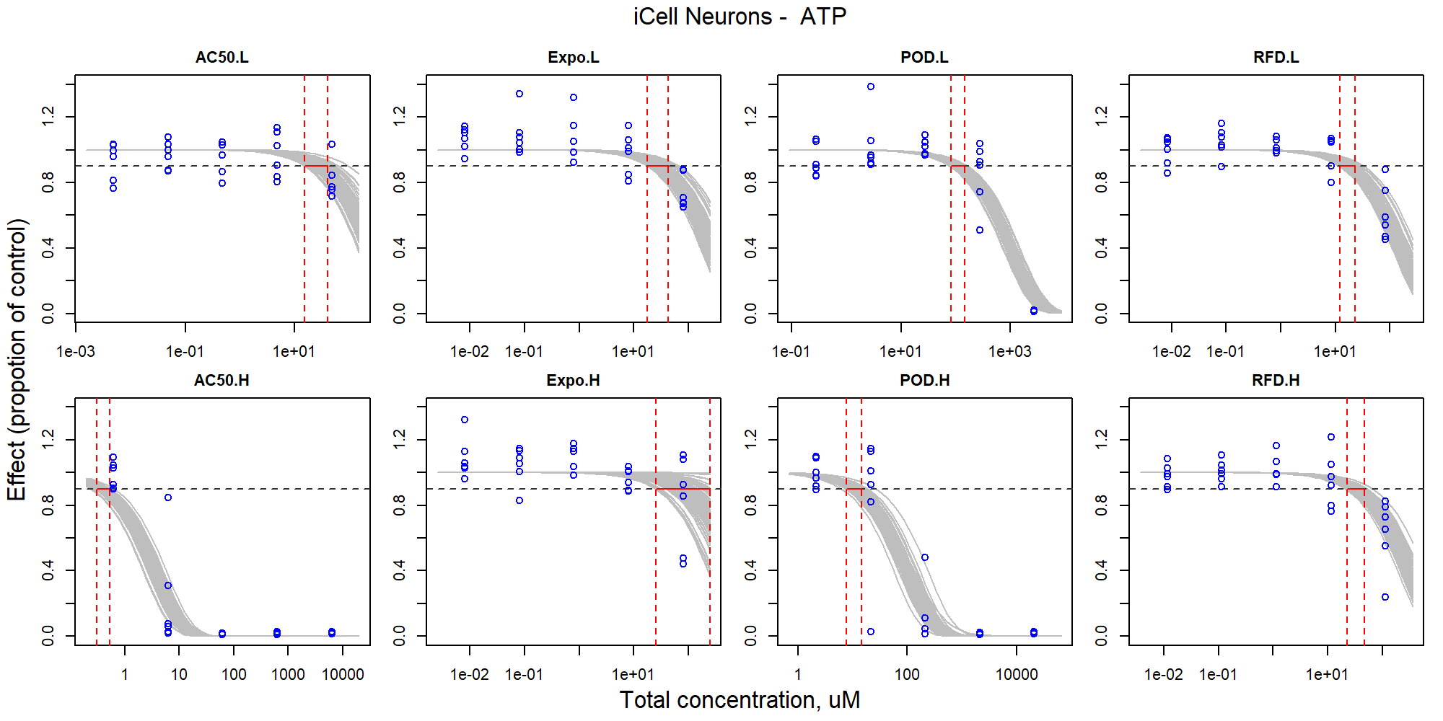

Figure S48. Curve-fitting of mixture concentration and observed response (ATP) in iCell Neurons.

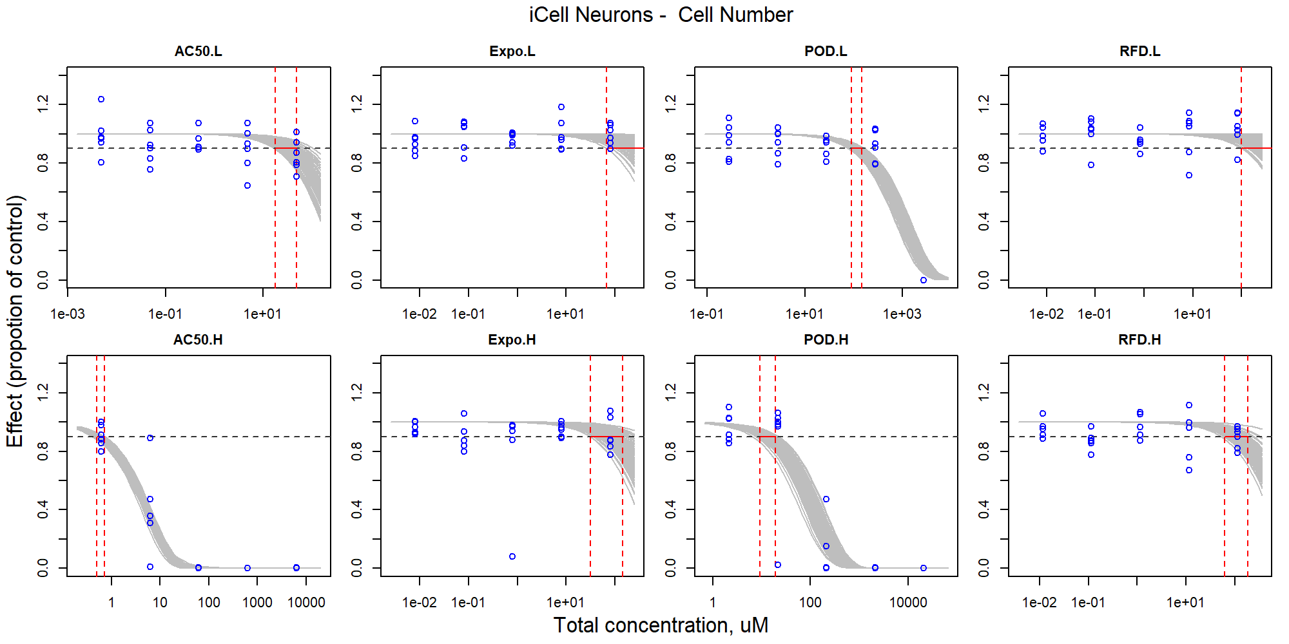

Figure S49. Curve-fitting of mixture concentration and observed response (Cell Number) in iCell Neurons.

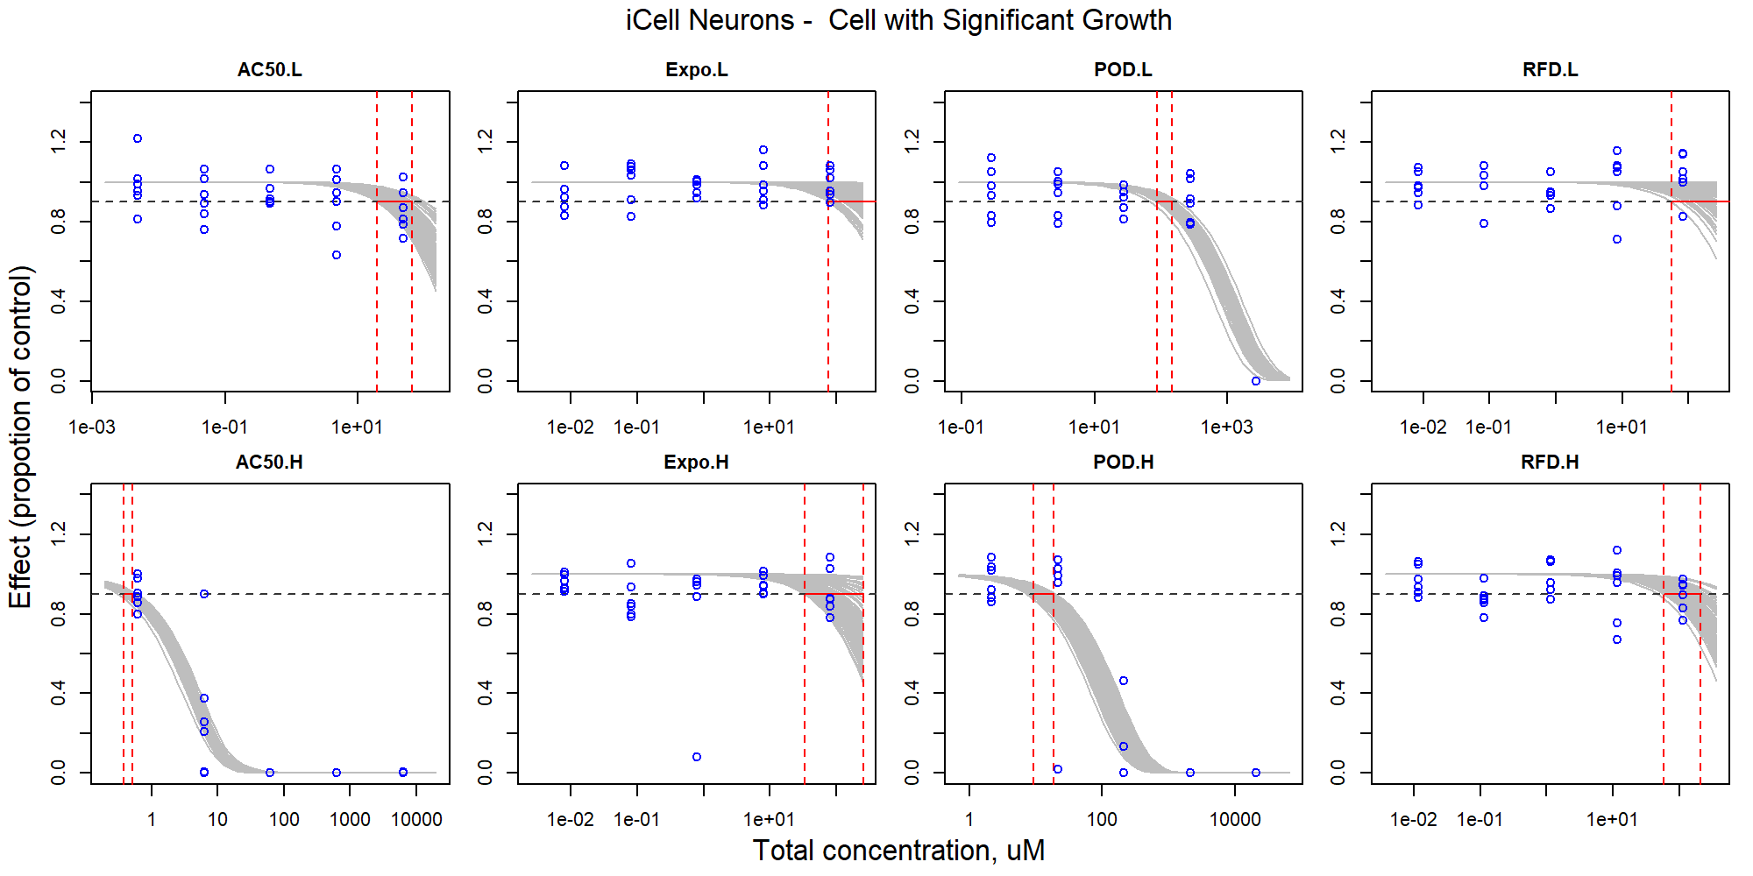

Figure S50. Curve-fitting of mixture concentration and observed response (Cell with Significant Growth) in iCell Neurons.

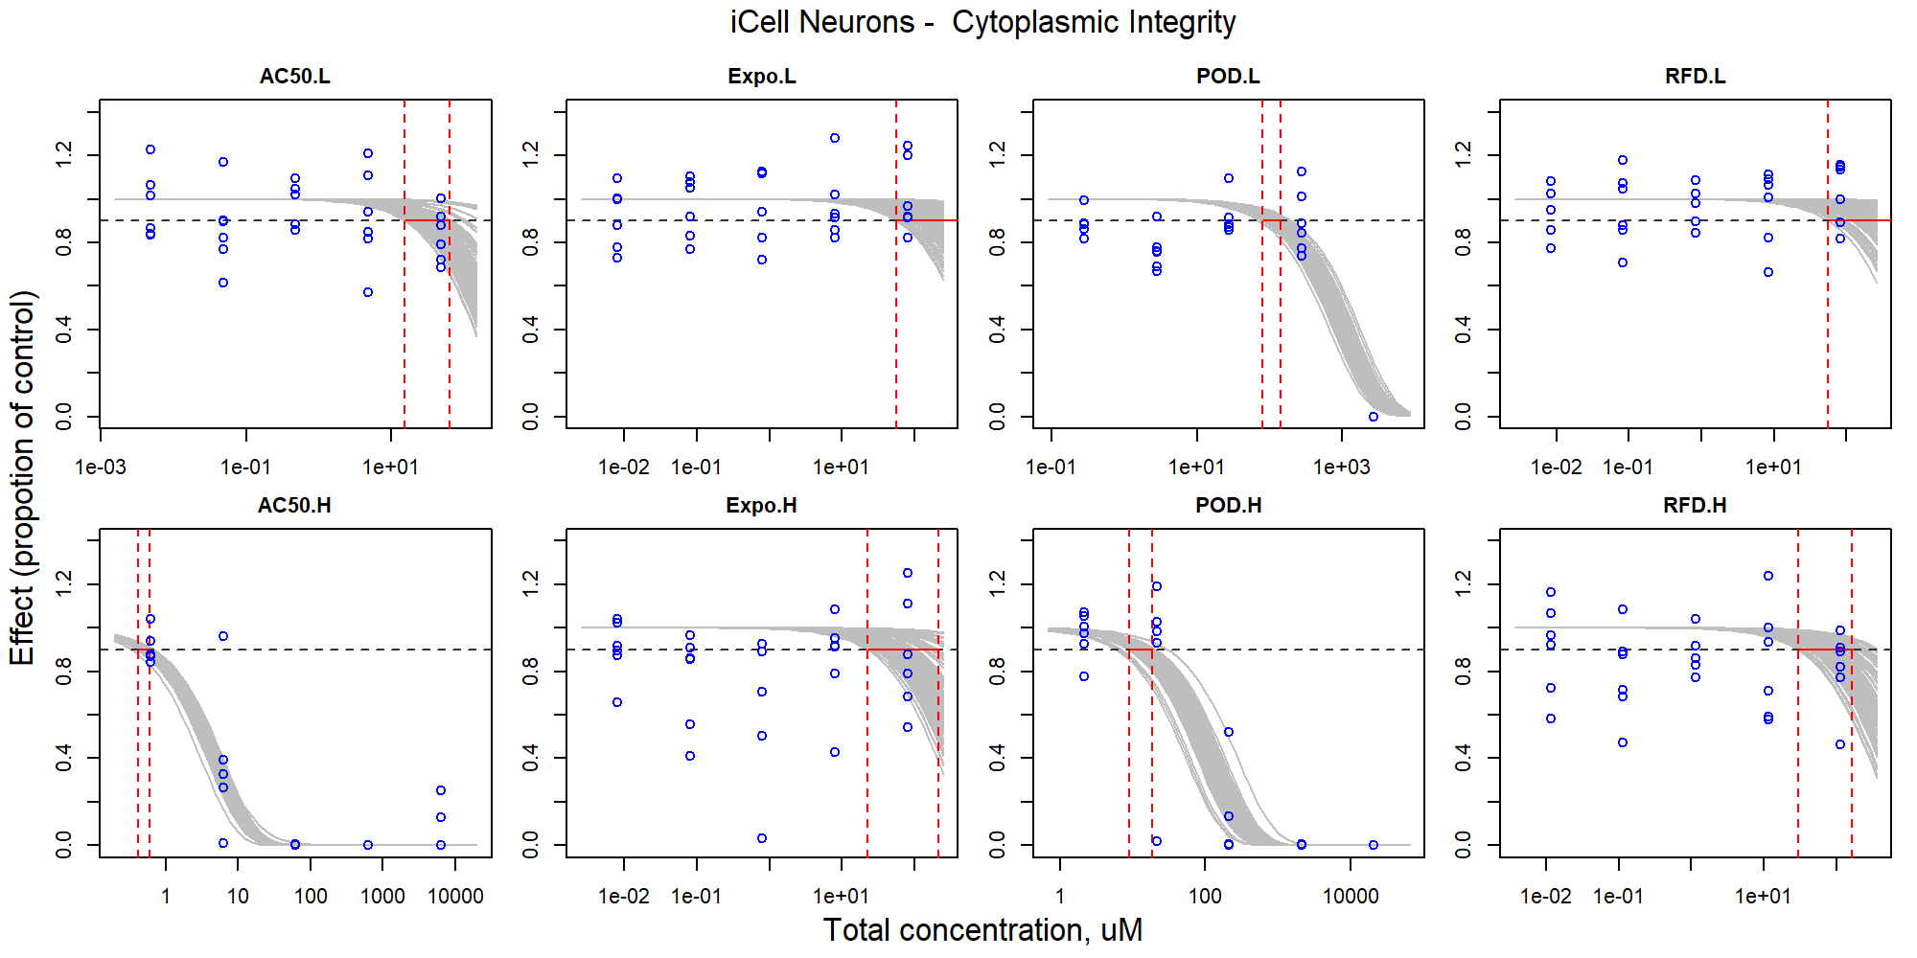

Figure S51. Curve-fitting of mixture concentration and observed response (Cytoplasmic Integrity) in iCell Neurons.

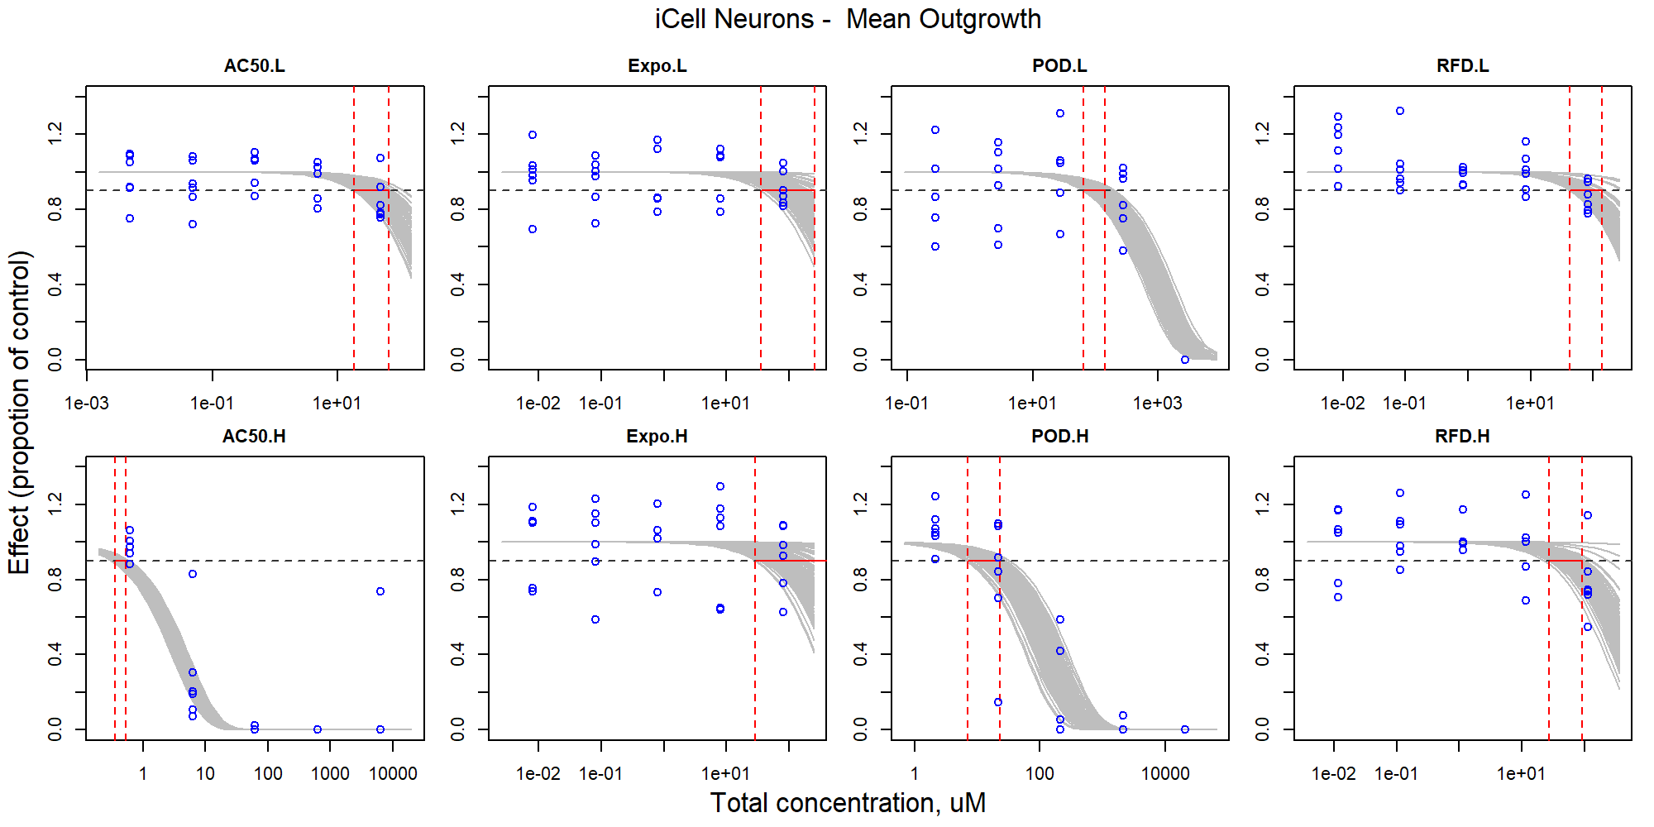

Figure S52. Curve-fitting of mixture concentration and observed response (Mean Outgrowth) in iCell Neurons.

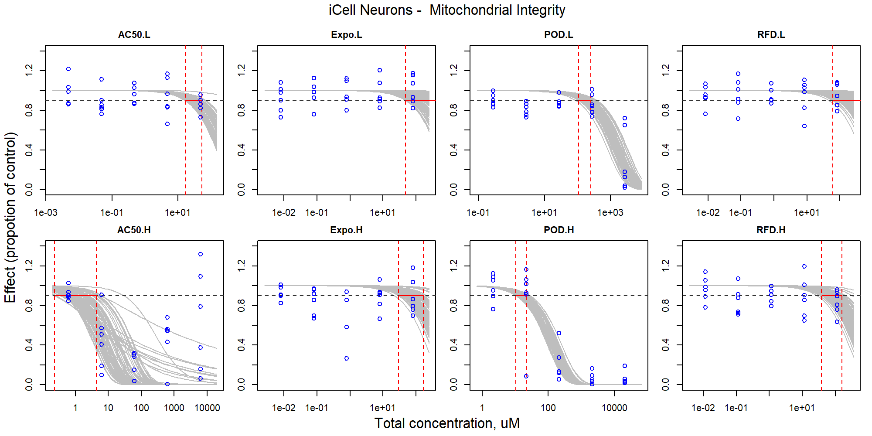

Figure S53. Curve-fitting of mixture concentration and observed response (Mitochondrial Integrity) in iCell Neurons.

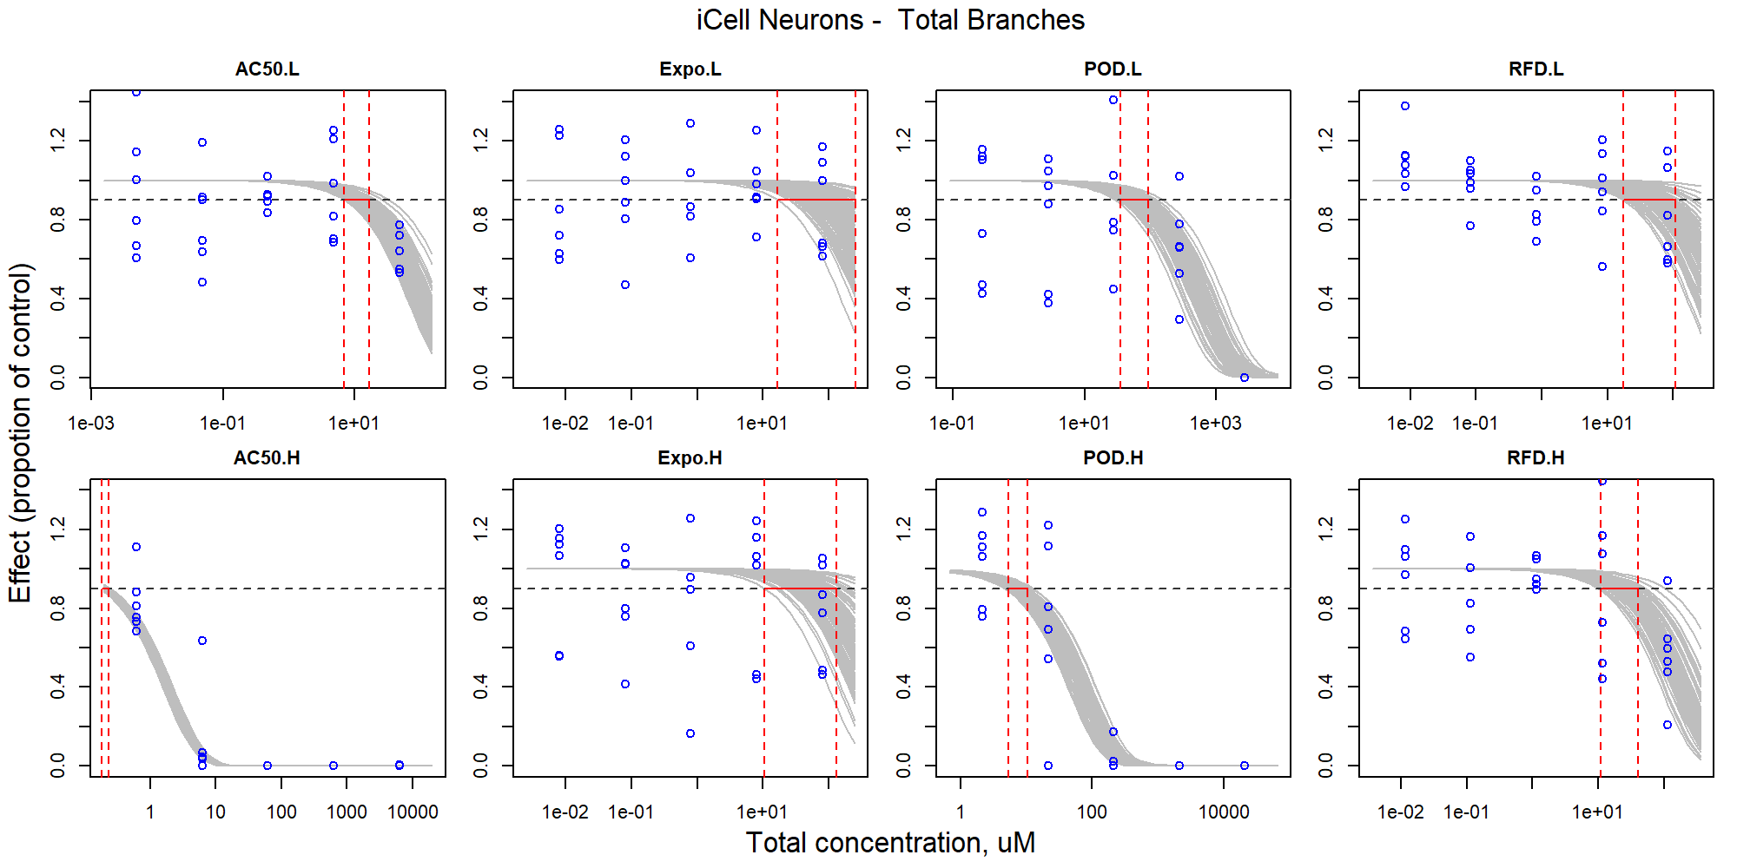

Figure S54. Curve-fitting of mixture concentration and observed response (Total Branches) in iCell Neurons.

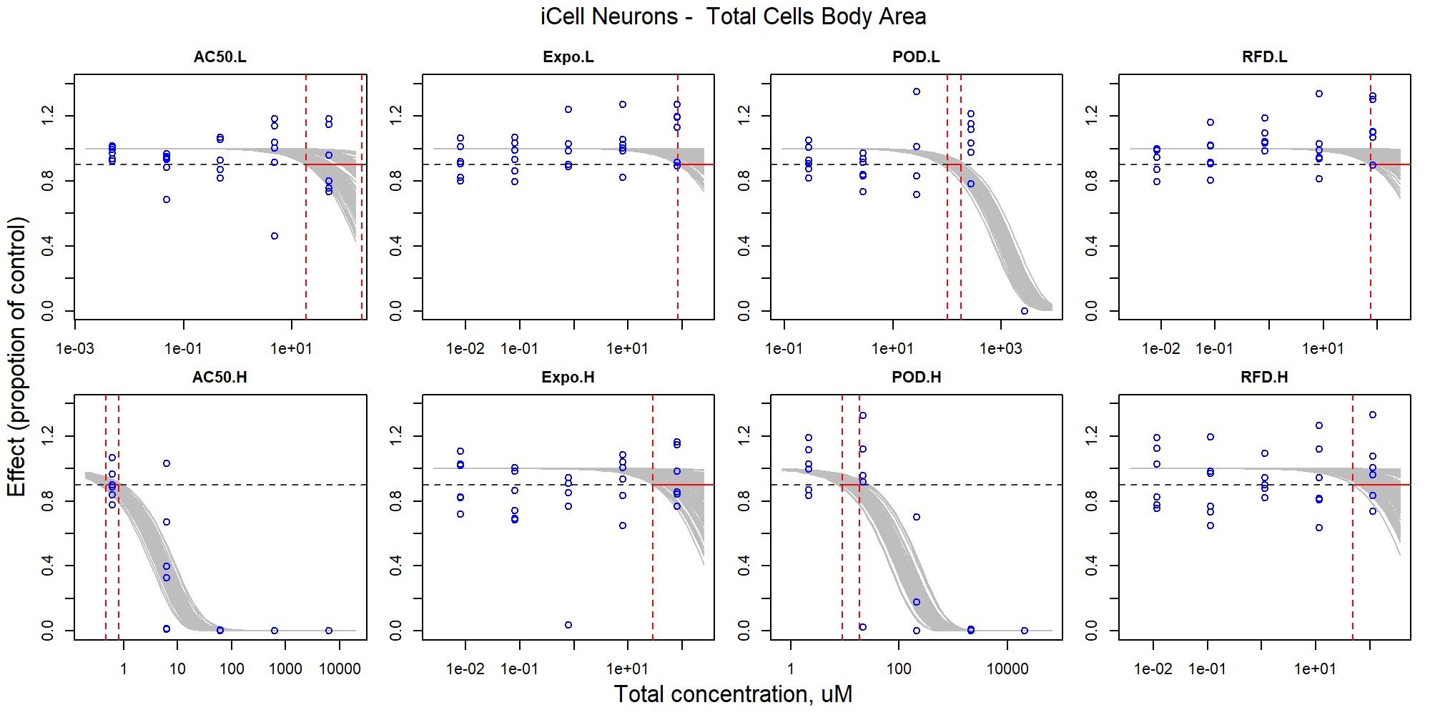

Figure S55. Curve-fitting of mixture concentration and observed response (Total Cells Body Area) in iCell Neurons.

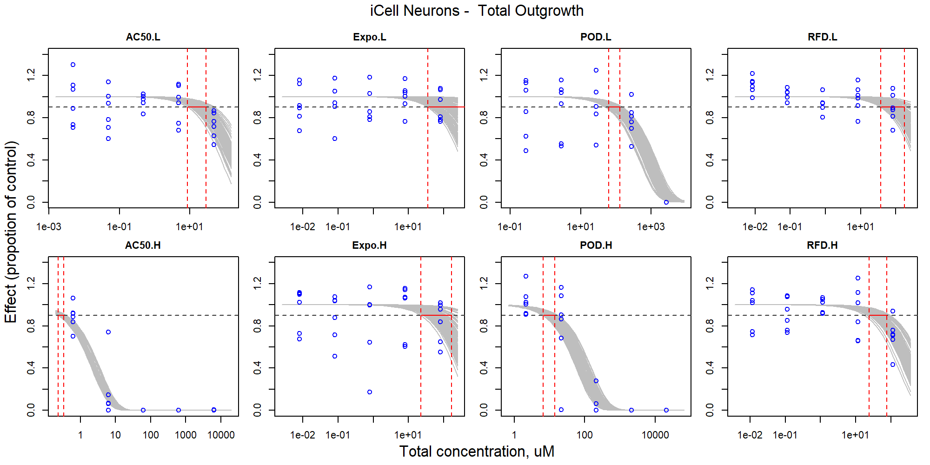

Figure S56. Curve-fitting of mixture concentration and observed response (Total Outgrowth) in iCell Neurons.

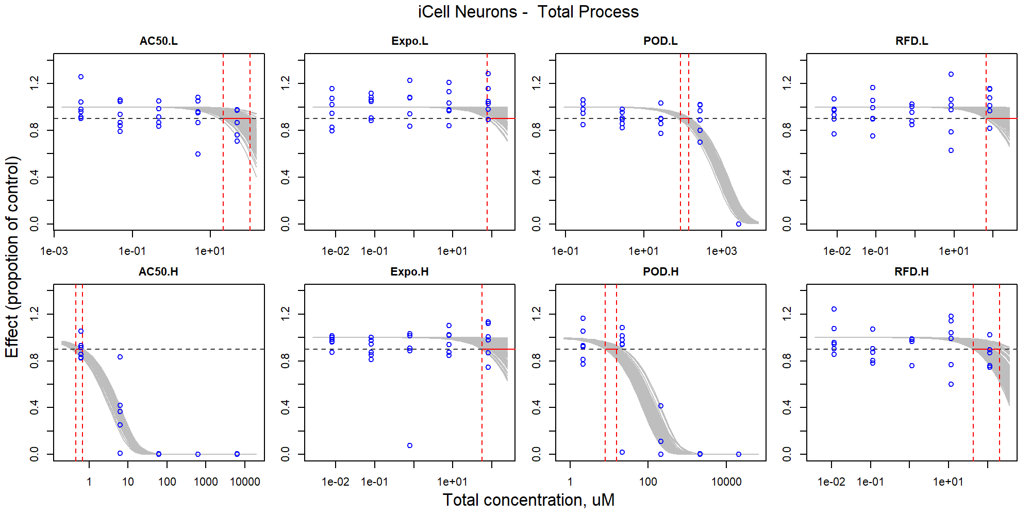

Figure S57. Curve-fitting of mixture concentration and observed response (Total Process) in iCell Neurons.

### HUVECs

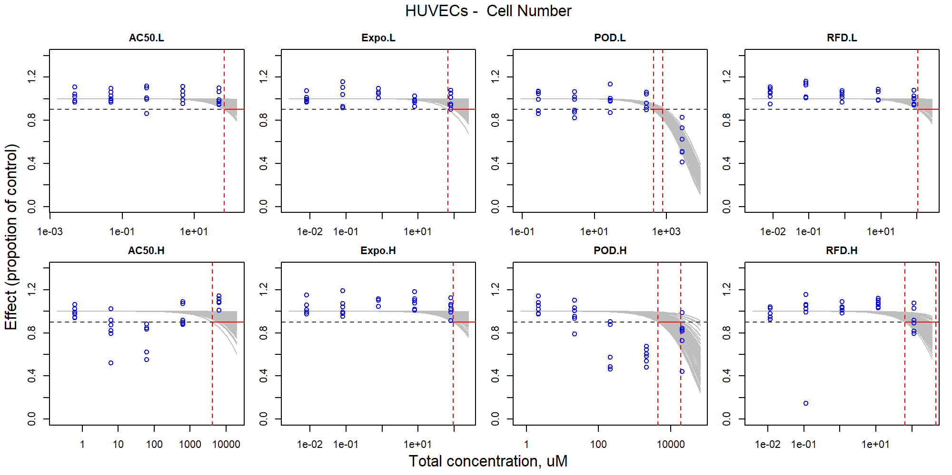

Figure S58. Curve-fitting of mixture concentration and observed response (Cell Number) in HUVECs.

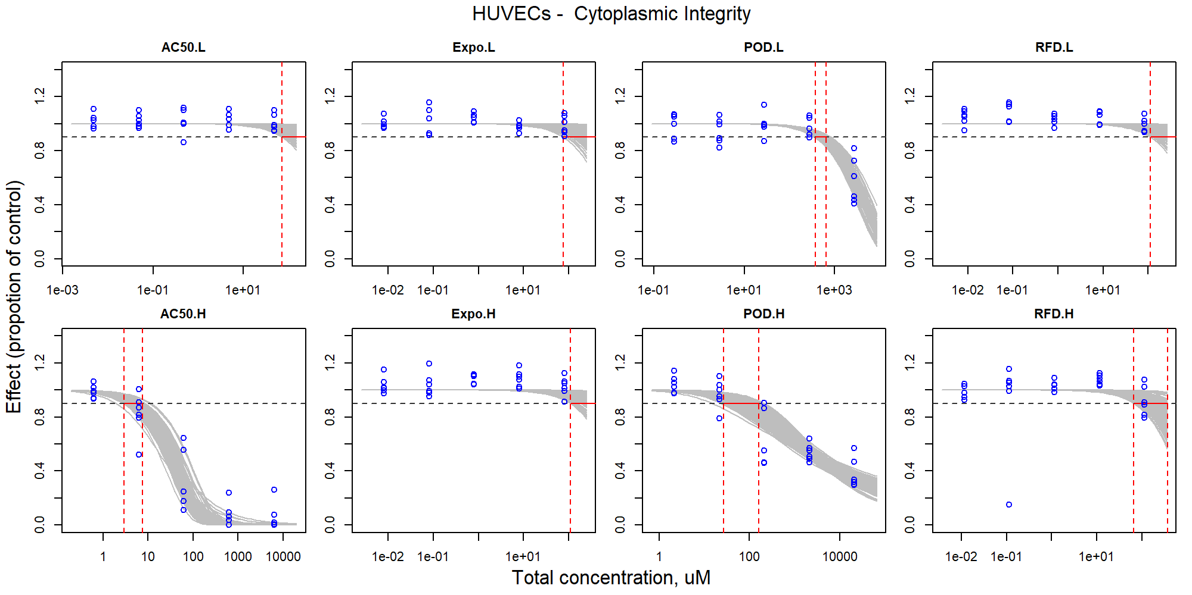

Figure S59. Curve-fitting of mixture concentration and observed response (Cytoplasmic Integrity) in HUVECs.

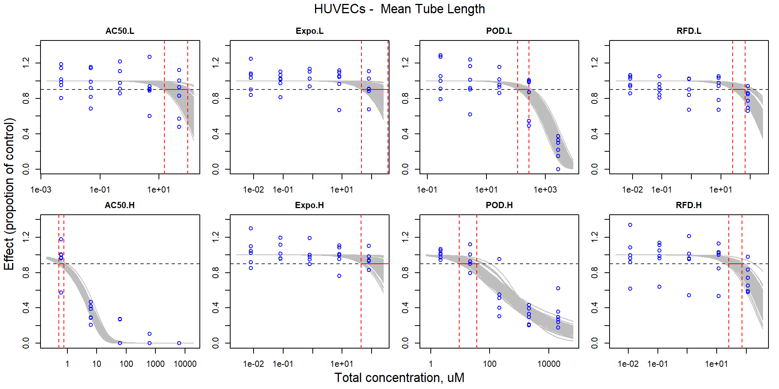

Figure S60. Curve-fitting of mixture concentration and observed response (Mean Tube Length) in HUVECs.

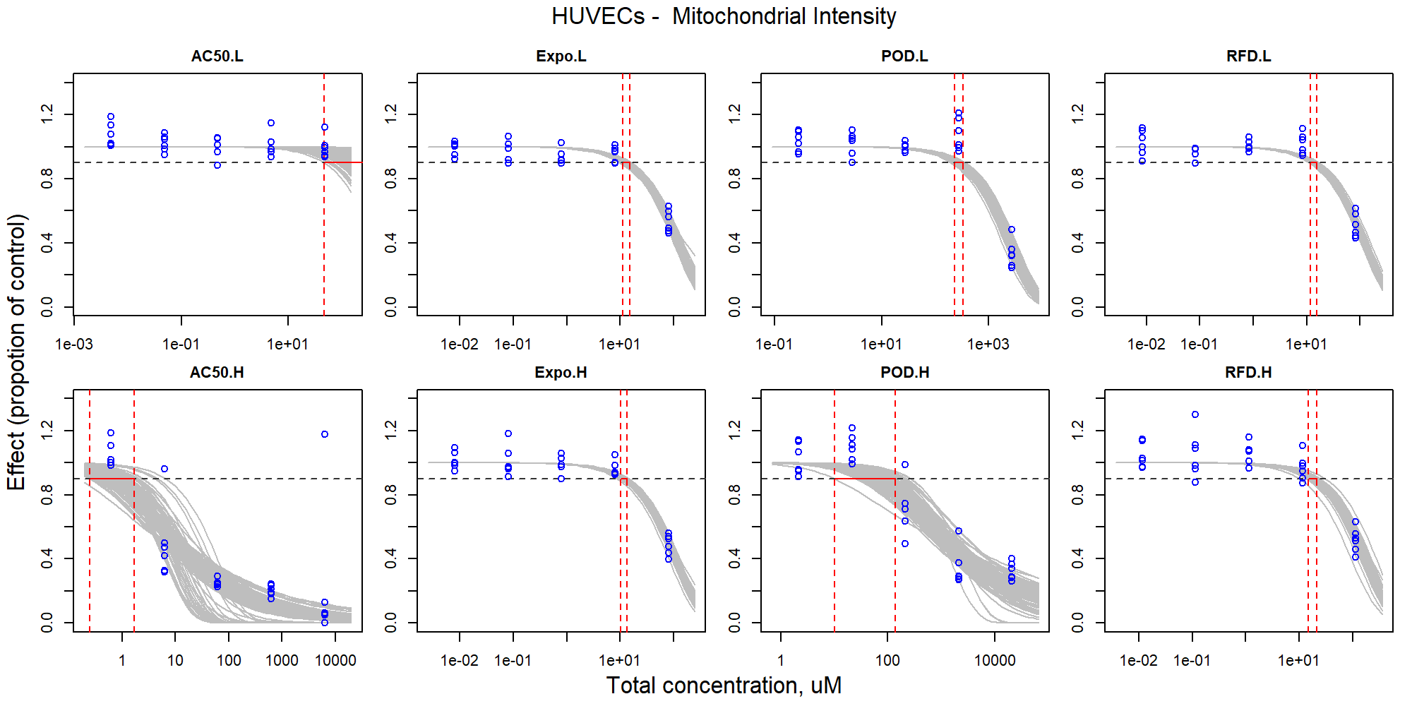

Figure S61. Curve-fitting of mixture concentration and observed response (Mitochondrial Intensity) in HUVECs.

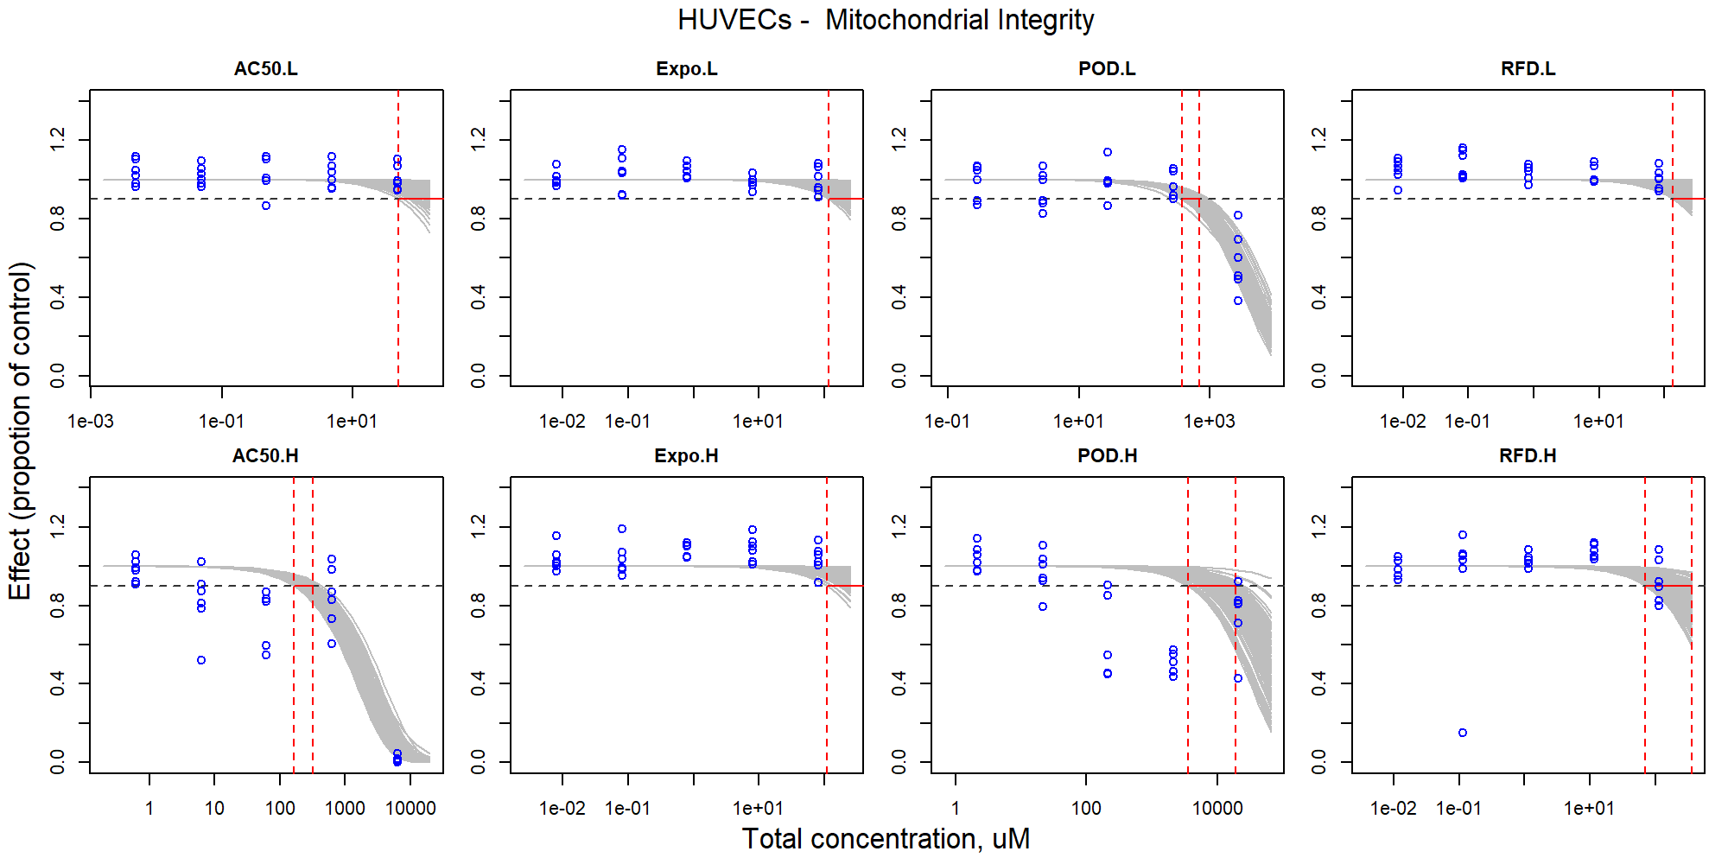

Figure S62. Curve-fitting of mixture concentration and observed response (Mitochondrial Integrity) in HUVECs.

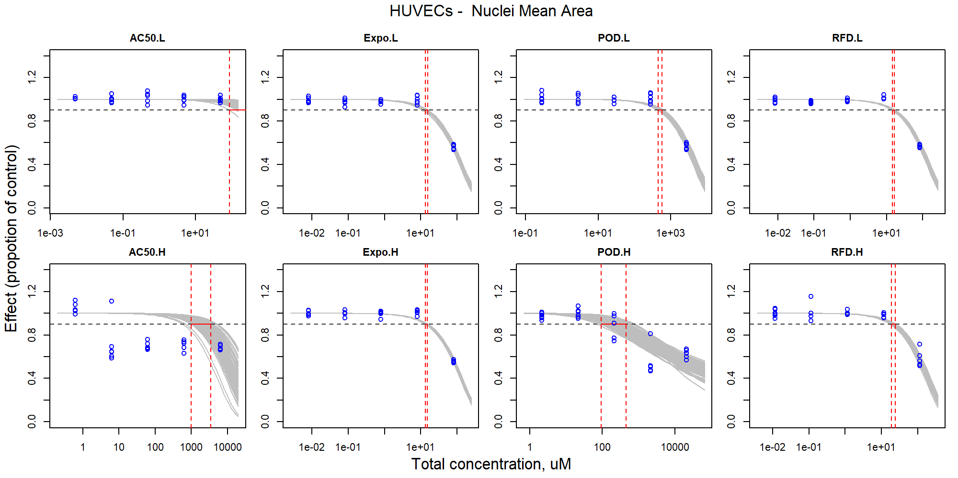

Figure S63. Curve-fitting of mixture concentration and observed response (Nuclei Mean Area) in HUVECs.

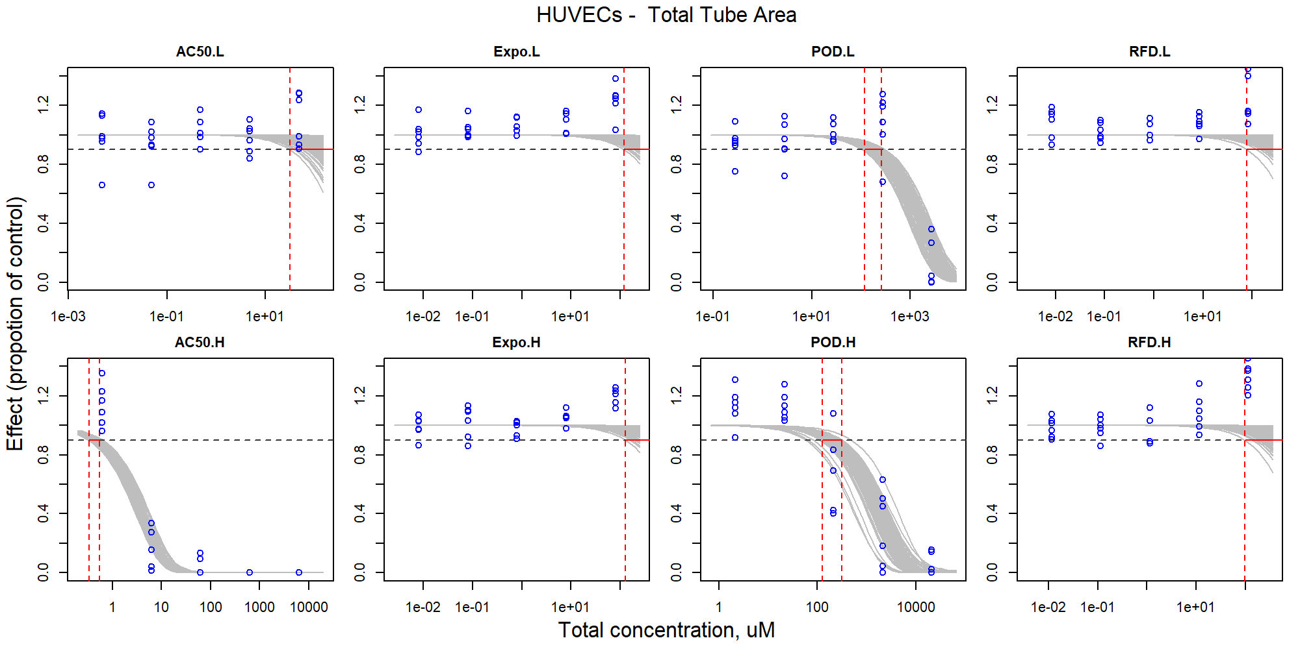

Figure S64. Curve-fitting of mixture concentration and observed response (Total Tube Area) in HUVECs.

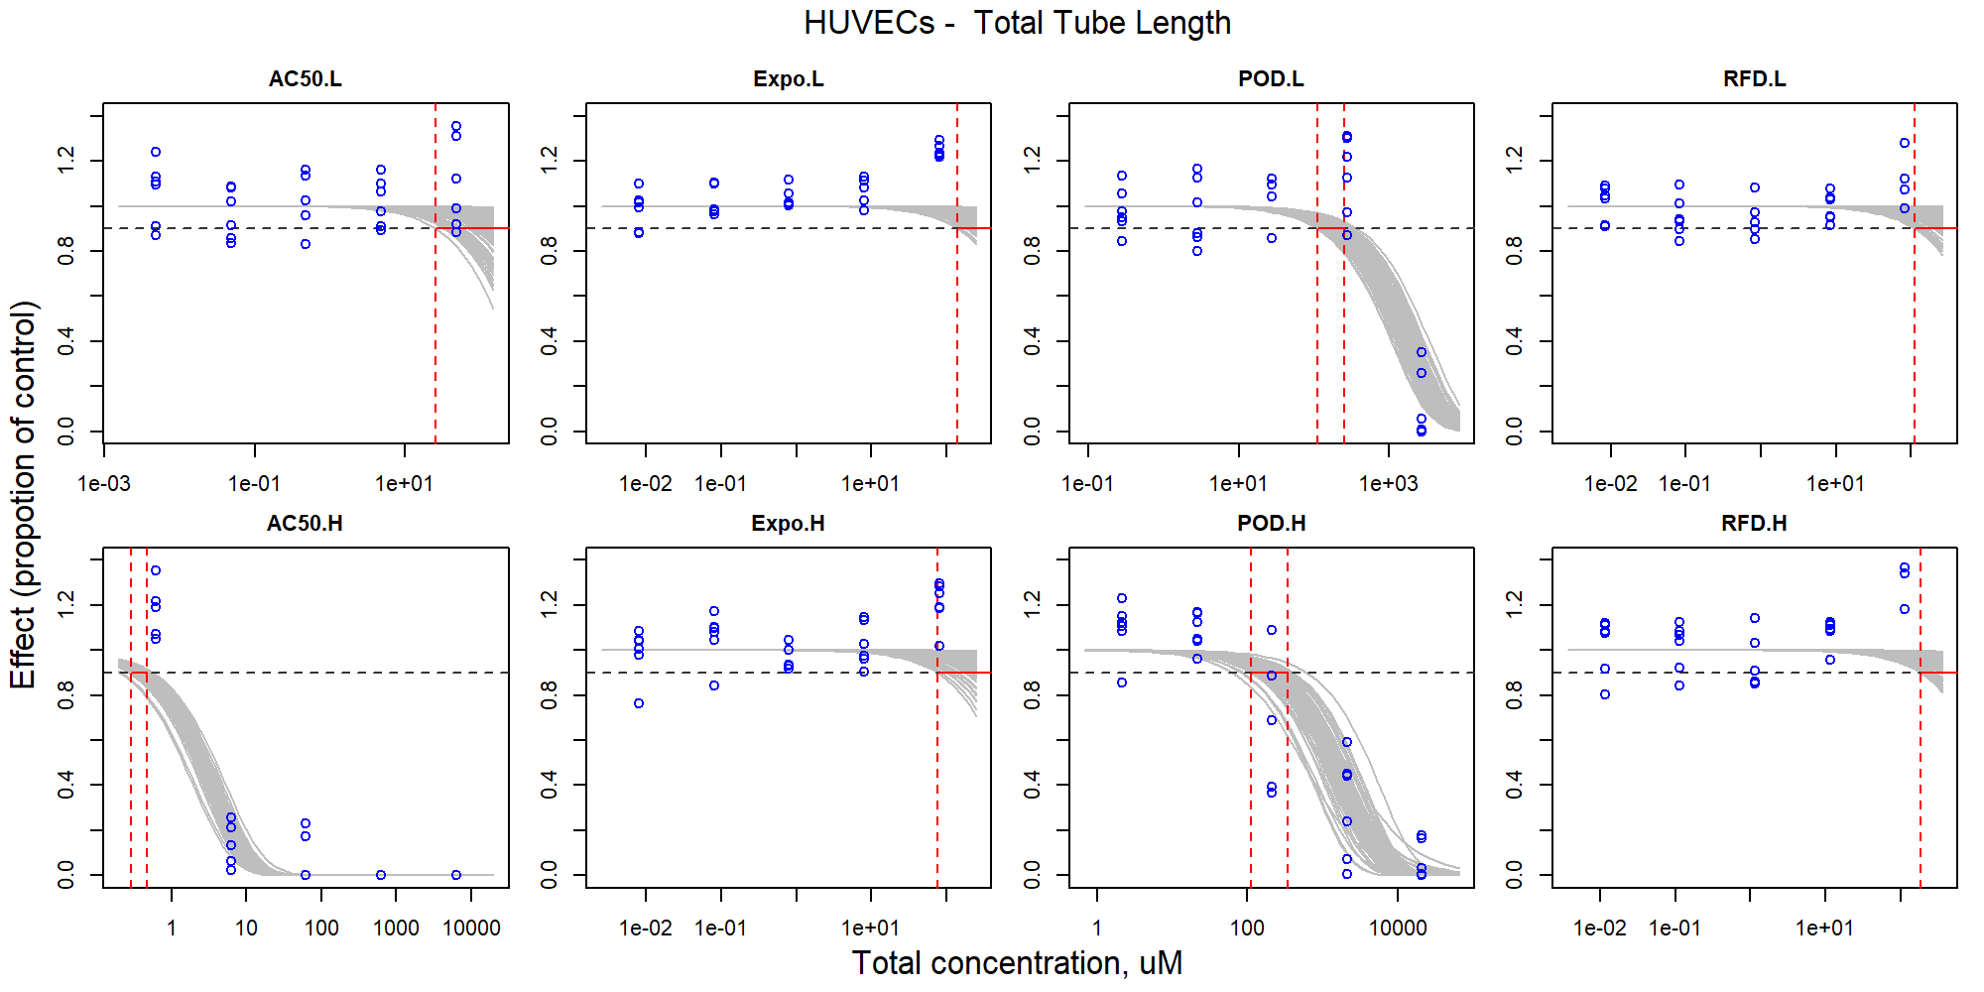

Figure S65. Curve-fitting of mixture concentration and observed response (Total Tube Length) in HUVECs.

### iCell Hepatocytes

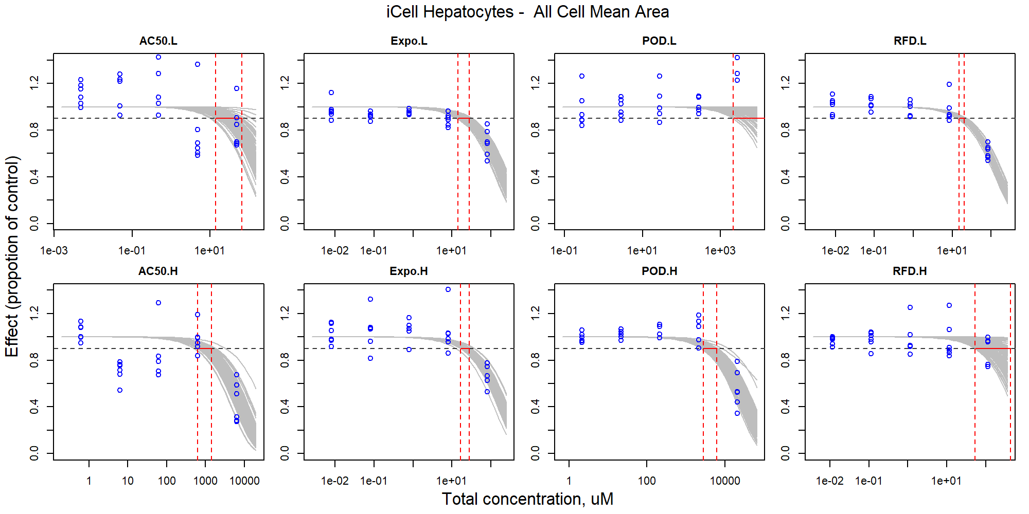

Figure S66. Curve-fitting of mixture concentration and observed response (All Cell Mean Area) in iCell Hepatocytes.

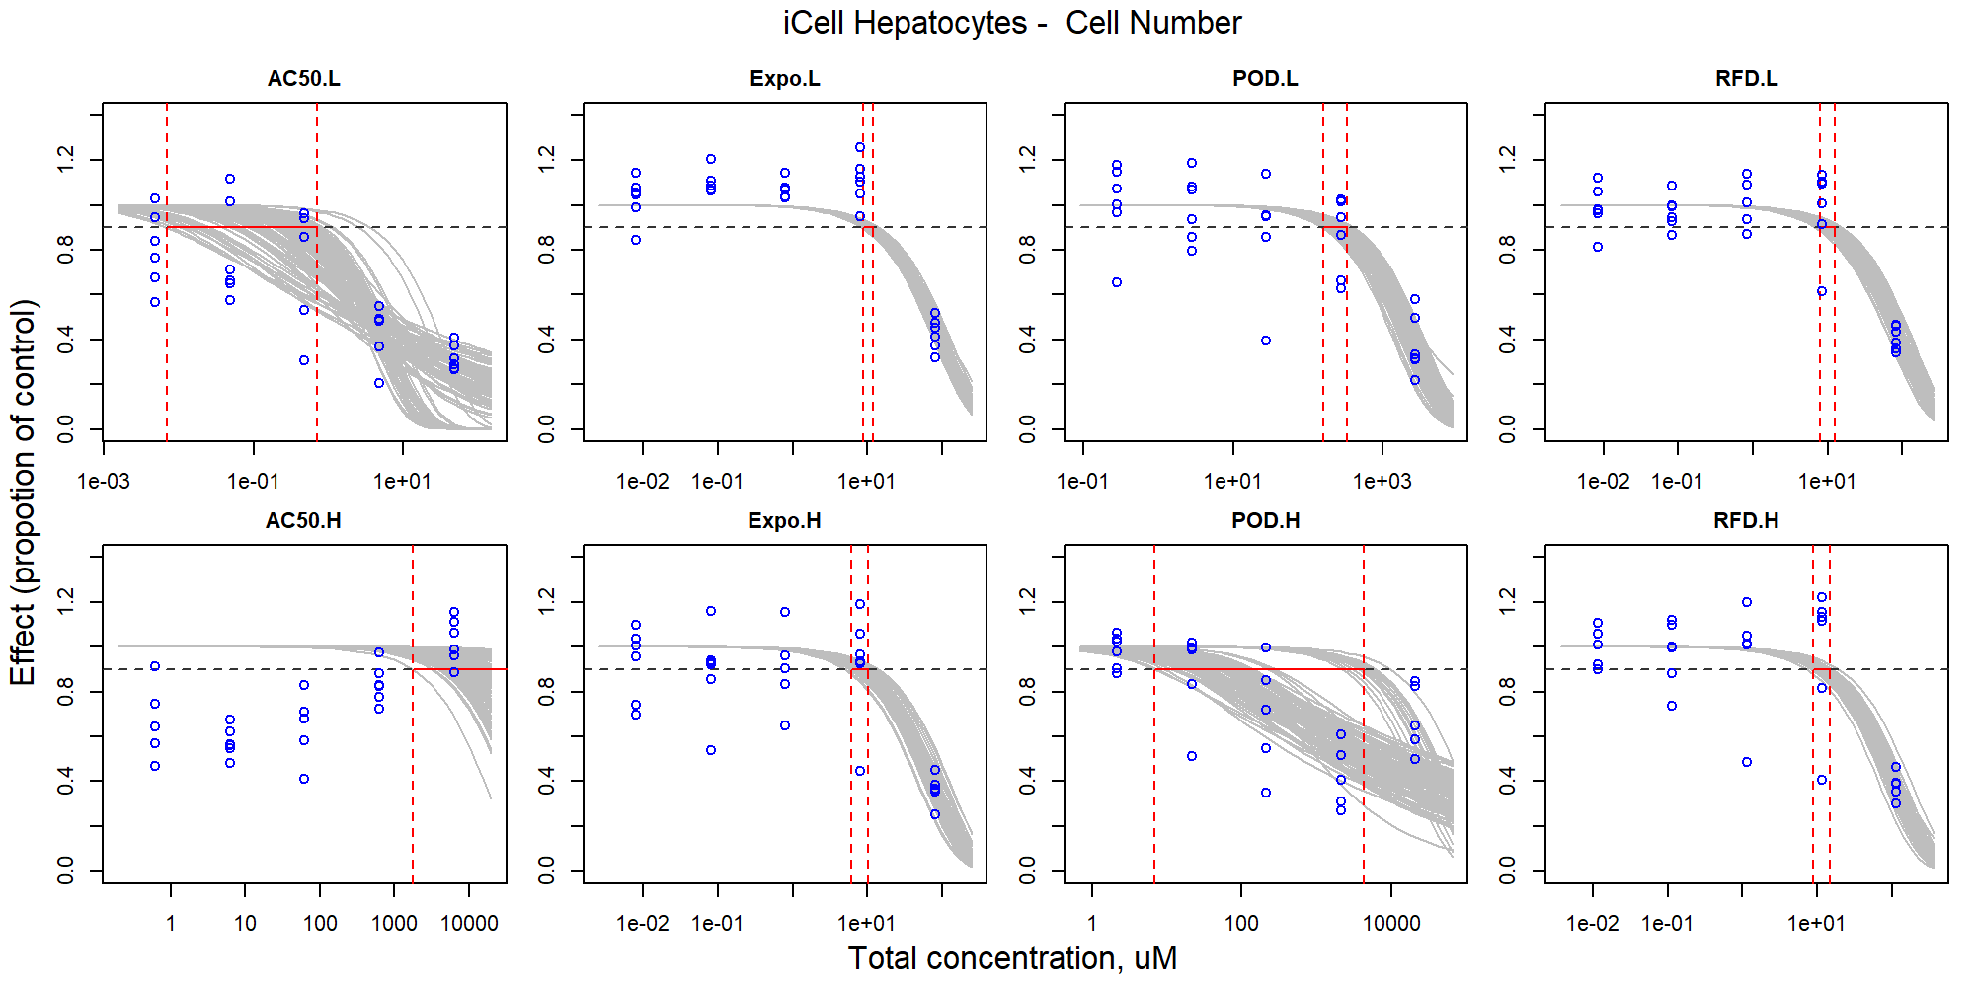

Figure S67. Curve-fitting of mixture concentration and observed response (Cell Number) in iCell Hepatocytes.

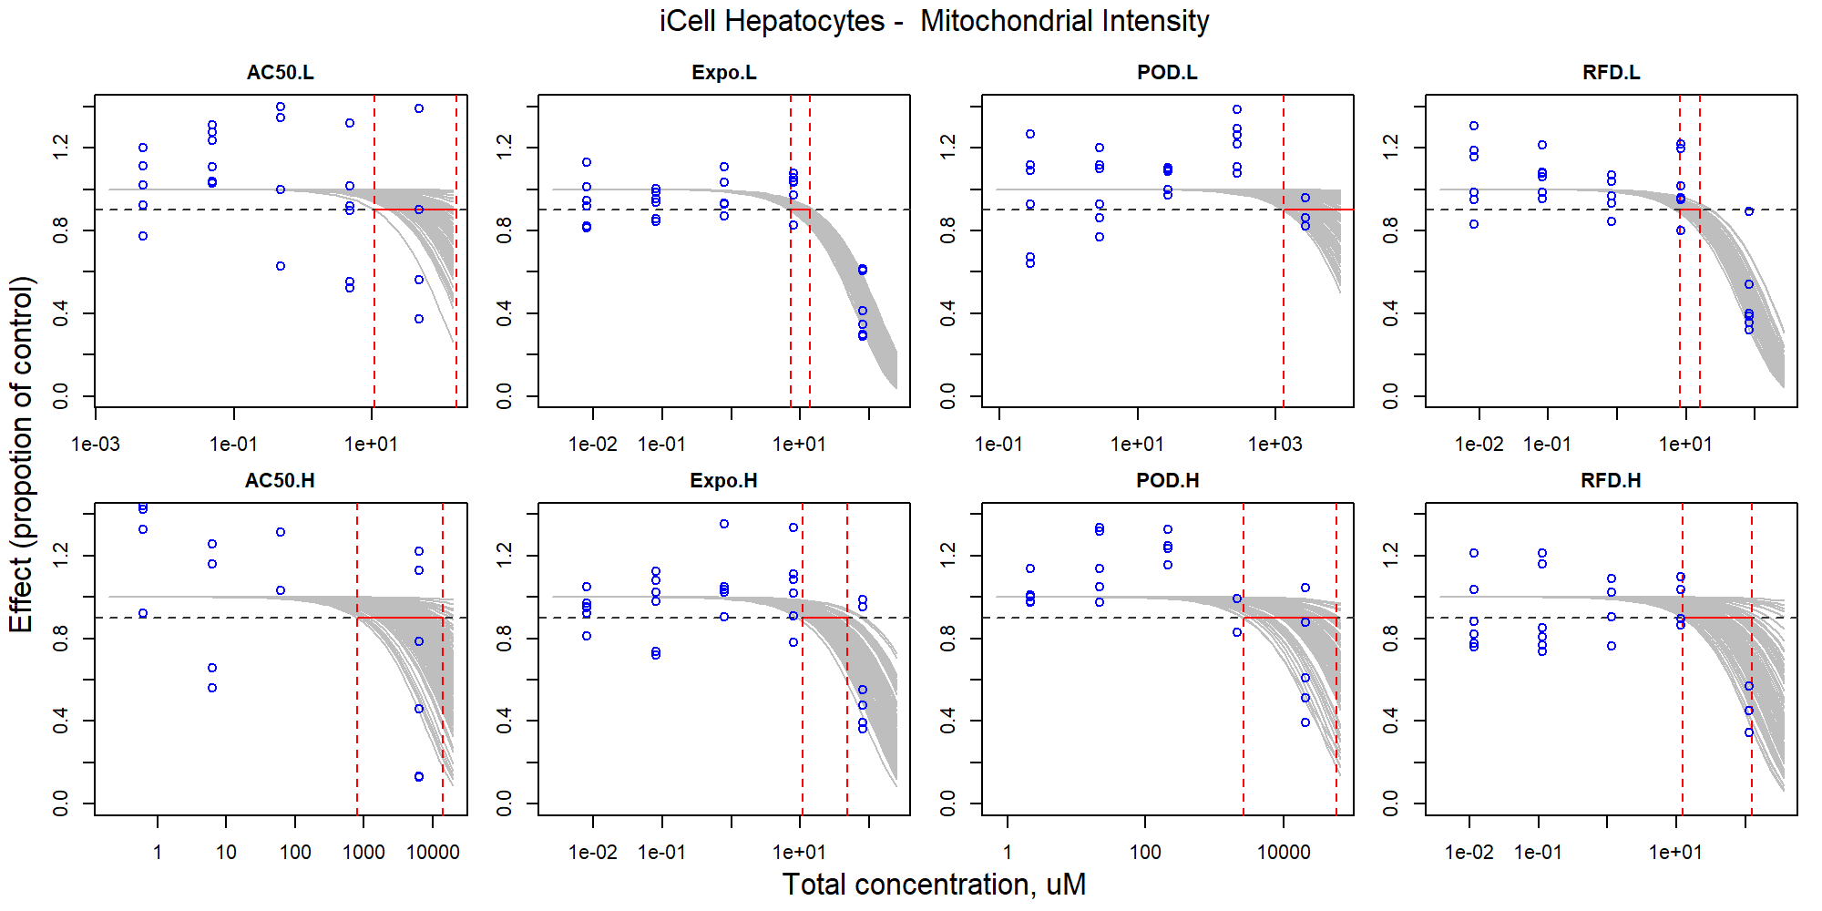

Figure S68. Curve-fitting of mixture concentration and observed response (Mitochondrial Intensity) in iCell Hepatocytes.

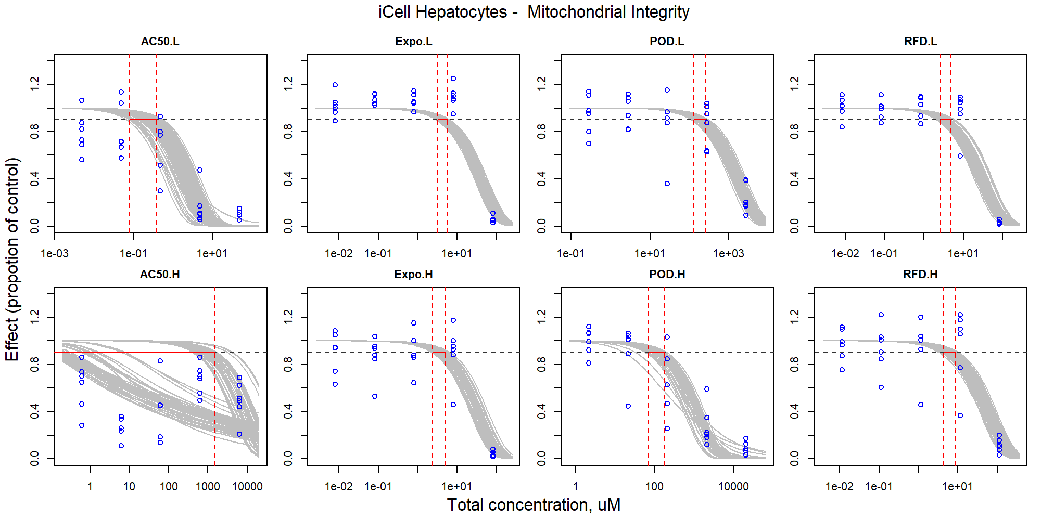

Figure S69. Curve-fitting of mixture concentration and observed response (Mitochondrial Integrity) in iCell Hepatocytes.

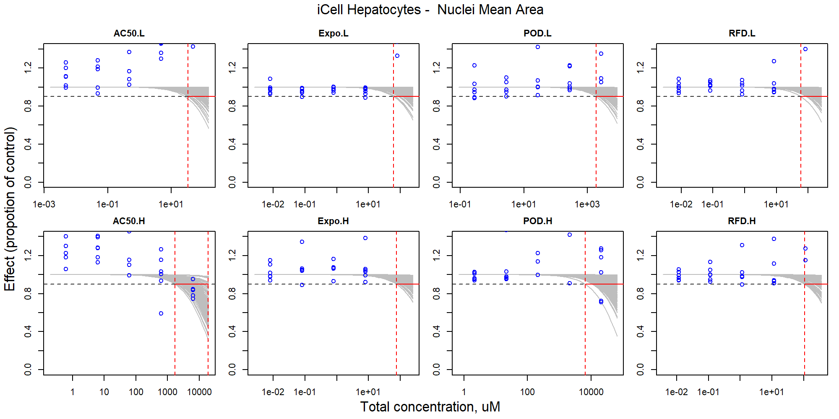

Figure S70. Curve-fitting of mixture concentration and observed response (Nuclei Mean Area) in iCell Hepatocytes.

### iCell Endothelial cells

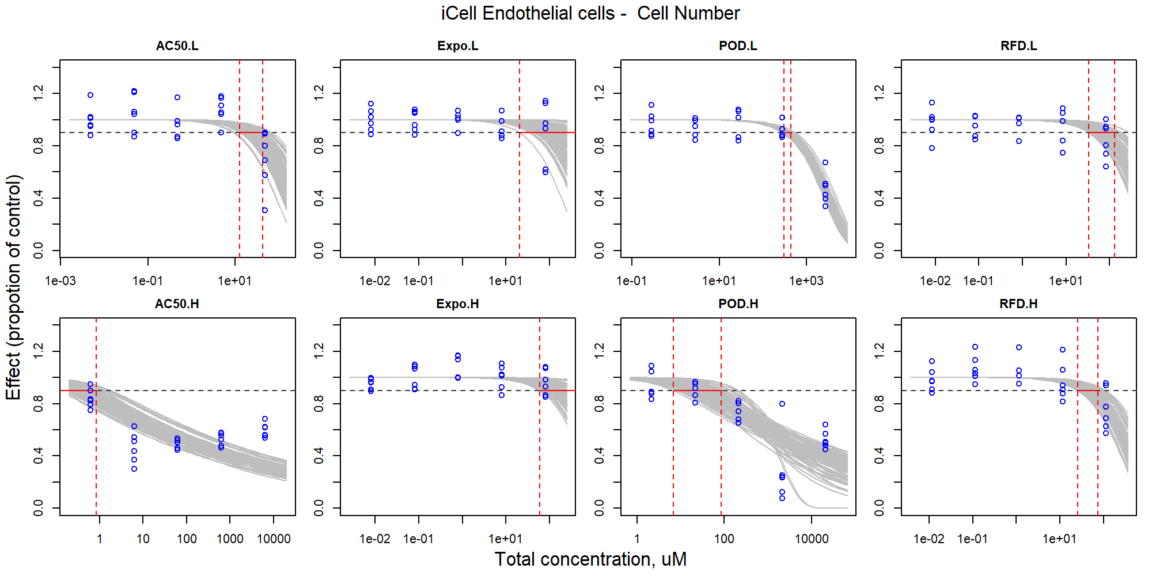

Figure S71. Curve-fitting of mixture concentration and observed response (Cell Number) in iCell Endothelial cells.

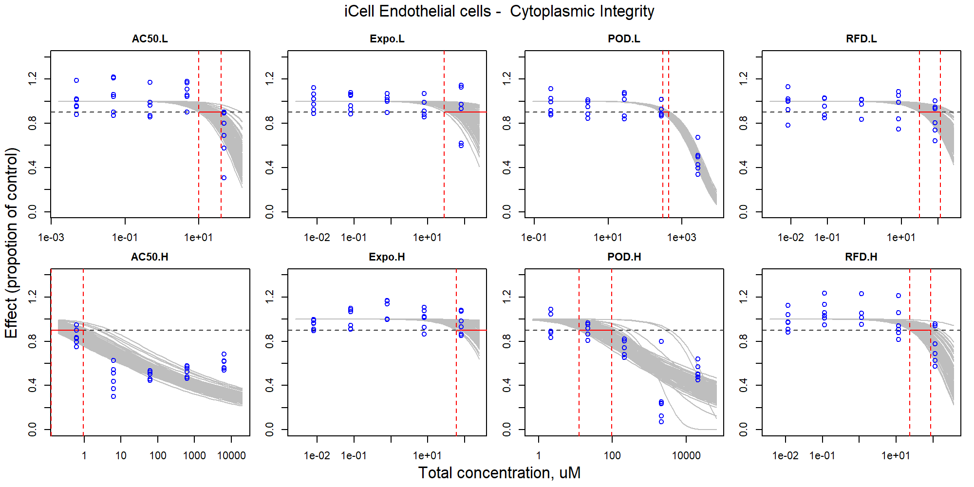

Figure S72. Curve-fitting of mixture concentration and observed response (Cytoplasmic Integrity) in iCell Endothelial cells.

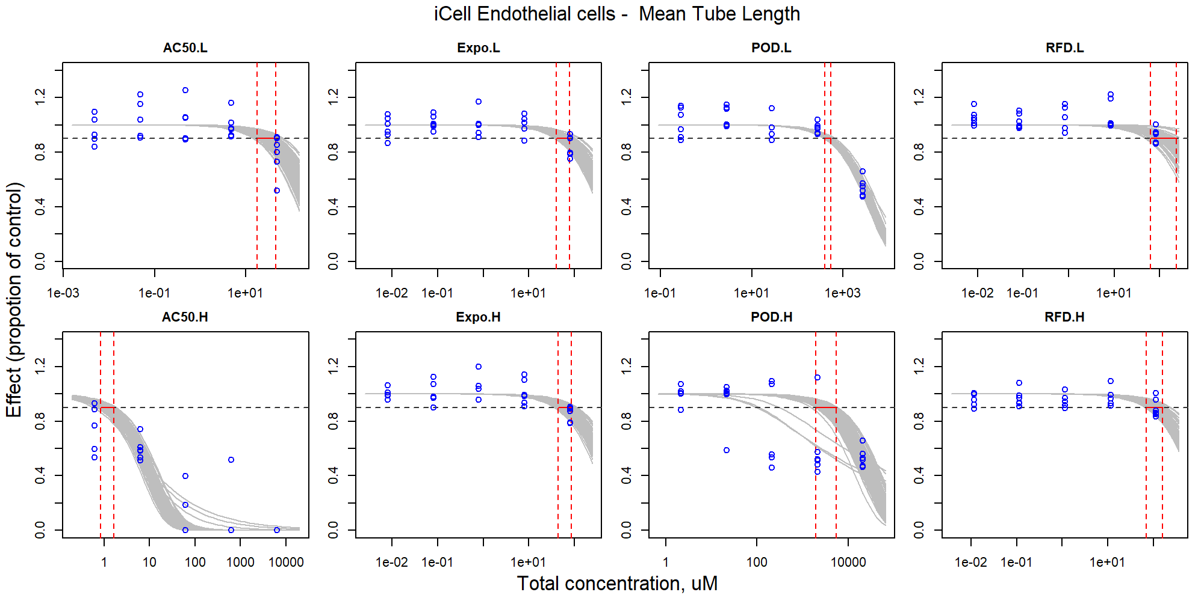

Figure S73. Curve-fitting of mixture concentration and observed response (Mean Tube Length) in iCell Endothelial cells.

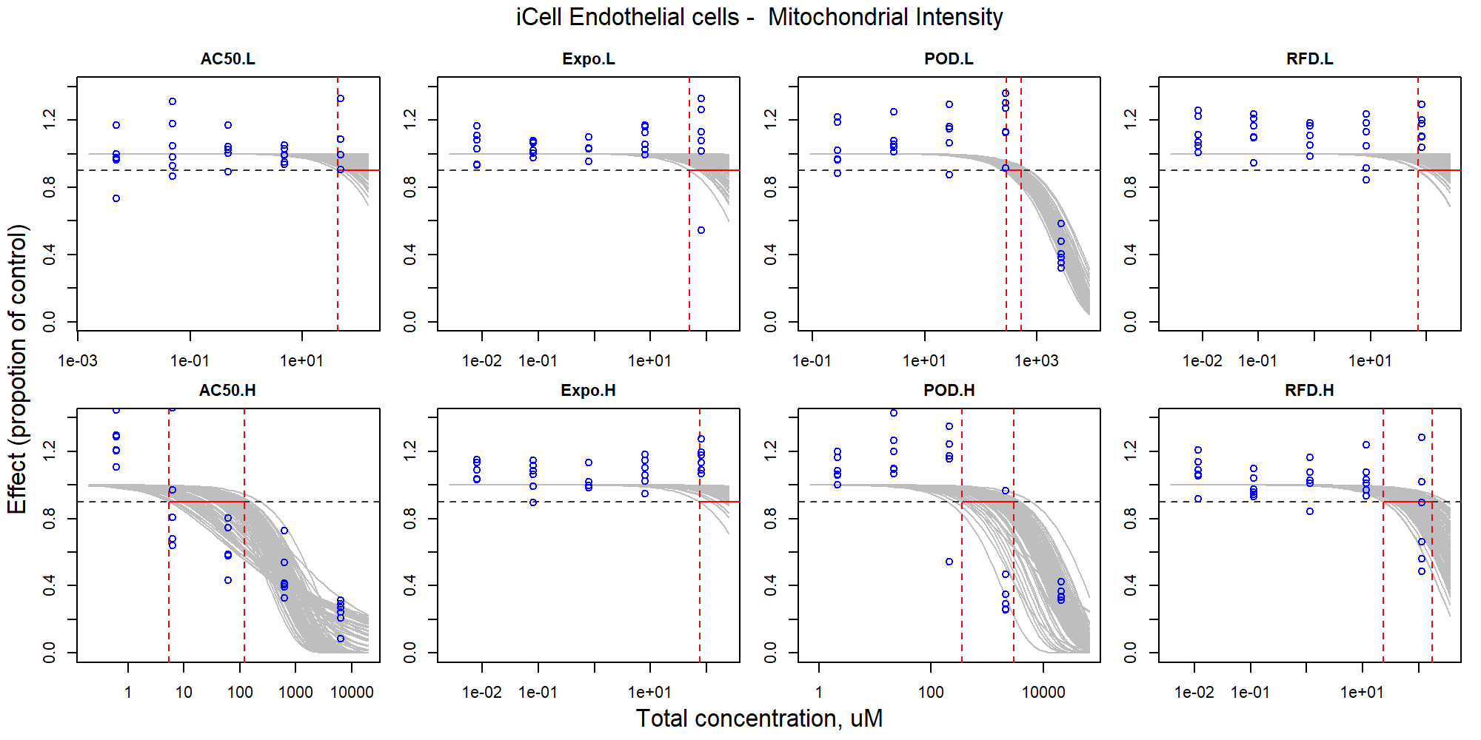

Figure S74. Curve-fitting of mixture concentration and observed response (Mitochondrial Intensity) in iCell Endothelial cells.

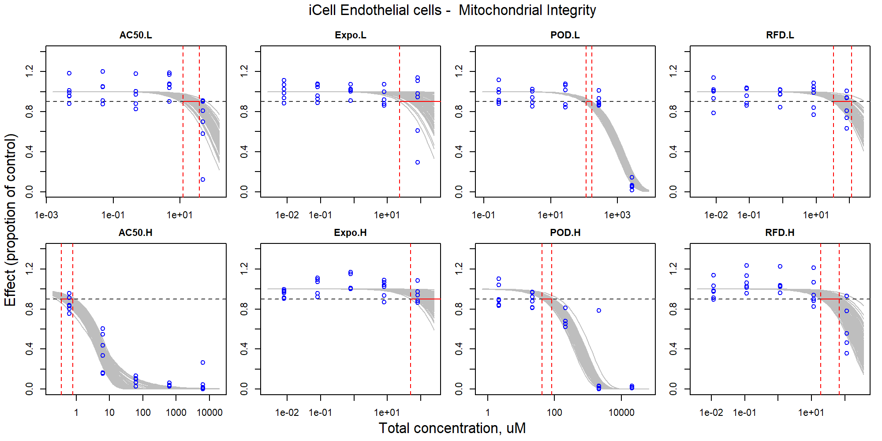

Figure S75. Curve-fitting of mixture concentration and observed response (Mitochondrial Integrity) in iCell Endothelial cells.

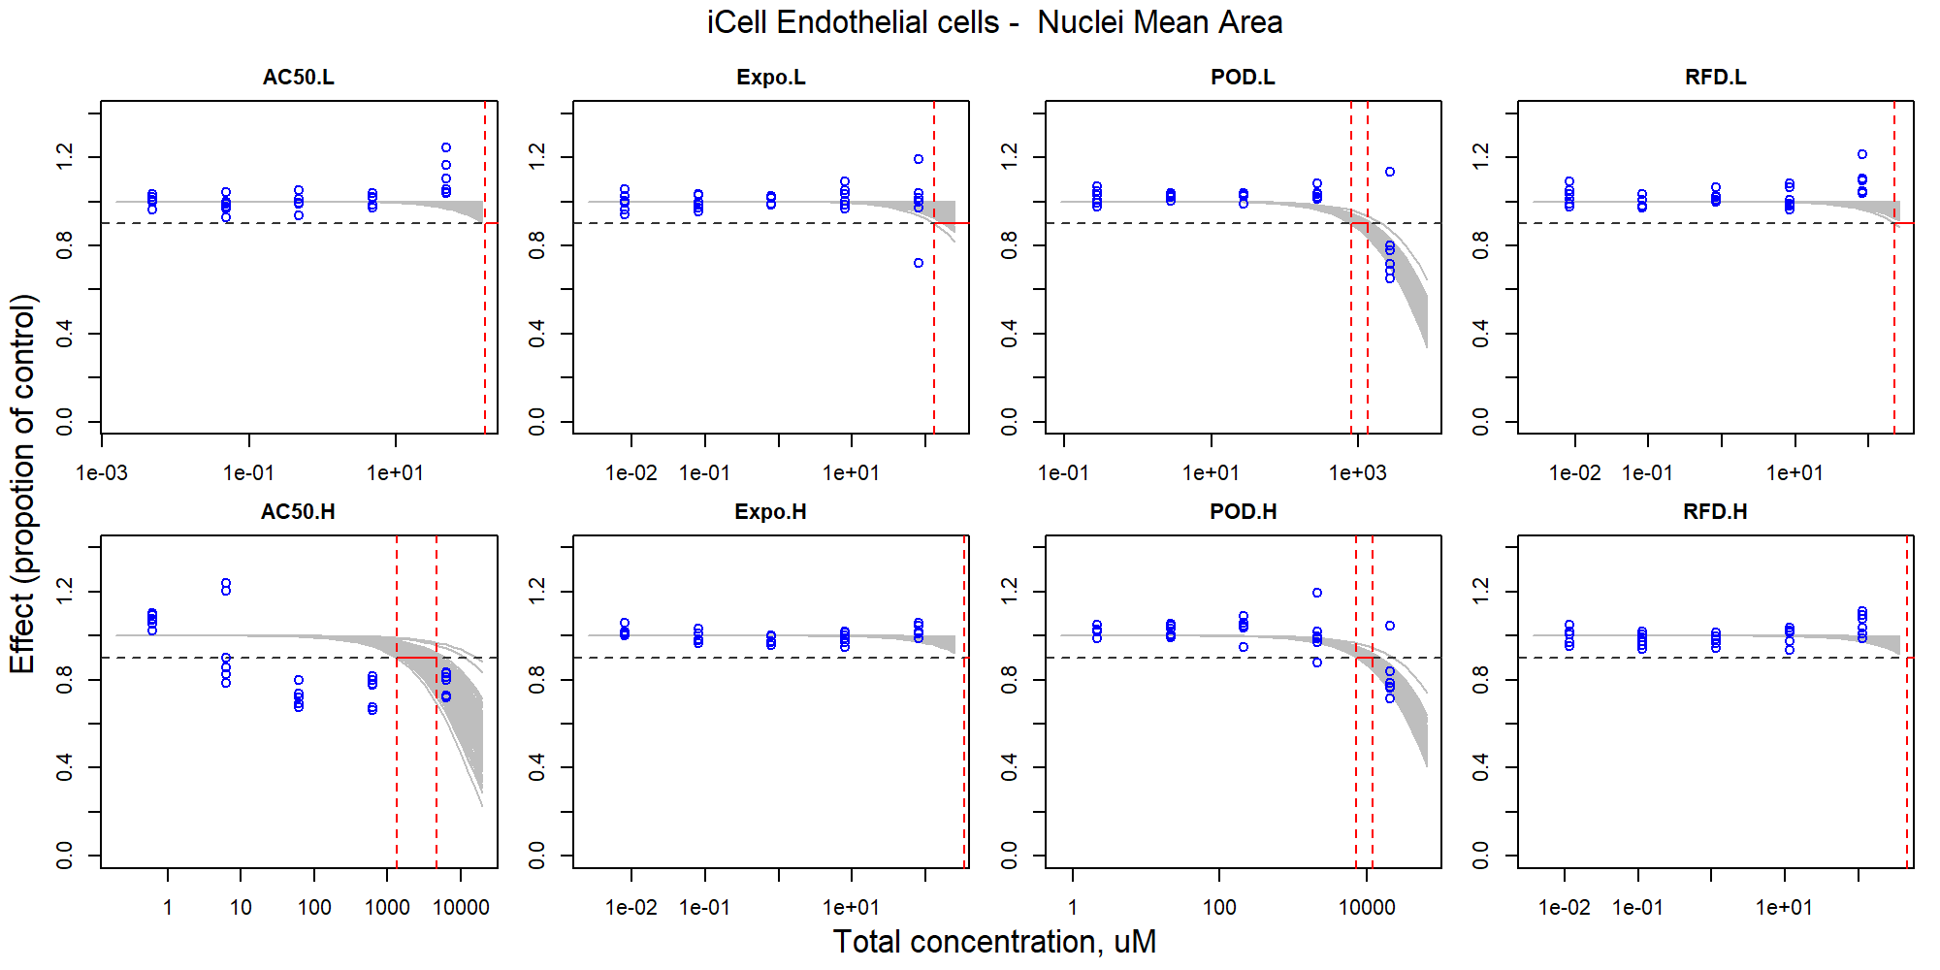

Figure S76. Curve-fitting of mixture concentration and observed response (Nuclei Mean Area) in iCell Endothelial cells.

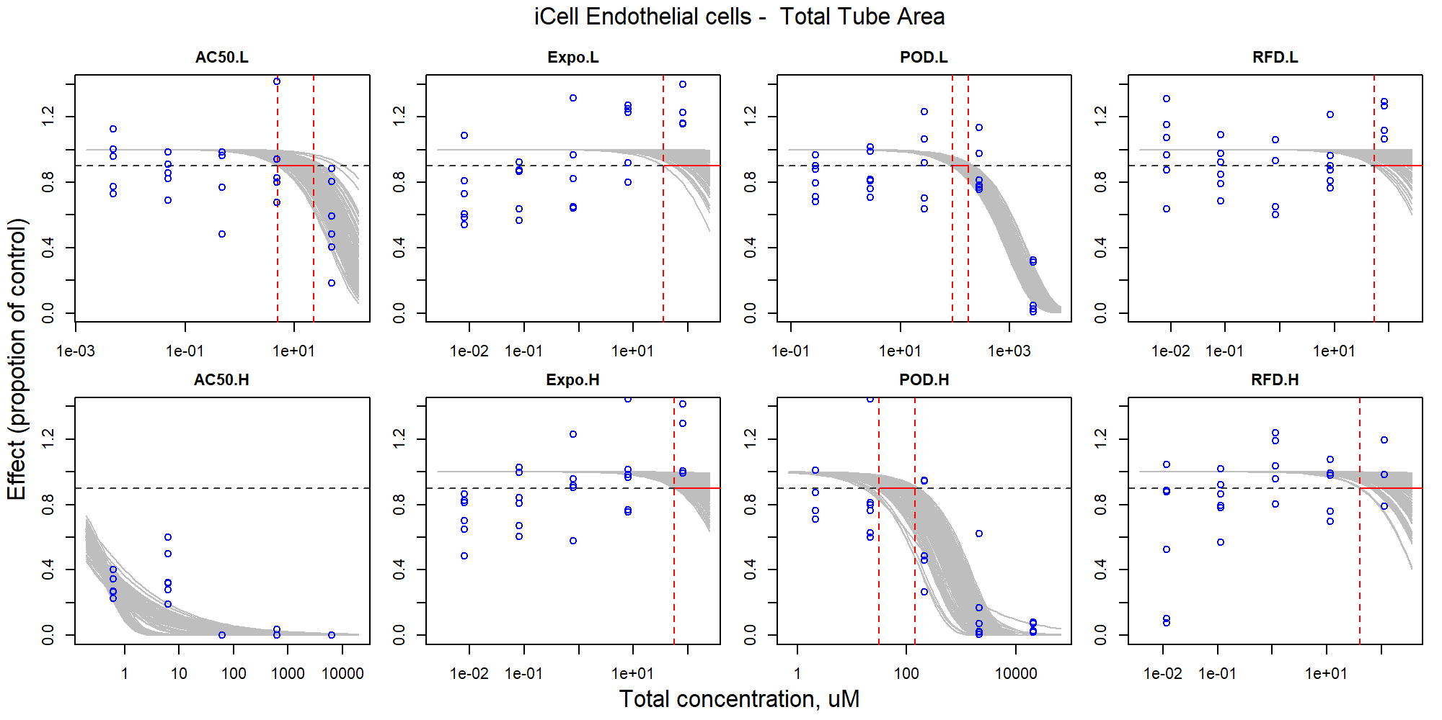

Figure S77. Curve-fitting of mixture concentration and observed response (Total Tube Area) in iCell Endothelial cells.

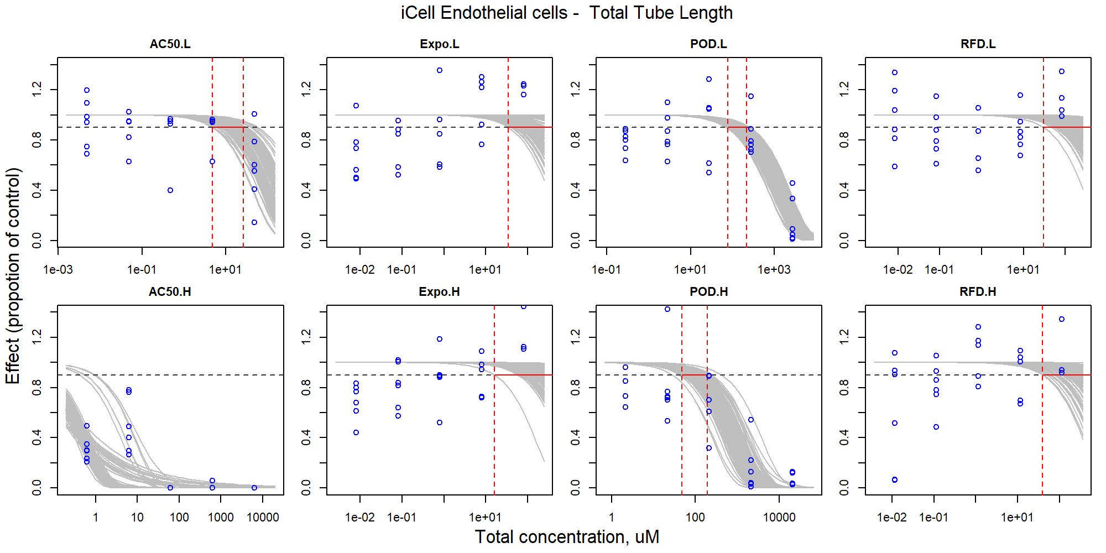

Figure S78. Curve-fitting of mixture concentration and observed response (Total Tube Length) in iCell Endothelial cells.

### iCell Cardiomyocytes

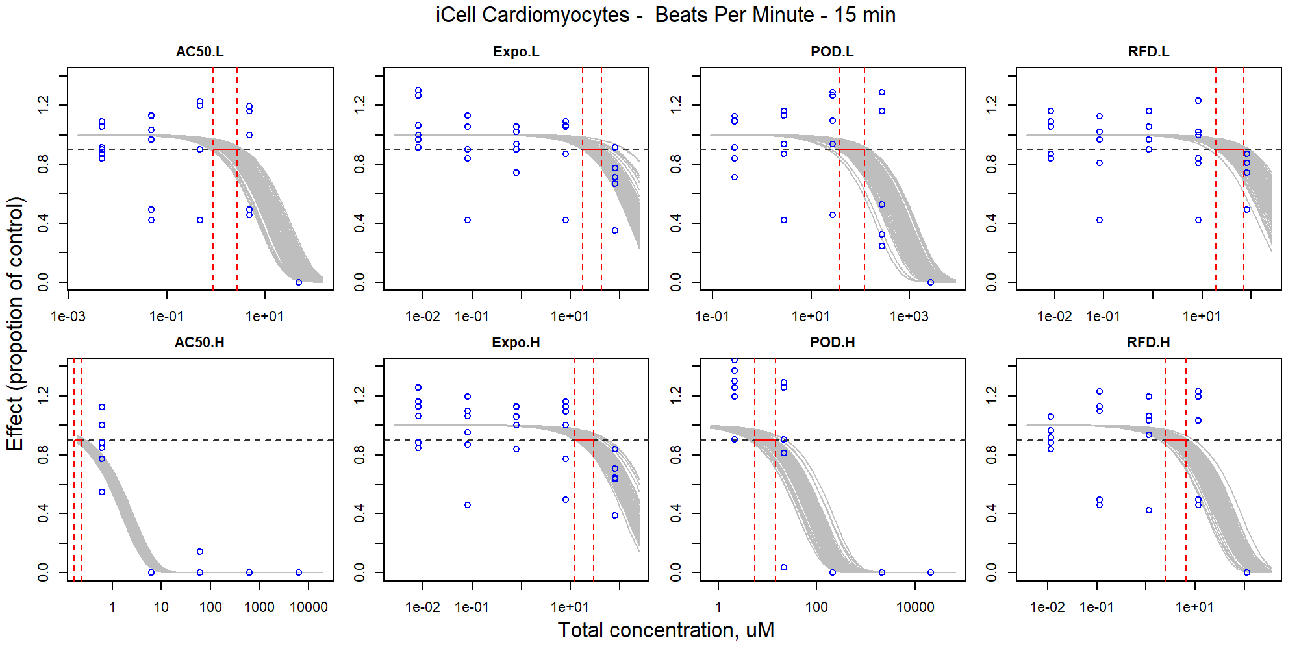

Figure S79. Curve-fitting of mixture concentration and observed response (Beats Per Minute - 15 min) in iCell Cardiomyocytes.

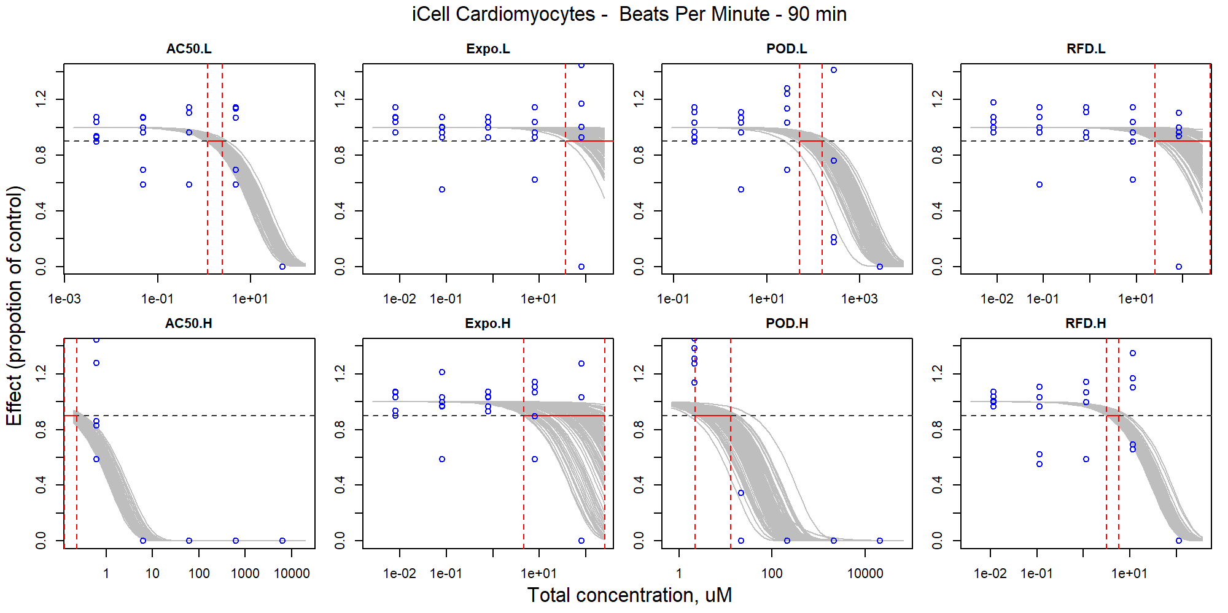

Figure S80. Curve-fitting of mixture concentration and observed response (Beats Per Minute - 90 min) in iCell Cardiomyocytes.

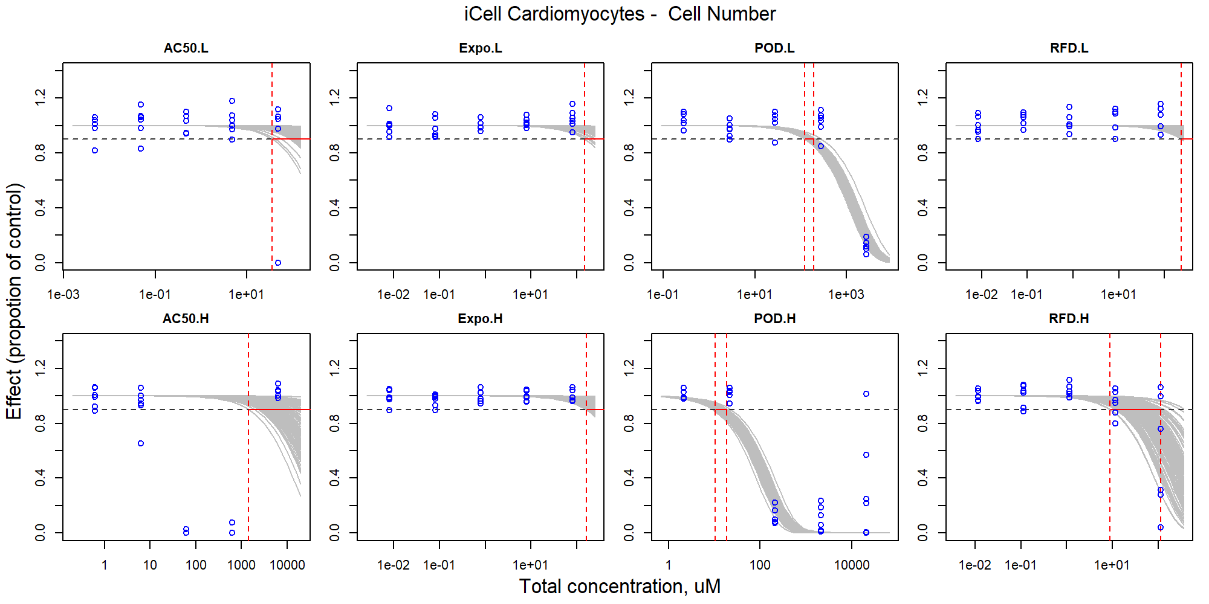

Figure S81. Curve-fitting of mixture concentration and observed response (Cell Number) in iCell Cardiomyocytes.

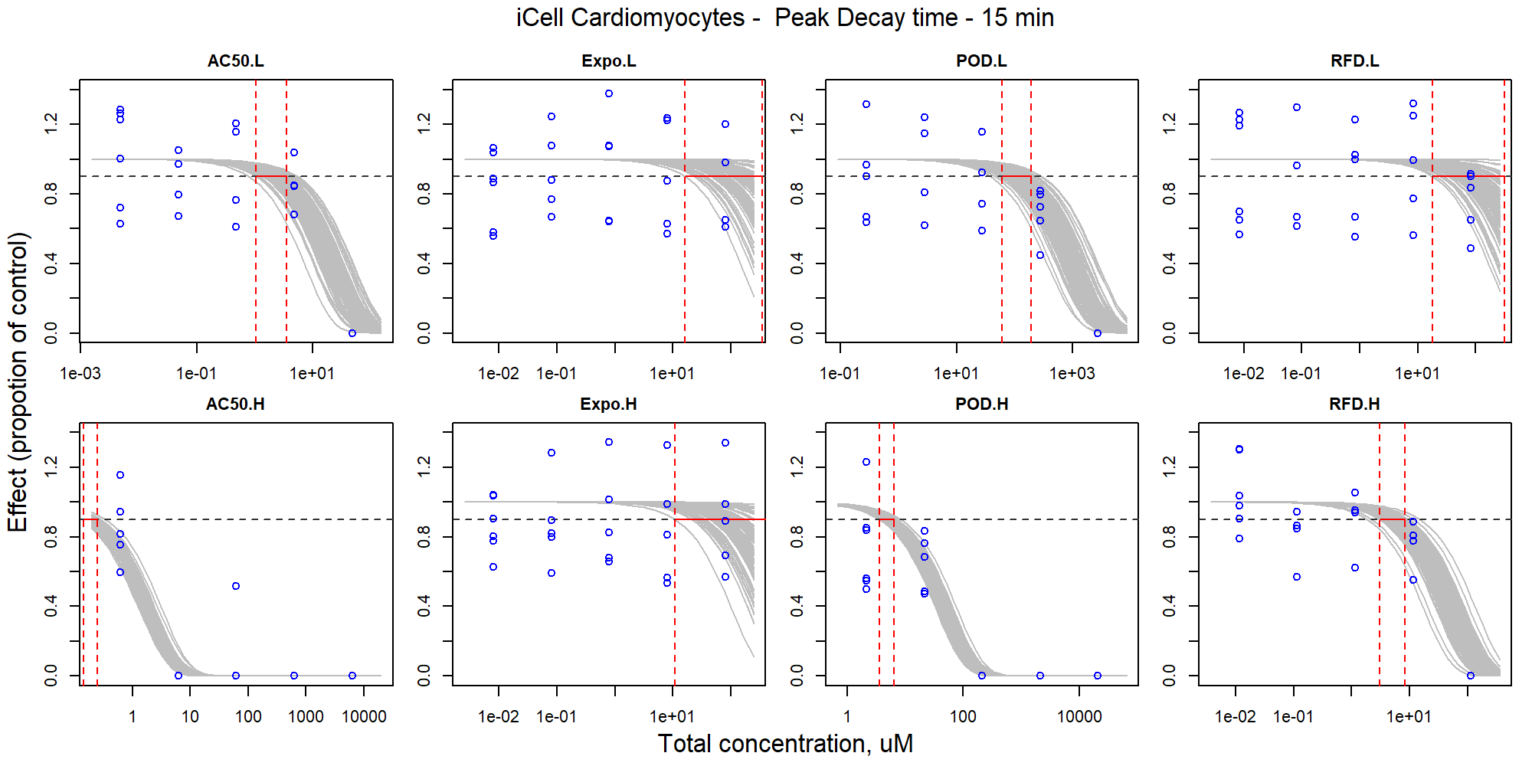

Figure S82. Curve-fitting of mixture concentration and observed response (Peak Decay time - 15 min) in iCell Cardiomyocytes.

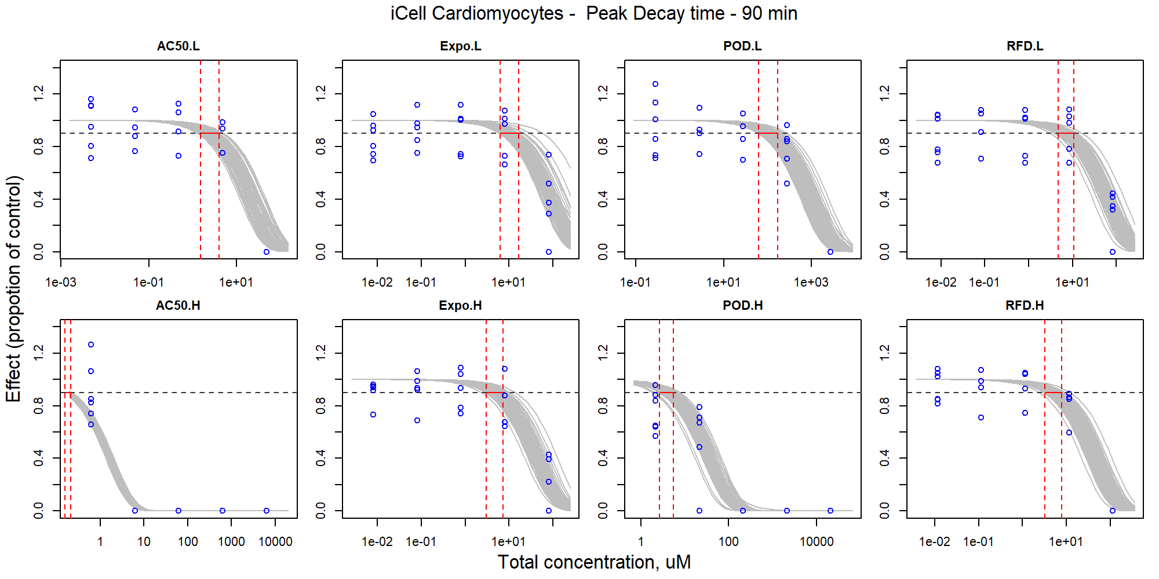

Figure S83. Curve-fitting of mixture concentration and observed response (Peak Decay time - 90 min) in iCell Cardiomyocytes.

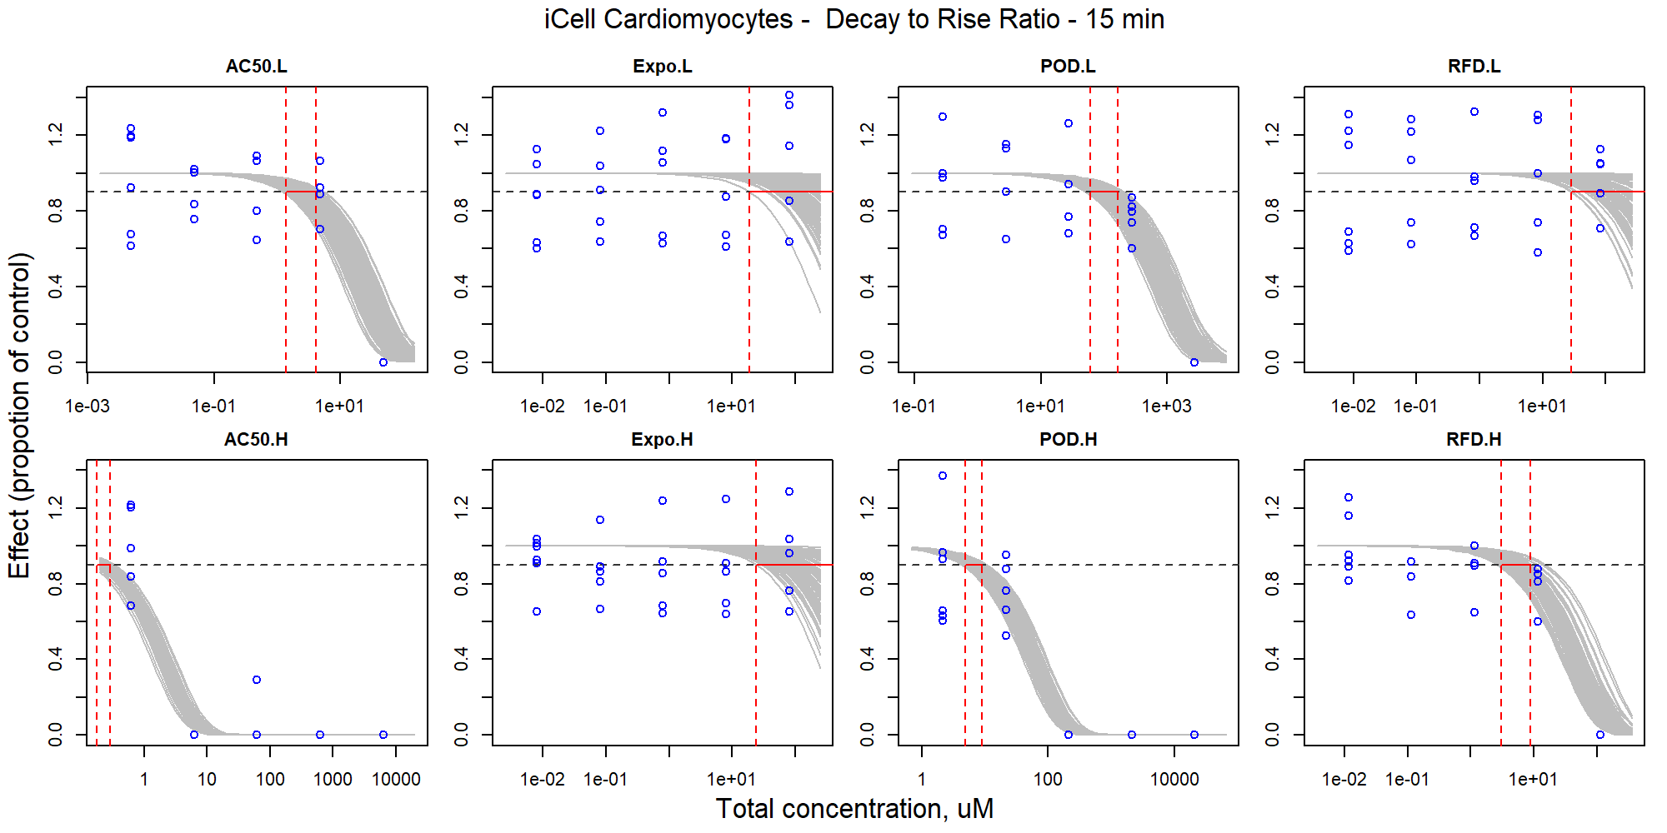

Figure S84. Curve-fitting of mixture concentration and observed response (Decay to Rise Ratio - 15 min) in iCell Cardiomyocytes.

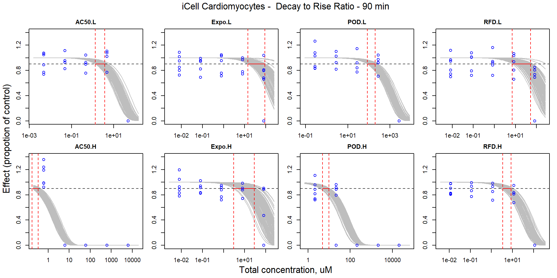

Figure S85. Curve-fitting of mixture concentration and observed response (Decay to Rise Ratio - 90 min) in iCell Cardiomyocytes.

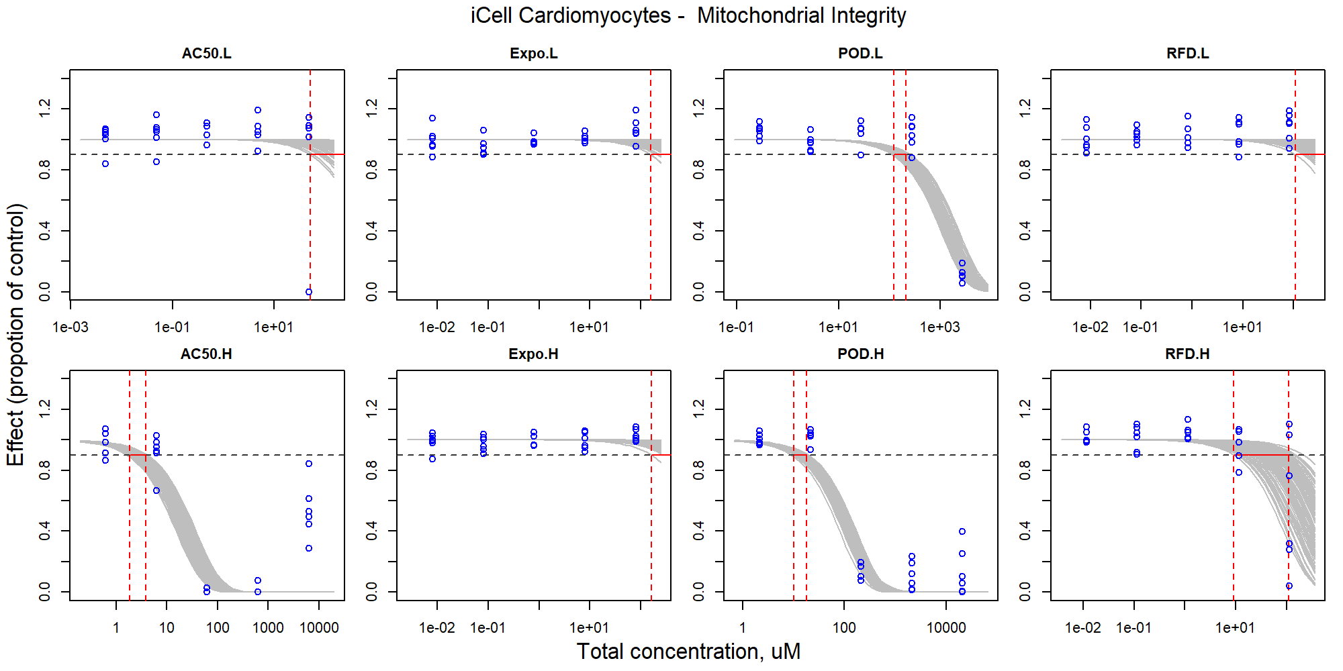

Figure S86. Curve-fitting of mixture concentration and observed response (Mitochondrial Integrity) in iCell Cardiomyocytes.

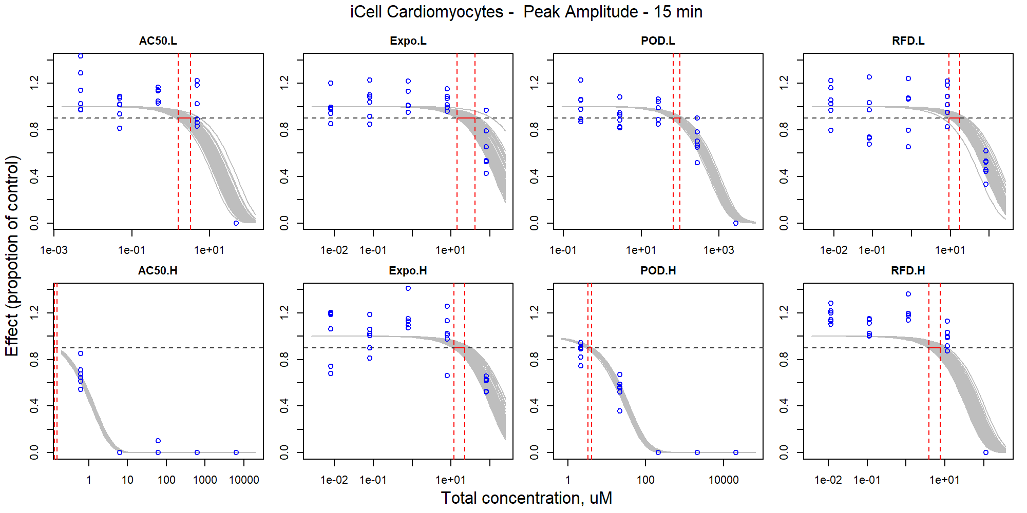

Figure S87. Curve-fitting of mixture concentration and observed response (Peak Amplitude - 15 min) in iCell Cardiomyocytes.

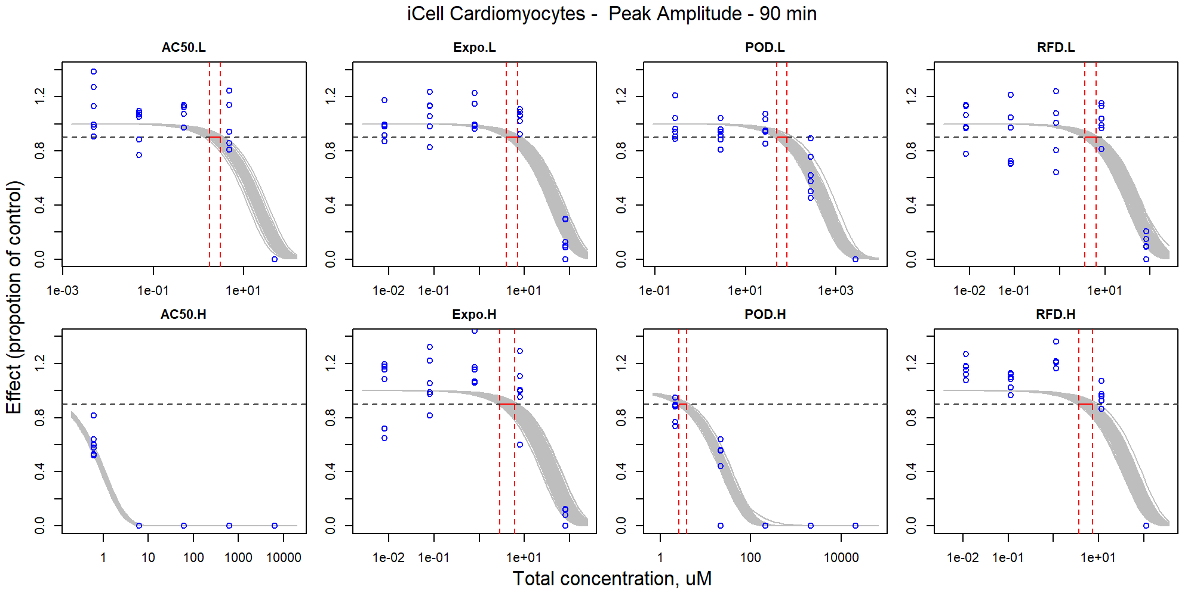

Figure S88. Curve-fitting of mixture concentration and observed response (Peak Amplitude - 90 min) in iCell Cardiomyocytes.

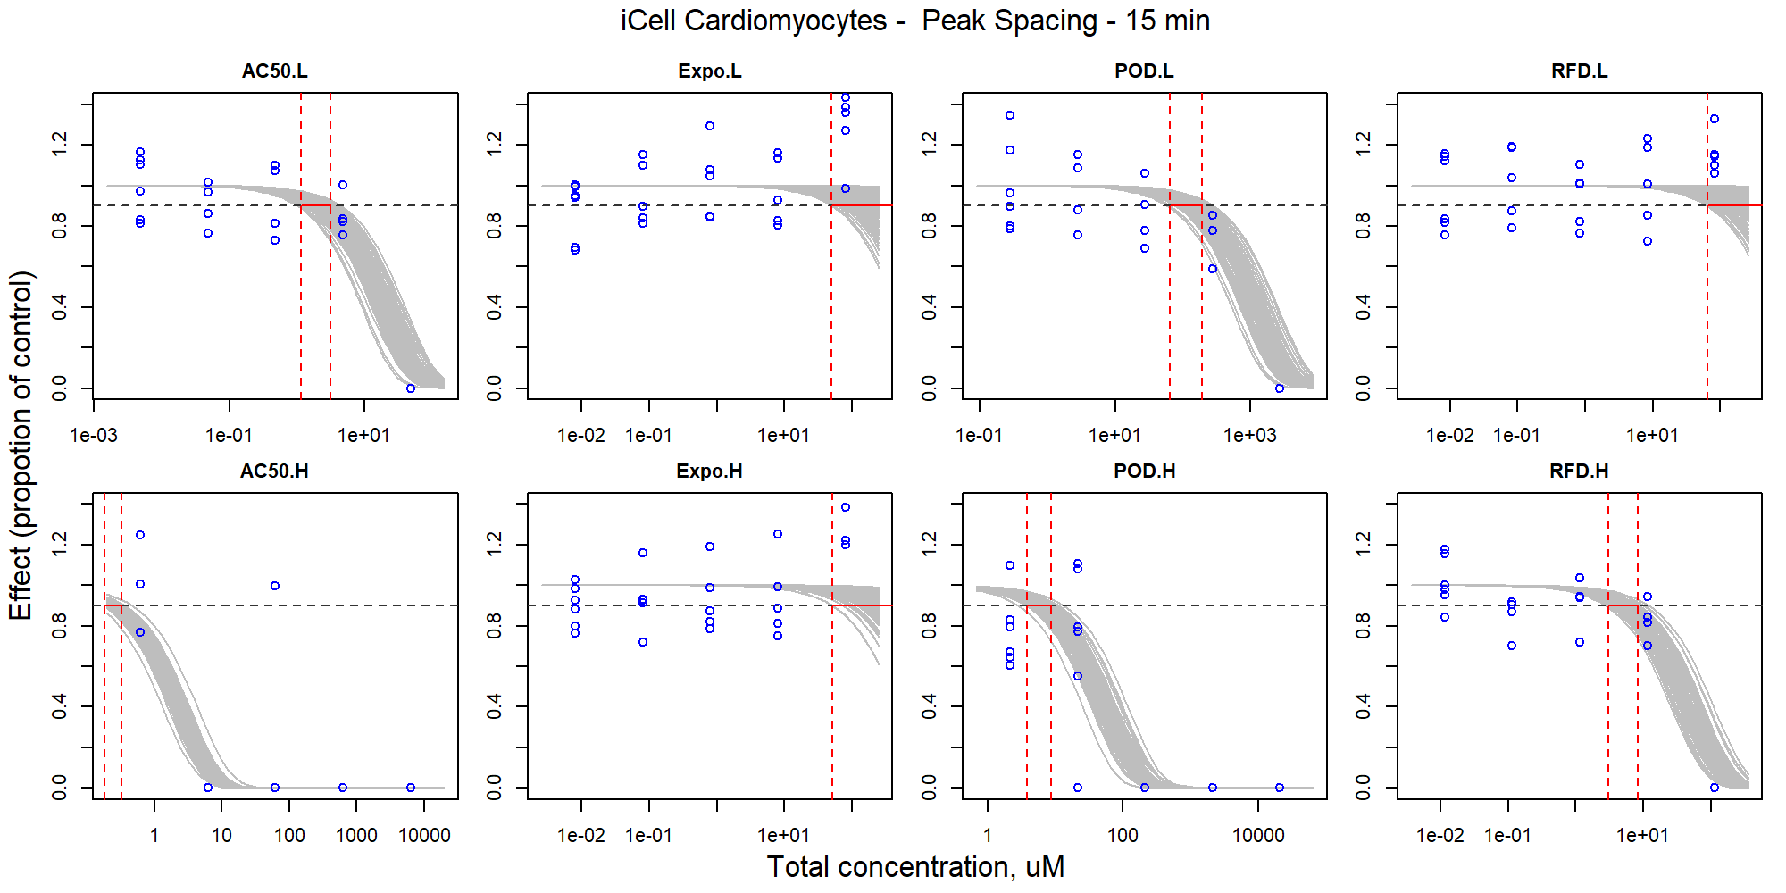

Figure S89. Curve-fitting of mixture concentration and observed response (Peak Spacing - 15 min) in iCell Cardiomyocytes.

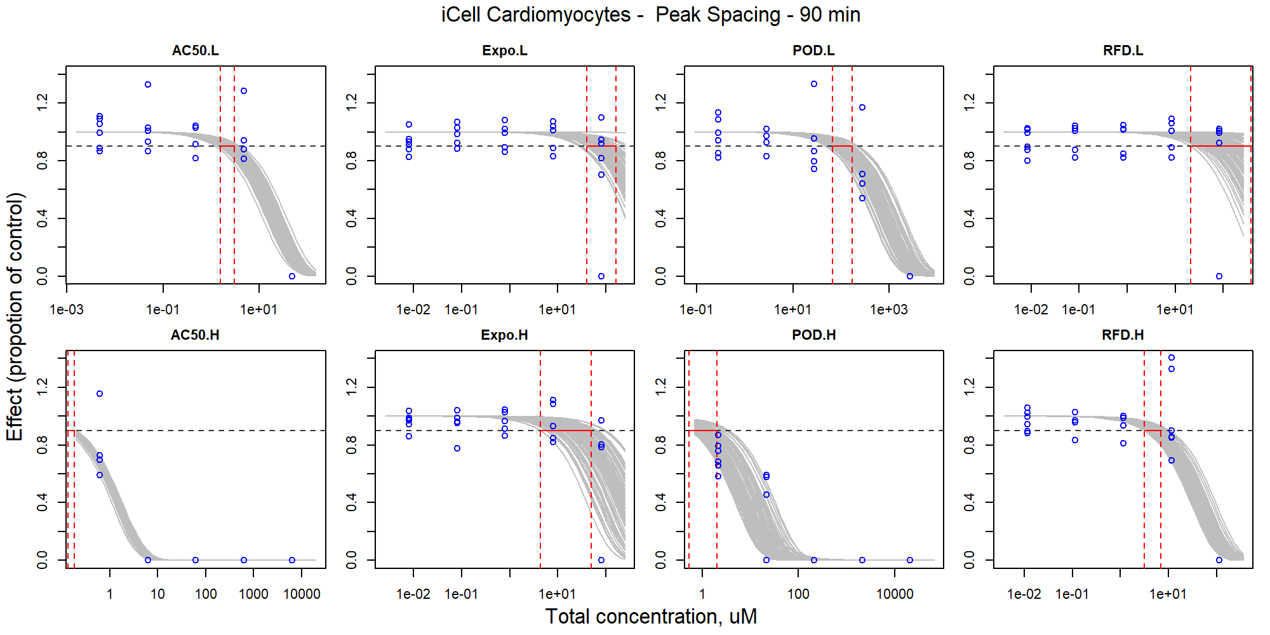

Figure S90. Curve-fitting of mixture concentration and observed response (Peak Spacing - 90 min) in iCell Cardiomyocytes.

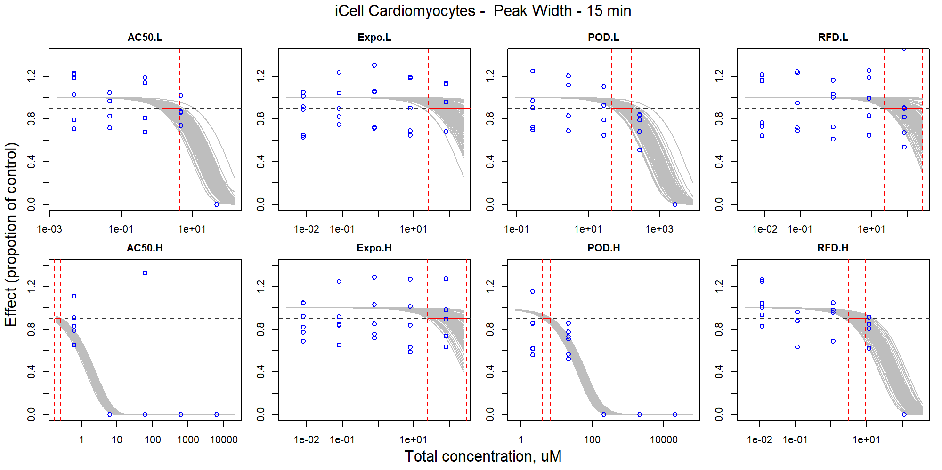

Figure S91. Curve-fitting of mixture concentration and observed response (Peak Width - 15 min) in iCell Cardiomyocytes.

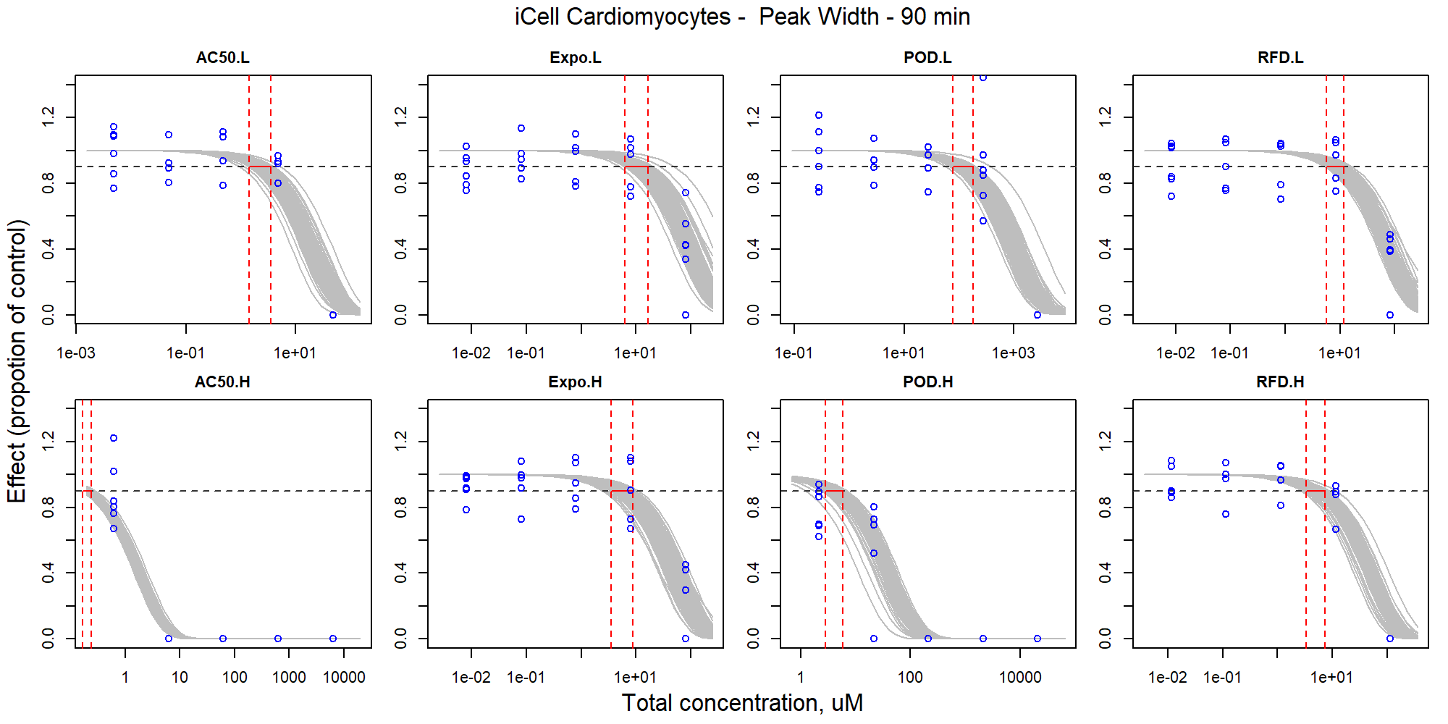

Figure S92. Curve-fitting of mixture concentration and observed response (Peak Width - 90 min) in iCell Cardiomyocytes.

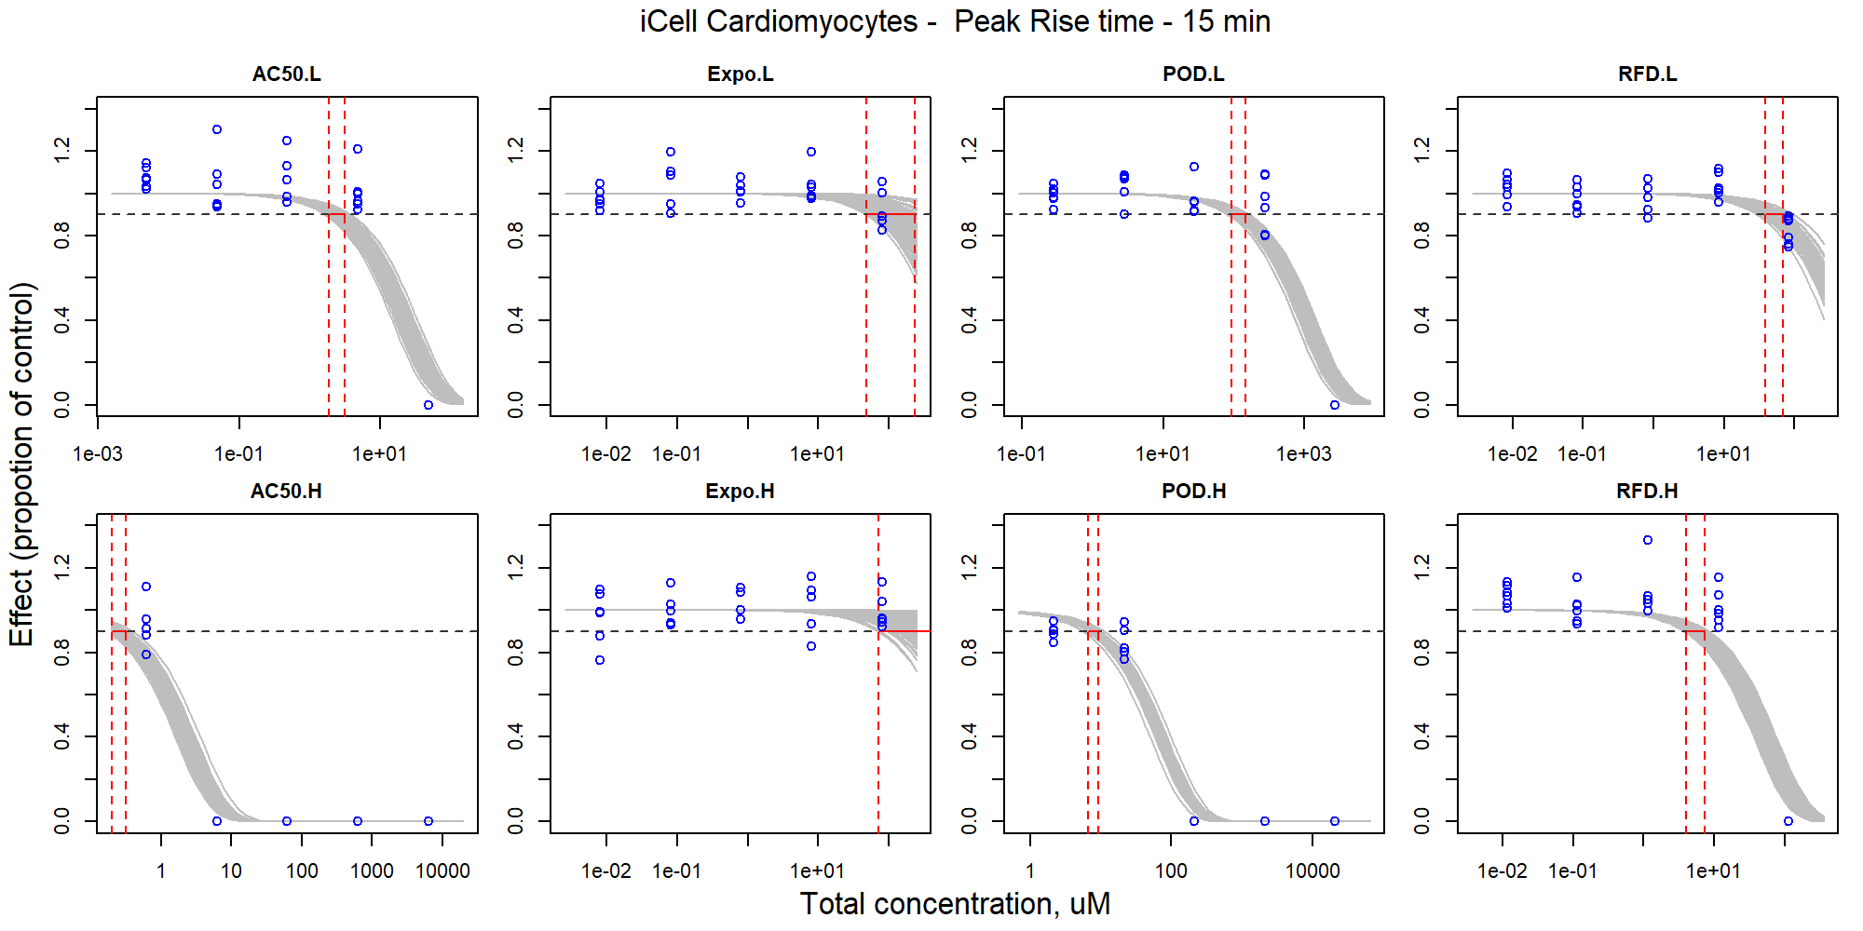

Figure S93. Curve-fitting of mixture concentration and observed response (Peak Rise time - 15 min) in iCell Cardiomyocytes.

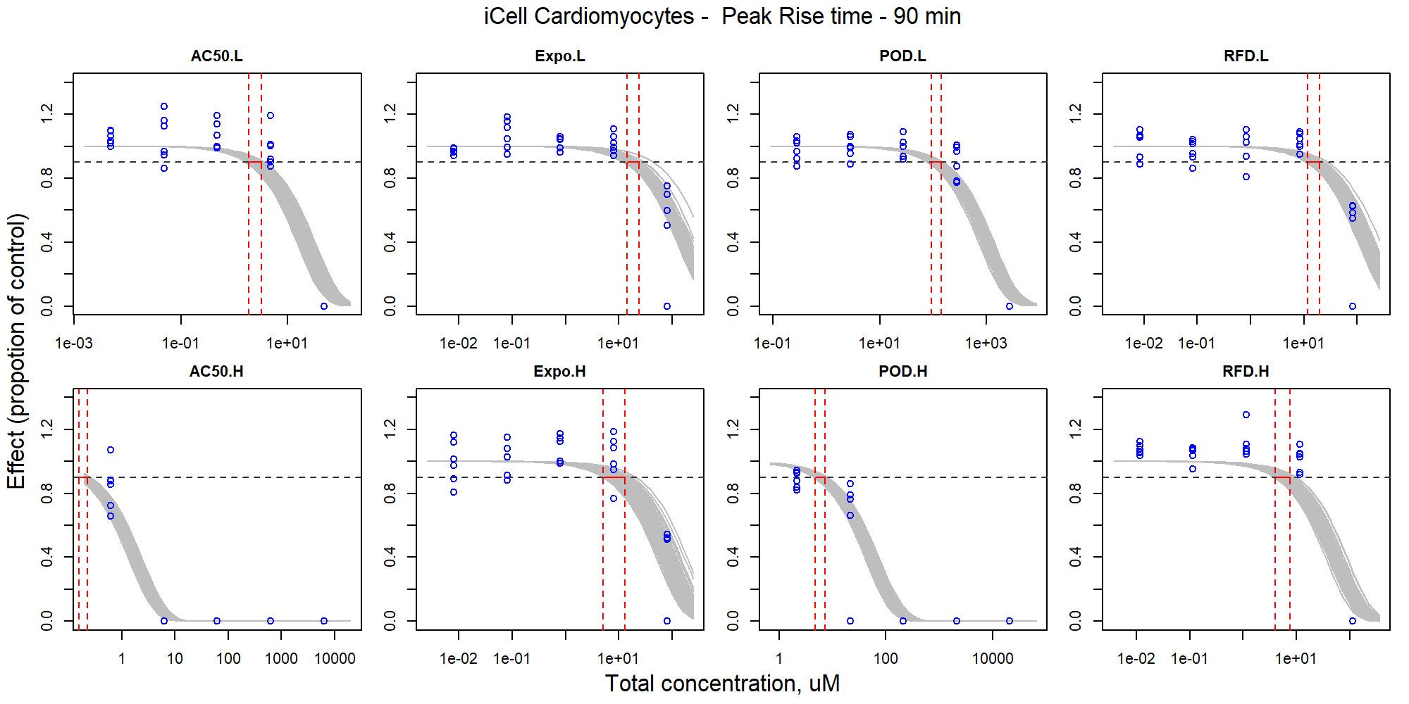

Figure S94. Curve-fitting of mixture concentration and observed response (Peak Rise time - 90 min) in iCell Cardiomyocytes.

## Curve-fitting and prediction of AC50-H concentration-response

### iCell Neurons

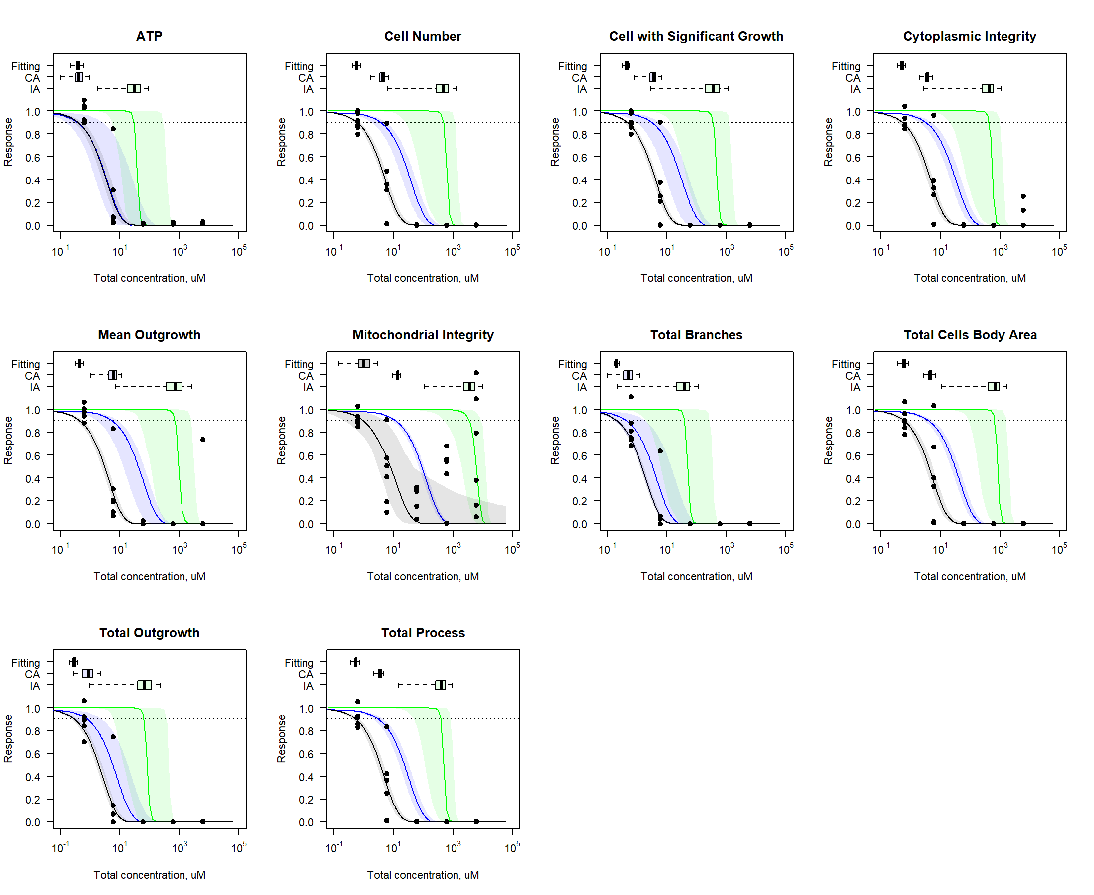

Figure S95. Comparison of curve-fitting and predicted concentration-response profile for iCell Neurons.

### HUVECs

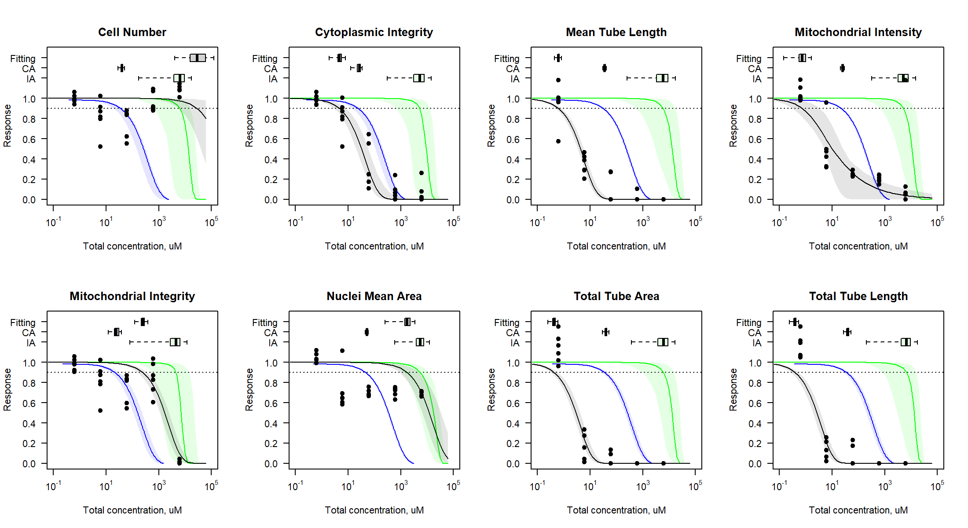

Figure S96. Comparison of curve-fitting and predicted concentration-response profile for HUVECs.

### iCell Hepatocytes

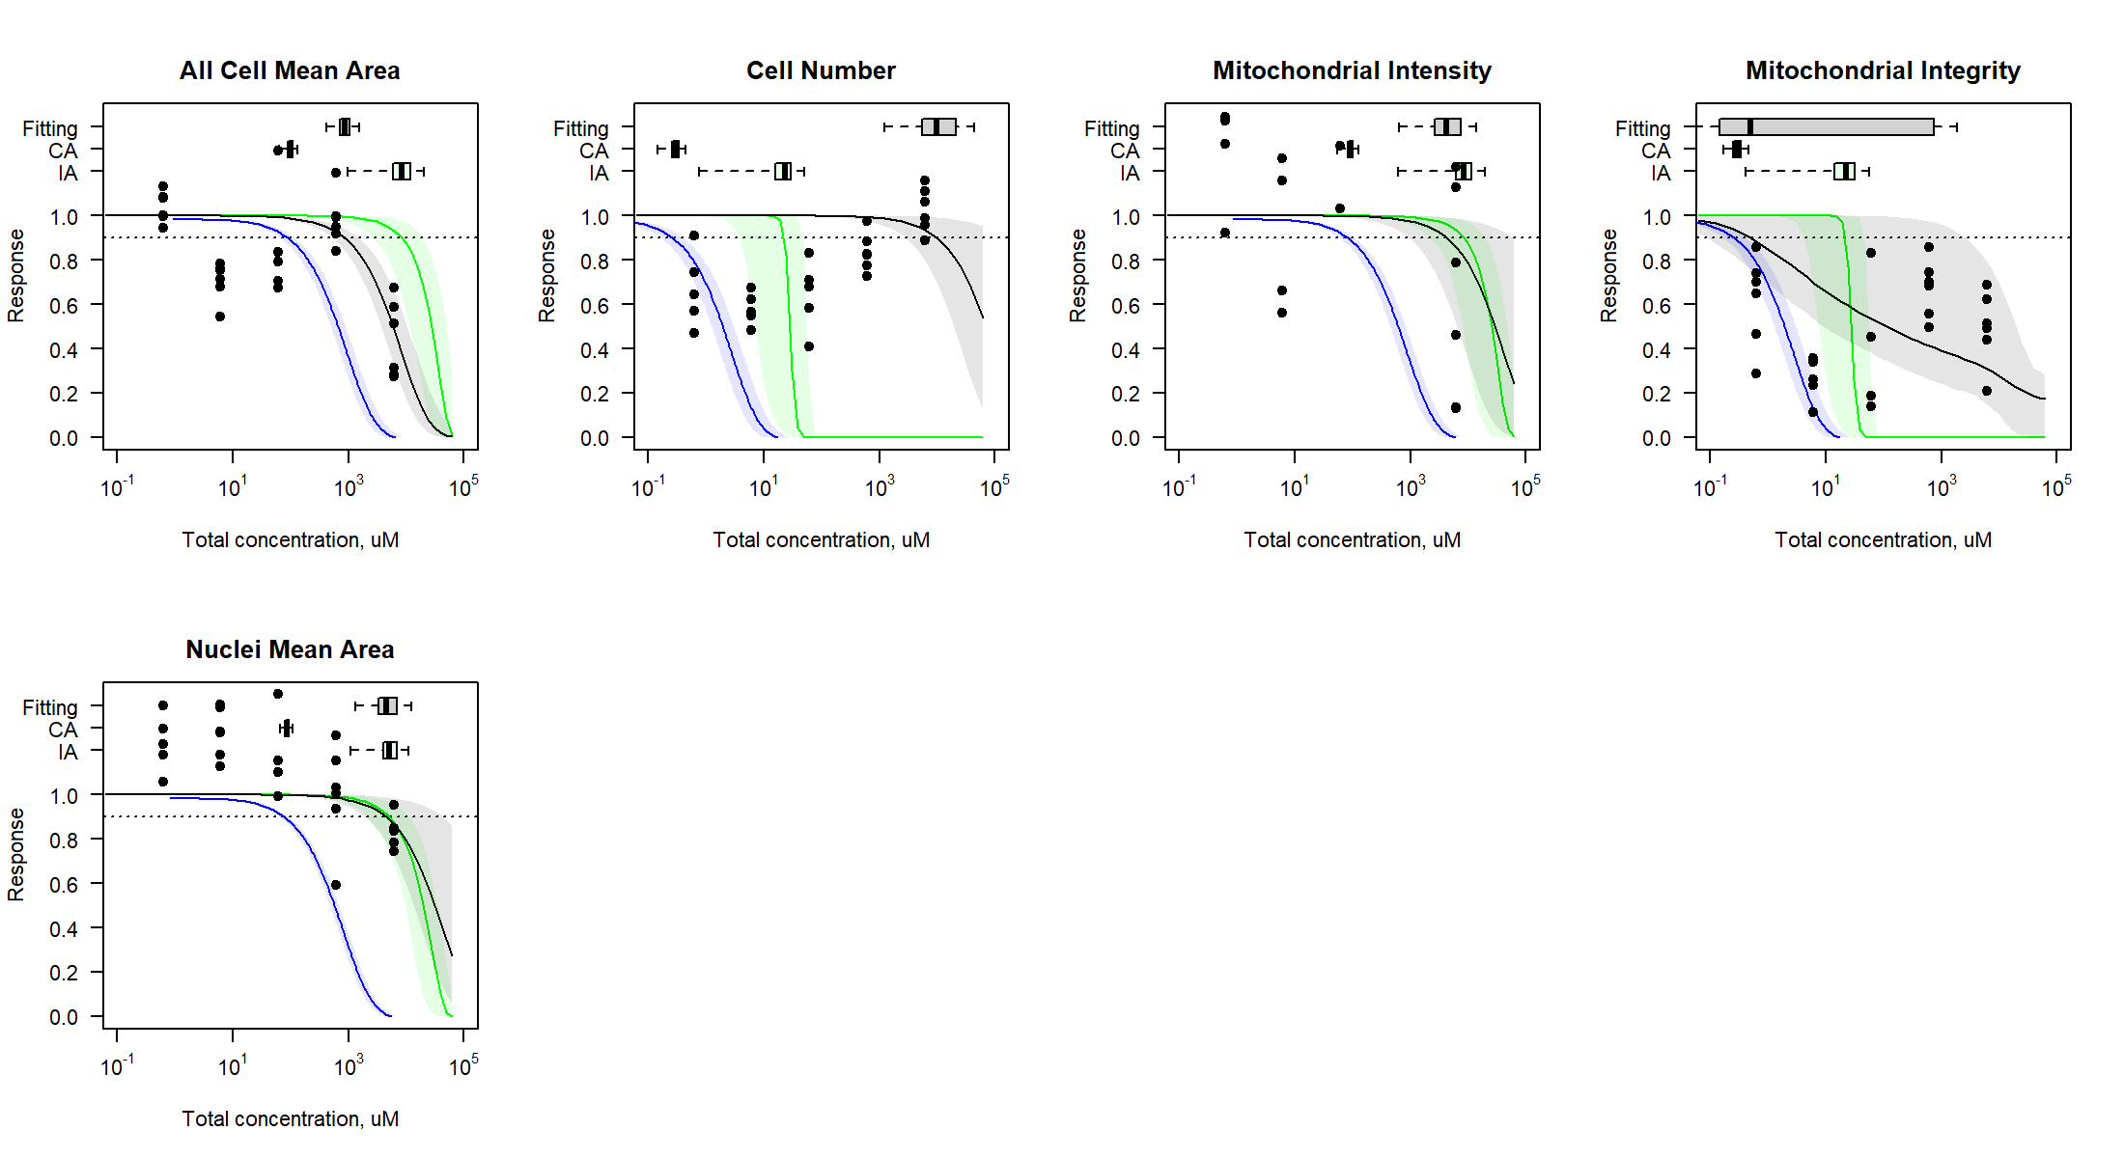

Figure S97. Comparison of curve-fitting and predicted concentration-response profile for iCell Hepatocytes.

### iCell Endothelial cells

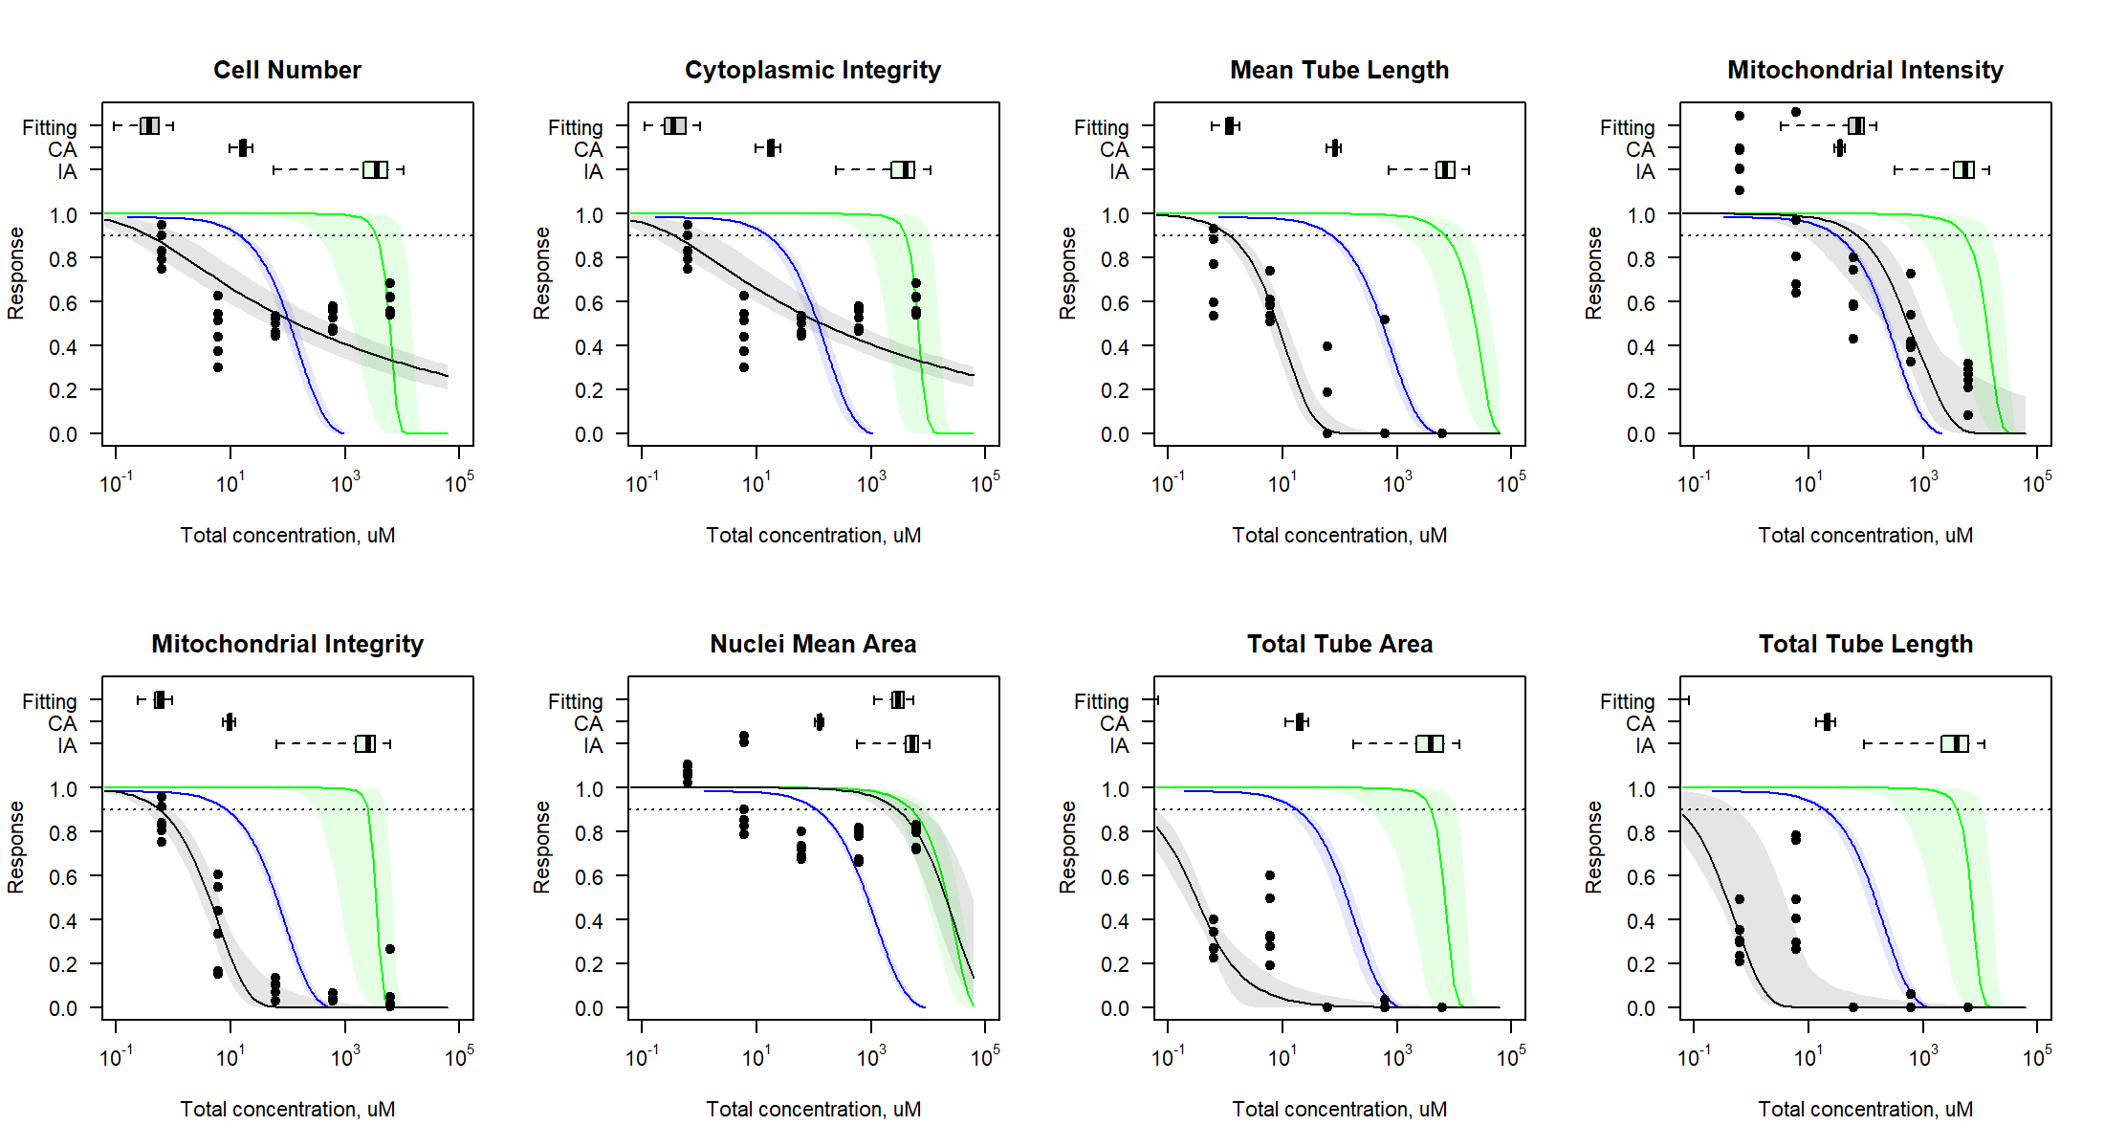

Figure S98. Comparison of curve-fitting and predicted concentration-response profile for iCell Endothelial cells.

### iCell Cardiomyocytes

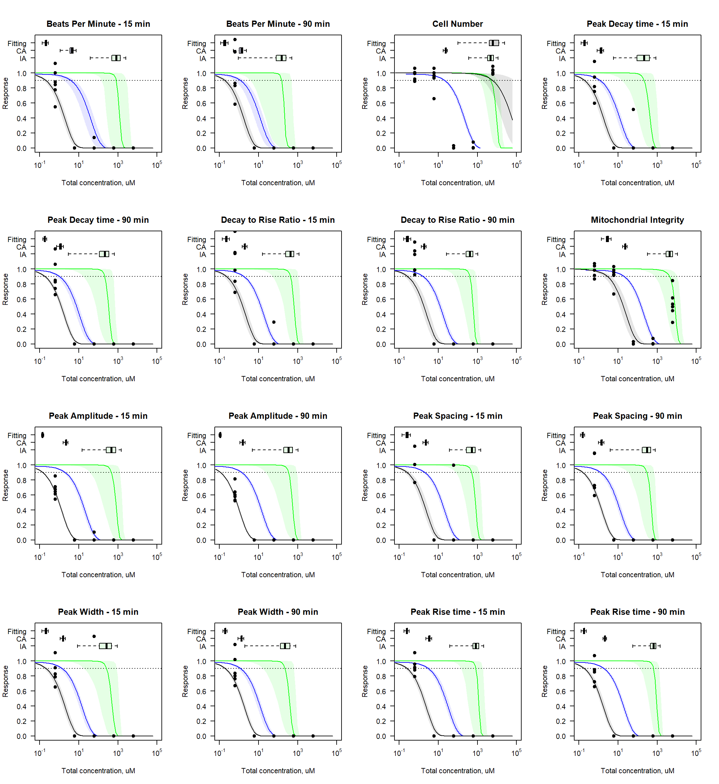

Figure S99. Comparison of curve-fitting and predicted concentration-response profile for iCell Cardiomyocytes.

## Estimation of the margin of exposure under AC50-H exposure

### iCell Neurons

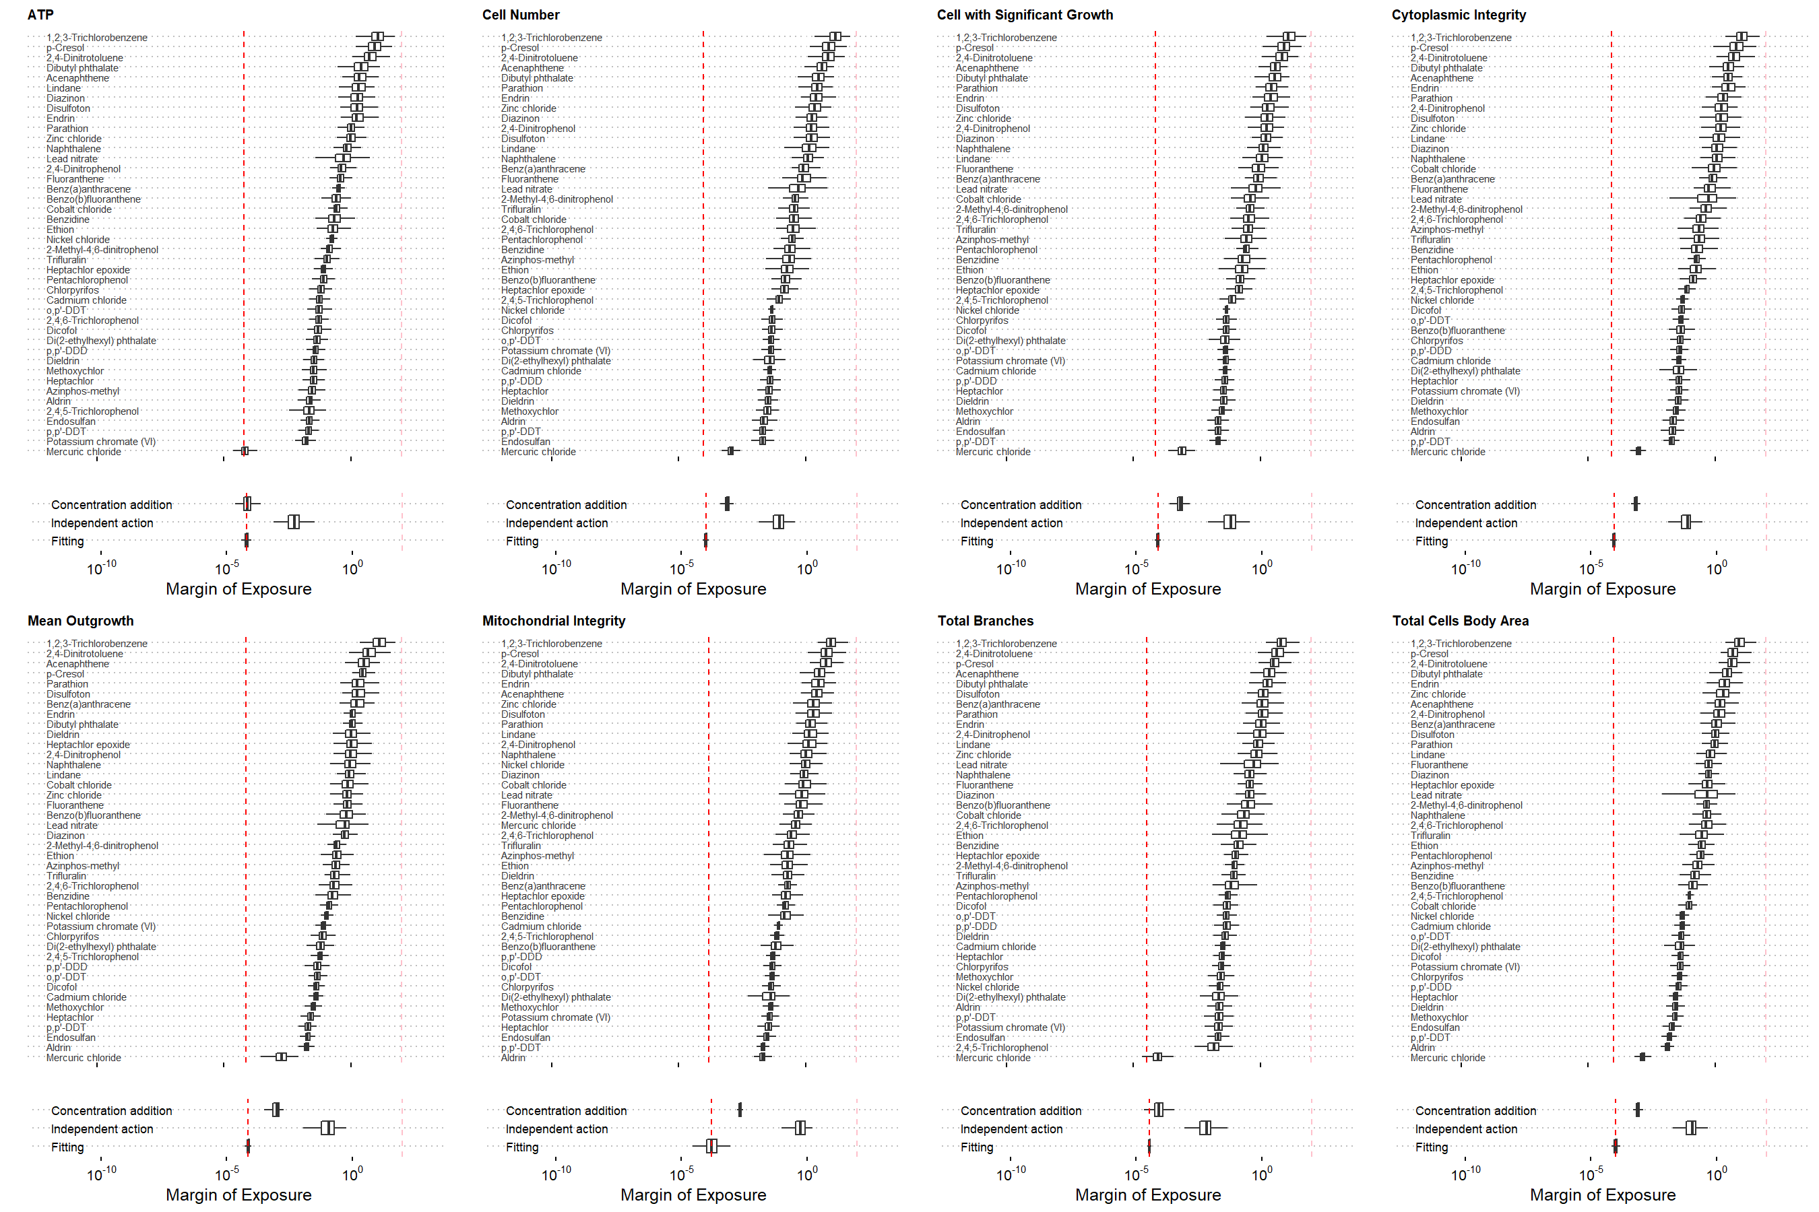

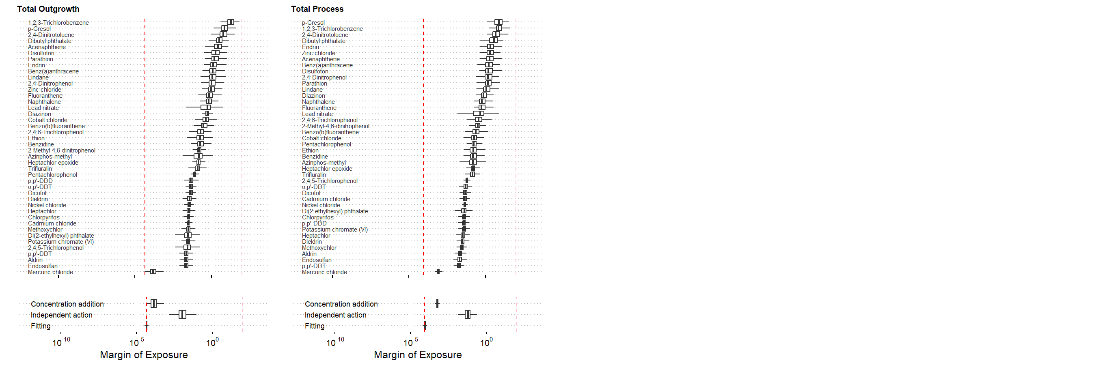

Figure S100. The estimation of the margin of exposure for cytotoxicity phenotypes in the iCell Neurons.

### HUVECs

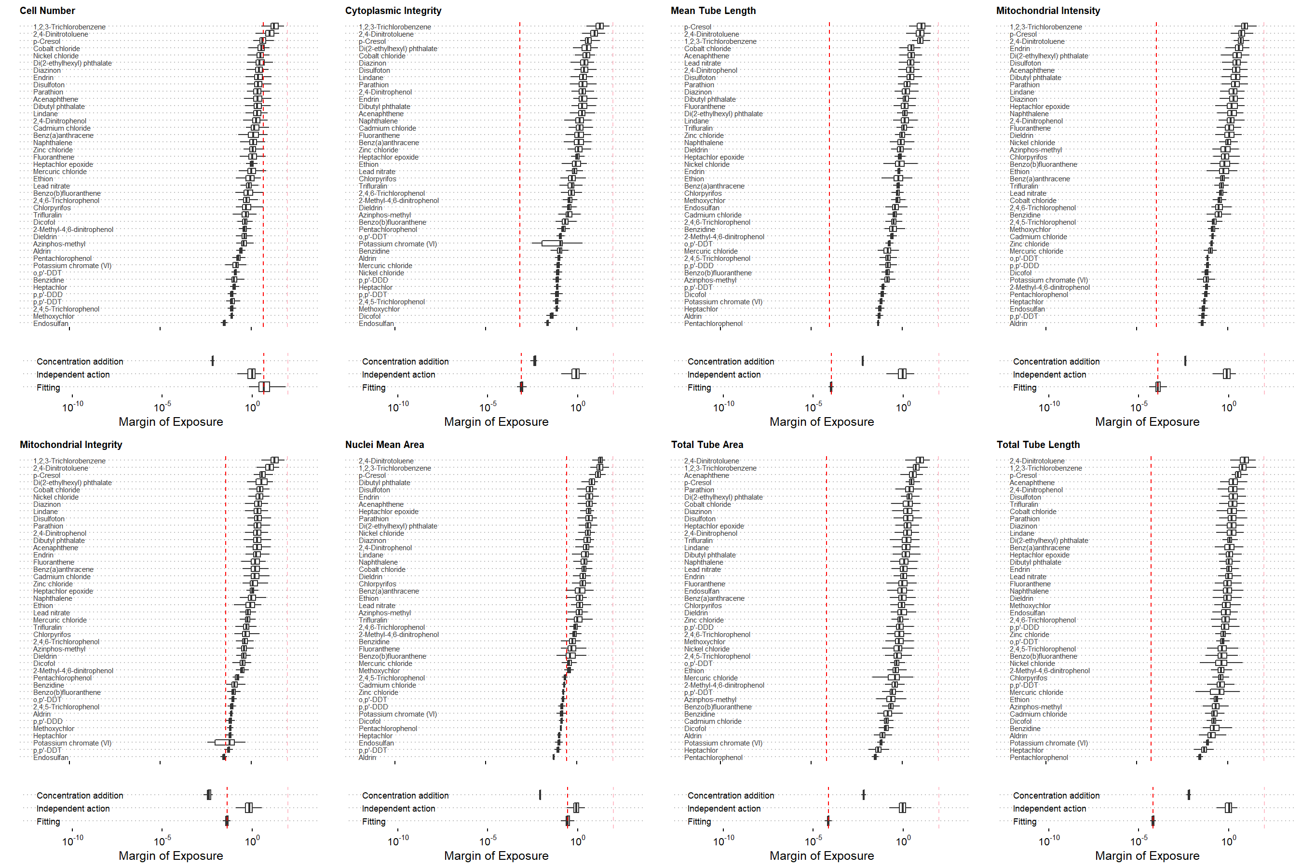

Figure S101. The estimation of the margin of exposure for cytotoxicity phenotypes in the HUVECs.

### iCell Hepatocytes

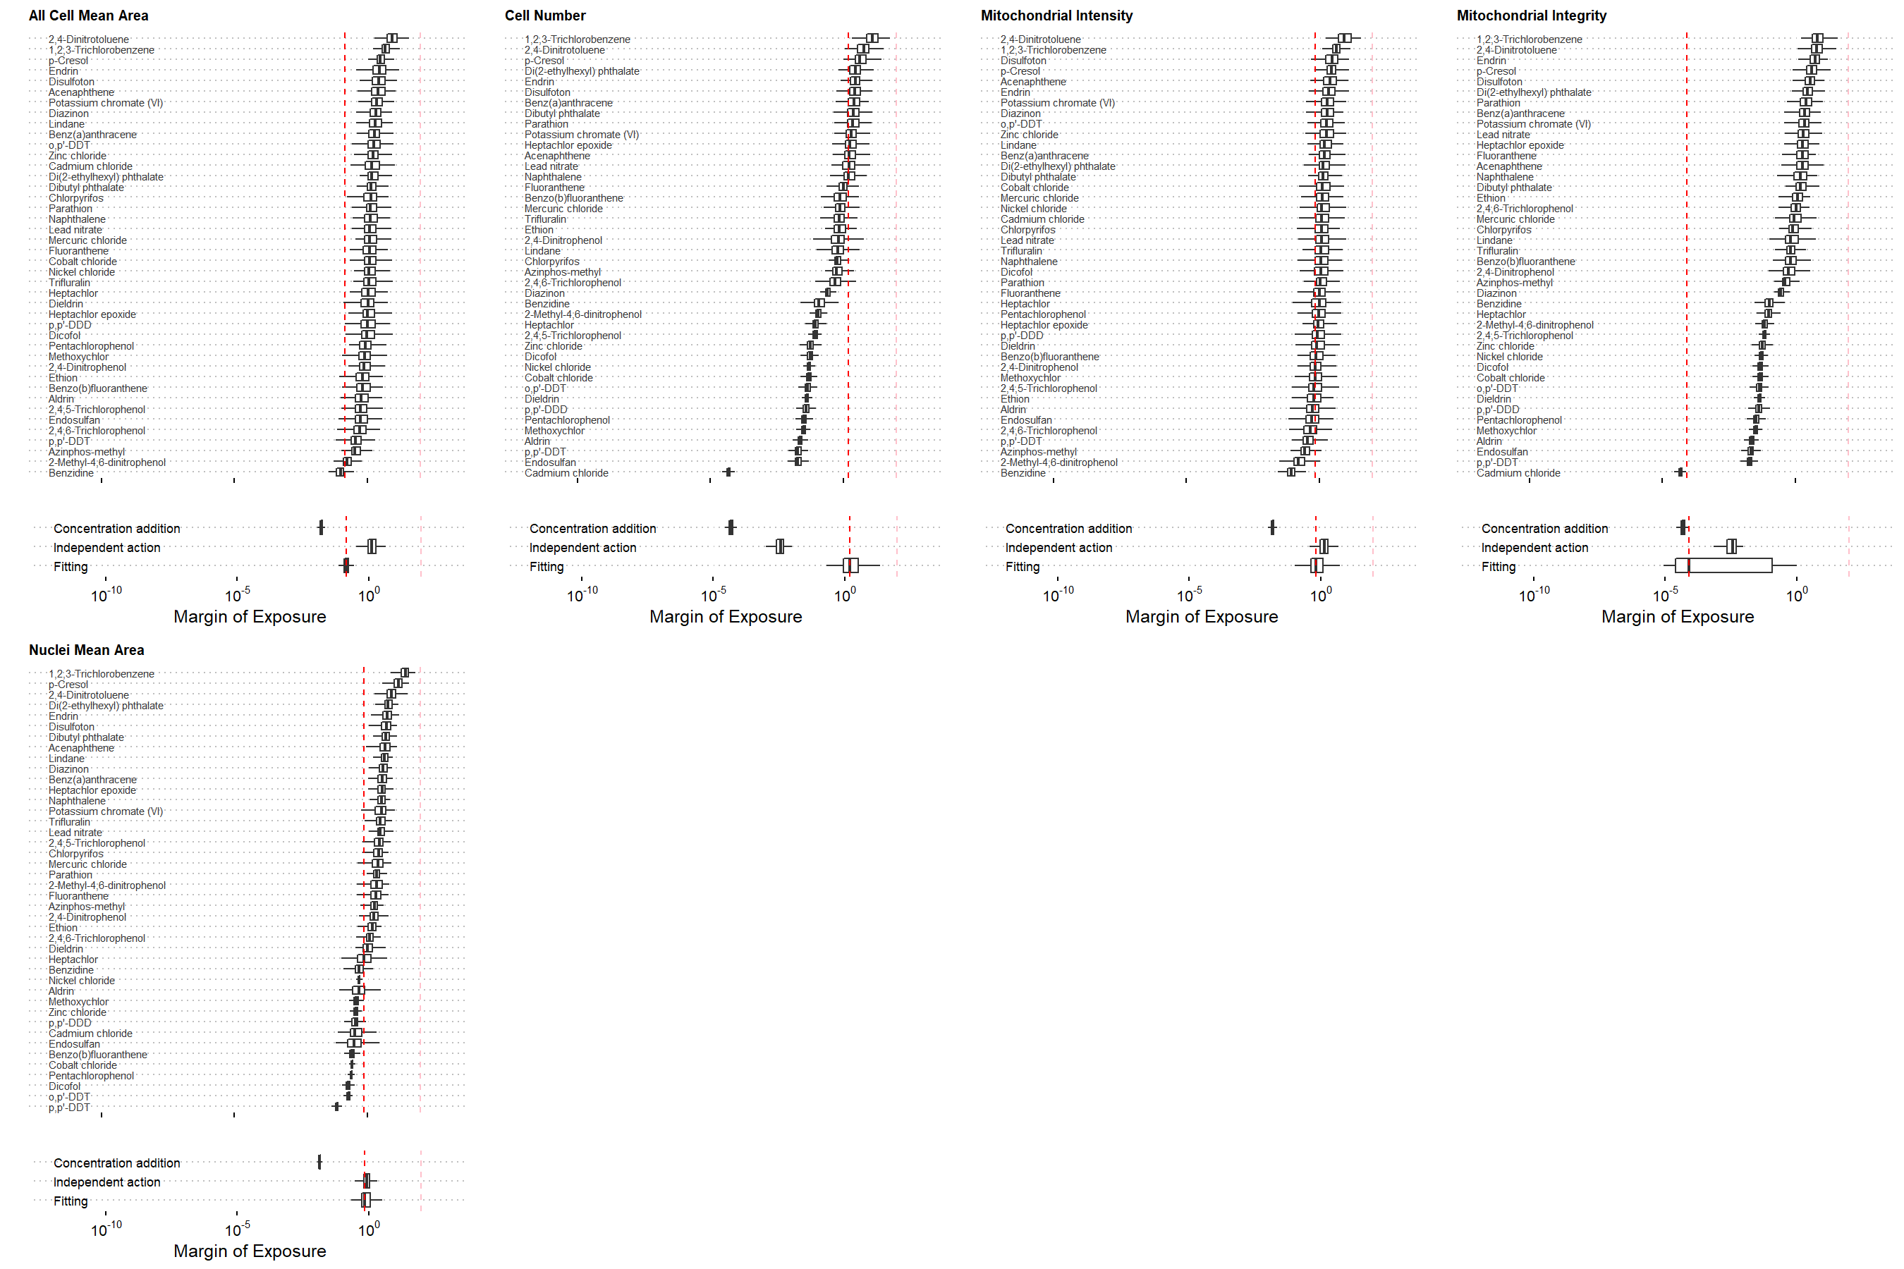

Figure S102. The estimation of the margin of exposure for cytotoxicity phenotypes in the iCell Hepatocytes.

### iCell Endothelial cells

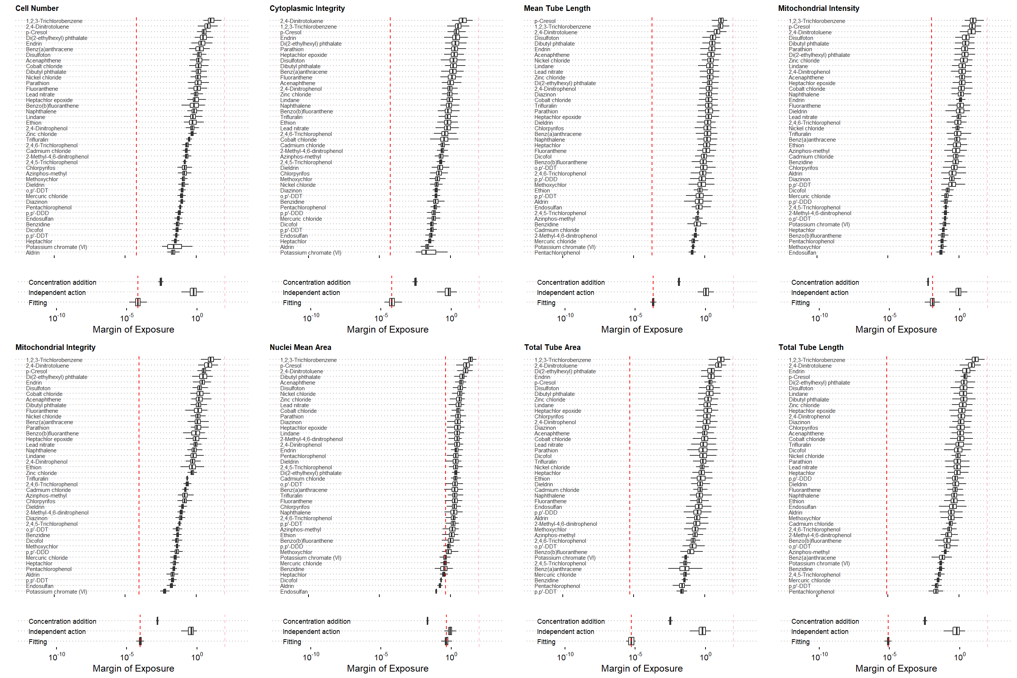

Figure S103. The estimation of the margin of exposure for cytotoxicity phenotypes in the iCell Endothelial cells.

### iCell Cardiomyocytes

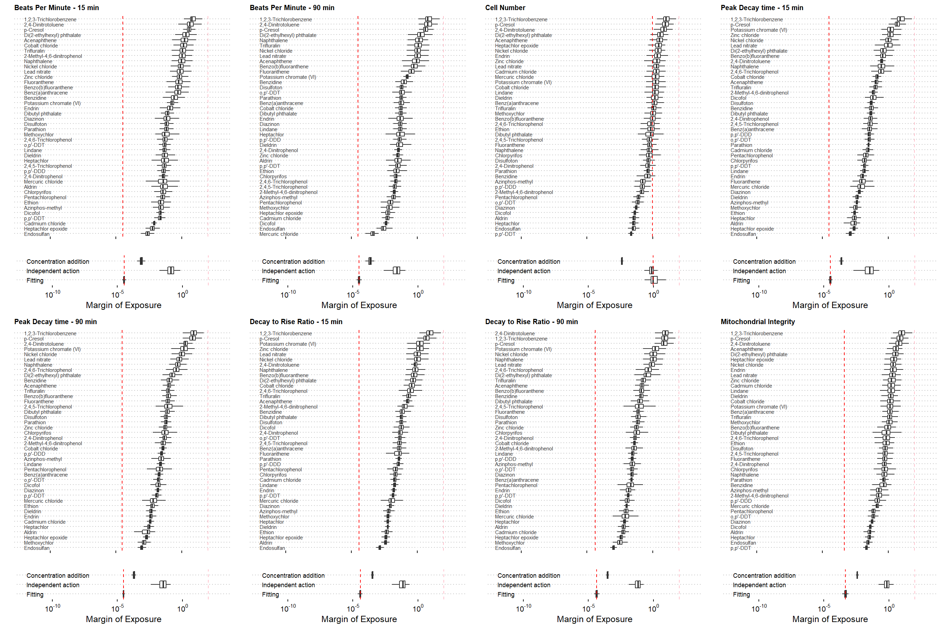

Figure S104. The estimation of the margin of exposure for cytotoxicity phenotypes in the iCell Cardiomyocytes.

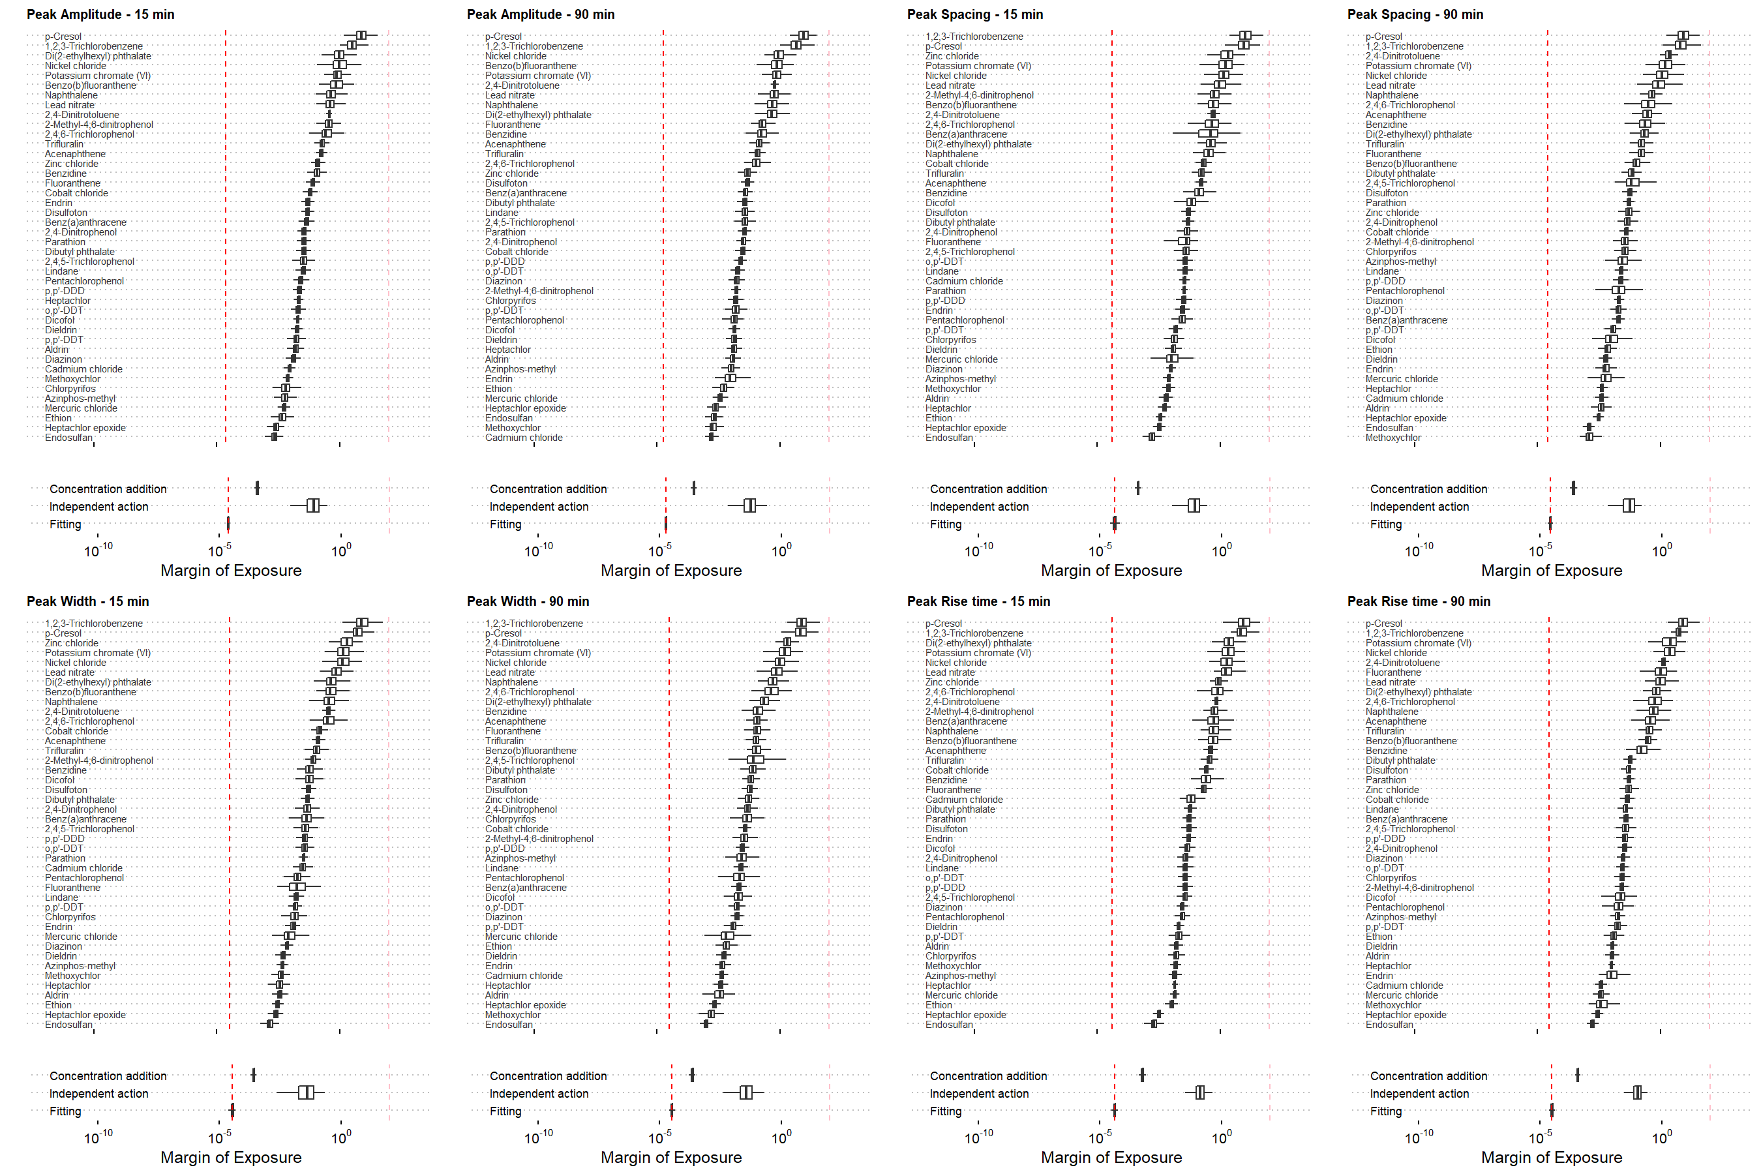

Figure S104. The estimation of the margin of exposure for cytotoxicity phenotypes in the iCell Cardiomyocytes (cont.).

# Session Information

─ Session info ───────────────────────────────────────────────────────────────  
 setting value   
 version R version 3.6.1 (2019-07-05)  
 os macOS Mojave 10.14.6   
 system x86_64, darwin15.6.0   
 ui X11   
 language (EN)   
 collate en_US.UTF-8   
 ctype en_US.UTF-8   
 tz America/Chicago   
 date 2020-09-10   
  
─ Packages ───────────────────────────────────────────────────────────────────  
 package * version date lib source   
 assertthat 0.2.1 2019-03-21 [1] CRAN (R 3.6.0)  
 backports 1.1.5 2019-10-02 [1] CRAN (R 3.6.0)  
 bayestestR * 0.5.2 2020-02-12 [1] CRAN (R 3.6.0)  
 broom 0.7.0 2020-07-09 [1] CRAN (R 3.6.2)  
 callr 3.4.0 2019-12-09 [1] CRAN (R 3.6.0)  
 cellranger 1.1.0 2016-07-27 [1] CRAN (R 3.6.0)  
 cli 2.0.0 2019-12-09 [1] CRAN (R 3.6.0)  
 colorspace 1.4-1 2019-03-18 [1] CRAN (R 3.6.0)  
 cowplot * 1.0.0 2019-07-11 [1] CRAN (R 3.6.0)  
 crayon 1.3.4 2017-09-16 [1] CRAN (R 3.6.0)  
 DBI 1.1.0 2019-12-15 [1] CRAN (R 3.6.0)  
 dbplyr 1.4.2 2019-06-17 [1] CRAN (R 3.6.0)  
 desc 1.2.0 2018-05-01 [1] CRAN (R 3.6.0)  
 devtools 2.2.1 2019-09-24 [1] CRAN (R 3.6.0)  
 digest 0.6.23 2019-11-23 [1] CRAN (R 3.6.0)  
 dplyr * 0.8.3 2019-07-04 [1] CRAN (R 3.6.0)  
 ellipsis 0.3.0 2019-09-20 [1] CRAN (R 3.6.0)  
 evaluate 0.14 2019-05-28 [1] CRAN (R 3.6.0)  
 fansi 0.4.0 2018-10-05 [1] CRAN (R 3.6.0)  
 forcats * 0.4.0 2019-02-17 [1] CRAN (R 3.6.0)  
 fs 1.3.1 2019-05-06 [1] CRAN (R 3.6.0)  
 generics 0.0.2 2018-11-29 [1] CRAN (R 3.6.0)  
 ggfittext 0.9.0 2020-06-14 [1] CRAN (R 3.6.2)  
 ggplot2 * 3.3.2 2020-06-19 [1] CRAN (R 3.6.2)  
 ggpubr * 0.2.5 2020-02-13 [1] CRAN (R 3.6.0)  
 ggridges * 0.5.1 2018-09-27 [1] CRAN (R 3.6.0)  
 ggsignif 0.6.0 2019-08-08 [1] CRAN (R 3.6.0)  
 glue 1.3.1 2019-03-12 [1] CRAN (R 3.6.0)  
 gridExtra * 2.3 2017-09-09 [1] CRAN (R 3.6.0)  
 gtable 0.3.0 2019-03-25 [1] CRAN (R 3.6.0)  
 haven 2.2.0 2019-11-08 [1] CRAN (R 3.6.0)  
 highr 0.8 2019-03-20 [1] CRAN (R 3.6.0)  
 hms 0.5.2 2019-10-30 [1] CRAN (R 3.6.0)  
 htmltools 0.4.0 2019-10-04 [1] CRAN (R 3.6.0)  
 httr 1.4.1 2019-08-05 [1] CRAN (R 3.6.0)  
 inline 0.3.15 2018-05-18 [1] CRAN (R 3.6.0)  
 insight 0.8.1 2020-02-02 [1] CRAN (R 3.6.0)  
 jpeg * 0.1-8.1 2019-10-24 [1] CRAN (R 3.6.0)  
 jsonlite 1.6 2018-12-07 [1] CRAN (R 3.6.0)  
 knitr * 1.26 2019-11-12 [1] CRAN (R 3.6.0)  
 lattice 0.20-38 2018-11-04 [2] CRAN (R 3.6.1)  
 lifecycle 0.2.0 2020-03-06 [1] CRAN (R 3.6.0)  
 loo 2.2.0 2019-12-19 [1] CRAN (R 3.6.0)  
 lubridate 1.7.9 2020-06-08 [1] CRAN (R 3.6.2)  
 magrittr * 1.5 2014-11-22 [1] CRAN (R 3.6.0)  
 matrixStats 0.55.0 2019-09-07 [1] CRAN (R 3.6.0)  
 memoise 1.1.0 2017-04-21 [1] CRAN (R 3.6.0)  
 modelr 0.1.5 2019-08-08 [1] CRAN (R 3.6.0)  
 munsell 0.5.0 2018-06-12 [1] CRAN (R 3.6.0)  
 PerformanceAnalytics * 2.0.4 2020-02-06 [1] CRAN (R 3.6.0)  
 pillar 1.4.3 2019-12-20 [1] CRAN (R 3.6.0)  
 pkgbuild 1.0.6 2019-10-09 [1] CRAN (R 3.6.0)  
 pkgconfig 2.0.3 2019-09-22 [1] CRAN (R 3.6.0)  
 pkgload 1.0.2 2018-10-29 [1] CRAN (R 3.6.0)  
 plyr 1.8.6 2020-03-03 [1] CRAN (R 3.6.0)  
 png 0.1-7 2013-12-03 [1] CRAN (R 3.6.0)  
 prettyunits 1.0.2 2015-07-13 [1] CRAN (R 3.6.0)  
 processx 3.4.1 2019-07-18 [1] CRAN (R 3.6.0)  
 ps 1.3.0 2018-12-21 [1] CRAN (R 3.6.0)  
 purrr * 0.3.3 2019-10-18 [1] CRAN (R 3.6.0)  
 quadprog 1.5-8 2019-11-20 [1] CRAN (R 3.6.0)  
 R6 2.4.1 2019-11-12 [1] CRAN (R 3.6.0)  
 Rcpp 1.0.3 2019-11-08 [1] CRAN (R 3.6.0)  
 readr * 1.3.1 2018-12-21 [1] CRAN (R 3.6.0)  
 readxl 1.3.1 2019-03-13 [1] CRAN (R 3.6.0)  
 remotes 2.1.0 2019-06-24 [1] CRAN (R 3.6.0)  
 reprex 0.3.0 2019-05-16 [1] CRAN (R 3.6.0)  
 reshape2 * 1.4.3 2017-12-11 [1] CRAN (R 3.6.0)  
 rlang 0.4.7 2020-07-09 [1] CRAN (R 3.6.2)  
 rmarkdown 2.0 2019-12-12 [1] CRAN (R 3.6.0)  
 rprojroot 1.3-2 2018-01-03 [1] CRAN (R 3.6.0)  
 rstan * 2.19.2 2019-07-09 [1] CRAN (R 3.6.0)  
 rstudioapi 0.10 2019-03-19 [1] CRAN (R 3.6.0)  
 rvest 0.3.5 2019-11-08 [1] CRAN (R 3.6.0)  
 scales * 1.1.0 2019-11-18 [1] CRAN (R 3.6.0)  
 sessioninfo 1.1.1 2018-11-05 [1] CRAN (R 3.6.0)  
 StanHeaders * 2.19.0 2019-09-07 [1] CRAN (R 3.6.0)  
 stringi 1.4.3 2019-03-12 [1] CRAN (R 3.6.0)  
 stringr * 1.4.0 2019-02-10 [1] CRAN (R 3.6.0)  
 testthat 2.3.1 2019-12-01 [1] CRAN (R 3.6.0)  
 tibble * 3.0.3 2020-07-10 [1] CRAN (R 3.6.2)  
 tidyr * 1.0.2 2020-01-24 [1] CRAN (R 3.6.0)  
 tidyselect 0.2.5 2018-10-11 [1] CRAN (R 3.6.0)  
 tidyverse * 1.3.0 2019-11-21 [1] CRAN (R 3.6.0)  
 tiff * 0.1-5 2013-09-04 [1] CRAN (R 3.6.0)  
 treemapify * 2.5.3 2019-01-30 [1] CRAN (R 3.6.0)  
 usethis 1.5.1 2019-07-04 [1] CRAN (R 3.6.0)  
 vctrs 0.3.2 2020-07-15 [1] CRAN (R 3.6.2)  
 withr 2.1.2 2018-03-15 [1] CRAN (R 3.6.0)  
 xfun 0.11 2019-11-12 [1] CRAN (R 3.6.0)  
 xml2 1.2.2 2019-08-09 [1] CRAN (R 3.6.0)  
 xts * 0.12-0 2020-01-19 [1] CRAN (R 3.6.0)  
 yaml 2.2.0 2018-07-25 [1] CRAN (R 3.6.0)  
 zoo * 1.8-7 2020-01-10 [1] CRAN (R 3.6.0)  
  
[1] /Users/wchiu/Library/R/3.6/library  
[2] /Library/Frameworks/R.framework/Versions/3.6/Resources/library